June 8, 2022

Michael Pierce
Video Franchising and Broadband Development Group
Communications Division
California Public Utilities Commission
505 Van Ness Avenue
San Francisco, CA 94102

SUBJECT: Cox Communications Video Service Application

Dear Mr. Pierce:

In accordance with California’s Digital Infrastructure Video Competition Act (DIVCA), Cox Communications California, L.L.C., doing business as Cox Communications, respectfully submits the following amendment to our existing state authorized Franchise Number 0003 to provide video service to a limited area within the county of San Diego. This area is currently not provided video service from Cox Communications. We request the state franchise amendment covering this area be effective on August 1, 2022.

Enclosed is a copy of the state authorized amended franchise application, pursuant to California Public Utilities Code § 5840(e), utilizing the 2020 Census Bureau’s census geometry. A copy of this application has been mailed to the aforementioned local franchise authority.

Should you have any questions or require additional information, please contact myself at 858-836-7313 or by email at Marcie.Evans@cox.com.

Sincerely,

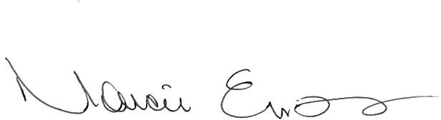

Marcie Evans
Senior Analyst, Regulatory Affairs
Cox Communications

Enclosure: State Franchise Application

