

CPUC 2025 PG Model User's Guide

**Prepared for California Public Utilities Commission**

*April 25, 2025*

Table of Contents

Overview iv

1. Introduction To Analytica 1

1.1 Downloads 1

1.2 Introductory Videos 1

1.3 User Guide Excerpts 2

1.3.1 Toolbar Introduction 3

1.3.2 Classes of Variables and Objects 3

1.3.3 Influence Diagrams 5

1.3.4 Input/Output Nodes 6

1.3.5 Numeric Suffixes 6

1.3.6 Attributes of a Variable 7

1.3.7 Attribute Panel 8

1.3.8 Result Viewing Options 9

2. CPUC PG Desktop Model 2

2.1 Opening the Model 2

2.2 Changing Key Model Settings and Viewing Results 4

2.2.1 Exercise: Using Measure Filters 5

2.2.2 Exercise: Viewing Key Outputs in the GUI 8

2.2.3 Exercise: Changing Key Inputs in the GUI 9

2.2.4 Exercise: Pivoting and Customizing Result Tables and Graphs 11

2.2.5 Exercise: Copying and Pasting Results into Excel 15

2.2.6 Exercise: Finding a Variable using its Identifier 18

2.3 Navigating Through Model Logic 19

2.3.1 Exercise: Navigating using the Module Hierarchy 19

2.3.2 Exercise: Navigating using the Model Details 21

Table of FIgures

Figure 2‑1. Initial Pop-up 2

Figure 2‑2. Disclaimer and Terms of Use 3

Figure 2‑3. Graphical User Interface 4

Figure 2‑4. Measure Filters Module in Top-level GUI 5

Figure 2‑5. Measure Filters GUI 5

Figure 2‑6. Set the First Filter Category to Utility 6

Figure 2‑7. Set the First and Second Filter Elements 6

Figure 2‑8. Location of Calc Button for Incremental_Market_P in GUI 7

Figure 2‑9. Verifying Index Elements in Result Window 7

Figure 2‑10. Accessing Key Outputs in GUI 8

Figure 2‑11. Accessing Measure-Level Outputs 9

Figure 2‑12. Location of Calc Button for Economic Potential 9

Figure 2‑13. Edit Table for Benefit-Cost Threshold 10

Figure 2‑14. Verifying Impact of Changing B/C Ratio 10

Figure 2‑15. Default Graphical View of Incremental_Market_P 12

Figure 2‑16. Changing Graph Key to Selected Building Types 12

Figure 2‑17. Result Graph after Key Change 13

Figure 2‑18. Opening the Graph Setup Dialog Box 13

Figure 2‑19. Customizing Chart Type 14

Figure 2‑20. Graphical View after Changing Chart Type to Stacked Bar Graph 15

Figure 2‑21. Switching from Graphical View to Tabular View 15

Figure 2‑22. Copy Table Function Illustration in Analytica 16

Figure 2‑23. Excel Paste Illustration 16

Figure 2‑24. Pasted Multi-Dimensional Data in Excel 17

Figure 2‑25. Copying a Slice of a Data Table 18

Figure 2‑26. Pasted Data Slice in Excel 18

Figure 2‑27. Searching for an Object Based on its Identifier 19

Figure 2‑28. Diagram Window with Variable Highlighted 19

Figure 2‑29. Show Module Hierarchy Preference Setting 20

Figure 2‑30. Access Building Stock Module Using Module Hierarchy 21

Figure 2‑31. Example Influence Diagram 21

[Figure 2‑32. Accessing Model Details 22](https://accesshub.sharepoint.com/sites/CPUC2023PGStudy/Shared%20Documents/Deliverables/PG%20Study%20Model/CPUC%20PG%20Model%20User's%20Guide%202023.docx#_Toc132631956)

Figure 2‑33. Accessing the Building Stock Module 22

Overview

Guidehouse and its partners prepared this 2025 Potential and Goals Study for the California Public Utilities Commission (CPUC). The purpose of this study is to develop estimates of energy and demand savings potential in the service territories of California’s major investor-owned utilities (IOUs) during the post-2025 energy efficiency (EE) rolling portfolio planning cycle.

A key component of the 2025 Study is the Potential and Goals Model (PG Model), which provides a single platform in which to conduct robust quantitative scenario analysis that reflects the complex interactions among various inputs and policy drivers. The model was built in the Analytica platform.

This document provides helpful material for getting started with Analytica as well as links to more comprehensive Analytica tutorials and user guides. Guidehouse has organized information in the following sections:

* General Analytica Instructions:
  + Downloads: How to download Analytica and reference documents
  + Introductory Videos: Links to videos that provide a good first stop for background on how to use Analytica
  + User Guide Excerpts: Highlights from the comprehensive Analytica users guide for quick reference
  + Useful Shortcut Keys: Table of shortcut keys in Analytica
* CPUC PG Desktop Model: how to use run CPUC PG Model on your desktop.

# Introduction To Analytica

## Downloads

Visit [this page](https://lumina.com/support-2/analytica-downloads/) to download and install Analytica 6.5. The Analytica Free 101 edition is free and will allow you to run the model.

Tips and recommended documents:

* Check your system properties (Windows Button->Computer->System Properties->System Type) to figure out if you have 32- or 64-bit operating system.
* Download the appropriate free version.
* New users are strongly encouraged to complete the Tutorial document (see "Tutorial" under "Help" menu when you open Analytica). The following tutorials are applicable to model users:
  + [Tutorial: Open a model to browse](http://wiki.analytica.com/index.php?title=Tutorial%3A_Open_a_model_to_browse)
  + [Tutorial: Reviewing a model](http://wiki.analytica.com/index.php?title=Tutorial%3A_Reviewing_a_model)
  + [Tutorial: Analyzing a model](http://wiki.analytica.com/index.php?title=Tutorial%3A_Analyzing_a_model)
* A user's guide is also available under the "Help" menu when you open Analytica.

Additional information on computer needs from Lumina Decision Systems (maker of Analytica):

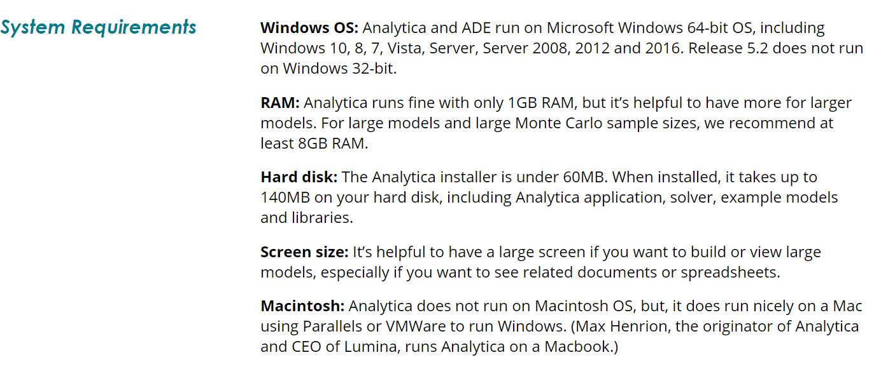

Source: <https://lumina.com/support-2/analytica-downloads/>

## Introductory Videos

Guidehouse recommends viewing the following introductory videos from Lumina:

* Introduction to Analytica
  + <https://www.youtube.com/watch?v=9s40FjHBm3E>
* Getting Started with Analytica
  + <https://www.youtube.com/watch?v=2rm6WTn2js0>
* Analytica Tutorial Chapter 1
  + <https://www.youtube.com/watch?v=GQV0dnDN0Q0>
* Analytica Tutorial Chapter 2
  + <https://www.youtube.com/watch?v=mpF4xcmKaao>
* Analytica Tutorial Chapter 3
  + <https://www.youtube.com/watch?v=scVOq29NMG4>

## User Guide Excerpts

Guidehouse has selected the following excerpts from the Lumina-produced user guide to highlight key terminology and navigation features in Analytica. All figures that appear in this section are sourced from the Lumina-produced users guide.[1]

### Toolbar Introduction

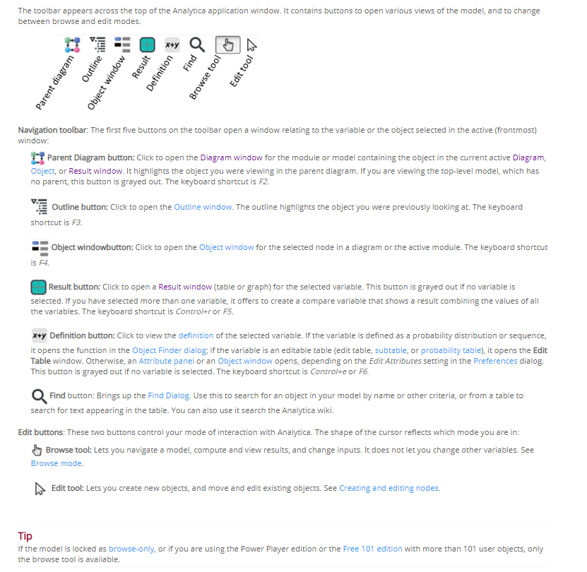

Source: Lumina

### Classes of Variables and Objects

The descriptions provided below are generalized and your model may not align with these definitions exactly. This is especially true for decision nodes in the model, which often represent a user input, rather than a decision to make. Furthermore, the model often employs constant nodes to depict imported data in addition to fixed conversion factors. Lastly, the color scheme within the model may differ from the information below.

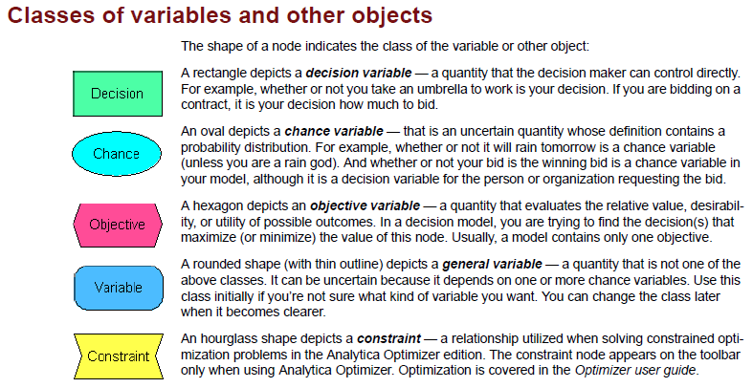

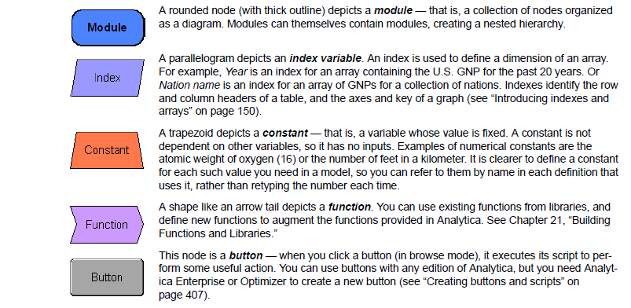

Source: Lumina

### Influence Diagrams

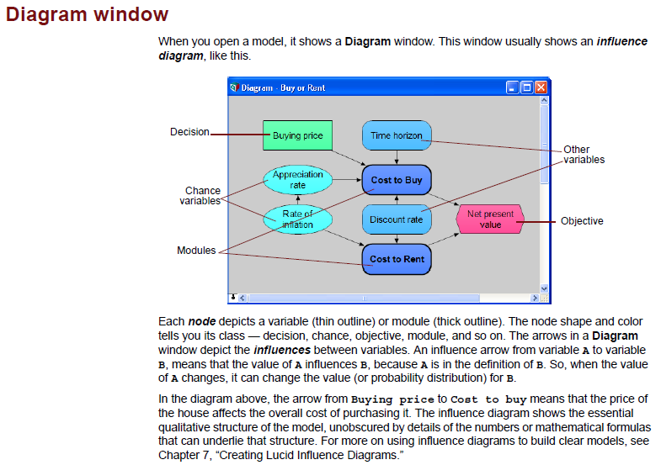

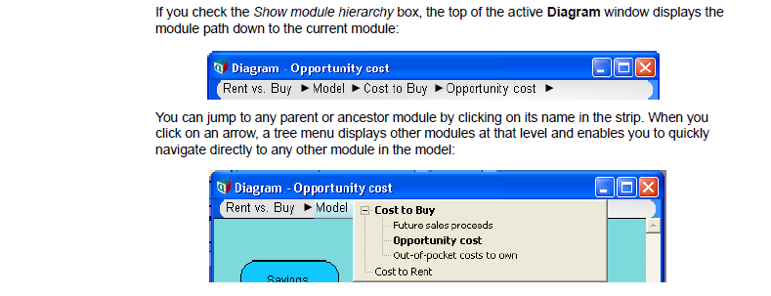

Source: Lumina

### Input/Output Nodes

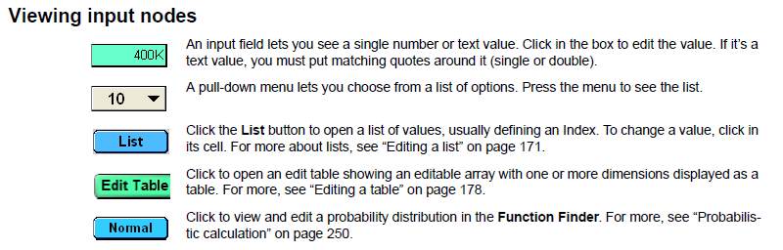

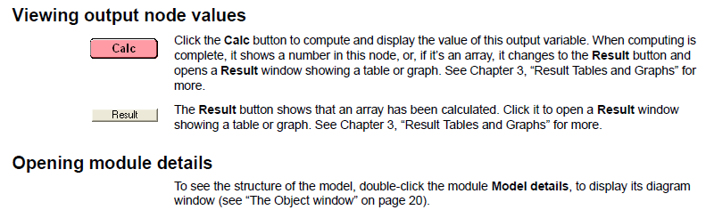

Source: Lumina

### Numeric Suffixes

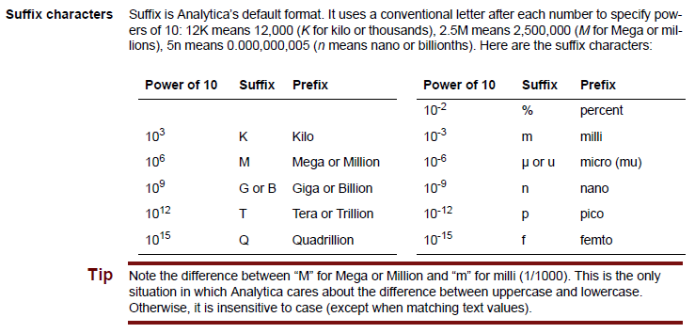

Source: Lumina

### Attributes of a Variable

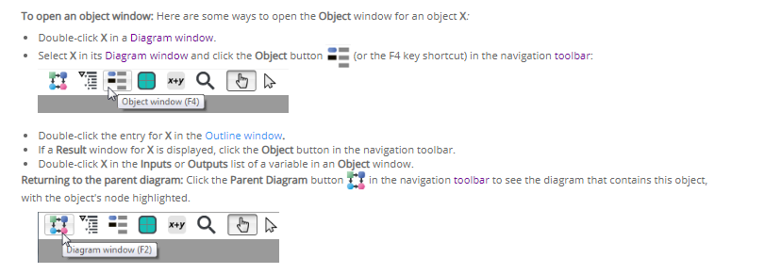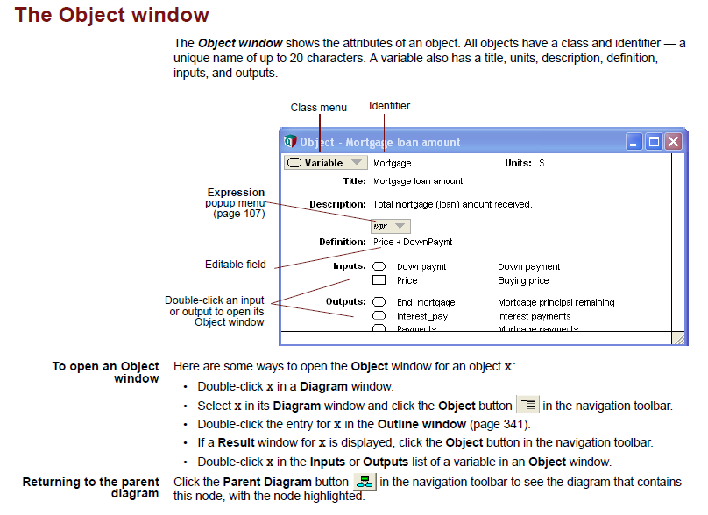

Source: Lumina

### Attribute Panel

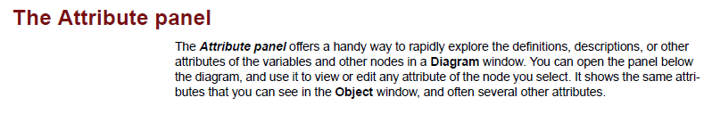

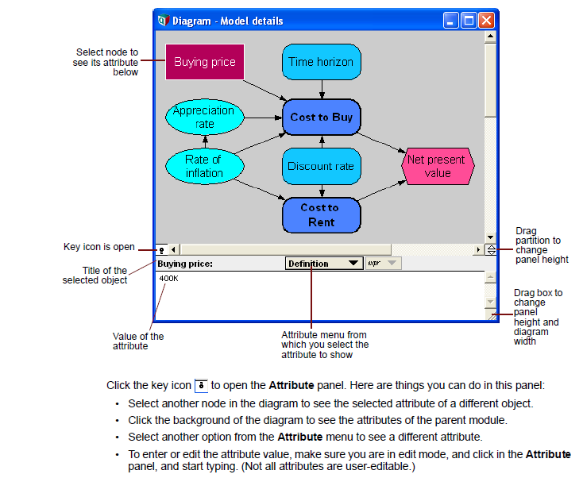

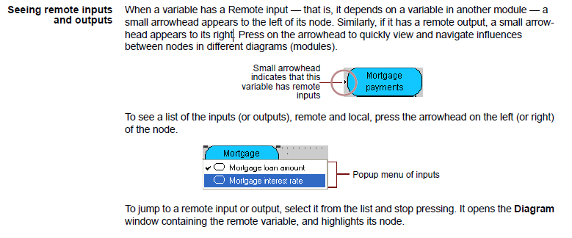

Source: Lumina

### Result Viewing Options

There are many options for viewing results. Note that in the uncertainty view menu, only the “Mid value” (i.e., deterministic results) is valid because this is not a probabilistic model.

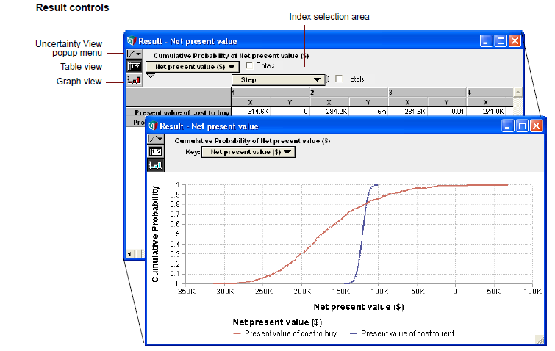

Source: Lumina

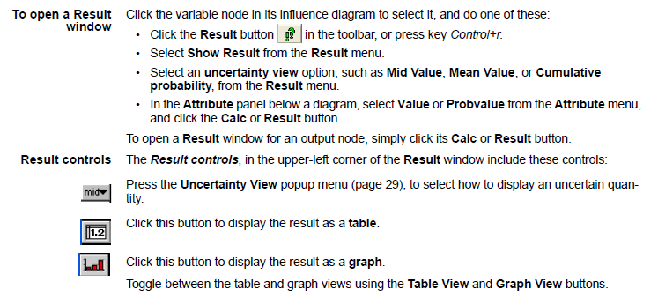

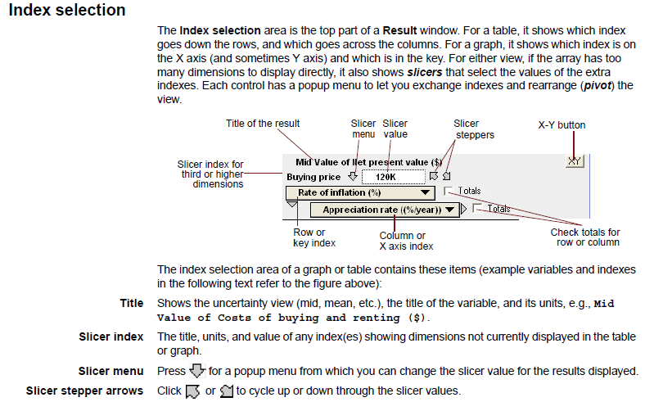

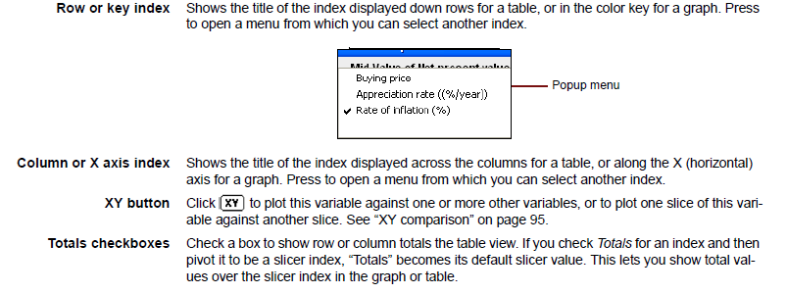

Source: Lumina

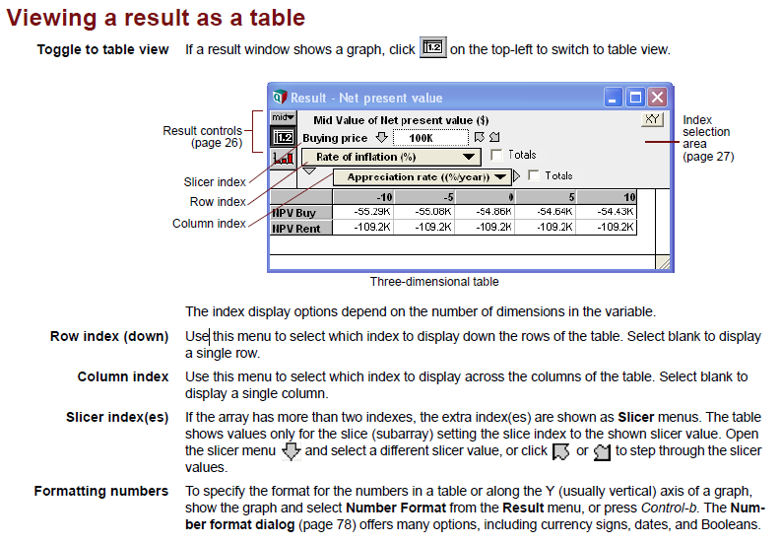

Source: Lumina

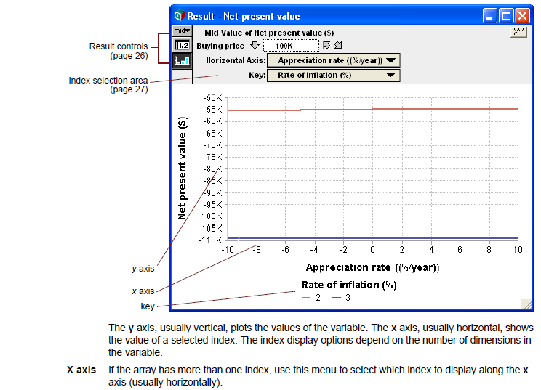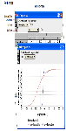

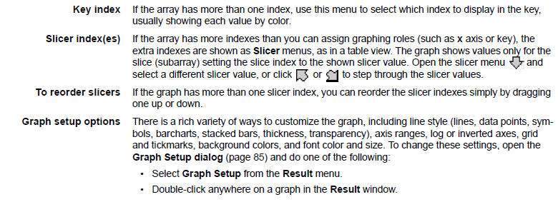

Source: Lumina

# CPUC PG Desktop Model

This section provides exercises related to changing key model settings and viewing results. To perform these exercises, you will first need to open the model.

## Opening the Model

Open the model by double-clicking on the CPUC_2025_PG_Model_PublicVersion.ana file in the folder where it resides. After you have opened the model file, you will see an “Information” pop-up like the one shown in Figure 2‑1 if you are using Analytica Free 101. This is not an error and will not cause any issues with the model. Click “OK” to proceed to the Disclaimer and Terms of Use.

Figure ‑. Initial Pop-up

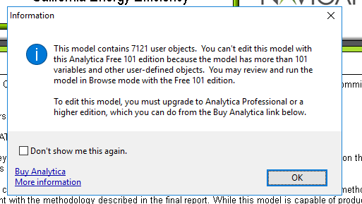

The next screen will show the disclaimer, terms of use, and runtime notes as shown in Figure 2‑2. Click “Accept” to proceed to the main top-level Graphical User Interface (GUI) as shown in Figure 2‑3.

Figure ‑. Disclaimer and Terms of Use

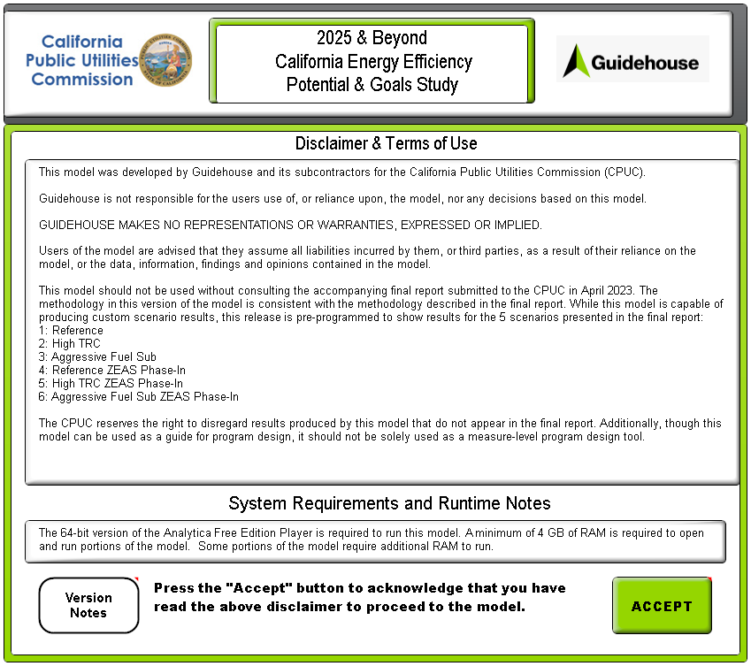

Figure ‑. Graphical User Interface

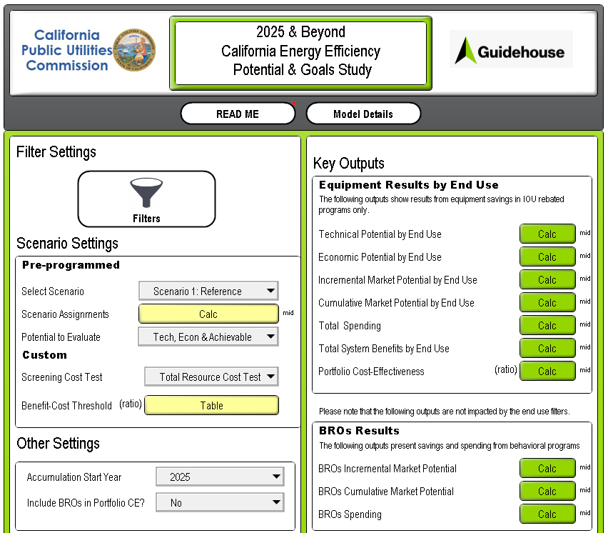

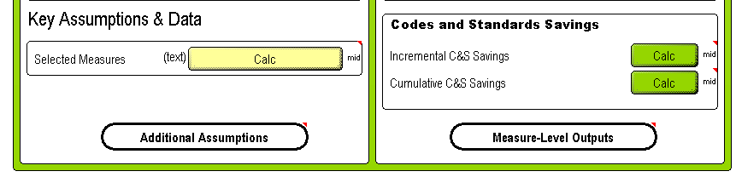

## Changing Key Model Settings and Viewing Results

Note that the figures in this section are illustrative. For the most up-to-date modeling results, please use the results viewing dashboard or the model.

### Exercise: Using Measure Filters

**Goal**: In this exercise, you will learn how to use measure filters to run subsets of the model based on the available filters provided: building type, utility, end use, replacement type, and measure name. By using filters you decrease the amount of data the model processes decreasing model run time and RAM usage.

1. Open the “Filters” module by double-clicking on the module (or use Ctrl+f to search for the Filters identifier)

Figure ‑. Measure Filters Module in Top-level GUI

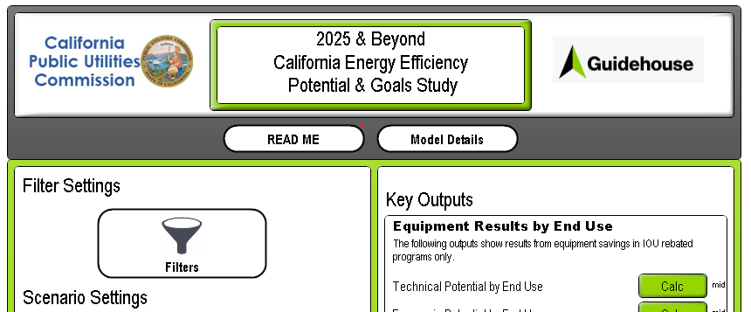

This should then open the GUI. Depending on the utility and model version, there may already be a set of filters that have been applied. For the purposes of this exercise, please set all the filter drop-downs to “None”, as shown below.

Figure ‑. Measure Filters GUI

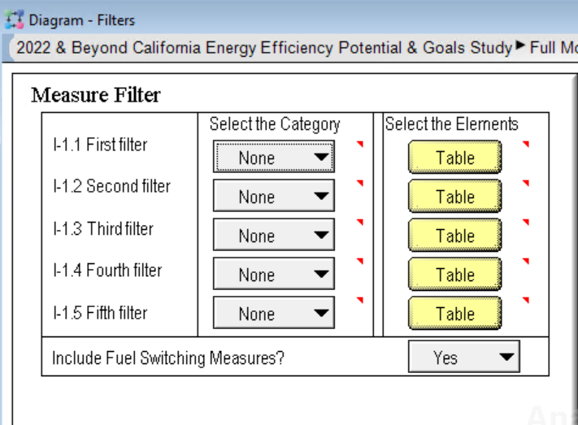

1. Next, the goal is to run a subset of the model by selecting one utility and a subset of building types. To do this, set the first filter category to “Utility” and the second filter category to “Building Type” using the drop-down menus.

Figure ‑. Set the First Filter Category to Utility

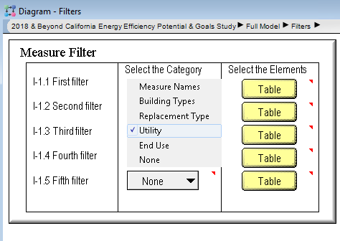

Once the filter categories for the first and second filters have been set, the filter elements need to be selected by clicking on the “Edit Table” buttons as shown below to the right of the drop-down menus. For this exercise, select only one service territory as appropriate (e.g., PG&E) and only the building types that correspond to the commercial sector. This is done by placing 1s next to the elements to be included and 0s next to elements to be excluded. Copy-paste functionality is supported in tables. Figure 2‑7 below illustrates the use of the “Edit Tables” to select filter elements for one service territory (PG&E) and the commercial sector.

Figure ‑. Set the First and Second Filter Elements

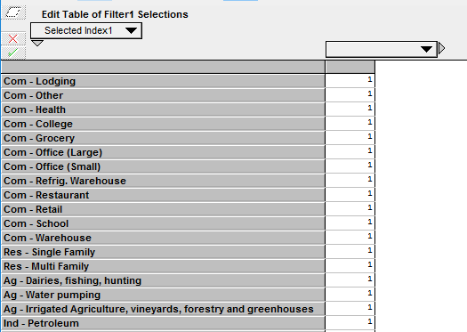 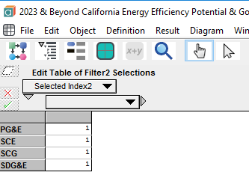

1. To verify that the filter settings are correct, go to the top-level GUI and click the “Calc” button next to “Incremental Market Potential by End Use” under the “Key Outputs” section (or use Ctrl+f to search for the identifier Incremental_Market_P).

Figure ‑. Location of Calc Button for Incremental_Market_P in GUI

After the result has been computed, you can verify that the drop-downs for “Selected Building Types” and “Selected Utilities” are correct by clicking on the downward facing arrow next to each Index element as shown below.

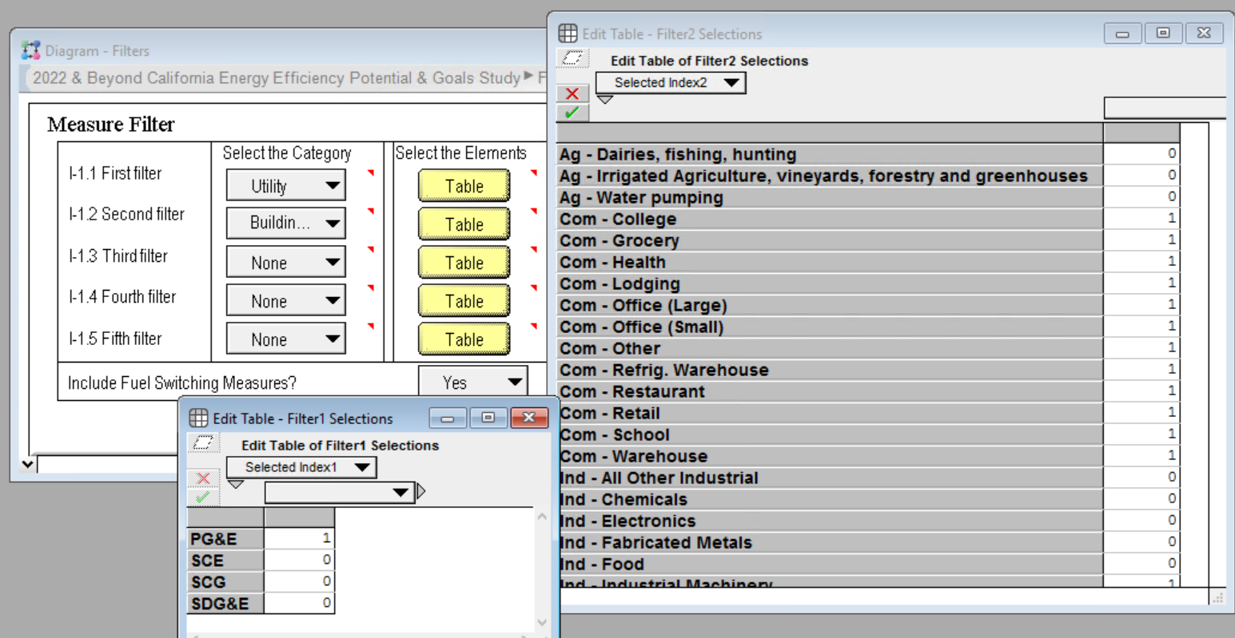

Figure ‑. Verifying Index Elements in Result Window

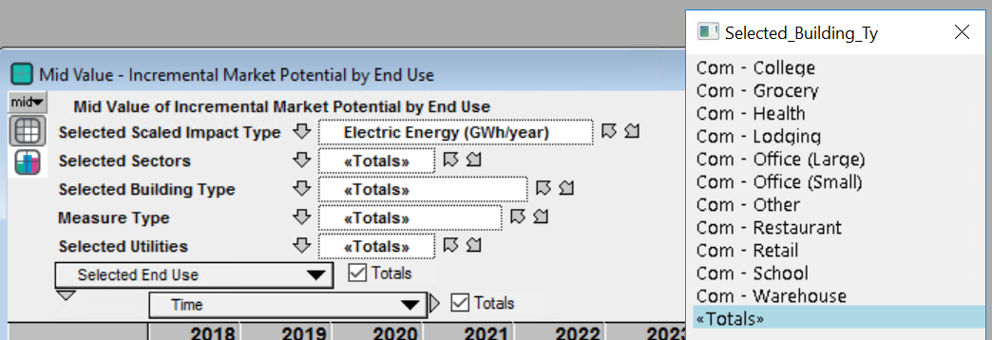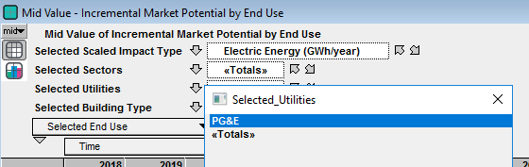

**Optional Task**: For further practice, go back to the “Measure Filters” module and select residential building types to run in addition to the commercial building types. Now go back and recompute Incremental_Market_P to verify that the appropriate building types show up in the “Selected Building Types” index.

### Exercise: Viewing Key Outputs in the GUI

**Goal:** The goal of this exercise is to use the GUI to display model results.

1. Navigate to the right-hand side of the GUI to access key outputs. Hover over any of the text to the left of the “Calc” buttons to see a description of the node. Then, click on the “Calc” button to generate results for the settings selected on the left-hand side of the GUI. **Depending on the filters applied and output result, these results can take a few seconds to several minutes to run**. A progress bar will apear as the model is running to indicate status of calcultions.

Figure ‑. Accessing Key Outputs in GUI

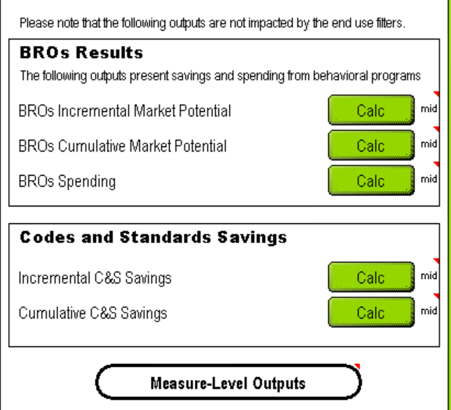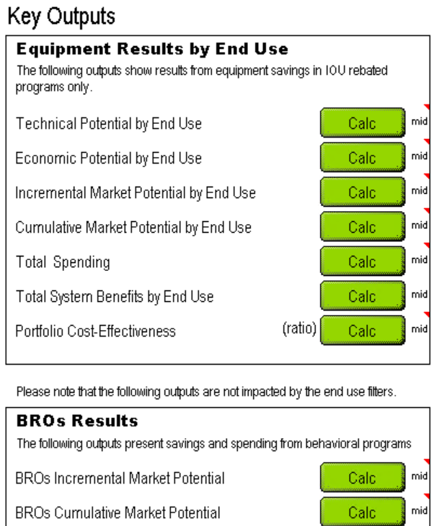

1. To access outputs displayed by measure, double click on the node labeled ‘Measure-Level Outputs”. This will open a window as shown in Figure 2‑11, and results can be viewed by clicking on any of the green buttons.

Figure ‑. Accessing Measure-Level Outputs

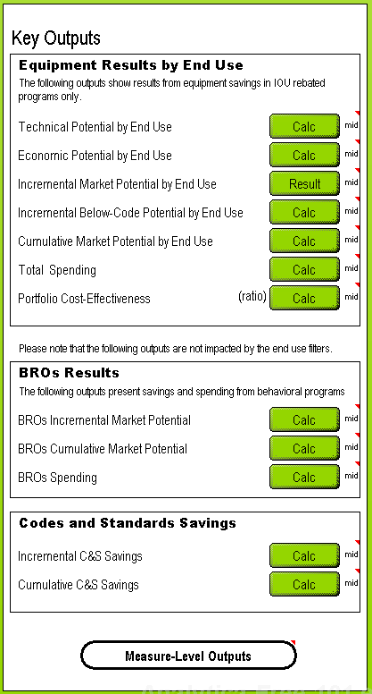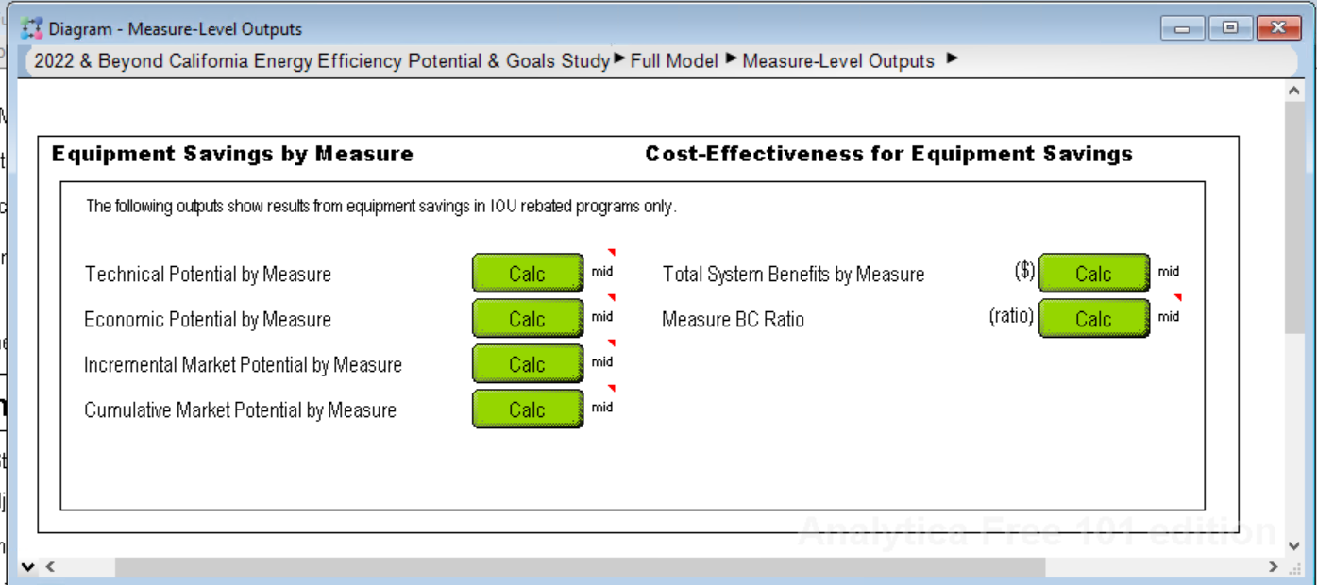

### Exercise: Changing Key Inputs in the GUI

**Goal:** The goal of this exercise is to make a change to one or more key inputs in the GUI and re-evaluate the model. This will help you get familiar with making changes to model settings and inputs using the customized GUI.

1. Evaluate “Economic Potential by End Use” to examine the Economic Potential before making custom changes to the cost settings.

Figure ‑. Location of Calc Button for Economic Potential

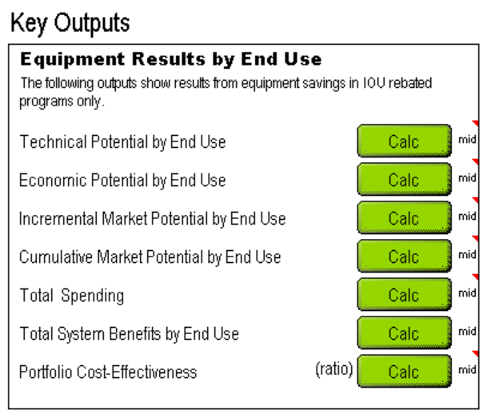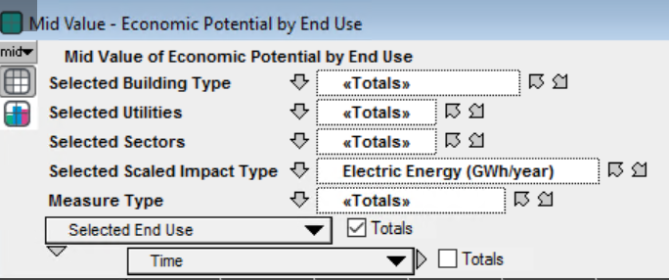

1. Click on the “Table” button next to “Benefit-Cost Threshold” and change the ratio for Commercial to 0.85 as illustrated in Figure 2‑13.

Figure ‑. Edit Table for Benefit-Cost Threshold

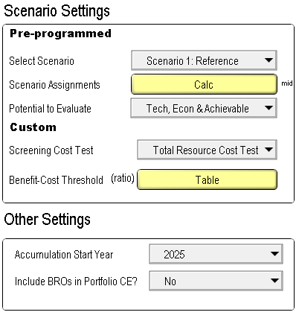

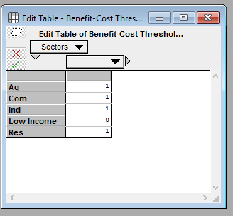

1. To verify the impact of changing this input, evaluate the output node “Economic Potential by End Use”. You should now see a noticeable increase in the Economic Potential due to a lowering of the Benefit-Cost Threshold, as illustrated in Figure 2‑14 below.

Figure ‑. Verifying Impact of Changing B/C Ratio

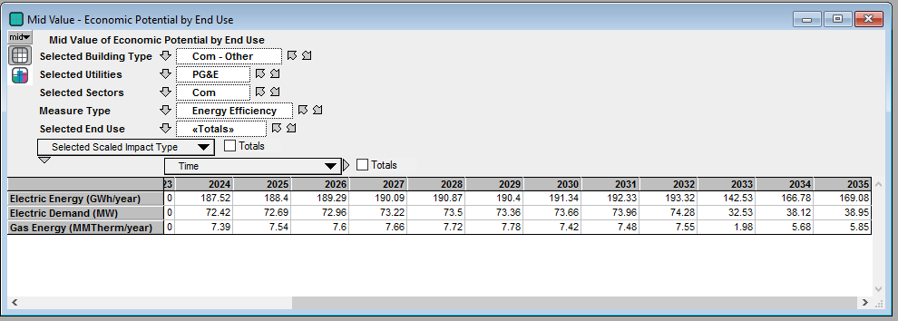

B/C Ratio: 1.0

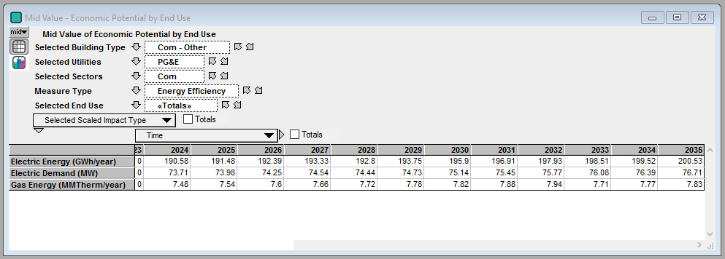

B/C Ratio: 0.85

**Note:** While this exercise only covered changing the B/C Threshold, all dropdown menus, tables, and input fields on the left-hand side of the GUI can all be modified to generate custom results. Note that selecting a scenario under “Pre-Programmed” scenarios will auto-populate all fields according to the table “Scenario Assignments”. Additional inputs can be found by double-clicking the “Additional Assumptions” module.

### Exercise: Pivoting and Customizing Result Tables and Graphs

**Goal:** The goal of this exercise is to learn how to pivot indexes in result tables as well as to customize graphs. When representing multi-dimensional results, Analytica will display only a two-dimensional slice of the data. This exercise will show you how to change the orientation and selection of data by pivoting the graph or table. It will also illustrate how to make changes to graph settings.

1. For this exercise, you will first run the model with customer segments across a subset of building types. Using the “Filters” module, select your desired customer segments. The example shown in Figure 2‑15 was run with the first four Commercial segments selected.
2. Re-evaluate the result node “Incremental Market Potential by End Use” (Incremental_Market_P). You should see a default graphical view as shown in Figure 2‑15 with “Time” on the horizontal axis and “Incremental Market Potential by End Use” on the vertical axis. The task is to pivot this graph such that we can graphically view the sum total achievable potential across all building types over time.

Figure ‑. Default Graphical View of Incremental_Market_P

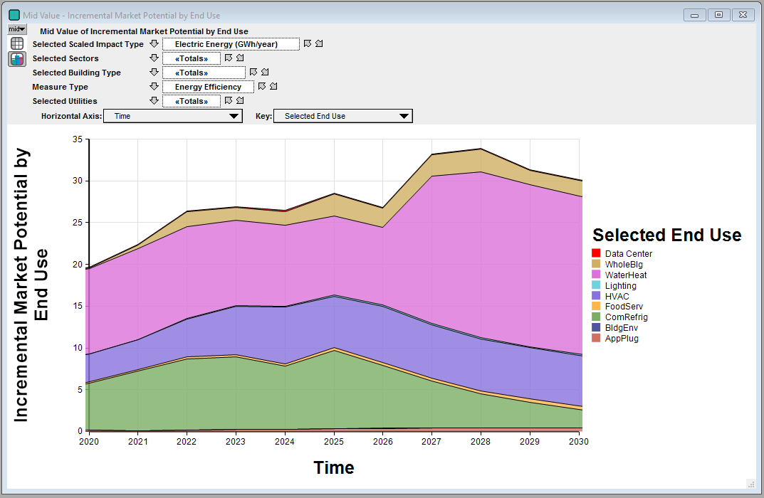

1. To accomplish this, click on the drop-down next to “Key” and select “Selected Sectors” from there as shown in Figure 2‑16. The updated result graph should look like the screenshot in Figure 2‑17.

Figure ‑. Changing Graph Key to Selected Building Types

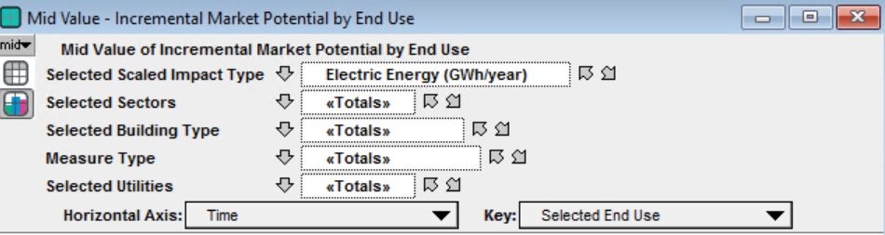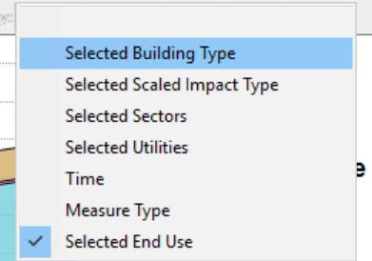

Figure ‑. Result Graph after Key Change

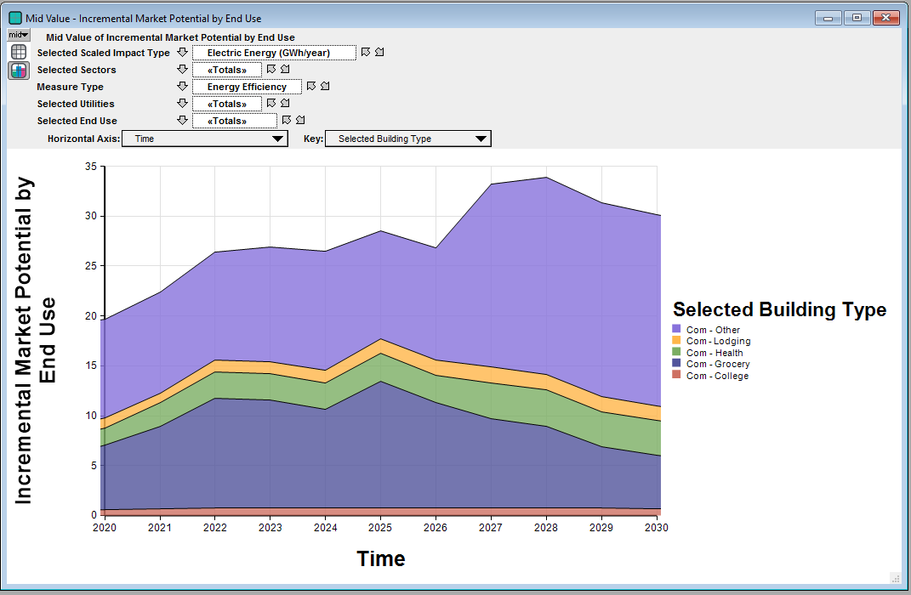

1. Next, to graphically view achievable potential across both selected sectors, right click on the graph and select “Graph setup” to open the dialog box as shown below (alternatively, you can double-click on the graph to open the dialog box).

Figure ‑. Opening the Graph Setup Dialog Box

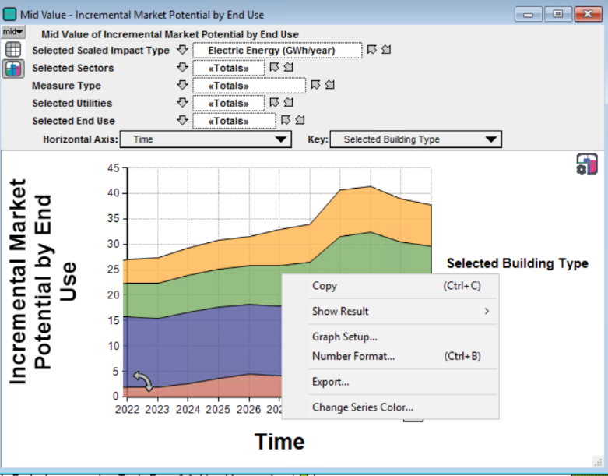

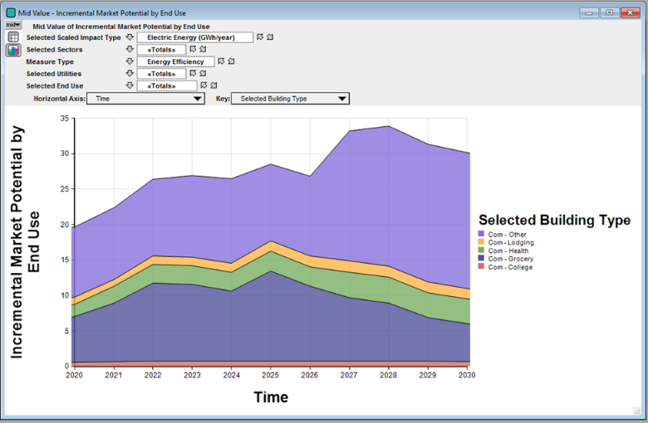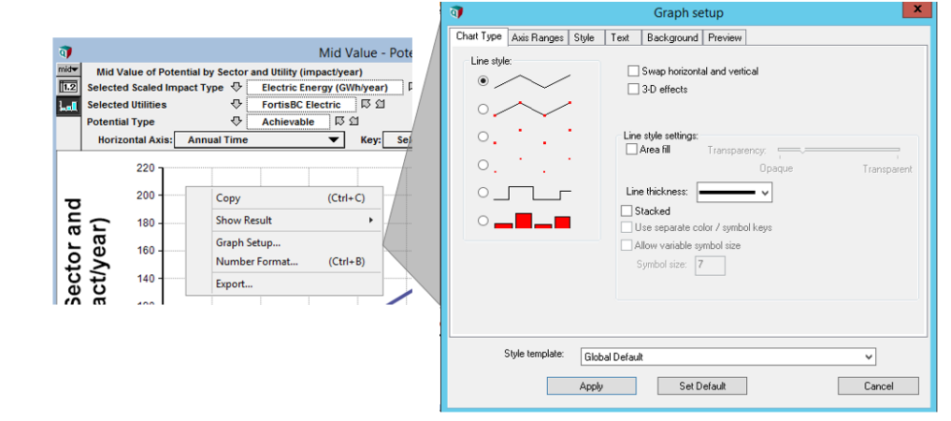

1. You will now customize the Chart Type by selecting the “bar graph” icon under “Line style” and checking the box next to “Stacked”, before clicking on “Apply”. The updated graph should resemble Figure 2‑20.

Figure ‑. Customizing Chart Type

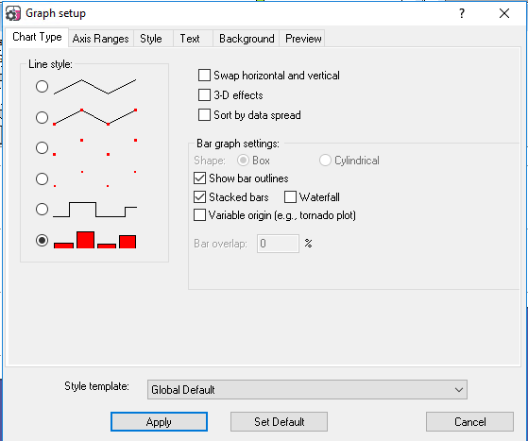

Figure ‑. Graphical View after Changing Chart Type to Stacked Bar Graph

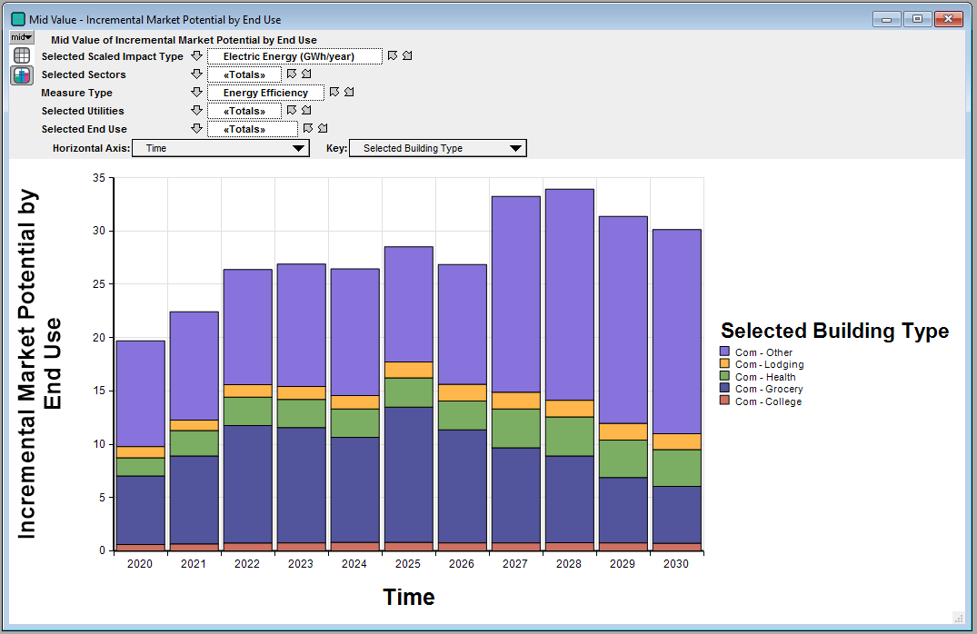

1. Finally, switch from the Graphical view to the Tabular view in Analytica by clicking on the numbered icon as shown on the top left of the graph.

Figure ‑. Switching from Graphical View to Tabular View

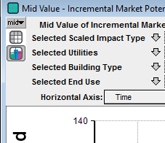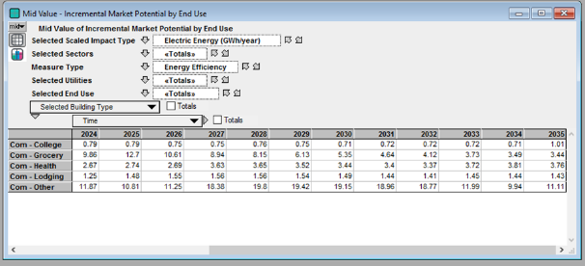

### Exercise: Copying and Pasting Results into Excel

There are several methods to copy and paste results to Excel. This exercise walks through each of those methods.

**Goal**: The goal of this exercise is to manually copy and paste results from the model into Excel using the CopyTable feature to copy multi-dimensional results into Excel. This offers a quick and easy way to port results into Excel. The one caveat about this approach is that the multi-dimensional results when pasted into Excel are in a format that makes it difficult to manipulate easily (e.g. using Pivot tables).

1. Re-evaluate Incremental_Market_P and switch to the Tabular view. Right-click on the table and select “Copy Table” as shown below.

Figure ‑. Copy Table Function Illustration in Analytica

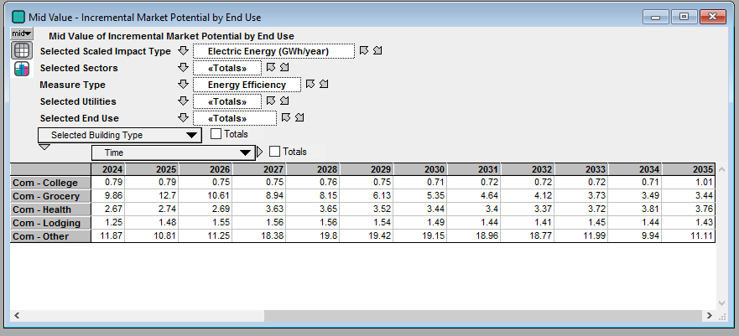

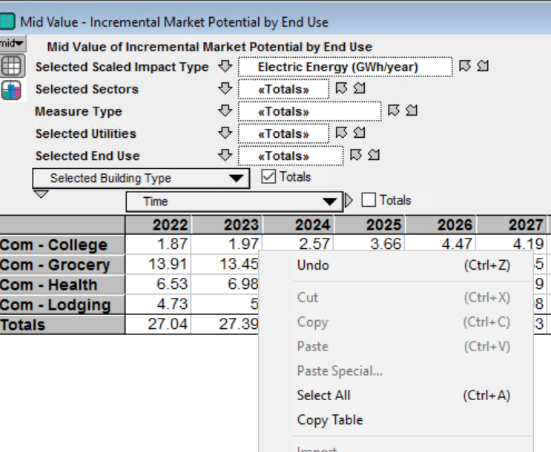

1. To paste the results, open a new Microsoft Excel workbook and right-click in an empty cell before selecting the “Paste” icon as shown below

Figure ‑. Excel Paste Illustration

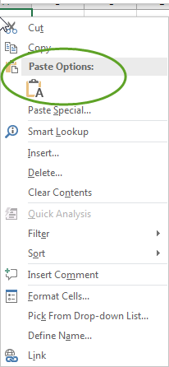

The pasted multi-dimensional results in Excel will look like Figure 2‑24.

Figure ‑. Pasted Multi-Dimensional Data in Excel

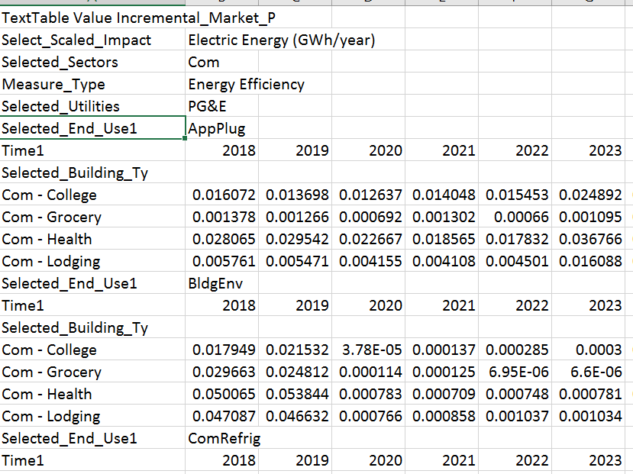

**Goal:** the goal of this exercise is to manually copy and paste a 2-D slice, rather than the entire multi-dimensional table, into Excel. Often, Analytica’s formatting when using the CopyTable feature is difficult to work with, so this approach offers an alternative method.

1. With the Incremental_Market_P result window still open, click on the gray cell at the upper left hand corner of the result table. This will highlight all data, column headers, and row headers in the slice of data being viewed. Use “Ctrl+C” to copy the highlighted data selection (alternatively, you can right click on the data table and select “Copy”).

Figure ‑. Copying a Slice of a Data Table



1. The copied data can then be pasted into excel using “Ctrl+V” (or using Excel’s paste features). The pasted data will have the same orientation as shown in Analytica (e.g., rows represent sectors and columns represent time). Note that the number format in Analytica does not always carry over to Excel, so it is best to apply number formatting directly in Excel.

Figure ‑. Pasted Data Slice in Excel

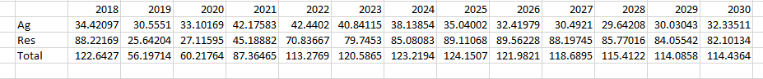

**Tip:** If you’re not interested in copying/pasting an entire multi-dimensional table or 2-D slice of a table, you can highlight just the (adjacent) cells of interest from a data table and paste them into Excel. Highlighting individual cells in Analytica is performed the same way as you would in Excel (i.e., click and drag your cursor over desired cells). Additionally, you can click on the row headers and column headers to highlight all cells pertaining to a selection of contiguous rows or columns, respectively, and copy/paste that subset of data into Excel.

### Exercise: Finding a Variable using its Identifier

**Goal:** The goal of this exercise is to use the search feature in Analytica to locate a variable in the model. This is particularly useful if you know the identifier of a variable and are trying to locate it in the model. While this exercise illustrates how to search by using the identifier of a variable, it is also possible (and useful) to search based on the title of a variable.

1. Click “Ctrl +F” and search for the object Incremental_Market_P by using its identifier (make sure “Identifier” is selected in the dropdown) and clicking the “Find” button.

Figure 2‑27. Searching for an Object Based on its Identifier

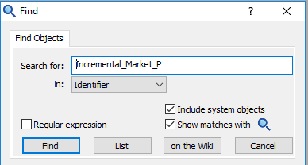

This should then launch the diagram window with the variable highlighted as illustrated below.

Figure 2‑28. Diagram Window with Variable Highlighted

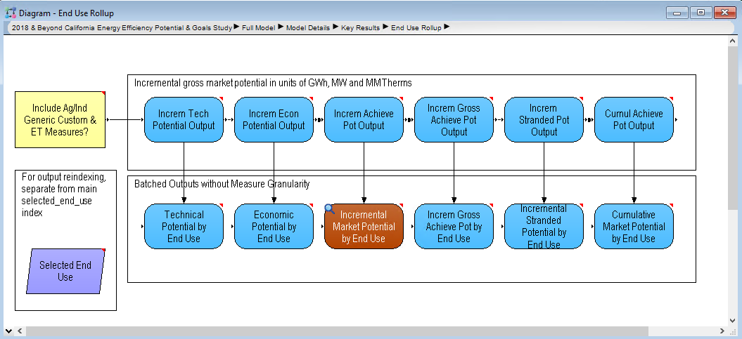

## Navigating Through Model Logic

This section provides exercises that will help you get comfortable with navigating through the model logic. There are two main options for navigating through the model to explore the logic and locate select variables in downstream modules. This section offers an exercise for each of these options.

### Exercise: Navigating using the Module Hierarchy

**Goal**: In this exercise, you will learn how to explore the model using the Module Hierarchy feature in Analytica. Often large models have many layers of hierarchy. The hierarchy depth of each module can be viewed by simply setting a global preference (covered below) at which point you will be able to easily navigate the hierarchy of the model.

1. Select “Preferences” from the Edit menu to display the Preferences dialog. Next, check the “Show module hierarchy” box as shown in Figure 2‑29. After you do this, the top of the active Diagram window displays the module path to the current module:

Figure ‑. Show Module Hierarchy Preference Setting

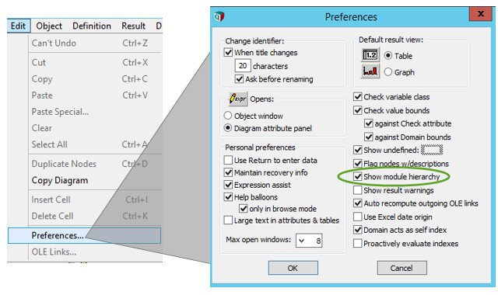

1. Next, the goal is to use the module hierarchy outline to navigate to the Building_Stock module and locate the variable Bldg_Stk_by_Source. First, click on the black arrow next to “Full Model” which will open a tree menu as shown below. Click on the + sign next to “Model Details” and this should open a module hierarchy for the “Model Details” module. From there, navigate to the “Building Stock” module within “Building & End Use Stocks” module, as illustrated in Figure 2‑30 and Figure 2‑29.

Figure ‑. Access Building Stock Module Using Module Hierarchy

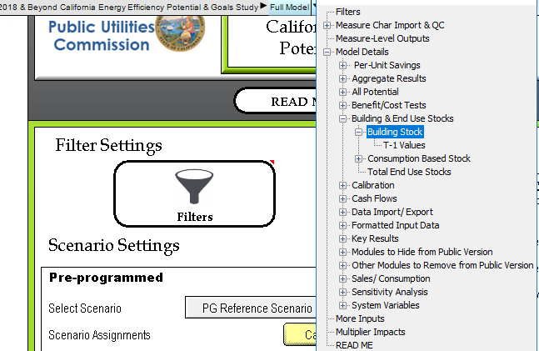

Figure ‑. Example Influence Diagram

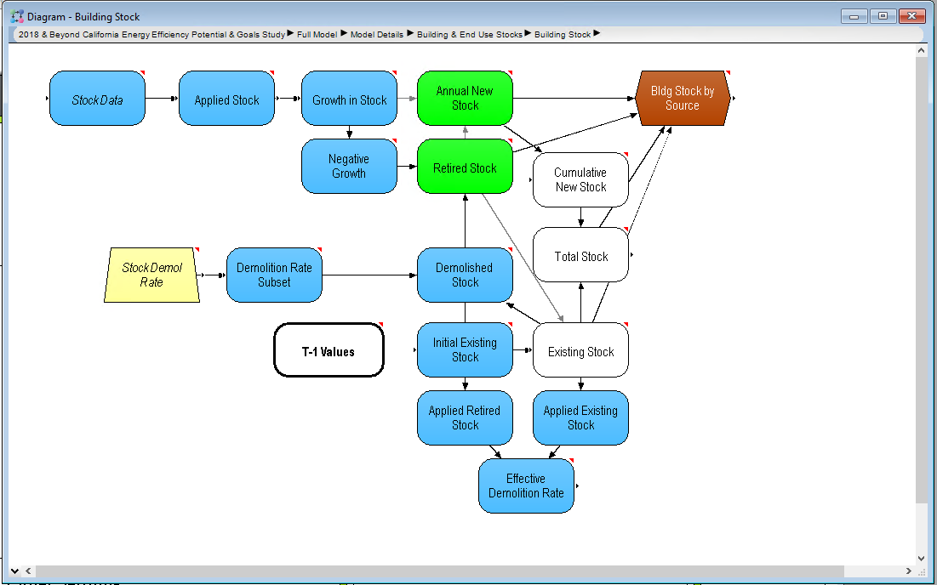

### Exercise: Navigating using the Model Details

**Goal:** In this exercise, you will learn to use the “Model Details” module to navigate. This offers a second option for browsing the model logic.

1. From the top-level GUI, under the title, double-click on the “Model Details” module, as shown in Figure 2‑32.

Figure ‑. Accessing Model Details

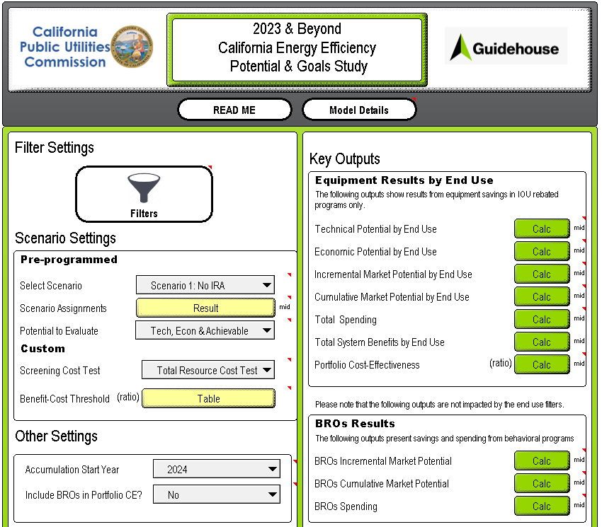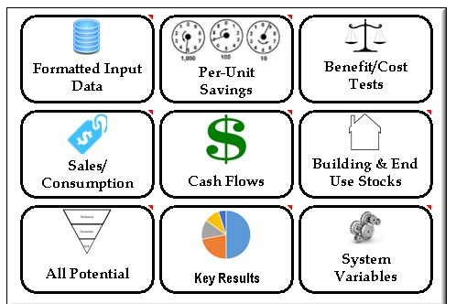

1. Next, double-click on the “Building & End Use Stocks” module under “Core Model Logic”. This will open-up a module with several variables and sub-modules. To launch the “Building Stock” influence diagram, double-click on the relevant module as illustrated in Figure 2‑33.

Figure ‑. Accessing the Building Stock Module

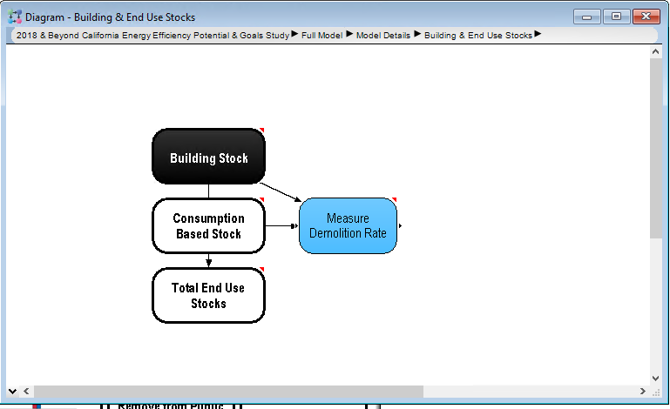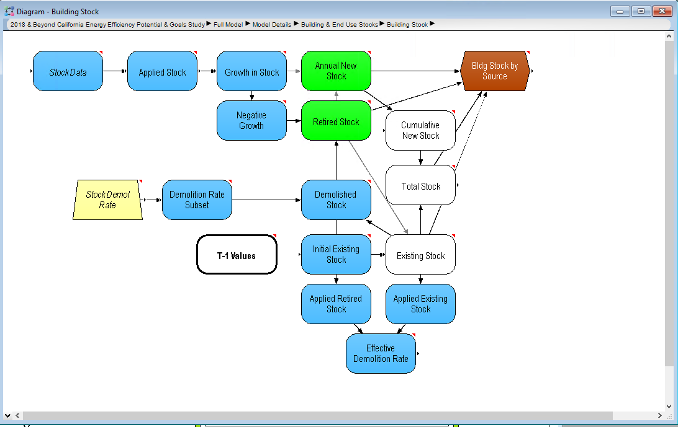

1. Lumina Decision Systems. (2019). *Analytica User Guide*. Retrieved from Analytica Wiki: https://wiki.analytica.com/index.php?title=Analytica_User_Guide