|  |
| --- |
|  |
|  |

March 24, 2025

ATTN: All SEM and Custom Program Administrators

FROM: Lisa Paulo, Energy Division, CPUC

CC: Leanne Hoadley, Energy Division, CPUC; Jeorge Tagnipes, Energy Division, CPUC

RE: SEM Program Treatment of Custom Capital and Deemed Measure

The purpose of this Memo is to clarify treatment of measures that have been identified and developed within the SEM program and planned to be claimed as a custom calculated or deemed measure. This Memo also clarifies an additional scenario where a SEM participant wishes to pursue a deemed or custom-calculated incentive for measures that have not been identified and developed within a SEM program.D.16.08.019 defines the treatment of these special case measures:

*“Strategic energy management is a holistic, whole-facility approach that uses NMEC and a dynamic baseline model to determine savings from all program activities at the facility, including capital projects, maintenance and operations and retrocommissioning,* ***as well as*** ***custom calculated projects****. The customer engagement is long term.* *Because a well-designed strategic energy management approach provides for project tracking by the customer and the program administrator, these programs will facilitate identification of project influence and* ***allow a default net-to-gross value of 1.0 to apply to custom projects when program influence is evident****.”*

D.16.08.019 emphasizes the holistic nature of SEM, encompassing all program activity at a facility and encouraging long-term, long-range actions, and states that “custom calculated projects” linked to the SEM program and carry SEM attributes of an existing baseline and the SEM NTGR. As a logical extension “all program activities” suggest inclusion of deemed measures, and as such, these measures can also be claimed by the SEM program using a deemed pathway calculation and incentive, where the deemed or custom incentive level is needed to influence the customer to move forward with the project.

The SEM M&V guide[1] contains explicit guidelines on what constitutes a “SEM Eligible” measure identification (through activities like the Treasure Hunt) and planning. The SEM MV Guide defines planning as follows:

*“The determination whether an energy performance improvement action (EPIA) was not only identified but also planned for implementation outside of any SEM Program Cycle shall be based on evidence of planning taking place within the 12 months prior to the SEM Program Cycle. Evidence older than 12 months indicates that while planning may have been started, EPIA implementation was stalled and the SEM program influenced its implementation. A, “wish-list,” or brainstorming list of EPIA ideas does not qualify as a planned EPIAs. Evidence of an EPIA being planned for implementation could include the following:*

* *Budget allocated for the EPIA.*
* *Contracts signed related to EPIA implementation.*
* *Purchase orders issued or other indications of spending on the EPIA.*
* *Internal project manager assigned.*
* *Detailed EPIA implementation scope and schedule developed.*

*EPIAs shall not be considered as identified and planned outside of an SEM Program Cycle.”*

In this document, a “SEM eligible” measure meets the criterium for having been a SEM generated measure that was not identified and planned prior to participation or was shelved for 12 months or longer prior to SEM participation. A fully compliant custom calculated project application or deemed application must be submitted for each SEM-eligible measure intended for the higher incentive. The project review and approval will follow the standard custom CPR process that considers all SEM savings scenarios presented in Table 2. If the project is selected for CPR review, the measure installation should not proceed prior to the disposition issuance. However, an approved application will receive the SEM NTGR and existing baseline.

A SEM participant may submit a custom calculated project or deemed application for a measure that was identified and planned prior to SEM (in other words, SEM ineligible), but it would not qualify for the SEM NTGR or existing baseline. The project will follow the standard custom CPR process, and the NTGR will be subject to the standard CPR NTGR ex-post evaluation. The PA may apply the PA pilot RP2.1 tool to justify a modified NTGR approach in ex-ante.

It is up to the PA to support the SEM participant prerogative to pursue a custom or deemed incentive processed through a separate custom or deemed program. Alternatively, the SEM vendor could develop an application following the custom calculated or deemed pathways[2] and submit it under the SEM program. Where there is no custom program available, this method may be the only approach available. The PAs are directed to work with their SEM and other program vendors support the SEM participants they serve. Savings should be claimed by the program paying the incentive.

The table below summarizes the treatment of measures when a SEM participant wishes to purse deemed or custom level incentive, depending on whether the measure meets the SEM eligibility requirements or not.

Table 1. Treatment of SEM measures

|  | Treatment |
| --- | --- |
| SEM Eligible Measures | Measures identified and planned in SEM can be processed (at the customer’s discretion) to receive deemed or custom level incentives using deemed or custom protocols, methods, and rules to calculate ex-ante savings and define customer measure costs, however, the SEM NTGR and existing baseline will still apply.  The SEM participant must submit a standard custom application for the custom calculated measure through a custom pathway either through the SEM program or another PA program that offers a custom pathway. Other than the NTGR and baseline requirements, the application must meet all the standard custom calculated measure requirements, including savings estimation rigor, measure costs documentation, submission for CPR, and it must meet custom eligibility requirements. While it is exempt from Resolution E-5115 requirements to demonstrate accelerated replacement influence[3], it must demonstrate that the measure meets SEM eligibility requirements. Standard practice research will also be required to establish measure eligibility and second period savings consistent with dual baseline treatment.  Similarly, the SEM participant must submit a deemed measure application for a deemed incentive, and it must meet all of the requirements for a deemed measure. However, since baseline and NTGR assumptions are embedded in deemed savings estimates, there is currently no mechanism for adjusting deemed savings to reflect the SEM NTGR and existing baseline[4], therefore, the deemed savings and NTGR specified in the eTRM will apply.  For both deemed and custom measures, lifetime savings are calculated using the methods specified by the deemed or custom program, including the application of the effective useful life (EUL) defined in DEER EUL tables for the measure technology. The technology EUL more accurately represents the actual lifetime of the measure compared to the SEM EUL, which reflects a mix of capital and non-capital measures.  Incentives can be paid for by a standard custom or deemed program vendor or by the SEM program vendor. However, the savings are claimed by the program that pays the incentives. It is the responsibility of the PA to mediate this process between the vendors to prepare and submit an application in a manner that serves the customer. |
| Non-SEM Eligible - PA NTGR Pilot | Non-SEM eligible measures, those that were “identified and planned” less than 12 months prior to SEM engagement may be eligible for custom or deemed level incentives but will not be eligible for the SEM NTGR or blanket use of the existing baseline condition. A complete application must be developed and submitted for review and approval through the SEM program or another PA custom or deemed program. A custom calculated project will be required to the standard custom CPR process, including eligibility criteria, and the NTGR will be subject to the standard CPR NTGR ex-post evaluation. The PA may participate in and apply the RP2.1 tool pilot to justify a modified NTGR approach in ex-ante. Documentation provided in the RP2.1 submittal may be considered by ex-post NTGR evaluation. Similarly, a deemed application is subject to review and approval. |

The following table illustrates the review pathway for claiming a proposed SEM participant’s measure for a custom level incentive. The table classifies SEM participant measures into SEM eligible or non-SEM eligible measures and identifies the NTGR, baseline, and CPR review process required depending on SEM eligibility. Any eligible SEM measure may be considered for custom calculated incentives; however, it requires a complete custom application submission, and it will undergo a CPR review tailored to SEM requirements, for example, reviewing SEM models. If a SEM vendor does not have or chooses not to support a custom pathway for the project to go through, the PA should identify a path forward for that customer’s project. It is up to the PA to work with the SEM vendor or other program implementor to determine how to support the customer’s wish to pursue the custom measure while maintaining SEM program objectives.

Table 2. SEM review scenarios

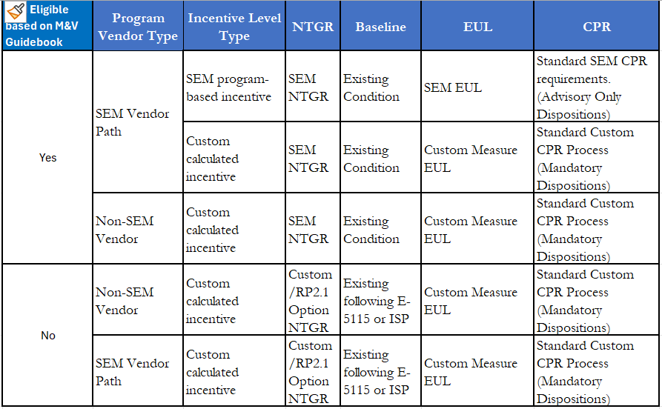

## Implementation Considerations

There are additional implementation and evaluation steps required to ensure the integrity of both the SEM and the custom or deemed programs providing the incentive.

PA steps:

* If the measure goes through a standard custom or deemed program, regardless of which program (SEM or Non-SEM) provides the incentive, ensure the measure meets all the requirements of the custom calculated or deemed pathways and/or program and that a full and complete application is submitted for review and approval. The custom measure application must also be submitted to the CMPA in the Bi-Monthly Upload (BMU) for potential CPR selection. The SEM project files will be reviewed for evidence of SEM eligibility, according to the criteria in the current M&V guide and may entail a request for additional documents and/or an interview with the participant staff, including mandatory dispositions.
* If the SEM program vendor is not going to support the custom incentive and custom project application process, the PAs must establish a path for a customer to submit their custom project. It is up to the PA to work with the SEM program or standard custom program vendors to determine how to support the customer’s wish to pursue the SEM identified custom measure while maintaining SEM program objectives and cost-effectiveness.
  + When a measure is claimed by a non-SEM standard custom program or deemed program, the PA must ensure that the savings claimed for the measure in the custom or deemed program is deducted from the SEM top-down savings estimates for each year of SEM participation, for the life of the measure. Bottom-up savings estimates must remove the measure from the savings totals.

The SEM evaluation should make these provisions:

* Cross-check SEM and custom/deemed program claims to ensure there is no double-counting of savings claims for the same project in both programs.
* Since the SEM NTGR will be applied to SEM eligible custom pathway measures, these measures will be included in any future evaluations of the SEM NTGR. Thus, the SEM NTGR evaluation population will include all SEM eligible measures receiving custom-level incentives and will be subject to selection for SEM NTGR data collection.
* Evaluation studies, SEM or otherwise, should assess whether these projects comply with the CPR process and key savings assumptions. Projects that deviate from the correct process should be flagged for further investigation and potential update to this memo.

1. <https://pda.energydataweb.com/api/view/2648/CA_SEM_MV_Guide_v3.02.pdf>, Section 8.2.2
2. By pathway – follows the policy, procedures and rules for measure qualification, calculating savings, identifying costs, documentation requirements
3. Due to the SEM program’s attributes that are linked to an existing baseline and the SEM NTGR, as stated in D.16.08.19
4. PAs may propose a mechanism for applying a SEM NTGR and an existing baseline to deemed migrated measures in the future if warranted.