Gas Procurement Rate Increase Alert November 16, 2021
The ED Gas teams are following up on information that indicates gas commodity prices this winter will be much more expensive than last winter, potentially close to 100% more on a per therm basis.
General volatility in the natural gas market resulting in seasonal high prices is caused by expanding global demand with supply being unable to keep up with the demand. For SoCalGas and SDG&E, this is compounded by an outage on an El Paso interstate pipeline that serves Southern California.
The table below compares the October and November 2021 procurement rates for average residential customers to the same months in 2020 and the bill impacts based on their average monthly consumption.

PG&E, SoCalGas, SDG&E Average Residential Customers
 | 2020 per therm procurement rate | 2021 per therm procurement rate | % change 2020 to 2021 | Bill impact to avg residential customer (procurement only) | Residential Avg. monthly consumption  (therm)
PG&E
October | $0.38 | $0.68 | 79% | $25.92 | 32
November | $0.45 | $0.81 | 80%
SoCalGas
October | 0.25 | 0.58 | 128% | $21.05 | 33
November | 0.34 | 0.64 | 86%
SDG&E
October | 0.25 | 0.58 | 128% | $14.69 | 23
November | 0.34 | 0.64 | 86%

Below are some notes about natural gas procurement:
- Procurement costs include the various costs associated with procuring natural gas supplies for a utility’s core gas customers, such as the cost of the commodity, interstate pipeline capacity costs, hedging costs, and other costs.

- Procurement rates change every month through advice letter filings. Utilities purchase natural gas through wholesale gas markets, the costs of which fluctuate month to month based on national gas market prices.
- Gas commodity procurement accounts for 20% of an average usage residential customer gas bill.

- To illustrate gas market prices, between 2020 and 2021 Henry Hub gas prices increased by 79%, 219% and 75% for the months of August, September, and October, respectively as reflected in the table below. The wholesale price of natural gas is driving California’s natural gas price trends in September – November 2021.

Comparison of Henry Hub Gas Prices from 2020 to 2021 for August to October
 | 2020 | 2021 | Percent Change
8/1/2020 | $2.43 | $4.34 | +79%
9/1/2020 | $1.75 | $5.58 | +219%
10/1/2020 | $3.19 | $5.59 | +75%

Henry Hub Natural Gas Price in Dollars Per Million Btu — Historical Chart (Last Five Years)
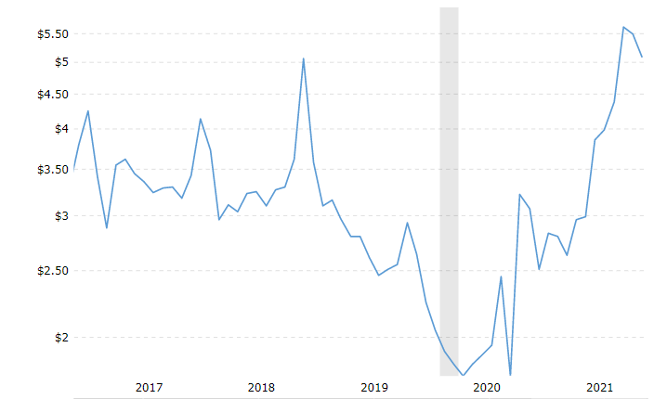
Graph Source: Natural Gas Prices - Historical Chart | MacroTrends

