Resource Adequacy Slice-of-Day Showing Template User's Guide



For Template Revision 30 – July 2, 2024
California Public Utilities Commission
Energy Division
Table of Contents
Introduction 3
Compatibility 3
Workbook Layout 4
Information Worksheets (grey) 5
Load-Serving Entity Input Worksheets (blue) 7
Showing Results Worksheets (gold) 8
Requirement and Allocation Worksheets (orange) 9
Resource Description Worksheets (green) 9
Information and Tools 10
Clear All Input Data 10
Clear Requirements and Allocations 10
Refresh Resource Database 11
Autofill LSE Showing Values 11
How to Input Resources 11
Certification Worksheet 11
LSE Showing Worksheet 12
Custom Profiles 14
Storage Resources and Hourly Profile Optimization 15
Hybrid Resources 17
Co-Located Resources 18
MCC Bucket 4 18
Energy-Only Resources 18
Grid-Charging and Grid-Restricted Storage Resources 18
Interconnection Limits 18
Unspecified Imports 19
Demand Response 19
Resources Currently Under Construction 19
Allocations 19
CAM Storage Allocations and Debits 19
Demand Response and Other CAM Allocations 20
Reviewing a Showing 20
Validation Overview 20
Hourly System Capacity 21
Local Capacity 22
Flexible Capacity 22
Contract Date 23
Shown Hours 23
Storage Excess Capacity 24
MCC Bucket 4 Storage Excess Capacity 25
Custom Profile 25
Storage Minimum State-of-Charge 26
Storage Energy 26
Grouped Resource Interconnection 27
Hybrid Deliverability 27
Demand Response 27
LSE Showing Complete 28
Availability Charts 28
Power Query 28
Resource Information 29
ResourceDatabase 30
ResourceDefaultProfiles 30
ResourceProfileCategories 30
Regions 30
Showing Information 30
Certification 30
ResourceCustomProfiles 30
LSEShowingProfilesUnoptimized 30
UnoptimizedResources 30
Optimization Setup 31
StorageProperties 31
SODProfilesForSOC 31
Validation Tests 31
LSEShowingComplete 31
CheckCapacity 31
CheckCustomProfiles 32
CheckStorageSOC 32
CheckGroupedResources 32
CheckHybridDeliverability 32
Storage Resource Optimization 32
Conclusion 37
Changelog 38
Revision 16 38
Revision 17 38
Revision 18 38
Revision 19 38
Revision 20 39
Revision 21 39
Revision 22 39
Revision 23 40
Revision 24 40
Revision 25 40
Revision 26 40
Revision 27 42
Revision 28 42
Revision 29 43

Introduction
As the Resource Adequacy program transitions to the new slice-of-day framework, the existing filing process requires updating. As directed in D.23-06-029, Energy Division has developed a template for showing slice-of-day resources based on sample templates provided by two Load-Serving Entities (LSEs). This document describes the overall design of the template and includes general instructions on how to input a showing.

Compatibility
The Resource Adequacy Slice-of-Day Showing Template was built and tested using Microsoft Excel for Microsoft 365 MSO (Version 2308 Build 16.0.16731.20542) 64-bit. Some calculations use dynamic arrays, introduced into Microsoft Excel for Office 365. Earlier versions of Excel may encounter problems when opening or using the template, and users may have to upgrade to a more recent version.

Workbook Layout
The template consists of an Excel workbook containing 10 visible worksheets, 3 visible chart sheets, and 15 hidden worksheets. All information required for developing a valid resource adequacy showing should be available in the visible worksheets, but the hidden worksheets may be helpful for investigating specific issues especially pertaining to validation tests.
The template uses Excel Tables extensively to help manage data and provide more legible formulas. Data stored in Tables as opposed to standard Cells and Ranges can be referenced using a verbose nomenclature indicating a table name and column header which can be easier to read and understand than cell addresses.
The worksheets are color-coded to help distinguish between their uses. Each set of worksheets is discussed in subsections below.
In addition to the visible and hidden workbooks, the workbook uses Excel’s Power Query to manage the flow of Table indices across worksheets. The Power Query editor is accessible from the “Data” tab of the ribbon menu by clicking on “Queries and Connections” to open a sidebar, and double-clicking on any of the listed queries. Alternatively, users can use the keyboard shortcut [Alt]+[F12] to open the editor. The Queries and Connections sidebar can be used to manually refresh queries if necessary. Note that the Power Query editor will limit functionality when viewing queries loaded into protected worksheets, so the user may unprotect the applicable sheet prior to opening the editor.
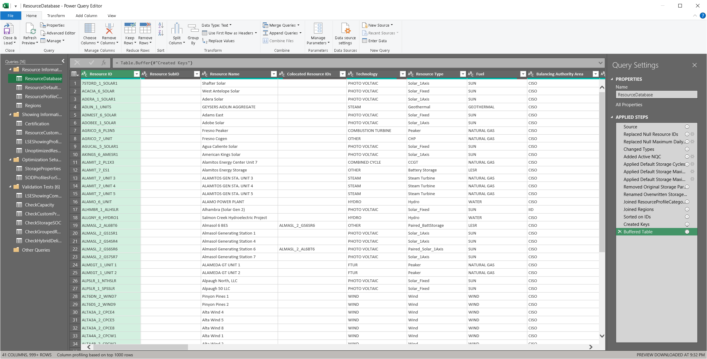
Figure 1 – Power Query Editor showing the ResourceDatabase query
Finally, the workbook includes a tool to help develop slice-of-day profiles for storage resources by optimizing shown hours to best meet LSE requirements, given the remaining need after other resources are shown. The optimization routine is set up in Power Query, exported to a worksheet, and then uses a custom algorithm to determine optimal hourly capacities. A Visual Basic script, triggered from a button in the worksheet, defines the optimization problem parameters and calls Solver. Please make sure Solver is enabled in Excel by navigating to the Ribbon MenuFileOptionsAdd-insManage: Excel Add-InsGo…, and verifying the box next to “Solver Add-in” is checked. Excel will need to be restarted after enabling Solver.
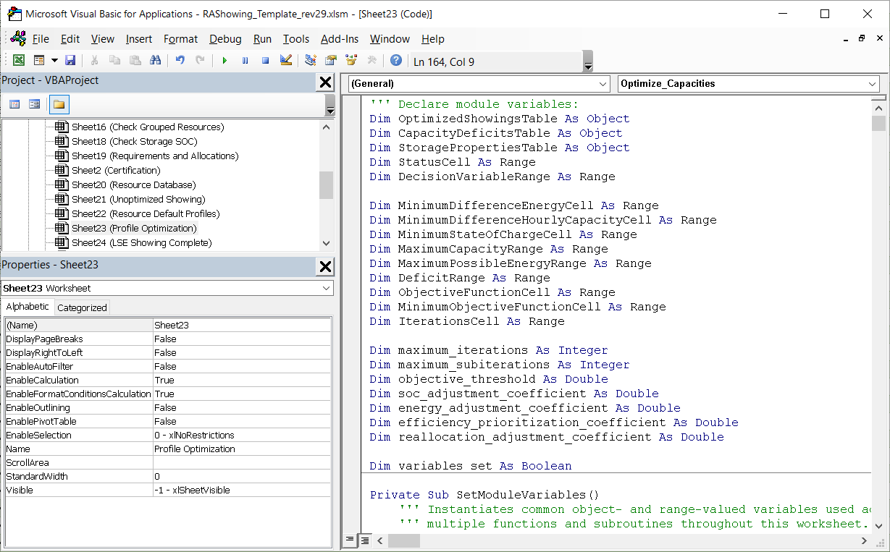
Figure 2 – Visual Basic for Applications editor showing the scripts for the Profile Optimization worksheet
Worksheets are hidden to help the general user navigate areas of the workbook most critical to the typical workflow, but all data, queries, and Visual Basic code are freely accessible within Excel, and users are welcome to explore the workbook.
Several worksheets are protected by default to avoid inadvertently overwriting values of formulas. All protected worksheets can be unlocked by any user without password, although, in some cases, scripts may run in the background to unprotect and protect sheets as needed when, e.g., refreshing query results.

Information Worksheets (grey)
Four visible sheets and four hidden sheets constitute a set of “informational” worksheets.
 … … 
Figure 3 – Information worksheet tabs, located at the bottom of the Excel application window
README – The first worksheet in the workbook contains basic information about how to navigate and use the template, along with template version information and a few settings and utilities for clearing and updating data. These tools are discussed in a later section.
Hourly Availability Chart – Three charts included in the template show the capacity contributions of each resource type toward meeting the LSE’s resource adequacy requirements. The bars show the combined capacities of resources from each group in different colors, while the line shows the hourly Resource Adequacy System Requirements less Demand Response (DR) Allocations and CAM Allocations excluding CAM Storage. The Hourly Availability Chart may be helpful in determining whether a showing meets requirements, hours where additional capacity may be needed, and when excess capacity may contribute toward storage charging requirements. The labels are “Battery Storage”, “Biogas”, “Biomass”, “CHP” (combined heat and power), “Demand Response”, “Fuel Cell”, “Geothermal”, “Hydro”, “Nuclear”, “Pumped Hydro”, “Solar”, “Thermal”, “Wind”, “Unspecified Imports”, and “Other.” Most of these groups are defined in the hidden “Resource Profile Categories” worksheet and map to the Resource Type field in the “Resource Database” worksheet. “Unspecified Imports” are selected on the “LSE Showing” worksheet, and “Other” is applied to any resource that doesn’t otherwise map to a label.
Hourly Availability (hidden) – This sheet contains the data visualized in the Hourly Availability Chart. Formulas throughout the Table look up and aggregate capacities from the LSE Showing Complete worksheet based on a static set of chart labels and hours ending.
Local Availability Chart – This chart shows the shown capacity attributed to each local capacity area, along with the LSE’s local capacity requirements (if applicable). Resources are grouped similarly to the Hourly Availability Chart.
Local Availability (hidden) – This sheet contains the data visualized in the Local Availability Chart. Formulas throughout the Table look up and aggregate capacities from the LSE Showing Complete worksheet based on a static set of chart labels and local areas.
Flex Availability Chart – This chart shows the shown capacity attributed to each flexible resource adequacy category, along with the LSE’s flex requirements. Resources are grouped similarly to the Hourly Availability Chart.
Flex Availability (hidden) – This sheet contains the data visualized in the Flex Availability Chart. Formulas throughout the Table look up and aggregate capacities from the LSE Showing Complete worksheet based on a static set of chart labels and flexible capacity categories.
Query Statuses (hidden) – This sheet contains two tables listing all worksheets and query tables. The table on the left side describes the “upstream” and “downstream” query tables relative to each worksheet, i.e., in which query tables do changes affect the given worksheet, and which query tables are impacted by changes to the given worksheet. The status column in this worksheet indicates with the value “EDITED” whether a change has been made while the worksheet is active—if not, the status is set to “COMMITTED”. The table on the right side indicates the location of each query table, and a second status column indicating whether the table is “STALE” meaning upstream data has changed. A Visual Basic for Applications script uses these tables to determine when to refresh the queries that load data into each query table.

Load-Serving Entity Input Worksheets (blue)
In general, LSEs should only need to edit the visible blue-colored worksheets when preparing a showing, and these should be completed in the order they appear in the workbook from left-to right.
Figure 4 – Load-Serving Entity input worksheet tabs
Certification – This worksheet will be partially completed when the template is sent to each LSE, but LSEs will be responsible for ensuring the sheet is current, accurate, and complete. This certification attests that the resource adequacy showing contained in the rest of the book, upon submission to CPUC, is accurate.
Ensure that the correct showing month is entered before entering data since this determines which monthly LSE requirements are used in the compliance tests.
Certification Table (hidden) – This worksheet reshapes the input data from the Certification worksheet into a Table for use in Power Queries. This worksheet also contains additional constants used throughout the workbook, including a “Month Ahead Coefficient” and “Year Ahead Coefficient” which are applied to hourly system requirements when the selected showing type is “Month Ahead” or “Year Ahead” respectively, and a “Maximum DR Ratio” which limits demand response programs’ contributions toward system requirements as a percentage of each hour’s system requirement.
LSE Showing – This worksheet contains one Table constituting most of the information required from LSEs for their showing. This information includes a contract and resource identifiers, and specific information about each resource’s contract capacity. The workbook matches shown resources against the Master Resource Database worksheet for additional information used in validating the showing.
Resource Custom Profiles – Users may manually input custom hourly capacity profiles for certain shown resources in a single Table in this worksheet. The Resource ID and Resource SubID for each row of the Table should match an entry in the LSE Showing worksheet. A custom profile must be entered for all Unspecified Imports.
Unoptimized Showing (hidden) – This worksheet contains the set of all resources input in the LSE Showing worksheet and the applicable default or custom hourly capacity profile. The data in this worksheet is used in the Profile Optimization worksheet for determining charging capacity from collocated resources for grid-restricted storage, and collocated capacity counting against any interconnection limits.
Profile Optimization – This worksheet contains three Tables, a single button, five user-adjustable settings, and several cells indicating optimizer status and diagnostics. The worksheet is designed to prepare and solve an optimization problem involving setting the hourly output capacities of single- and/or multi-cycle storage based on each individual resource’s properties and the difference between system requirements and capacities shown by other resources. This feature is explained in greater detail in the later section, Storage Resource Optimization.

Showing Results Worksheets (gold)
Showing results worksheets are intended to help users develop a valid and compliant showing. This group includes two visible and 11 hidden worksheets by default.
Figure 5 – Showing results workbook tabs
Validation Overview – This worksheet is designed as a dashboard presenting the results of various validation tests shown in several hidden worksheets described below.
Check Capacity (hidden) – This worksheet contains the Hourly System Capacity, Local Capacity, Flexible Capacity, Contract Date, Shown Hours, Storage Excess Capacity, and MCC Bucket 4 Storage Excess Capacity tests. The single Table on the worksheet shows the requirements and shown capacities for each hour, local area, and flexible category, along with contract start and end dates, a count of hours with non-zero shown capacities for each resource, and summed excess hourly capacities and charging requirements by resource. The three left-most columns “Contract ID”, “Resource ID”, and “Resource SubID” are output by the CheckCapacity query, and all other columns are calculated using cell formulas.
Check Storage SOC (hidden)– This worksheet contains a single Table used in the Storage State-of-Charge test. The CheckCapacity query loads the contract IDs, and resource IDs and sub-IDs into the first three columns of the Table. Cells in the columns to the right lookup resource properties, shown hourly capacities, and applicable hourly charging capacities, and calculates the state-of-charge and overall energy usage for each hour over the course of two days.
Check Grouped Resources (hidden) – This worksheet contains the Grouped Resource Interconnection test. The single Table on the worksheet shows groups of shown resources which the Resource Database indicates are either co-located or hybrid. The first two columns are populated by the CheckGroupedResources query, while cells in other columns contain formulas to lookup and aggregate capacities from the LSE Showing Complete worksheet and compare hourly totals against the interconnection limit.
Check Hybrid Deliverability (hidden)– This worksheet contains the Hybrid Deliverability test. The single Table on the worksheet lists each shown hybrid pair of resources and whether hourly capacities shown for the solar resource are consistent with its deliverability status. The contract IDs and resource IDs and Sub-IDs of each shown hybrid pair are filled by the CheckHybridDeliverability query, while cells in other columns contain formulas to lookup hourly capacities and resource properties from the LSE Showing Complete worksheet.
LSE Showing Complete – This worksheet constitutes the showing information that will be considered by CPUC in its resource adequacy process. The table is synthesized from the LSE’s inputs, the requirements and allocations assigned to the LSE, and general information about the resources. The contract IDs and resource IDs and sub-IDs are filled by the LSEShowingComplete query, while cells in other columns contain formulas to retrieve data from each of the input worksheets, the Requirements and Allocations worksheet, and the resource descriptions worksheets.

Requirement and Allocation Worksheets (orange)
A single, visible worksheet contains all LSE-specific requirements and allocations.

Figure 6 – Requirements and Allocations worksheet tab
Requirements and Allocations – This worksheet contains a table representing all system load forecasts, planning reserve margins, local and flexible requirements, and CAM allocations for a given LSE and month. These are used in evaluating the compliance of a filing.

Resource Description Worksheets (green)
Two visible and four hidden worksheets comprise the resource descriptions section of the workbook. These worksheets generally should not be modified by users, although doing so is permitted to correct errors and add new resources when necessary. These worksheets contain various parameters used when showing resources.
Figure 7 – Resource description worksheet tabs
Resource Database – This worksheet contains a snapshot of relevant data from the official Master Resource Database maintained by CPUC’s Energy Division published monthly to the Resource Adequacy Compliance Materials website. The included data are used in validating a slice-of-day showing.
Resource Default Profiles – This worksheet contains default slice-of-day profiles for certain resources that may be shown.
Regions (hidden) – This worksheet is a lookup table used in mapping a shown resource to a default profile. The table includes Path 26 Designations and Balancing Authority Areas as listed in the Master Resource Database, and Regions as listed in the Resource Default Profiles worksheet.
Resource Profile Categories (hidden)– This worksheet is a lookup table used in mapping a shown resource to a default profile. The table includes Resource Types as listed in the Master Resource Database, and Profile Categories as appearing in the Resource Default Profiles worksheet.
VER Categories (hidden) – This worksheet contains a list of profile categories constituting a subset of those used in the Resource Profile Categories which the workbook should treat as variable energy resources (VERs).
Expanded Default Profiles (hidden) – This worksheet contains a pivoted version of the Resource Default Profiles, replacing “Any” region with each of the defined geographic regions and the month “0” with all twelve months. This Table is referenced for any resources set to use default profiles. The Table is processed and exported by the ExpandedDefaultProfiles query, and should be refreshed manually upon changes to the Resource Default Profiles, Regions, Resource Profile Categories, or VER Categories worksheets.

Information and Tools
There are three buttons and one checkbox at the bottom of the README worksheet intended to help users update the template and select preferences. The usage of each option is described below. The Visual Basic for Applications scripts associated with each of the buttons are stored as subroutines in the “ThisWorkbook” module, while the auto-fill feature is implemented in the “Worksheet_Change” event subroutine stored in the “Sheet5 (LSEShowing)” module. All scripts used throughout the workbook are accessible from the Visual Basic for Applications editor.
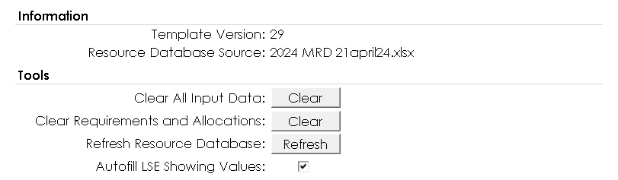
Figure 8 – Template Information and Tools, presented on the README worksheet

Clear All Input Data
Clicking this button runs a script that deletes all user-input data in the Certification, LSE Showing, Resource Custom Profile, and Profile Optimization worksheets. Additionally, the Unoptimized Showing worksheet and all worksheets supporting validation tests are reset. This can be done to prepare a template to be copied for multiple months of showings. The script prompts the user to confirm before performing the deletions.

Clear Requirements and Allocations
Clicking this button runs a script that deletes every row of data in the Table in the Requirements and Allocations worksheet. CPUC staff use this when preparing blank templates to be filled with LSE-specific information. The script prompts the user to confirm before performing the deletions.

Refresh Resource Database
Clicking this button allows the user to select a downloaded copy of the Master Resource Database to import into the template, replacing data in the Resource Database and Resource Default Profiles worksheets. The script prompts the user to confirm before deleting and replacing any data. Upon successful importation, the filename of the selected Master Resource Database is copied into the README worksheet.

Autofill LSE Showing Values
When the corresponding checkbox is selected, resources input one row at a time on the LSE Showing worksheet will automatically retrieve default values based on the Resource Database where available. It is recommended that users disable this feature when copying multiple rows.

How to Input Resources
Many components of the template use Excel Tables rather than the default Ranges and Cells. Tables help structure the data for use across multiple worksheets, allow for more readable formulas, ensure calculation complexity scales with data size, and facilitate automated data entry and extraction. Tables are recognizable in the template by their banded blue or green rows with dark blue or green headers with white text. Blue tables generally indicate source data which is referenced in calculations elsewhere in the workbook, while green tables generally indicate calculated data which should not be modified or overwritten.
When adding data to a Table, the Table will automatically resize within the worksheet to include new rows. Table rows should be removed by either overwriting the contents entirely or by deleting the entire row, rather than deleting the contents of the cells. When done working with a Table, users should ensure that no rows within the Table’s boundaries are empty.

Certification Worksheet
The Certification Worksheet contains basic information about the Load Serving Entity and its representatives, along with the date and type of showing.
The cells labeled “Load Serving Entity Abbreviation”, “Showing Type”, and “Showing Month” must be filled in with valid values corresponding to the Requirements and Allocations worksheet—make sure the same value for LSE is used in both the Certification worksheet and the Requirements and Allocations worksheet. The Showing Type cell must either contain “Year Ahead” or “Month Ahead”—the selected value is used to determine whether 90% or 100% of the system and flexible requirements listed in the Requirements and Allocations are used in validation tests and charts. The Showing Month cell should be the first day of the month for which resources are to be shown, and the applicable requirements will be applied.
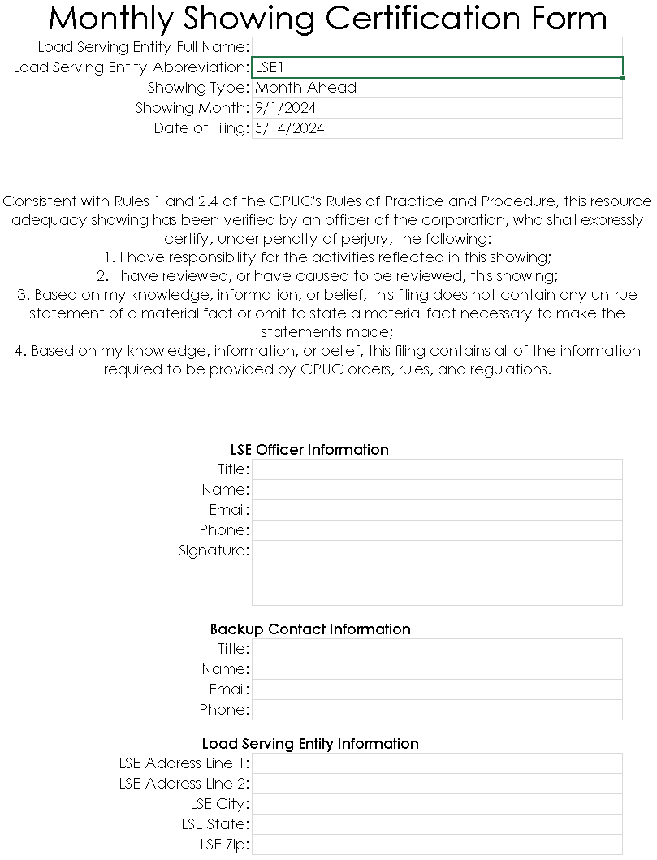
Figure 9 – The Certification Form before completing
The remaining cells should be filled in with all relevant information. This worksheet represents the Load Serving Entity’s certification of their showing and attestation to its accuracy.

LSE Showing Worksheet
A simple showing can be entered exclusively on the LSE Showing worksheet. LSEs will receive a fresh template each month with updated resource information and the current month’s requirements and allocations. A CAM storage allocation, reflective of the allocation specified on the Resource and Allocations worksheet, should also be present on the LSE Showing worksheet. Additional resources should be entered in subsequent, contiguous rows, using the following procedure:
- Enter a Contract ID in Column A reflecting the contract for resource adequacy capacity in a new row of the LSE Showing worksheet.
- Check that the table boundaries automatically expanded to include the new row. Also check that no empty rows appear in the table or before the new row.
- Enter a Resource ID matching an entry in the Resource Database worksheet in Column B. The ID can either be typed in, pasted from the Master Resource Database worksheet or another source. Unspecified import resources need not be listed in the Resource Database worksheet.
If the “Autofill LSE Showing Values” option on the README worksheet is selected, the worksheet will first determine whether the input Resource ID corresponds to a hybrid resource with multiple sub-IDs, then, for hybrid resources, the workbook will add a dropdown menu to the Resource SubID field to allow the user to select the desired sub-resource. For non-hybrid resources, the workbook will automatically apply default values for all remaining fields based on the resource database. Default values appear in blue text and may be overwritten by the user, causing the text to become black. If the autofill option is not selected, the user must provide input values for all fields.
- For most resources, the Resource SubID field (Column C) should be left empty, but hybrid resources must be input as a valid paired Resource ID and Resource SubID, corresponding to a row in the Resource Database.
If the “Autofill LSE Showing Values” option on the README worksheet is selected, the workbook will load default values into the remaining cells in the same row once a valid Resource SubID is input or selected from the dropdown menu. Default values appear in blue text and may be overwritten by the user, causing the text to become black. If the autofill option is not selected, the user must provide input values for all fields.
- In column D (NQC Under Contract (MW)), enter the Slice-of-Day NQC value under contract for each resource. Alternatively, the default value retrieved from the Resource Database may be used. When the default profile is selected in column L, the template will provide hourly shown MW values based on stored hourly profile shapes. For VERs, the input NQC under contract is scaled by the resource’s Pmax divided by the monthly Slice-of-Day NQC value before applying the hourly shape factors. The default value is the resource’s NQC for the showing month selected on the Certification worksheet.
- Fill in the Local RA capacity, and Committed Flexible RA capacity shown for the resource, all in units of MW, in Columns E and F. The input capacities count toward the local and flexible requirements in the resource’s local area and flexible category defined in the Resource Database. The default value for both fields is 0.
- Fill in the Capacity Effective Start Date and End Date as listed in the contract for the resource in the new row in Columns G and H. Alternatively, the default values based on the showing month may be used.
- Fill in the SCID or Counterparty if applicable in Column I.
- In Column J, type in or select “TRUE” for storage resources being shown in MCC Bucket 4 in 2024 compliance showings.
- In Column K select “TRUE” if the resource is an Unspecified Import.
- Type in or select “TRUE” in Column L from the dropdown menu to use the Default Profile for the resource. For battery storage, the default profile is a single daily discharge cycle at full capacity from HE18-HE21.
- When finished entering custom profiles, open the LSE Showing Complete worksheet and refresh the table by right-clicking on it and selecting “Refresh”.
- Verify the resource appears in the table as entered, and the Profile Source column indicates “Default”.
Selecting “TRUE” for Default Profile will apply a slice-of-day profile from the Resource Default Profiles worksheet to the shown resource, based on the shown NQC or total VER MW Under Contract. When a default profile is selected, the resource is fully specified by the user’s input in the LSE Showing worksheet, and the default profile will be applied to all validation tests and will be represented in the LSE Showing Complete worksheet.
If a resource does not map to a default to a default profile, or the default profile, the user may need to input a custom profile according to the next section.
Custom profiles must be used for all Unspecified Imports. Ensure that “FALSE” is selected under Use Default Profile for these resources.
Aside from Unspecified Imports, Custom Profiles and Profile Optimization will primarily be used for battery storage resources. The user may select whether to use the Default Profile, a Custom Profile where the user inputs a specific daily profile or the Optimization tool which will shape storage showings to meet the LSE’s hourly RA needs.
The SOD Showing Template is not designed to process individual resources procured through multiple contracts, i.e., each pair of Resource ID and Resource SubID in the LSE Showing worksheet should be unique. If a single resource appears in more than one contract, users must aggregate the resource into a single row.
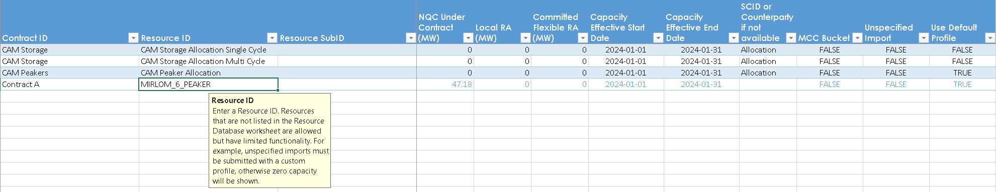
Figure 10 – Default allocations and a single resource with automatically filled default values

Custom Profiles
Users may manually specify hourly profiles for resources by setting the Default Profile to “FALSE” in the LSE Showing worksheet and filling in the Resource Custom Profiles worksheet. This may be useful where the default profiles do not apply to a specific resource and the user has more detailed information about a given resource’s capabilities.
Use the following procedure to input a custom profile:
- Enter a new resource as described for Basic Resources, but input “FALSE” for Use Default Profile.
- Copy the desired Resource ID and Resource SubID from the LSE Showing worksheet into a new row of the table in the Resource Custom Profiles worksheet.
- Check that the table boundaries automatically expanded to include the new row.
- Enter the hourly capacities to be shown in the “MW HE __” columns, making sure no hours exceed the value listed in the corresponding NQC Under Contract listed on the LSE Showing worksheet (or proportional Pmax for VERs).
- When finished entering custom profiles, open the LSE Showing Complete worksheet and refresh the table by right-clicking on it and selecting “Refresh”.
- Verify the resource shows the custom profile as entered, and the Profile Source column indicates “Custom”.

Storage Resources and Hourly Profile Optimization
The Profile Optimization worksheet is designed to facilitate showing storage resources based on the LSE’s requirements, allocations, and other shown resources, while accounting for the physical limitations of battery energy storage systems. Storage resources can be input according to the following procedure:
- Enter a new storage resource into the LSE Showing worksheet, selecting “FALSE” for Use Default Profile. Make sure the corresponding entry in the Master Resource Database worksheet has values for the following fields Daily Storage Cycle Physical Capability, Storage Efficiency, Maximum Continuous Energy, and Storage Maximum Daily MWh.
- Input any custom profiles in the Custom Resource Profile worksheet as described in the previous section.
- When finished entering resources into the LSE Showing and Custom Resource Profile worksheets, open the Profile Optimization worksheet.
- Click on the button labelled “Optimize” to update the three tables on the worksheet, reset the Fractional Showing values to zero, and run Solver to attempt to optimize the showing.
- The following preconditions are tested to determine which optimization path to pursue:
  - The total sum of the Maximum Capacities (MW)of all storage resources to be optimized must be greater than the highest value of the Deficit (MW) column in the Capacity Deficits table.
  - The total sum of the Maximum Daily Energies (MWh) of all storage resources to be optimized must be greater than the sum of all Deficits (MW).
  - If these conditions are met, the script will attempt to find a compliant solution that prioritizes any higher-efficiency storage resources, but a compliant and convergent solution is not guaranteed to exist.
  - If these conditions are not met, the script will run an alternate optimization algorithm to use all storage as much as possible within each resources’ constraints and without exceeding the hourly deficits, but a compliant solution is impossible.
- A cell to the left of the button will display progress throughout the optimization process, and two of the tables will turn grey, then orange to indicate they are refreshing, then green indicating they have finished refreshing.
- Once the optimizer script has completed, check the status cell for information about the results. This cell indicates “Optimization Complete” if the script converges to an optimal, compliant solution. If the script finds a compliant solution but determines additional iterations may yield a more optimal showing, the status cell indicates “Optimum Not Reached After [selected Maximum Iterations value] Iterations,” and if the user is unsatisfied with the current solution, they may adjust either the “Maximum Iterations” or the “Objective Threshold Coefficient” settings and re-run the optimizer.
  - If sufficient capacity is shown in the default and custom profiles to allow for a compliant optimized storage showing, the “Difference (MW)” column of the Table labeled “Capacity Deficits” should be all zeros. The table in the LSE Showing Complete worksheet, and the Hourly Availability Chart will update automatically. Open the LSE Showing Complete worksheet and verify that the resource is correctly shown with the Profile Source listed as “Optimized” and corresponding hourly capacities based on the optimization results.
  - If the total maximum capacities of the storage resources available to the optimizer are insufficient for any hourly deficit, or if the total maximum possible energy shown by the storage resources is less than the sum of all hourly deficits, the optimization script will run an alternative optimization algorithm which relaxes the constraint to meet the hourly deficits, and does not prioritize using more efficient storage. The resulting solution will not be compliant but will attempt to show as much storage as possible within the constraints of the storage resources’ power and energy capabilities, without overshooting the hourly deficits.
- If the optimization script is unable to find a solution within the resource constraints, either no solution exists due to state-of-charge constraints or the algorithm became stuck in a local optimum regime with no viable solution. A solution may be found by either:
  - Manually adjusting the decision variables to find a solution; or
  - Adding resources to the showing and re-running the optimization script—additional storage resources may help overcome some constraints in the optimization problem, and additional non-storage resources can reduce the hourly deficits.
- Note that the optimization routine does not include a Storage Excess Capacity check, so make sure all applicable validation tests pass after optimizing storage resources.
There should be positive values in the Shown MW column of the table labelled “Unshown Resource Adequacy” in each row with a positive value in the “Deficit (MW)” column of the same table.
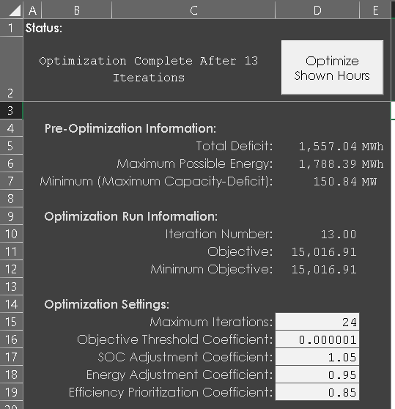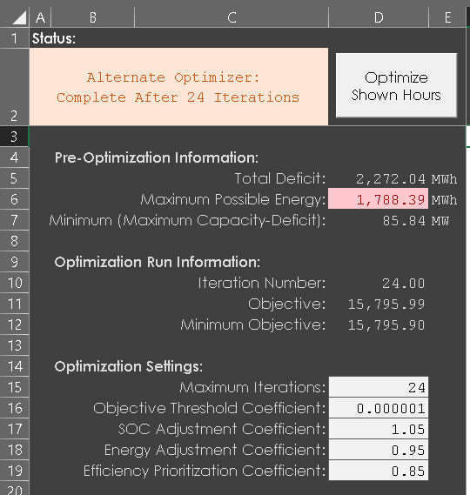
Figure 11 – In two of the possible optimization outcomes, the status indicating a convergent and compliant solution on the left, and a convergent but noncompliant solution on the right
The optimization script is intended to produce useful showings across a wide variety of input scenarios, but users may manually override the “Shown MW” column in the “Optimized Showings” to fine-tune their results, or copy any of the storage resources and their optimized profiles to the Resource Custom Profiles worksheet to remove them from subsequent optimization runs. The script which implements the optimization is available for review and adjustment by pressing <alt>+<F11> or accessed from the Developer tab of the Ribbon menu.
The optimization worksheet works with both physical storage resources and CAM storage allocations, however debits must use either default or custom profiles. See the section on CAM Storage Allocations and Debits for more information.

Hybrid Resources
Hybrid resources typically consist of a solar resource and a battery energy storage system resource sharing the same Resource IDs and different Resource SubIDs. Hybrid resources should be listed in pairs with both solar and storage resources appearing on the LSE Showing worksheet. Both individual resources in hybrid pairs may be entered using the LSE Showing, Resource Custom Profiles, and Profile Optimization worksheets according to the procedures listed above. Hybrid resources must be shown with the same Contract ID as their pair.
Two validation tests check that the hybrid resources are shown within constraints defined in the Master Resource Database.

Co-Located Resources
Co-Located resources can be input into the LSE Showing worksheet according to any of the procedures above, but a validation test will check that each group of co-located resources do not exceed their interconnection MW limits.

MCC Bucket 4
For the 2024 Test Year, in which the existing RA framework is binding, an LSE may show storage capacity in MCC Bucket 4 if it demonstrates sufficient charging capacity on the Slice-of-Day showing template. As such, storage resources in MCC Bucket 4 are subject to their own version of the Storage Excess Capacity test. Inputting “TRUE” in the MCC Bucket 4 column on the LSE showing will include the resource in this test. The MCC Bucket 4 column only affects standalone storage resources and should be set to “FALSE” for all others. Hybrid and co-located storage may already be shown in MCC Bucket 4 so demonstration of charging sufficiency is not necessary for these resources.

Energy-Only Resources
A subset of hybrid and collocated resources in the Resource Database worksheet have a Deliverability Status of “EO”, indicating “Energy-Only”. Capacity from these resources is allowed only to help charge paired or collocated storage resources. Any capacity shown, either using the default profile or a custom profile, does not count toward satisfying hourly system requirements or storage excess capacity checks, but is subtracted from the corresponding storage resource’s charging requirement.

Grid-Charging and Grid-Restricted Storage Resources
Certain hybrid and collocated storage resources are restricted from using grid power to charging, indicated by a “FALSE” value in the “Allows Grid Charging” field in the Resource Database worksheet. State-of-charge calculations for these resources (appearing in both the Profile Optimization and the Check Storage SOC worksheets) constrain the capacity available for charging in each hour to the capacity shown by paired or collocated resources. Because these resources do not use from the grid, they are excluded from the Storage Excess Capacity and MCC Bucket 4 Storage Excess Capacity tests.

Interconnection Limits
Hybrid and collocated resources share interconnections, and the combined capacities in each hour must be less than or equal to the interconnection limit defined in the Resource Database worksheet. The Grouped Resource Interconnection test performs this check, and the profile optimizer is designed to constrain storage resources by the interconnection limit and capacities shown by paired or collocated resources where applicable.

Unspecified Imports
Unspecified imports will not be included in the Master Resource Database. Such resources will thus trigger an informational validation message to this effect. Users should input the resource normally on the LSE Showing sheet, indicating NQC Under Contract, Capacity Effective Start and End Dates, and SCID, and set MCC Bucket 4 to “FALSE”, Unspecified Import to “TRUE”, and Use Default Profile to “FALSE”. Hourly availability of the import should then be reported on the Custom Profile tab. Note that if Unspecified Import and Use Default Profile are both set to “TRUE”, the workbook will attribute zero capacity for all hours.

Demand Response
Demand response should be entered on the LSE Showing worksheet in the same manner as basic physical resources, with the Use Default Profile column set to “TRUE”. Hourly capacities from demand response programs, including DR Allocations, are capped at 8.3% of the system requirement for that hour—any capacity shown in excess of the cap is excluded from the Hourly System Capacity and Storage Excess Capacity tests, and will cause the Demand Response test to fail. The cap is applied in the storage optimization worksheet so that the final showing will meet the hourly system requirements, if possible, even if demand response capacity is shown above 8.3% in any hour.

Resources Currently Under Construction
Load Serving Entities are allowed in their year-ahead submissions to show resources that are currently under construction. These resources may not appear in the Resource Database, which may result in erroneous outputs to the LSE Showing Complete worksheet. Such resources must be added manually to the Resource Database worksheet.

Allocations
CAM and DR resources will be allocated by resource or program type. For resources with a fixed hourly profile, allocations will be made as an aggregate unit and debited or credited to an LSE’s hourly RA requirement.

CAM Storage Allocations and Debits
CAM storage resources are allocated as resources that can be shown flexibly by LSEs similarly to other storage resources. Allocations are defined in the Requirements and Allocations worksheet, and corresponding resources are added to both the Resource Database worksheet and as the first entries in the LSE Showing worksheet. CAM storage resources are grouped according to certain characteristics, namely physical daily cycle capability and charging efficiency, which must be considered when assigning shown hourly capacities. The Profile Optimization worksheet uses these characteristics as constraints in the optimization problem for Solver, and validation tests compare the showing against the characteristics regardless of how the slice-of-day profile is defined.
IOUs will be assigned CAM storage debits, consisting of negative capacity and energy requirements equivalent to the CAM storage allocations provided to other LSEs. IOUs are responsible for fully showing the entire debit, but are not required to anticipate the same hours as the other LSEs. The Profile Optimization worksheet is not able to determine optimal showings for negative capacities at this time, so IOUs must either use the default profile or input a custom profile for CAM storage debits. Note that the default profile for storage only shows 4 hours, so multi-cycle storage debits must be input as custom profiles. Ideally, the storage debit will be shown in the same hours that the IOU shows the associated CAM resource(s). However, in the case of resource replacement, the debit must be shown during the availability assessment hours.
The template should include a completed row in the LSE Showing worksheet to reflect the CAM Storage Allocations listed in the Requirements and Allocations worksheet. Either default or optimized profiles may be applied, although the default profile for storage resources does not reflect multi-cycle capabilities. Storage validation tests apply to CAM storage.
CAM Peaker Allocations
Some CAM peaker resources are available for a limited number of hours per day, but may be shown in any hour. LSEs may elect to use a default or custom profile for these resources, but note that default profiles do not account for hours-of-use restrictions.

Demand Response and Other CAM Allocations
DR Allocations and Other CAM Allocations are applied to showings through queries. These allocations apply default profiles which LSEs are not permitted to modify in their showings.

Reviewing a Showing
Once a set of resources are defined in the worksheets with blue tabs, users can check whether the showing is compliant by reviewing the worksheets with golden tabs. The process for developing a valid showing may involve iteratively adjusting the shown resources, including custom and optimized resources, and reviewing the validation test results, charts, and complete showing.

Validation Overview
The Validation Overview worksheet lists all validation tests performed within the workbook. Each test result, indicating “Pass” or “Fail,” represents a summary of a Power Query output on a hidden worksheet. If all tests pass, the showing may be ready to submit. The worksheet offers a brief description of each test, and users may investigate test results by un-hiding the corresponding worksheets, listed in Column D, which may provide information about the cause of a failed test. Buttons labeled “Go to Sheet” unhide and navigate to the listed worksheets. Users can use the buttons labeled “Refresh” to update the data supporting each test in order to ensure test results reflect the current showing. Additional information may be found by inspecting the pertinent query in the Power Query editor.
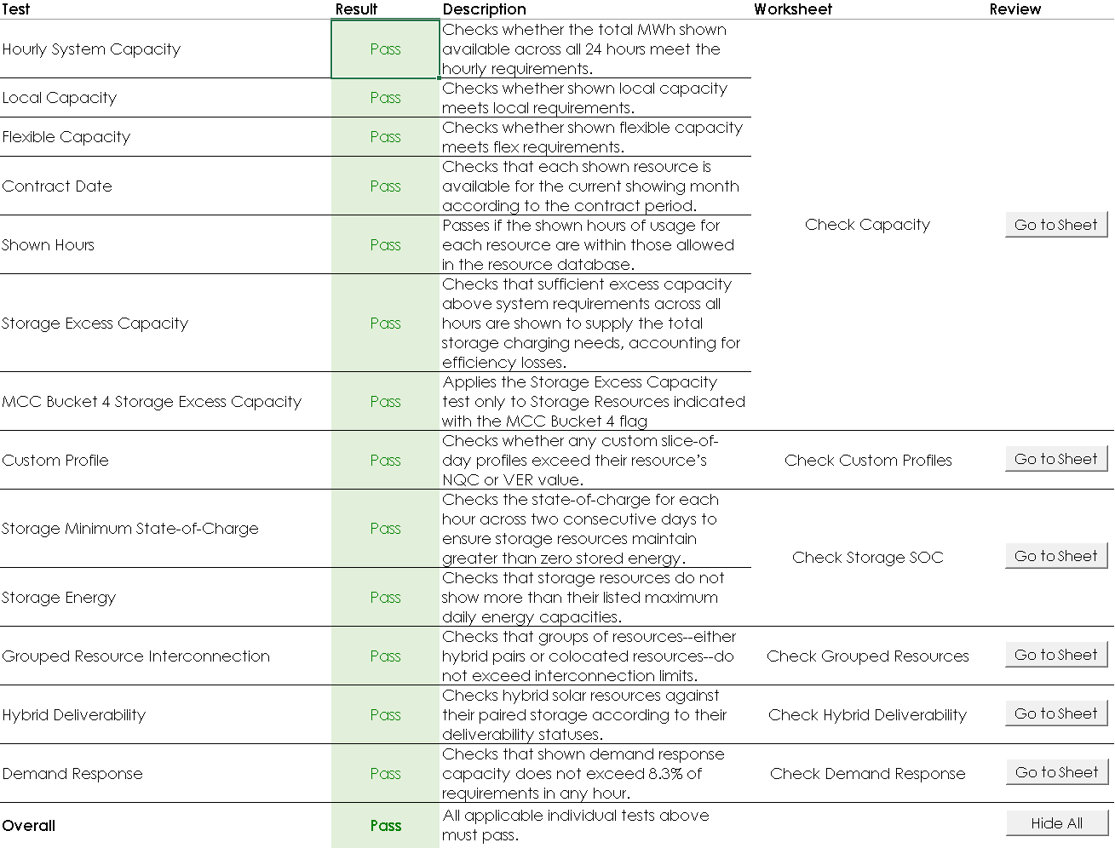
Figure 12 – Validation Overview worksheet indicating all tests have passed
The descriptions for each test is copied from the Validation Overview worksheet below, followed by additional explanation.

Hourly System Capacity
“Checks whether the total MWh shown available across all 24 hours meet the hourly requirements.”
This test sums total capacities across all shown resources and allocations (positive or negative), and subtracts hourly system requirements, for each slice-of-day hour. Each hourly total must be greater than or equal to zero for the test to pass. Capacities from energy only resources, i.e., where Deliverability Status is “EO”, are excluded from the calculation.
In certain cases, the capacities indicated in the hourly system capacity test will differ from the LSE Showing Complete worksheet:
- Capacities from demand response programs are constrained to a maximum of 8.3% of the hourly system requirements. If the sum of all capacities shown through DR programs exceeds this limit,
- Storage resource capacities will be excluded in any hour where the State-of-Charge test indicates <0% state-of-charge in either test day.
See the Check Capacity worksheet for more granular results and to inspect the calculations.

Local Capacity
“Checks whether shown local capacity meets local requirements.”
This test sums total capacities across all shown resources less requirements for each local area. The total for each local area must be greater than or equal to zero for the test to pass. The local areas are defined as LA Basin, Big Creek-Ventura, San Diego-IV, Bay Area, Fresno, Sierra, Stockton, Kern, Humboldt, NBNC. Capacities from energy only resources, i.e., where Deliverability Status is “EO”, are excluded from the calculation.
See the Check Capacity worksheet for more granular results and to inspect the calculations.

Flexible Capacity
“Checks whether shown local capacity meets flex requirements.”
This test determines countable capacity for each Flexible Category, and compares against Flexible Capacity requirements. The summed countable capacities for Flexible Categories 1 and 2 must be greater than the summed flexible requirements for the same Flexible Categories, as per the following formula
$${CC}_{\text{Flex1}}+{CC}_{\text{Flex2}}≥R_{\text{Flex1}}+R_{\text{Flex2}}+R_{\text{Flex3}}$$
Where:
${CC}_{\text{Flex1}}$ is the total countable capacity in Flexible Category 1 shown across all resources, allocations, and debits, calculated as
$${CC}_{\text{Flex1}}=\sum_{i∈\text{Res}}{{NQC}_{i,\text{Flex1}}}$$
${CC}_{\text{Flex2}}$ is the total countable capacity in Flexible Category 2 shown across all resources, allocations, and debits, capped at the Flexible Category 2 Requirements, calculated as
$${CC}_{\text{Flex2}}=max\left(\sum_{i∈\text{Res}}{{NQC}_{i,\text{Flex2}}}+{CC}_{\text{Flex3}},R_{\text{Flex2}}\right)$$
${CC}_{\text{Flex3}}$ is the total countable capacity in Flexible Category 3 shown across all resources, allocations, and debits, calculated as
$${CC}_{\text{Flex3}}=max\left(\sum_{i∈\text{Res}}{{NQC}_{i,\text{Flex3}}},R_{\text{Flex3}}\right)$$
$i$ is a resource, allocation, or debit in the set $\text{Res}$ comprising all resources, allocations, and debits,
$R_{\text{Flex1}}$ is the required capacity for Flexible Category 1,
$R_{\text{Flex2}}$ is the required capacity for Flexible Category 2,
$R_{\text{Flex3}}$ is the required capacity for Flexible Category 3,
${NQC}_{i,\text{Flex1}}$ is the flexible capacity shown by resource, allocation, or debit $i$ for Flexible Category 1,
${NQC}_{i,\text{Flex2}}$ is the flexible capacity shown by resource, allocation, or debit $i$ for Flexible Category 2, and
${NQC}_{i,\text{Flex3}}$ is the flexible capacity shown by resource, allocation, or debit $i$ for Flexible Category 3.
Capacities from energy only resources, i.e., where Deliverability Status is “EO”, are excluded from the calculation.
See the Check Capacity worksheet for more granular results and to inspect the calculations.

Contract Date
“Checks that each shown resource is available for the current showing month according to the contract period.”
This test compares the contract start and end dates for each resource in the LSE Showing worksheet against the current filing month as defined on the Certification worksheet. Each contract must start on or before the first day of the filing month, and end on or after the last day of the filing month.
See the Check Capacity worksheet for more granular results and to inspect the calculations.

Shown Hours
“Passes if the shown hours of usage for each resource are within those allowed in the resource database.”
This test determines which hours are shown with non-zero capacity for each resource and compares the first and last shown hours against the first and last available hours as defined in the Resource Database worksheet. If any resource has shown capacity before its first available or after its last available hour, the test fails.
See the Check Capacity worksheet for more granular results and to inspect the calculations.

Storage Excess Capacity
“Checks that sufficient excess capacity above system requirements across all hours are shown to supply the total storage charging needs, accounting for efficiency losses.”
This test calculates the sum of all shown hourly capacities for non-storage resources and allocations less system requirements, which is considered excess capacity expressed in MWh. Separately, the sum of shown storage capacities divided by their storage efficiencies represents the energy required to charge the storage resources, also in MWh. These summations operate on the same capacities used in the Hourly System Capacity test, thus demand response and storage showings may differ from the LSE Showing Complete worksheet. Excess capacity must be greater or equal to the required charging, or the test fails. The following formula describes the conditions required for a showing to pass this test:
$$\sum_{i∉\text{S}}{\left(max\left(0,\sum_{t=1}^{24}{C_{i,t}}-\sum_{t=1}^{24}{\frac{C_{\hat{i},t}}{η_{\hat{i}}}}\right)\right)}-\sum_{t=1}^{24}{R_{t}}≥\sum_{j∈\text{S}}{\left(max\left(0,\sum_{t=1}^{24}{\frac{C_{j,t}}{η_{j}}}-\sum_{t=1}^{24}{C_{\hat{j},t}}\right)\right)}$$
Where:
$i$ is one resource, allocation, or debit in the set of resources, allocations, and debits excluding grid-charging storage resources in set $\text{S}$, or an aggregation of multiple non-storage resources which share a common interconnection,
$\hat{i}$ is a grid-restricted storage resource paired or colocated with resource $i$,
$j$ is a resource in the set of storage resources which allow grid charging $\text{S}$,
$\hat{j}$ is an energy-only non-storage resource paired or colocated with storage resource $j$,
$t$ is a slice-of-day hour among 24 hours, indicating the hour ending label,
$C_{i,t}$ or $C_{j,t}$ is the shown capacity for resource, allocation, or debit $i$ or $j$ for hour $t$, where a debit is valued less than zero,
$R_{t}$ is the system requirement for hour ending $t$, and
$η_{j}$ is the storage efficiency of storage resource $j$.
Grid-restricted storage resources are not included in the charging requirements; however, the total capacity of any non-storage resource $i$ is reduced by the total charging energy of any paired or colocated grid-restricted storage resource $\hat{i}$, with a minimum of 0 MWh.
Energy-only resources do not contribute toward excess capacities; however, the required charging energy required for grid-charging storage resource $j$ is reduced by the total shown capacity of any paired or collocated energy-only non-storage resources $\hat{j}$. Additionally, the contribution toward excess energy from demand response programs is capped at 8.3% of each hourly system requirement.
See the Check Capacities worksheet for more granular results and to inspect the calculations.

MCC Bucket 4 Storage Excess Capacity
“Applies the Storage Excess Capacity test only to Storage Resources indicated with the MCC Bucket 4 flag.”
This test is calculated identically to the regular Storage Excess Capacity test but only applies to storage resources flagged as MCC Bucket 4 on the LSE Showing worksheet. Other storage resources are ignored, contributing neither toward nor against excess capacity. The following formula differs from that in the previous test only by summing the right-hand side across the intersection of resources that are both storage resources and in the set of resources $\text{MCC4}$ designated as in MCC Bucket 4:
$$\sum_{i∉\text{S}}{\left(max\left(0,\sum_{t=1}^{24}{C_{i,t}}-\sum_{t=1}^{24}{\frac{C_{\hat{i},t}}{η_{\hat{i}}}}\right)\right)}-\sum_{t=1}^{24}{R_{t}}≥\sum_{j∈\text{S∩MCC4}}{\left(max\left(0,\sum_{t=1}^{24}{\frac{C_{j,t}}{η_{j}}}-\sum_{t=1}^{24}{C_{\hat{j},t}}\right)\right)}$$

While complimentary sets of resources $\text{S}$ and $¬\text{S}$ appear on either side of the inequality in the full Storage Excess Capacity test, this test limits storage resources to those in MCC Bucket 4, thus excluding storage resources other than MCC Bucket 4 from consideration. Note that these other storage resources are also not then included in the sum of shown capacities, so they do not contribute toward excess capacity available for charging MCC Bucket 4 storage resources.
See the Check Capacity worksheet for more granular results and to inspect the calculations.

Custom Profile
“Checks whether any custom slice-of-day profiles exceed their resource’s NQC or VER value.”
This test compares the capacities input into the Resource Custom Profiles worksheet against various maximum capacity measures according to the type of resource shown, as follows:
- Unspecified Imports – hourly capacities must be less than or equal to the NQC Under Contract input in the LSE Showing worksheet;
- Solar or Wind resources – hourly capacities must be less than or equal to the resource’s Pmax defined in the resource database;
- Resources with negative NQC Under Contract - hourly capacities should be nonnegative and must be greater than the lower of the NQC Under Contract input in the LSE Showing worksheet or the current filing month NQC defined in the Resource Database worksheet.
- All others – hourly capacities must be less than the lower of the NQC Under Contract input in the LSE Showing worksheet or the current filing month NQC defined in the Resource Database worksheet.
If any resource at any hour exceeds its associated maximum capacity, the test fails.
See the Check Custom Profiles worksheet for more granular results and to inspect the calculations.

Storage Minimum State-of-Charge
“Checks the state-of-charge for each hour across two consecutive days to ensure storage resources maintain greater than zero stored energy.”
This test approximates the state-of-charge of all shown storage resources to ensure the state-of-charge never falls below zero. An initial state-of-charge of 100% is assumed for all resources at the beginning of hour ending 1 of the first day (i.e., HE 24 for an assumed day 0). Any hour when non-zero capacity is shown, the shown capacity divided by the resource’s maximum continuous energy is subtracted from the prior state-of-charge. Any hour during which zero capacity is shown, it is assumed the resource will recharge at a rate of either its maximum capacity or, when grid charging is not allowed, the shown slice-of-day capacities of its collocated non-storage resources divided by its efficiency up to a maximum state-of-charge of 100%. The state-of-charge of each storage resource is calculated for two consecutive 24 hour days with identical shown capacities to help account for initial states-of-charge less than the assumed 100%. Note that maximum continuous and daily energy values are scaled based on the contracted capacities, and that, because CAM storage debits are expected to have negative power capacities and energy maximums, the absolute values of these terms are used throughout.
The assumptions and calculations used in this test are identical to those used in the Profile Optimization worksheet, but apply to all storage resources regardless of the source of the slice-of-day profile. See the later section titled Storage Resource Optimization, which provides an explanation of the state-of-charge calculations.
See the Check Storage SOC worksheet for more granular results and to inspect the calculations.

Storage Energy
“Checks that storage resources do not show more than their listed maximum daily energy capacities.”
This test calculates the sum of each resource’s shown hourly slice-of-day capacities, which must be less than or equal to the associated maximum daily energy defined in the Resource Database worksheet.
See the Check Storage SOC worksheet for more granular results and to inspect the calculations.

Grouped Resource Interconnection
“Checks that groups of resources--either hybrid pairs or co-located resources--do not exceed interconnection limits.”
This test aggregates any co-located or hybrid resources and sums the shown capacities of each group. The summed capacities must not exceed the maximum capacity of the interconnection as defined in the Resource Database worksheet.
See the Check Grouped Resources worksheet for more granular results and to inspect the calculations.

Hybrid Deliverability
“Checks hybrid solar resources against their paired storage according to their deliverability statuses.”
This test identifies shown resources which are part of hybrid pairs and evaluates their shown capacities of hybrid solar sub-resources based on the Deliverability Status of defined in the Resource Database worksheet:
- “FC” – shown capacities must not exceed the Pmax defined in the Resource Database worksheet scaled by the ratio of the input NQC Under Contract divided by the total NQC for the current showing month defined in the Resource Database worksheet.
- “EO” – shown capacities must not exceed the interconnection limit as defined in the Resource Database worksheet.
- “ID” – shown capacities must not exceed the Deliverable % multiplied by Pmax, both defined in the Resource Database worksheet, scaled by the ratio of the input NQC Under Contract divided by the total NQC for the current showing month defined in the Resource Database worksheet.
- “PD” – shown capacities must not exceed the Deliverable MW defined in the Resource Database.
The worksheet supporting this test indicates whether both sub-resources in a hybrid pair are shown together, but doing so is not required.
See the Check Hybrid Deliverability worksheet for more granular results and to inspect the calculations.

Demand Response
“Checks that shown demand response capacity does not exceed 8.3% of requirements in any hour.”
This test calculates the sum of all shown capacities among demand response resources and allocations for each hour. The shown demand response must be less than or equal to the hourly system requirements multiplied by 8.3%
See the Check Demand Response worksheet for more granular results and the CheckDemandResponse query to review calculations step-by-step.

LSE Showing Complete
After completing all relevant worksheets with blue-colored tabs (LSE Showing, Resource Custom Profiles, and Profile Optimization), the LSE Showing Complete worksheet will contain a summary of all information about the showing. Once submitted, the CPUC will extract data from the table in this worksheet as the data source used when validating the showing.

Availability Charts
The three availability charts allow users to compare the capacities shown for each hour and for local and flexible resource adequacy against their requirements.
The Hourly Availability chart shows groups of resources as stacked bars contributing towards the total capacity shown during each slice-of-day hour. A black line overlaying the bars indicates the system requirements adjusted for any CAM and DR allocations aside from CAM storage and peakers. A compliant showing must have capacities at or above the requirements for each hour plus sufficient excess capacity to account for storage charging and losses. Hourly demand response, including DR allocations, are capped at 8.3% of the applicable hourly system requirement, and any storage resource capacities shown coincident with less than zero state-of-charge are excluded, as reflected in the System Hourly Capacity validation check.
The Local and Flex Availability charts show the same groupings of resources as stacked bars with the contributing capacities toward each local capacity area and flexible capacity category. Black points indicate the local and flexible RA requirements. A compliant showing must have capacities at or above the requirements for each applicable local area and meet the flexible RA requirement.
Each of the three charts are supported by hidden worksheets which aggregate the showing and apply labels for the chart. These worksheets can be unhidden and accessed by clicking the “Go To Sheet” button at the top left corner of each chart.

Power Query
The template contains 18 queries organized into four groups based on their use. All queries are available for inspection in the Power Query Editor. To access the Power Query Editor from the Excel Ribbon Menu select:
Data Queries and Connections Double-click on any listed query
Power Query is primarily an extract, transform, and load (ETL) utility that has been built into Excel since 2010. This feature allows queries to be written in Microsoft’s proprietary M language, and translates these queries to connect natively to a variety of underlying data sources, such as external flat files and offsite SQL servers.
Although capable of managing external connections, the Resource Adequacy Slice-of-Day Showing template uses Power Query to process data contained entirely within the single Excel workbook. Power Query provides some advantages over cell-based formula calculations particularly when handling variably-sized data tables. Specifically, Power Query functions operate on entire tables rather than individual cells, simplifying certain table-based operations versus equivalents implemented using standard Excel formulas. Additionally, complicated calculations can be presented within the Power Query editor as a sequence of Steps, available for inspection but otherwise out of the way for users who may be interested only in the results. Finally, Tables exported from Power Query are automatically resized to match the data, while formulas in any additional columns are copied into new rows.
One downside of Power Query is its speed. Users accustomed to immediate results when updating formulas or values in Excel cells may find the need to refresh tables generated by queries cumbersome or be put off by the comparatively slow loading times to and from Power Query. While query performance was a consideration when developing the template and designing the queries, some tables may still take several seconds to refresh. VBA scripts are included to control when queries refresh using manual button controls and worksheet events. These scripts should help limit the number of queries refreshing at a given time and minimize time spent waiting for queries.
In Revision 29, the template was updated to use Power Query primarily to manage a few columns used as indices throughout the workbook and filtering resources, allocations, and requirements for each Table. Earlier versions of the template use Power Query more extensively to perform calculations. Limiting the complexity of operations in Power Query results in faster refresh times, while necessarily increasing the complexity of formulas in cells throughout the workbook.
Many of the queries are programmed to refresh automatically when activating certain worksheets or running the storage profile optimizer. All queries may be refreshed manually by unprotecting the worksheet from the Review menu, and either right-clicking any area of the table and selecting “Refresh”, or, with any cell in the table selected, clicking “Refresh” in the Table Design menu.
The queries are grouped according to their purpose, with each group described in the following subsections.

Resource Information
The four queries in this group correspond to the two visible and three hidden worksheets with green tabs, extracting data from the tables contained therein and applying filters and transformations to make the data useable in later queries.

ResourceDatabase
This query loads data from the Resource Database worksheet and joins the table to the ResourceDefaultProfiles query, using the ResourceProfileCategories and Regions queries as intermediate lookup tables. The query also applies default values where data is missing. The resulting table is used throughout the queries discussed in later subsections.

ResourceDefaultProfiles
This query loads data from the Resource Default Profiles worksheet. The table is designed to allow many resources to match each profile, based on resource properties listed in the ResourceDatabase query, as described for the ResourceProfileCategories and Regions queries below. This query replaces values of “Any” in the Regions column and zero in the Month column of the Resource Default Profiles worksheet with all other values, resulting in additional rows. The results are loaded to the Expanded Default Profiles worksheet.

ResourceProfileCategories
This query loads data from the Resource Profile Categories worksheet. The query is a small lookup table that matches the Resource Type values listed in the ResourceDatabase query and the ProfileCategory values listed in the ResourceProfileCategories query.

Regions
This query loads data from the Regions worksheet. The query is a small lookup table that matches combinations of Path 26 Designation and Balancing Authority Area values listed in the ResourceDatabase query and Region values listed in the ResourceDefaultProfiles query.

Showing Information
The four queries in this group represent the information completed by LSEs in the worksheets with blue tabs.

Certification
This query loads data from the hidden CertificationTable worksheet which itself pulls data from the Certification worksheet into a table format.

ResourceCustomProfiles
This query loads data from the Resource Custom Profiles worksheet.

LSEShowingProfilesUnoptimized
This query loads data from the LSE Showing worksheet and joins the table to the ResourceDatabase and ResourceCustomProfiles queries.

UnoptimizedResources
This query filters the results of the LSEShowingProfilesUnoptimized worksheet to for all resources using either default or custom profiles, along withDR allocations. Any storage resources that will be loaded into the Profile Optimization worksheet are excluded. The results are loaded into the hidden Unoptimized Showing worksheet, which looks up resource information and applies the selected profiles. The resulting Table is used in the Profile Optimization worksheet for evaluating remaining capacity deficits, capacities counting toward interconnection limits, and capacities available for charging grid-restricted storage resources.

Optimization Setup
This group of two queries retrieves Resource IDs and Resource SubIDs for storage resources for which the default profile is not selected on the LSE Showing worksheet, and which are not listed in the Resource Custom Profiles worksheet. The resulting set of storage resources are thus available for the optimizer to build capacity profiles.

StorageProperties
This query retrieves and sorts the storage resources that will be available to the optimizer, exporting the resulting Resource IDs and Resource SubIDs to the Table labelled “Storage Properties” on the Profile Optimization worksheet. The selected resources are identified as “Battery Storage” based on the Chart Category, identified on the Resource Profile Categories worksheet corresponding to the Resource Type on the Resource Database worksheet, are not set to “Use Default Profile” on the LSE Showing worksheet, and are not input in the Resource Custom Profiles worksheet. The resource IDs and sub-IDs are sorted alphabetically.

SODProfilesForSOC
This query expands the list of storage resources from the StorageProperties query to show 24 slice-of-day hours for each resource, maintaining alphabetic order. The results are loaded into the table labelled “Optimized Showings” on the Profile Optimization worksheet.

Validation Tests
The six queries in this group represent different aspects of the complete Resource Adequacy showing, including shown resources with their default, custom, or optimized profiles. Each query is exported to a worksheet with a golden tab, with all but one hidden by default.

LSEShowingComplete
This query combines the resource listed in the LSE Showing tab with whichever slice-of-day profile is selected and appends Demand Response and Other CAM allocations. The resulting Contract IDs, Resource IDs, and Resource SubIDs are loaded to the LSE Showing Complete worksheet.

CheckCapacity
This query combines the resources and allocations from the LSEShowingComplete query with system requirements. The resulting Contract IDs, Resource IDs, and Resource SubIDs are loaded to the hidden Check Capacity worksheet.

CheckCustomProfiles
This query compares shown capacities in any custom profiles against the NQC or total VER MW Under Contract listed in the LSE Showing worksheet and the NQC MW in the ResourceDatabase query to ensure the custom profile does not exceed either value during any hour. The resulting Resource IDs and Resource SubIDs are loaded to the Check Custom Profiles worksheet.

CheckStorageSOC
This loads all resources indicated as “Battery Storage” based on the Chart Category identified on the Resource Profile Categories worksheet, corresponding to the Resource Type on the Resource Database worksheet. The filtered Contract IDs, Resource IDs, and Resource SubIDs are loaded to the Check Storage SOC worksheet.

CheckGroupedResources
This query identifies co-located or hybrid resources which share an interconnection and calculates the combined capacities for each hour. A compliant showing must not exceed the interconnection limit. The query generates a list of Associated Resources, with each entry consisting of comma-separated lists of interconnected or paired resources, with each hybrid resource’s ID and SubID separated by a period. The resulting Associated Resources and the maximum reported Interconnection Limit among each group’s resources are loaded to the Check Grouped Resources worksheet.

CheckHybridDeliverability
This query identifies hybrid resources, defined as sharing a Resource ID and having distinct Resource SubIDs, and determines the deliverable capacity for the solar resource based on its Deliverability Status and the attributes of both resources in each hybrid pair. The results are loaded to the Check Hybrid Deliverability worksheet.

Visual Basic for Applications
The Slice-of-Day Showing Template includes several scripts, written in Visual Basic for Applications (VBA). The scripts fall into four categories:
- External Data Tools
- LSE Showing Autofill Functionality
- Query Refresh Control
- Storage Optimization
All scripts are accessible from Excel’s built-in VBA editor. The VBA editor can be opened from the Developer tab on the Ribbon menu, which may need to be activated in Excel’s Options dialogue box. Once opened, the editor, shown in Figure 13, displays a list of modules corresponding to each worksheet and the whole workbook, followed by separately named modules. Most of the scripts are stored in the four named modules, matching the categories listed above. A fifth category could include trivial scripts contained in the Sheet7 (Validation Overview) module, which unhide and open or hide worksheets with associated button presses.

Many of the VBA scripts modify worksheet and workbook settings, such as manual or automatic calculation and worksheet protection. The primary purposes of these side effects are to:
- Minimize redundant calculation steps which affect application responsiveness, and
- Prevent accidental changes that may break workbook features and calculations.
Worksheet protections can be removed by opening the desired worksheet and clicking “Unprotect” from the Review tab of the Ribbon menu, but certain protections may be reset by scripts triggered by certain user actions.
The following sections describe each of the categories in more detail.
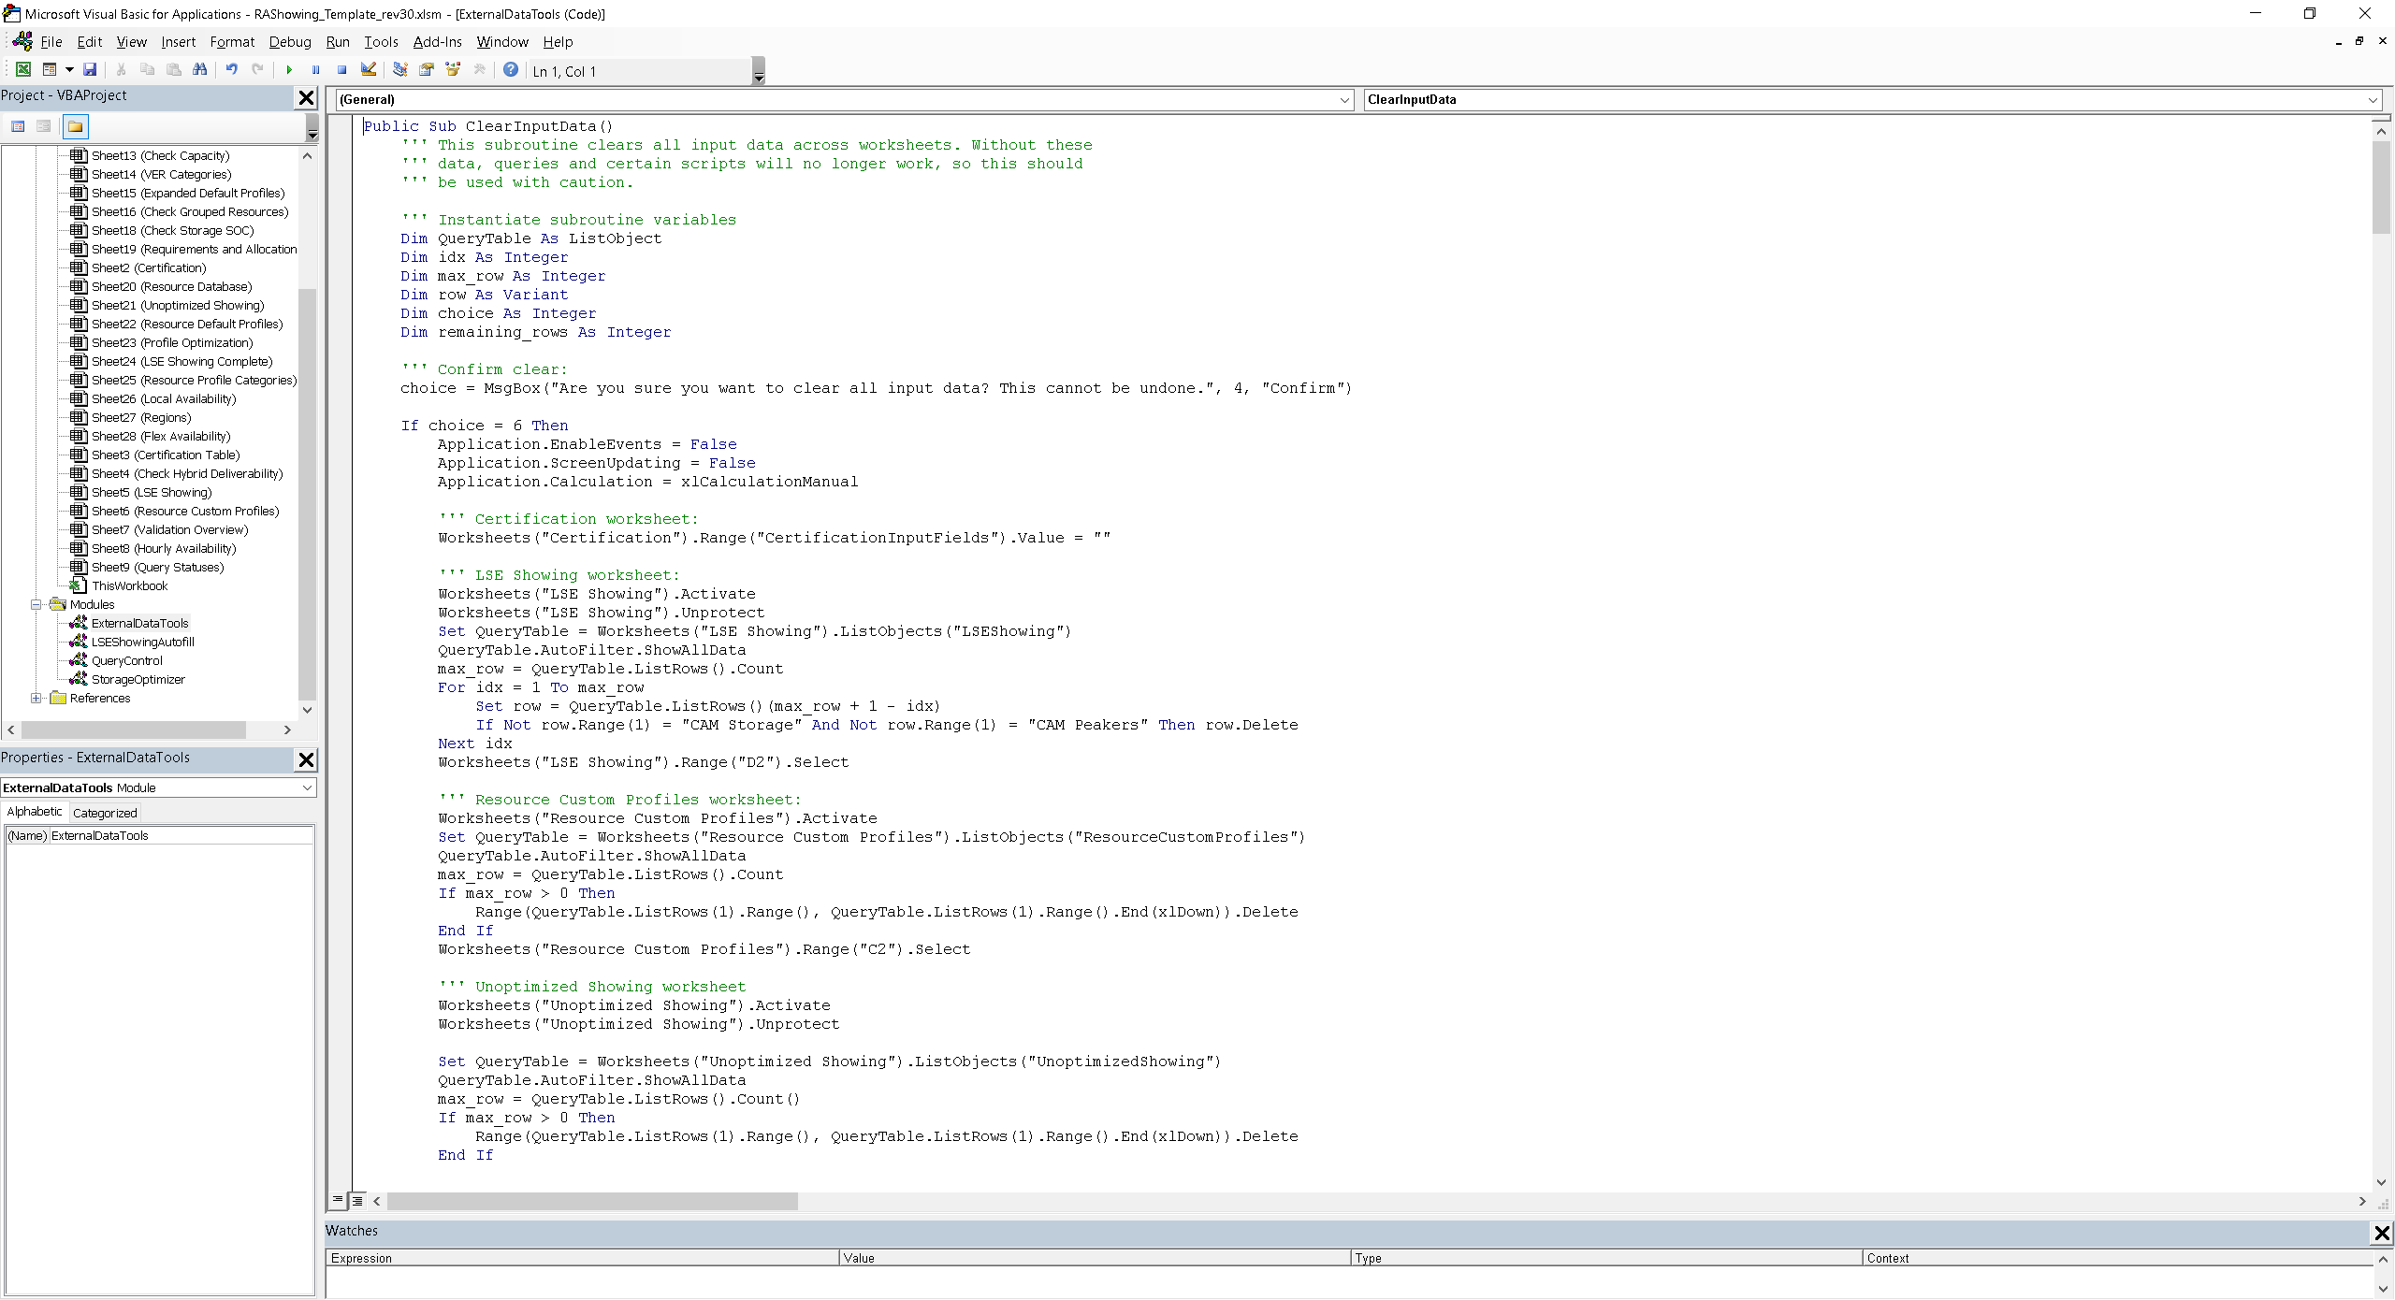
Figure 13 - Visual Basic for Applications Editor

External Data Tools
The functions and subroutines stored in the ExternalDataTools module provide the functionality described in the sections on the Clear All Input Data, Clear Requirements and Allocations, and Refresh Resource Database tools described in previous sections. The main functions are called when a user clicks on the associated button on the README worksheet.

LSE Showing Autofill Functionality
The LSEShowingAutofill module stores a single subroutine and a single function which, together, provide the Autofill LSE Showing Values functionality described in a previous section. Excel calls a special subroutine named “Workbook_SheetChange” stored in the ThisWorkbook module when any cell changes. This subroutine calls another subroutine named “WorksheetChangeEvent”, stored in the QueryControl module described below. Finally, if the “WorksheetChangeEvent” subroutine determines the change occurred in the LSE Showing worksheet, it calls the “LSEShowing_Autofill” subroutine in the LSEShowingAutofill module.

Query Refresh Control
The QueryControl module interacts with the Query Status worksheet to track when and where changes occur, determine which query tables are affected by changes, and trigger query refreshes when needed.
Excel calls the special “Workbook_SheetChange” subroutine, stored in the ThisWorkbook module, when any cell changes. This subroutine passes the location of the change (worksheet and cell range) to the “WorksheetChangeEvent” subroutine in the QueryControl module, which then logs the affected worksheet change as a status “EDITED” in the Query Status worksheet.
When the user navigates to another worksheet, Excel calls the special “Workbook_SheetDeactivate” subroutine, also stored in the ThisWorkbook module, which in turn calls the “CommitWorksheetChanges” subroutine in the QueryControl module. This subroutine sets the statuses of all “Downstream Query Tables” to “STALE”, indicating they will need to be refreshed, and resets the worksheet status to “COMMITTED”.
Upon opening a worksheet, Excel calls the special “Workbook_SheetActivate” subroutine in the ThisWorkbook module, which then calls the “RefreshUpstreamQueryTables” subroutine. This subroutine looks up any “Upstream Query Tables” listed in the Query Tables worksheet and their statuses, and triggers query refreshes for any listed as “STALE”. Once a query table is refreshed, its status returns to “FRESH”, indicating it doesn’t need to be refreshed until further changes are made to upstream data sources.

Storage Optimization
The StorageOptimizer module contains subroutines and functions which, together, setup and implement the optimization algorithm described in the next section.

Storage Resource Optimization
This section provides additional details on the storage resource optimization worksheet and associated queries and Visual Basic script.
The optimization problem is defined by the following equations:
$$\underset{x}{\text{minimize}}\sum_{i∈\text{RG}}{\left(\sum_{t=1}^{24}{\left(\frac{P_{i,t}}{η_{i}-η_{min}+0.1}\right)}\right)}$$

$$\text{subject to}:$$
$$P_{i,t}≥0 ∀ i∈\text{R},t∈\left\{1,2,3,…,24\right\} \\ P_{i,t}≤P_{i,t}^{*} ∀ i∈\text{R},t∈\left\{1,2,3,…,24\right\} \\ E_{\text{max daily}, i}-\sum_{t=1}^{24}{P_{i,t}}≥0 ∀ i∈\text{R} \\ \min\left(P_{\text{Deficit, }t}-\sum_{i∈\text{RG}}{P_{i}x_{i,t}}\right)≥0 ∀ i∈\text{RG},t∈\left\{1,2,3,…,24\right\} \\ {SOC}_{i,d,t}≥0 ∀ i∈\text{RG},d∈\left\{1,2\right\}, t∈\left\{1,2,3,…,24\right\}$$Where:
$i$ is a storage resource in the set of resources requiring optimization $\text{R}$;
$t$ is a slice-of-day hour among 24 hours, indicating the hour ending label;
$P_{\text{Deficit, }t}$ is the required capacity and allocations less the sum of capacities shown among resources with default or custom profiles in hour ending $t$;
$P_{i,t}$ is the decision variable adjusted by the optimizer, representing the shown capacity of storage resource $i$ in hour ending $t$;
$P_{i,t}^{*}$ is the calculated maximum capacity for storage resource $i$ in hour ending $t$, accounting for interconnection limits and shown capacities of collocated resources where applicable;
$η_{i}$ is the storage efficiency of resource group $i$;
$E_{\text{max daily}, i}$ is the maximum daily energy rating for storage resource $i$;
${SOC}_{i,d,t}$ is the state-of-charge of resource group $i$ on day $d$ in hour ending $t$, calculated as follows:
$${SOC}_{i,d,t}=\left\{\begin{matrix}100\% & \left|d=1∧t=1\right. \\ min\left({SOC}_{i,1,24}+{ΔE}_{i,t},100\%\right) & \left|d=2∧t=1\right. \\ min\left({SOC}_{i,d,t-1}+{ΔE}_{i,t},100\%\right) & \left|otherwise\right.\end{matrix}\right. \\ {ΔE}_{i,t}=\left\{\begin{matrix}-\frac{abs\left(P_{i,t}\right)}{abs\left(E_{\text{max cont.},i }\right)} & \left|P_{i,t}\right.>0 \\ \frac{η_{i}⋅abs\left(P_{i}^{*}\right)}{abs\left(E_{\text{max cont.}, i}\right)} & \left|x_{i,t}=0∧\right.∄P_{\text{nongrid},\overline{i},t} \\ \frac{η_{i}⋅abs\left(P_{\text{nongrid},\overline{i},t}\right)}{abs\left(E_{\text{max cont.}, i}\right)} & \left|\text{otherwise}\right.\end{matrix}\right.$$
Where:
${ΔE}_{i,t}$ is the possible change in stored energy in storage resource $i$ due to charging or discharging during hour ending $t$ (state-of-charge is capped at 100%, thus ${ΔE}_{i,t}$ is not guaranteed to yield equivalent changes in ${SOC}_{i,d,t}$);
$E_{\text{max cont.}, i}$ is the maximum continuous energy rating for storage resource $i$;
$P_{i}^{*}$ is the maximum overall capacity of storage resource $i$ (e.g., NQC under contract), applicable when grid charging is allowed; and
$P_{\text{nongrid},\overline{i},t}$ is the sum of shown capacities of resources $\overline{i}$ paired or collocated with storage resource $i$ in hour ending $t$ where grid charging is not allowed for storage resource $i$.
This optimization problem allows the decision variables $P_{i,t}$, to be set by the optimization algorithm, which attempts to minimize the objective function while matching the deficit capacities, limiting the maximum charge and discharge rates in each hour, and respecting the state-of-charge and daily energy constraints. The objective function applies a cost to showing capacity, with capacity shown by less efficient storage resource costing more than the same MW shown by more efficient storage resource. The decision variables appear in the “Shown MW” column of the table labeled “Optimized Showings” and are constrained between 0 MW and the calculated maximum capacities listed in the “Maximum Capacity (MW)” column of the same table.
A valid solution will not allow any values in the “State-of-Charge Day 1” and “State-of-Charge Day 2” columns of the “Optimized Showings” table to fall below 0%. These columns represent calculated states-of-charge across two days with identical shown capacities, assuming 100% state-of-charge at the beginning of the first hour of the first day, and allowing charging during any hour where no capacity is shown at the rate listed in the “Capacity Available for Charging (MW)” column. Additionally, each storage resource should not exceed its “Maximum Daily Energy Capacity (MWh)”, listed in the “Storage Properties” table, which is equal to its “Maximum Continuous Energy (MW)” multiplied by daily storage cycle capability.
After pressing the “Optimize Showings” button in the top left of the Profile Optimization worksheet, the optimization script first refreshes the three queries which output to the tables within the worksheet, then performs two checks to make sure the optimization problem is not clearly unsolvable:
- The deficit MW for each hour must not exceed the sum of the maximum capacities across all storage resources for the same hours; and
- The sum total deficit MW across all hours must not exceed the total maximum daily capacities of all storage resources.
If both these checks pass, the script then executes the primary optimization algorithm consisting of four distinct stages, which are repeated iteratively as needed or up to a configurable maximum number of iterations:
- Increase shown capacities for a resource with high efficiency and available state-of-charge;
- Redistribute shown capacities to minimize over-extended daily energies (skipped if no resources have negative “Difference Daily Energy (MWh)” in the “Storage Properties” table);
- Redistribute shown capacities to reduce negative states-of-charge (skipped if the overall minimum state-of-charge is nonnegative); and
- Reallocate any differences between the “Deficit (MW)” and “Shown MW” listed in the “Capacity Deficits” table.
Steps 2 and 3 may repeat up to 10 times within each iteration before progressing to step 4. The four steps are designed to work together to enforce the problem constraints and improve the objective function through each iteration. Every adjustment to a single resource and hour in steps 2 and 3 is balanced by opposite and approximately equal in aggregate adjustments to all other resources in the same hour. Adjustments to shown capacities will not exceed the associated maximum capacity or fall below zero, thus differences between the deficit capacities and total shown capacities may accumulate through each iteration—these differences are addressed in step 4.
If either of the pre-checks fail, the script will execute an alternate optimization algorithm which relaxes the constraint to meet hourly capacity deficits and does not prioritize storage resources with higher round-trip efficiencies than others available to the optimizer. This alternate algorithm has a similar structure to the primary, despite the modified problem:
- Increase shown capacities for all resources where the “Maximum Available Capacity (MW)”, “Difference Energy (MWh)”, and the “Minimum State-of-charge” columns in the Table labelled “Storage Properties” all have positive values;
- Redistribute shown capacities to minimize over-extended daily energies (skipped if no resources have negative “Difference Energy (MWh)” in the “Storage Properties” table);
- Redistribute shown capacities to reduce negative states-of-charge (skipped if the overall minimum state-of-charge is nonnegative); and
- Reallocate positive differences between and “Shown MW” and the “Deficit (MW)” columns listed in the Table labelled “Capacity Deficits”.
This algorithm applies similar second and third steps to the primary algorithm, although while the primary algorithm balances every change in one resource against the others such that the total storage capacity in a given hour doesn’t change in these steps, the alternate algorithm allows some differential slippage that increases with each iteration until reducing the showing of one resource to remedy constraint exceedances does not affect other resources. The first step differs by increasing capacities among all resources wherever possible, and the fourth step only reduces showings to avoid exceeding deficits while leaving hours with unmet capacity deficits unchanged. When the alternate optimizer runs successfully, the resulting showing should utilize each storage resource as much as possible within each resource’s limitations without exceeding the capacity deficit in any hour, but will not meet the system requirements.
When the script applies the primary algorithm, the objective function generally should improve (i.e., decrease) each iteration and converge to an optimal and valid solution, although certain conditions may cause the script to fail. Note that passing the two checks prior to optimization does not guarantee a valid solution exists, as the checks do not account for state-of-charge limitations. The optimization script may thus exit after the maximum number of iterations with either invalid states-of-charge, capacities exceeding the relevant maximum, or both, either indicating that no solution exists or additional iterations are required. Alternatively, the script may exit with a valid solution that is suboptimal after the maximum number of iterations, with optimality defined by consecutive iterations resulting in similar objective function values within a threshold. In these cases, the user may attempt any combination of the following:
- Manually adjust the values in the “Shown MW” column of the “Optimized Showings” table to find a valid solution;
- Adjust the maximum iterations setting and/or other settings to help the optimization algorithm find a solution; or
- Show additional resources or capacities to make the optimization problem more readily solvable, either by reducing the deficit or by increasing the storage capacity available for optimization.
The optimization algorithm should find a valid solution with close to the lowest possible objective function value, indicating full prioritization of more efficient resources, in most cases.
The optimization algorithm applies a few user-configurable settings, located in the outlined range below the “Capacity Deficits” table:
- Maximum Iterations – an integer number defining the maximum number of iterations for the algorithm to execute before exiting even if constraints or optimality conditions are not satisfied. Default value: 24.
- Objective Threshold Coefficient – a coefficient which, multiplied by the total deficit across all hours, defines the minimum difference between the objective function values evaluated at the ends of two consecutive iterations to trigger the exit criteria. Default value: 0.0001.
- SOC Adjustment Coefficient – a coefficient applied to adjustments to hourly shown capacities when enforcing the state-of-charge constraint. A value of 1.0 will reduce the showing of a resource with a negative minimum state-of-charge such that its minimum state-of-charge will be zero immediately following its adjustment (when multiple discharge/charge cycles are present, only the cycle containing the minimum state-of-charge is affected, so the resource may still have a negative minimum state-of-charge during a separate cycle). Since multiple resources may require adjustment, it is recommended to use a value greater than 1 but not greater than 1.5, so that adjustments slightly overshoot to yield a slightly positive state-of-charge. Default value: 1.05.
- Energy Adjustment Coefficient – a coefficient applied to adjustments to all shown capacities for a resource when enforcing the maximum daily energy constraint. A value of 1.0 will reduce the applicable resource’s overall showing by exactly the amount of unused energy represented by its minimum state-of-charge multiplied by its maximum continuous energy. Since the energy adjustment coefficient impacts all hours and resources, potentially causing other resources to become invalid, a value between 0.5 and 1 is recommended. Default value: 0.95.
- Efficiency Prioritization Coefficient – a coefficient applied to adjustments to the resource identified as having the greatest potential impact on the objective function. The potential impact is determined based on a combination of the unused possible energy and minimum state-of-charge, and accounts for storage efficiency. The optimizer adjusts each resource with higher than the lowest efficiency in the group, and to keep adjustments from negating each other, a value between 0.5 and 1 is recommended. Default value: 0.85.
As the optimizer runs, adjustments among all four steps should get smaller in magnitude, indicating convergence toward a solution. If the user finds values start exploding or oscillating, adjusting a combination of these settings may stabilize the problem and allow a solution to be found.

Conclusion
We hope this template is helpful for developing compliant resource adequacy showings in the slice-of-day framework and anticipate further refinement as it is used by more people throughout the upcoming year. We look forward to your feedback and questions as you begin to use the template.

Changelog

Revision 16
First Public Release

Revision 17
Internal Revision
- New validation test, labelled “Demand Response” on Validation Overview worksheet, calculates total shown demand response capacity (DR allocations and any resource with Resource Type="Demand Response") divided by required capacity (without Other CAM allocations) for each hour and compares against 8.3%--if any hour exceeds 8.3%, the test indicates "Fail".
- Added "Demand Response" as a capacity category in the charts.
- Added new section in User's Guide regarding Resources Under Construction.
- Consolidated buttons on the Profile Optimization worksheet.
- Added fourth table to the Profile Optimization worksheet showing only resources and hours where additional capacity is needed beyond shown default and custom profiles, reducing the number of independent variables for Solver and increasing the number of resources that can be optimized before grouping.
- Implemented two-day state-of-charge calculations on the Profile Optimization worksheet, assuming 100% stored at midnight of day 1, still constraining SOC to greater than 0 across both days.
- Implemented the same two-day state-of-charge calculations in SOC validation test, replacing original version assuming 0% initial SOC with one day.
- Wrote definition of the optimization problem in mathematical terms with text explanation in a new section of the User’s Guide.
- Added Resource SubID field to Resource NQC worksheet to allow correct joining to Resource Database table.

Revision 18
Internal Revision
- The Profile Optimization worksheet and SOC Validation both apply proportional energy storage (maximum continuous and daily) weighted by the input NQC or VER Under Contract divided by the showing month's NQC MW in the Resource NQC worksheet rather than the entire resource energy storage capacity.

Revision 19
Public Release
- More visual feedback while refreshing tables for optimization and charts.
- Various formatting changes throughout.

Revision 20
Internal Revision
- Revised default profile capacity calculations for wind and solar resources, calculating VER based on resource NQC and Pmax if Fuel field indicates “SUN” or “WIND”.
- Revised hybrid deliverability test to use Pmax scaled by input NQC divided by resource total NQC for current showing month.
- Updated column header and hint for column “NQC Under Contract (MW)” (previously “NQC or VER Under Contract (MW)”).
- Renamed “NQC or VER Under Contract (MW)” to “NQC Under Contract (MW)” in LSE Showing worksheet and queries.
- Renamed “NQC MW” to “NQC (MW)” in Resource NQC worksheet and queries.
- Added weighting columns to the “Optimized Showings” and “Capacity Deficits” tables on the Optimization worksheet to prioritize higher efficiency storage, and set initial values of variable cells to 50% instead of 0%.
- Applied absolute values to state-of-charge calculations in both optimization worksheet and validation tests to accommodate CAM storage debits.
- Updated text on README worksheet to reflect recent changes.
- Updated user’s guide to reflect recent changes and merged changelog into user’s guide.

Revision 21
Internal Revision
- Imported data from latest Master Resource Database.
- Replaced numeric values with lookup formulas for CAM storage and peaker allocations in LSE Showing and Resource Database worksheets.
- Reformulated storage profile optimization problem.
- Updated user’s guide to reflect changes to optimization.

Revision 22
Public Release
- Modified HourlyAvailability query to include negative capacities to accommodate CAM debits.
- Modified OptimizationGroupMap query to exclude storage resources with capacities less than or equal to zero to accommodate CAM debits.
- Added Showing Type field to the Certification worksheet to select Year Ahead or Month Ahead and apply correct requirements.
- Applied new coefficient in SystemRequirements and FlexRequirements queries, equal to 0.9 if Showing Type is “Year Ahead” and 1.0 otherwise.
- Added validation hints to the Certification worksheet.

Revision 23
Public Release
- Excluded hours with negative excess capacities from Storage Excess Capacity tests.
- Revised Flexible Category test according to program requirements.
- Implemented a pre-check into the storage resource optimization routine to inform the user when insufficient power or energy capacities are shown.
- Added explanation of minimum criteria for running storage resource optimization in User’s Guide.
- Revised and expanded explanation of the Flexible Capacity test according to revised calculations.
- Added details to User’s Guide regarding the Storage Excess Capacity tests.
- Removed “Table.StopFolding” expressions from queries for backward compatibility.
- Added buttons to each chart to navigate to supporting data table.

Revision 24
Internal Release
- Applied “Table.Distinct” expression to the ResourceOptimizationGroupMap query to ensure no duplicate resources (e.g., two contracts for portions of the same resource).
- Added “Chart Category” column to Resource Profile Categories worksheet.
- Revised HourlyAvailability, LocalAvailability, and FlexAvailability queries to use “Chart Category” instead of “Profile Category” values.
- Modified specification for Resource and Allocations worksheet to calculate System Requirements based on Load Forecast and PRM instead of direct input.
- Revised default load profile calculations for VER resources consistent with stored profiles calibrated for Pmax.

Revision 25
Public Release
- Revised storage optimization objective function and various cell formulas.
- Set initial conditions for optimizer to meet requirements.
- Updated User’s Guide with revised optimization problem definition.

Revision 26
Public Release
- Clarified explanation for inputting VERs into LSE Showing template in User’s Guide.
- Added signature line on Certification worksheet.
- Clarified NQC entries use SOD NQC rather than Compliance NQC in User’s Guide.
- Added conditional formatting to optimization to highlight unfavorable conditions.
- Fixed error in Chart Label evaluation in the LSEShowingComplete query which had been applying Profile Category instead of Chart Category. The query is loaded into the “LSE Showing Complete” worksheet and used in hidden worksheets for charts.
- Fixed error in lookup formulas for CAM Storage Allocation Multi Cycle in “Resource Database” which had not correctly been retrieving the current month from the “CertificationTable” worksheet.
- Fixed labelling error for CAM Peaker Allocations so their capacities now count toward Requirements and Allocations in charts.
- Added checks in the Year column in the Requirements and Allocations worksheet against the showing year on the Certification worksheet throughout workbook. Previously, only checked showing month.
- Fixed errors in the ResourceDefaultProfile query so that region=“Any” now expands to all regions listed in the Regions worksheet and month=0 now map to all 12 months.
- Added VBA script to facilitate clearing input data from workbook.
- Added VBA script to replace resource database and default profiles from selected Master Resource Database file.
- Removed “Resource NQC” worksheet and added monthly NQC columns to “Resource Database” worksheet, and updated queries accordingly
- Rebuilt the storage optimizer
  - Removed usage of Solver and implemented fully custom script for optimizing storage showing.
  - Removed Optimization table.
  - Removed “Nongrid Charging Capacity (MW)” column from optimized showings table.
  - Added “Capacity Available for Charging (MW)” to “Optimized Showings” table, indicating either non-grid or maximum grid charging rate.
  - Added “Maximum Capacity (MW)” to “Optimized Showings” table.
  - Renamed the “Group Definitions” table to “Storage Properties”.
  - Updated capacity check to consider hourly maximum capacities rather than NQC under contract.
  - Removed resource grouping functionality and instead use “Resource ID” and “Resource SubID” throughout.
  - Removed fractional showing column, instead adjusting hourly capacities directly, constrained between zero and the resource’s hourly maximum capacity.
  - Added optimization status and settings panel below the “Capacity Deficits” table.
- Reformatted validation output tables.
- Made “Resource Group ID” values more readable in “Check Grouped Resource” validation output table.
- Excluded Energy-Only resources (indicated by value “EO” in Deliverability Status column of Resource Database) in CheckCapacity query, removing their shown capacities from all system, local, and flexible capacity checks.
- Modified Storage Excess Energy and Storage Excess Energy for MCC Bucket 4 tests to limit capacity from Energy-Only resources to offset charging requirements collocated storage resources.
- Recategorized labels for charts, defined in the hidden “Resource Profile Categories” worksheet, and sorted labels so that “Battery Storage” appears at top of stack.
- Applied color scheme to chart labels based on CAISO’s Today’s Outlook charts.
- Applied rounding to two decimal places in validation checks.
- Added script to filter for resource sub-ids in validation rules on LSE Showing worksheet and auto-populate fields with default values from Resource Database after inputting Resource ID and SubID.

Revision 27
Public Release
- Modified storage optimization script to prevent divide-by-zero errors when optimizing small numbers of resources.
- Modified queries to ensure storage resources in optimizer worksheet don’t overwrite default profile when “Use Default Profile” is selected.
- Resolved error in CheckStorageSOC query causing capacities of co-located resources to be ignored in calculating available capacity for charging.
- Added NP 26 designations for non-CAISO BAAs on Regions worksheet to map default profiles to updated Master Resource Database entries.
- Added checkbox on README worksheet to switch auto-filling default values on or off for LSE Showing worksheet.
- Updated Refresh Resource Database script to generate resource types for demand response programs to apply correct default profiles.
- Fixed errors in Refresh Resource Database script causing duplicate demand response resources and misaligned deliverable percentage and capacity values.

Revision 28
Internal Revision
- Fixed error in the “LSEShowingProfilesUnoptimized” query where LESR logic was not applied to hybrid resources. The query now applies LESR logic to convert from NQC- to Pmax-scaled capacities when the applicable “Profile Category” field in the “Profile Categories” worksheet is “Solar Fixed”, “Solar Tracking”, “Solar Thermal”, or “Wind”, rather than when the “Resource Type” in the “Resource Database” worksheet is “SUN” or “WIND”.
- Added deterministic sorting to the “StorageProperties” query, which loads to the table labelled “Storage Properties” on the “Storage Optimization” worksheet, to ensure resources are listed in the same order as the “SODProfilesForSOC”, which loads to the table labelled “Optimized Showings” on the same worksheet.
- Replaced the “Resource Type” for the “CAM Peaker” resource from “Peaker” to “CAM Peaker” to apply the correct default profile.

Revision 29
Public Release
- Rewrote queries for storage optimization, validation tests, and charts, and rebuilt corresponding worksheets. Queries now focus on handling table indices, shifting most lookups and calculations from queries to cell formulas.
- Moved Contract Date, Shown Hours, Storage Excess Capacity, and MCC Bucket 4 Storage Excess Capacity to the Check Capacity worksheet.
- Removed “Refresh” buttons from the Validation Overview worksheet and now run refresh script when worksheet is viewed.
- Updated logic in Shown Hours, Storage State-of-Charge, and Storage Energy tests to allow for negative CAM Storage allocations.
- Excluded storage resources from Shown Hours validation test.
- Excluded storage capacity from the Hourly System Capacity test and the Hourly Availability Chart for resources and hours ending where the State-of-Charge test indicates less than zero state-of-charge.
- Distributed grid-restricted storage charging requirements across hybrid or co-located resources in excess capacity tests.
- Constrained demand response contribution toward system capacity to 8.3% of system requirements. Resource-level hourly capacities for DR programs on the Check Capacity worksheet are decreased proportional to their shown capacities on the LSE Showing Complete worksheet, relative to other DR programs, such that the sum of all programs is at most 8.3% of system requirements. Capped demand response capacities are also used in the Hourly System Availability chart.
- Added rows to the hidden Certification Table worksheet with settings for year and month ahead system requirement coefficients, and maximum demand response ratio, and replaced corresponding constants in calculations with lookups.
- Updated Clear Input Data and Clear Requirements and Allocations scripts to work with new table formats.
- Modified Master Resource Database refresh script to handle missing data and correct filters upon import.
- Replaced “Maximum Daily Energy (MWh)” column in the Storage Properties Table on the Profile Optimization worksheet with “Maximum Possible Energy (MWh)”, representing the minimum of either the resource’s listed maximum continuous energy, pro-rated by contracted NQC, or the sum of all hourly maximum capacities during hours with deficits.

Revision 30
Internal Revision
- Fixed error excluding Demand Response Allocations in Demand Response Test calculations.
- Fixed error in Check Custom Profiles worksheet to apply correct calculations for VERs based on the Chart Label.
- Fixed error in “Last Shown Hour” column of Check Capacity worksheet to correctly determine the latest hour with non-zero shown capacity.
- Fixed error in “State-of-Charge Day 2” column of Profile Optimization worksheet which erroneously allowed grid charging in HE 1 for grid-restricted resources.
- Modified sheet protection in Default Profiles worksheet to allow sorting.
- Removed “ROUND()” from State-of-Charge calculations in the Check Storage SOC worksheet to prevent accumulated errors, and applied “ROUND()” to the “Minimum SOC” column and in all “MW HE __” columns of the Check Capacity worksheet.
- Applied filters in the “Grid Capacity (MWh)” column of the Check Capacity worksheet to exclude hours where shown capacities of “Grid” and “Paired” resources, as defined in the “Excess Capacity Group” column, do not meet the system requirements.
- Added logic to the “” column of the Check Capacity worksheet to allow negative allocations, i.e., debits for Investor-Owned Utilities, to reduce charging requirements in the Storage Excess Capacity and MCC Bucket 4 Storage Excess Capacity tests.
- Relocated most VBA scripts from sheet modules to named modules.
- Added worksheet “Query Statuses” and updated query refresh scripts to perform refreshes only when needed. Queries will now only refresh after changes to upstream data are detected.
- Modified formulas on Validation Overview worksheet to indicate “Refreshing …” while supporting query tables are stale.
- Modified VBA scripts to set calculation mode to “Manual” for LSE Showing and Resource Custom Profiles, and to recalculate the current sheet only upon changes, to improve performance while inputting data
- Modified the formulas in the “First Hour Available (HE)” and “Last Hour Available (HE)” columns in the Check Capacity worksheet to use capacities from the LSE Showing Complete worksheet instead of those on the same sheet, to allow Energy Only resources
- Added logic to the formula in the “Valid Hours” column on the Check Capacity worksheet to handle resources with zero shown capacity across all slice-of-day hours

https://www.cpuc.ca.gov/industries-and-topics/electrical-energy/electric-power-procurement/resource-adequacy-homepage/resource-adequacy-compliance-materials
Slice-of-Day NQC Under Contract can be calculated as [Compliance NQC Under Contract] * [Total Slice-of-Day NQC] / [Total Compliance NQC].
The “Maximum Possible Energy (MWh)” field in the Storage Properties table is the minimum of either each resource’s “Maximum Daily Energy (MWh)” in the Resource Database or the sum of each resource’s “Maximum Capacity (MW)” in the Optimized Showings table.
Excel’s Developer menu must be active in order to access the Visual Basic editor. This menu can be activated from FileOptionsCustomize Ribbon, and ensuring Developer is checked in the “Main Tabs” pane.

