PU Code 913.8 Reporting Requirements
The Public Utilities (PU) Code Section 913.8 includes a list of reporting requirements that must be addressed by the SOMAH evaluation. The table below provides a summary of these reporting requirements and how and where they are addressed by within the Phase I and Phase II SOMAH reports. As of the final data download for this report (April 29, 2021) only four solar PV systems have been installed through the program (one has received the SOMAH incentive payment and the other three have submitted the SOMAH incentive claim form but have not received their incentives) and thus some the PU Code reporting requirements, as indicated below, are based upon ex-ante estimates of program performance rather than actual performance data.
PU Code 913.8 Reporting Requirement | Phase II Reporting Status
The number of qualified MF affordable housing property sites that have a qualifying solar energy system. | As of April 29, 2021, one SOMAH project has been completed and received the SOMAH incentive. An additional three projects have filed their Incentive Claim Package. A summary of the status of active SOMAH applications is included in Section 4.1 of this report.
The dollar value of the award and the electrical generating capacity of the qualifying renewable energy system. | As of April 29, 2021, the PV system capacity of the 405 active SOMAH applications is 68 MW_{AC}. This is a reduction from the 81.6 MW_{AC} reported in the Phase I report primarily because of the 124 SOMAH applications have been cancelled or were ineligible. The total value of the submitted/reserved SOMAH incentive for completed and active projects is $152M.
The bill reduction outcomes of the program for the participants. | There has been an insufficient number of SOMAH projects completed to allow for the calculation of ex-post bill impacts for program participants resulting from the SOMAH Program at this time. Phase II of the SOMAH evaluation estimated the ex-ante bill impacts for 381 SOMAH projects which had submitted a SOMAH application as of March 3, 2021. The estimated ex-ante bill impacts are provided in Section 6.3 of this report.
The cost of the program. | Section 4.5 of the Phase II report provides the total program expenditures, budget, and incentives paid through December 31, 2020.
The total electrical system benefits. | There has been an insufficient number of SOMAH projects completed to allow for the calculation of ex-post electrical system benefits of the SOMAH Program at this time. Phase II of the SOMAH evaluation estimated the ex-ante energy and demand impacts for 381 SOMAH projects which had submitted a SOMAH application as of March 3, 2021. The estimated ex-ante energy and demand impacts are provided in Section 6.1 of this report.
The environmental benefits. | There has been an insufficient number of SOMAH projects completed to allow for the calculation of ex-post environmental benefits resulting from the SOMAH Program at this time. Phase II of the SOMAH evaluation estimated the ex-ante greenhouse gas impacts for 381 projects which had submitted a SOMAH application as of March 3, 2021. The estimated ex-ante GHG impacts are provided in Section 6.2 of this report.
The progress made toward reaching the goals of the program. | Goal 1) Expanding access to solar generation and its benefits to low-income customers in multifamily housing, where it is typically limited.  As detailed in Section 7 of the Phase I report, the evaluation team found the SOMAH PA, the IOUs, and the Energy Division are broadly aligned in their understanding of the SOMAH Program’s role in delivering solar to disadvantaged and low-income communities through incentivizing affordable solar energy in multifamily affordable housing. Section 3.2.3 provides details on the benefits of the program across a diverse group of tenants, property owners, job seekers, and contractors.  Goal 2) Incentivizing the installation of at least 300 MW of solar generation capacity.  Section 4.1 of the Phase II report presents analysis of the SOMAH applications submitted through April 29, 2021. As this analysis shows, the PV system capacity of the 405 active SOMAH applications is 68 MW_{AC} which is 23 percent of the overall program goal of 300 MW_{AC}. This is 4 percent lower than estimated during Phase I of this study due to project cancellations and ineligibility since the Phase I was completed.  Goal 3) Ensuring financial benefits accrue primarily and directly to tenants, and are not recaptured by other means.  Section 4.2.3 of the Phase II report presents analysis of the program tracking data through April 29, 2021. While the SOMAH Program requires a minimum 51 percent of a project’s electrical output be allocated to offset tenant’s load, currently on average across SOMAH non-cancelled applications, the tenant allocation (both on an application and system capacity weighted basis) is 88 percent.  Goal 4) Providing greater accessibility to the program for applicants through a single point of contact, full service technical assistance, and coordination with other low-income programs.  Section 4.1.4 of the SOMAH Phase I report provides details on how the SOMAH Program is coordinating with other low-income programs.  Goal 5) Promoting local economic development through job training requirements and hiring practices.  Section 3.3.2 of the SOMAH Phase I Report and Section 5.4.4 of the Phase II report provide details regarding SOMAH workforce development activities.  Goal 6) Facilitating efficient program administration by a single, statewide administrator.  Section 7 of the SOMAH Phase I report presented the evaluation findings one of which was that the SOMAH PA is clear and internally aligned on the goals and objectives of the program and is working in the spirit of the legislation. Research conducted for Phase II of the evaluation further supported this finding. Contractors rated their interactions with the SOMAH PA highly. Both contractors and property owners rated their satisfaction with the SOMAH Program around a seven (on a scale of 0-10) primarily due to the program participation requirements being overly burdensome which is evident by the program’s limited distribution of program incentives to date.
The program’s impact on the California Alternate Rates for Energy (CARE) Program budget. | Section 6.3.1 estimates ex-ante bill impacts for customers in the CARE Program based on submitted applications through March 3, 2020.
Recommendations for improving the program to meet its goals. | A summary of the findings and recommendations for program improvements to help ensure the program met its stated goals are provided in Section 7 of this report.
Analysis of pending program commitments, reservations, obligations, and projected demands for the program to determine whether future ongoing funding allocations for the program are substantiated. | As detailed in Section 4.1 of the Phase II report, to date a total of 534 SOMAH applications have been received. Of these:  2 are currently in the Upfront Technical Assistance Request step;  103 are in the Reservation Request step;  198 are in the Energy Efficiency Compliance Milestone step;  48 are in the Proof of Project Milestone step;  4 are in the Incentive Claim Phase (of which one has received the SOMAH incentive); and  129 have been cancelled, withdrawn, or were ineligible
A summary of the other programs intended to benefit disadvantaged communities, including, but not limited to, the Single-Family Affordable Solar Homes Program established by the commission in Decision 07-11-045, the Multifamily Affordable Solar Housing Program established by the commission in Decision 08-10-036, and the Green Tariff Shared Renewables Program. | This summary is provided in Appendix F of the Phase I Report which can be found here:  https://www.cpuc.ca.gov/-/media/cpuc-website/files/legacyfiles/s/6442465840-somah-phase1-evaluation-final-report.pdfError! Hyperlink reference not valid.
Additional DAC Reporting Requirement | Phase II Reporting Status
Number and percentage of applications received for projects located in a DAC | As presented in Section 4.2.2 of the Phase II report, as of April 29, 2021, a total of 147 submitted project applications are within a DAC (28 percent of all applications)
Number and percentage of applications for projects located in a DAC that are approved | 95 of the 147 submitted projects in a DAC have been approved as of April 20, 2021 (18 percent of all submitted applications)

SOMAH Metrics and KPI Assessment
A key component of Phase II of the evaluation was to finalize a set of SOMAH Program metrics and key performance indicators (KPIs) that can be used to track program performance over time against the programs stated goals. A memo was delivered in December of 2020 that laid out the metrics and KPIs proposed by the evaluation team. These metrics and KPIs are presented in the tables below, along with their focus, associated goals, and the measurement approach. The sections that follow present the evaluation team’s assessment of these metrics and KPIs.
Table B-1: SOMAH Program Metrics
# | Metric | Metric Focus | Associated Goal(s) | Measurement Approach
1 | Applicant Projects with Reservation Request Approval, Milestone Status, and Incentive Package Submitted in Track A and Track B | Successful Installations | 1, 2, 6 | #, % of total, △
2 | Number of job trainees who complete training per number of projects completed | Workforce Development | 5 | #:#
3 | SOMAH-sponsored Job Trainings Conducted and Attendees | Workforce Development | 5 | #, △
4 | SOMAH Projects with Reservation Request Approval, Milestone Status, and Incentive Package Submitted benefiting tenants who are income qualified and/or live in a DAC. | Distribution of Program Benefits | 1, 3, 4 | #, % of total, △
5 | SOMAH Projects with Reservation Request Approval, Milestone Status, and Incentive Package Submitted in HUD & USDA Housing | Distribution of Program Benefits | 1, 4, 6 | #, % of total, △
6 | Applicants Satisfied with Technical Assistance | Technical Assistance | 4 | #, % of total, △

The KPIs presented below are categorized by the program year in which they need to progress to meet the program’s eventual goals, with short-term KPIs occurring within the first year of the program, midterm occurring in years 1 through 3 of the program, and long-term occurring in year 3 or later.

Table B-2: SOMAH Program Key Performance Indicators (KPIs)
# | Timing | KPIs | KPI Focus | Associated Goal(s) | Measurement Approaches
1 | Within 1 year | SOMAH Projects with Reservation Request Approval, Milestone Status, and Incentive Package Submitted by Capacity (0-50kW, 50-100kW and over 100kW), Budget, and IOU territory | Successful Installations | 2, 4, 6 | #, % of total, △
2 |  | Targeted Audiences Aware of SOMAH | ME&O Effectiveness | 1 | % aware, △
3 | 1-3 years | CBOs Participating in SOMAH | ME&O Effectiveness | 6 | #, △
4 |  | MW of Installed Capacity in MF Affordable Housing | Successful Installations | 1, 2 | #, △
5 |  | Reduced Electricity Bill Costs among SOMAH Tenants | Economic Development | 1, 3 | % of total, △
6 |  | SOMAH Trainees Hired for Solar Jobs | Economic Development | 5 | #, % of total, △
7 |  | Program cost and impact on the California Alternate Rates for Energy (CARE) program budget | N/A | N/A | #, △
8 |  | Energy Savings Assistance (ESA) Program enrollment among SOMAH tenants | Economic Development | 1, 3 | #, % of total, △
9 | 3 or more \ years | Avoided CO₂ emissions (tons) | Environmental Benefit | 2 | #, △

SOMAH Metric Assessment
The evaluation team’s assessment of the proposed SOMAH metrics is provided in the section below.
Application Status Summary
The focus of Metric #1 is the degree to which the program is leading to the successful installation of solar on multifamily affordable housing properties. This is measured by the number of applications currently at each stage of the SOMAH application process. The figure below shows the distribution of the 405 active projects as of the time of reporting. As this this exhibit shows, three-quarters of the active projects (298) have received approval of their Reservation Request and are working towards a later project milestone. Three projects completed their incentive claim package but have not yet received their SOMAH incentive and one additional project has received their SOMAH incentive.
Figure B-1: Cumulative SOMAH Active Applications by Program Status
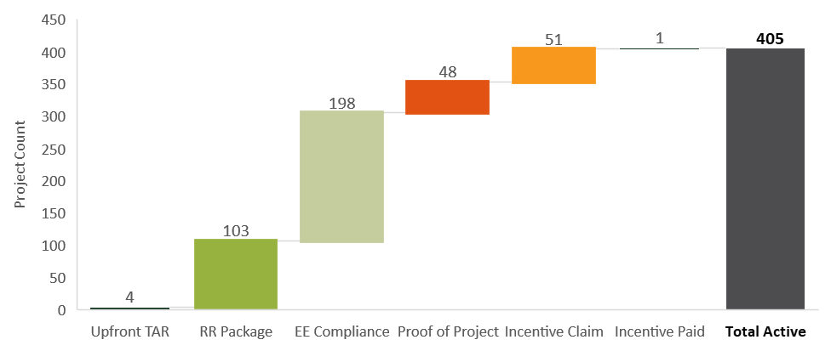

Workforce Development Summary
The focus of Metrics #2 and #3 are the degree to which the program is assisting the development of a solar workforce via SOMAH’s job trainee activities and hiring requirements. This metric has been adjusted during Phase II to better reflect the program’s job training activities and the job training data being tracked by the program. The SOMAH Program does not conduct SOMAH job “trainings” events on its own, rather it partners with organizations that provide job training (such as trade schools, community colleges, or other organizations such as the California Conservation Corp). The SOMAH Program then provides opportunities for these students to get “on the job” experience. As a result, Metrics #2 and #3 have been updated to remove the quantification of the number of “SOMAH Job Trainings” conducted and the number of trainees in attendance. Instead, they focus on the number of SOMAH job training opportunities made available to students who have received job training (via a partner organization) or who reside in a SOMAH property. The table below quantifies a number of important SOMAH workforce development statistics including:
- Number of individuals who have completed the SOMAH Job Trainee Intake Form. This form captures whether the individual is a resident of a SOMAH property and/or a recent graduate of a partner job training program, as well as other demographics which can be analyzed to assess the degree to which the program is recruiting local or diverse hires (such as female, minority, on government assistance, felons, ESL, formerly homeless, unemployed or under-employed).
- Number of SOMAH job training opportunities that have been made available (to-date and forecasted based on applications in progress). The required minimum number of job trainees and the job trainee hours used on a project varies by project size (0-<50 kW 1 trainee and >=40 hours/trainee, 50-<100 kW 2 trainees and >= 40 hours/trainee, 100 kW or greater 2 trainees and >=80 hours/trainee). It should be noted that these “opportunities” do not represent the number of unique individuals as one trainee can fill a number of job opportunities.
- Number of job trainees who have been hired for a SOMAH job. This metric should be reviewed in light of the number of SOMAH projects that have completed the Incentive Claim Package (ICP) as that is where projects submit their job training affidavit to certify they have met the program’s job training requirements. To date only one project has submitted that form.
- Number of job trainees who have been hired for a permanent position within the solar industry. As this time, it is too soon to determine the number of SOMAH job trainees that are getting hired for longer-term positions within the solar industry. The SOMAH PA has plans to conduct post-project surveys with contractors and job trainees after more SOMAH projects have been completed to start determining the longer-term impact of SOMAH’s workforce development efforts.
Table B-3: SOMAH Workforce Development Summary (as of 5/28/2021)
Workforce Development Activities | Number | %
SOMAH Job Trainee Intake Form Applicants | 296 | N/A
- Applicants residing in a SOMAH Property | 10 | 3.4%
- Applicants completed a Job Training program | 275 | 93%
- Minority applicants | 227 | 77%
- Applicants receiving government assistance | 109 | 37%
- Applicants that reside in DACs | 113 | 38%
SOMAH job training opportunities available through May 24. 2021 | 759 | N/A
SOMAH job training hours available through May 24, 2021 | 51,640 | N/A
Number of trainees who have been hired for a SOMAH project | 7 | N/A
- Number of SOMAH Projects completing the ICF step | 5 | N/A
Number of trainees who have been hired for a position in the solar industry | TBD¥ | N/A
¥ No data available at this time. This information will be collected in post-project contractor surveys.
Distribution of Program Benefits
The focus of Metrics #4 and #5 are the degree to which the program is distributing program benefits to low-income residents and/or individuals residing in DACs, as well as individuals residing in HUD or USDA housing. Table B-4 shows the number and percentage of active applications and system capacities across the various regulatory agreement types found in the program tracking data. One limitation of this data is that there is only one “Regulatory Agreement” field in the tracking data and a property may receive funding from various regulatory agencies. The field may be populated by the predominant regulatory agreement type of the project, but that has not been confirmed by the evaluation team. As this table shows, the majority of active applications have TCAC regulatory agreements (67 percent of applications and 71 percent of project capacity). USDA makes up 3 percent of the total and HUD makes up just under 10 percent.
Table B-4: SOMAH Distribution of Program Benefits Across Active Applications
Regulatory Agreement Type | Total Active Applications | % | Total MW | % MW | Average Size kW
Housing Authority, or City/County in the case of a project funded by HUD HOME Funds | 21 | 5% | 2.3 | 3% | 112
Redevelopment Agency (RDA) or RDA successor agency | 17 | 4% | 3.1 | 5% | 192
California Debt Limit Allocation Committee (CDLAC) | 4 | 1% | 1.6 | 2% | 393
California Department of Housing and Community Development/ The California Housing Finance Agency (HCD/CALHF) | 14 | 3% | 1.6 | 2% | 113
California Tax Credit Allocation Committee (TCAC) | 274 | 67% | 48.5 | 71% | 178
City or County in the case of a project funded by a local bond measure | 9 | 2% | 1.2 | 2% | 133
U.S. Department of Agriculture (USDA) | 14 | 3% | 1.8 | 3% | 127
U.S. Department of Housing and Urban Development (HUD) | 36 | 9% | 4.7 | 7% | 131
Unknown | 21 | 5% | 3.2 | 5% | 164

Figure B-2 below shows the distribution of SOMAH applications falling into one or both of SOMAH’s eligibility criteria. As this figure shows, roughly 28 percent of the current SOMAH applications by count and 26 percent by capacity are located within DACs. This proportion is only slightly higher than the percentage of California’s population that falls into the DAC designation (25 percent).
Figure B-2: Distribution of SOMAH Projects And System Capacity in Disadvantaged Communities
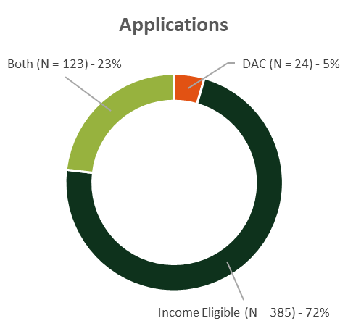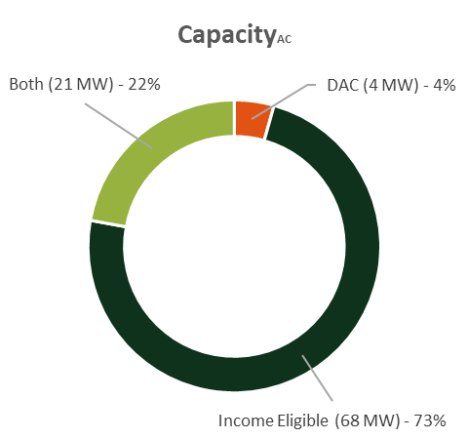

Satisfaction with Program Technical Assistance
The focus of Metric #6 is the applicant’s satisfaction with the technical assistance they have received through the program. To date, the amount of technical assistance (both upfront and standard) provided through the program has been low. As of April 29, 2021, only four Track A applications have been approved to receive Upfront Technical Assistance through the program, two of which have received a Technical Assistance Report for their project that provides an estimate of the space (roof or other) that is suitable for solar and the PV generation potential, a cost analysis for the project inclusive of the SOMAH incentive, and analysis of the project-level utility billing data including electric consumption and rate structure. Two property owners who received Upfront Technical Assistance were interviewed as part of the evaluation and both reported being satisfied with the technical assistance they received. One of these Track A property owners has since submitted a Reservation Request and the other is currently reviewing the options available to their organization to fund the installation of solar at their property.
According to the SOMAH PA, there have been 28 properties that have requested SOMAH standard technical assistance. The majority of these (24) had their SOMAH application cancelled as they had participated in MASH (MASH/SOMAH overlap) and thus were looking to the SOMAH PA to determine if other sources of funding were available to cover the funding gaps that existed on some of these projects. The evaluation team did not assess the satisfaction of those receiving standard technical assistance.

SOMAH KPI Assessment
The evaluation team’s assessment of the proposed SOMAH KPIs is provided in the sections below.
Successful Installations
Within 1 Year
KPI #1 tracks whether the program is encouraging program participation across a variety of property types which may be reflected in the distribution of project capacities, costs, and locations. Section 4 of the Phase II report presents a comprehensive assessment of participant and project characteristics.
1-3 Years
KPI #4 tracks SOMAH’s progress towards meeting its goal of installing 300 MW of solar capacity to ensure that adequate progress is being made towards that goal. As presented in the figure below, as of April 29, 2021, the PV system capacity of the 405 active SOMAH applications is 68 MW_{AC} which is 23 percent of the overall program goal of 300 MW_{AC}.
Figure B-3: Cumulative SOMAH Applications and Capacity Since Program Inception
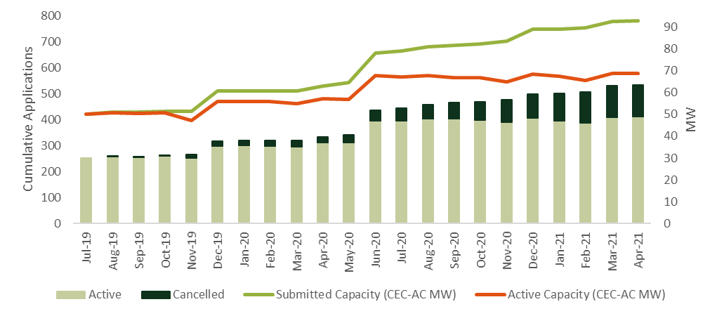
ME&O Effectiveness
Within 1 Year
KPI #2 tracks the percentage of SOMAH’s targeted audience that is aware of the SOMAH Program. The most recent ME&O plan developed by the SOMAH PA calls for surveys and focus groups with the program’s targeted audience to assess a number of topics including their level of program awareness.
1-3 Years
KPI #3 tracks the number of Community Based Organizations (CBOs) Participating in the SOMAH Program. This is being tracked by the SOMAH PA but at this time the evaluation team has not received access to this data.
Economic Development
Within 1 Year
KPI #5 tracks the reduction in electricity costs for tenants residing in a SOMAH property. Section 6.3.2 of the Phase II report presents the estimated ex ante tenant bill savings resulting from the SOMAH program. The average monthly tenant bill savings varied slightly by utility service territory and the type of rate the tenant was on post-SOMAH installation (a tiered rate or a TOU-rate). On average across utility service territories tenant bills were estimated to come down around $54/month (an 84 percent reduction) for customers not on CARE rates. For those on CARE rates, the average per-tenant monthly bill savings was estimated to be $36/month (a 92 percent reduction).
1-3 Years
KPI #6 tracks the number of individuals that are fulfilling the SOMAH workforce development training opportunities. According to the SOMAH PA, as of May 24, 2021 a total of 275 applicants have completed a SOMAH approved Job Training program and 759 SOMAH job training opportunities have been made available. In total 7 SOMAH job trainees have been hired onto a SOMAH project.
KPI #8 tracks the number of tenants residing at a SOMAH property who have been enrolled in the Energy Savings Assistance (ESA) Program. At the time of reporting there has been no verification that the IOUs who have received ESA Program referrals have acted upon them as the SOMAH PA is only able to request ESA data from the IOUs on an annual basis and no data was received last year. The SOMAH PA plans to plans to send out their next annual data request in June 2021. The evaluation team recommends future evaluations compare ESA Program enrollment across the IOUs to ascertain the effectiveness of these referrals.
Environmental Benefits
3+ Years
KPI #9 tracks the avoided tons of CO2 emissions. As part of this study the Verdant team estimated the ex-ante greenhouse gas (GHG) impacts of the SOMAH PV systems in reference year 2020. The emission impacts are calculated as the difference between the emissions generated by SOMAH PV systems and baseline emissions that would have occurred in the absence of the program. This analysis estimated the SOMAH PV systems would have reduced GHG emissions by 23,670 metric tons of CO₂ in 2020.
Other
1-3 Years
KPI #7 tracks the cost of the SOMAH program and the impact on the California Alternate Rates for Energy (CARE) program budget. Section 4.5 of the Phase II Report presents the total program expenditures to date. Table 4-9 shows the SOMAH Program expenditures through December 31, 2020 were just under $18 million. Section 6.3.2 of the Phase II report presents the estimated ex-ante tenant bill savings resulting from the SOMAH program. The average CARE program per-tenant monthly bill savings across all utility service areas was approximately $36/month (a 92 percent reduction). The total impact on the CARE budget is not known at this time as data on which customers are on CARE rates was not provided to the evaluation team.

Contractor And Property Owner Interview Guides and Web Surveys

SOMAH Contractor Interview Guide

SOMAH Property Owner Interview Guide

SOMAH Property Owner Web Survey

Interim Targets for MW Installed
The table below provides the estimated maximum MW installed per year based on 100 percent of system benefits allocated to tenants and 51 percent allocated to tenants (the minimum amount required to be allocated to tenants) as presented in the SOMAH Program Implementation Plan. Because the incentive paid for solar allocated to tenant spaces is higher than that allocated to common area spaces the incentives needed to reach program goals is higher under the 100% Tenant Load scenario and thus the estimated maximum MW installed per year is lower under this scenario than it is in the 51% Tenant Load allocation (which is the program minimum allocation to tenants) which represents the minimum incentives needed to reach program goals.
Table D-1: Estimated Maximum MW Installed Per Year
Year | 100% Tenant Load (MW) | 51% Tenant Load (MW)
2019 | 37 | 54
2020 | 39 | 57
2021 | 41 | 60
2022 | 30 | 45
2023 | 32 | 47
2024 | 34 | 50
2025 | 36 | 52
2026 | 37 | 55
2027 | 39 | 58
2028 | 41 | 61
TOTAL | 367 | 539

California Air Resources Board Greenhouse Gas Savings
The estimated lifetime greenhouse gas (GHG) emissions reductions attributable to proceeds used in 2020 were also calculated per the California Air Resources Board (CARB) requirements. The CARB GHG Benefits Estimation Tool was used to develop these estimates, as presented in Table E-1 below. All projects were modeled with a 25-year expected project lifetime and a 0.5 percent annual degradation factor. The CARB GHG Benefits Estimation Tool uses an emissions factor of 0.21182 MTCO₂e per MWh. The percentage of SOMAH projects funded with auction proceeds was calculated at the total SOMAH program level as the sum of the total (submitted or reserved) incentives for the in-scope impact projects and the total program expenditures through December 31, 2020 divided by the total project costs for the in-scope impact projects (net estimated ITC and LIHTC payments).
Table E-1: Estimated CARB GHG Benefits by Utility Service Area
Utility Service Area | Percentage of SOMAH Projects’ Funding from Auction Proceeds (%) | Total Annual Production  (MWh/year) | Estimated Annual GHG Emissions Reductions Attributable to 2020 Auction Proceeds (MTCO₂e) | Estimated Lifetime GHG Emission Reductions Attributable to 2020 Auction Proceeds (MTCO₂e)
PG&E | 80.8% | 56,358 | 9,640.41 | 225,392.90
SCE | 80.8% | 42,400 | 7,252.72 | 169,568.59
SDG&E | 80.8% | 20,059 | 3,431.15 | 80,220.38
TOTAL | 80.8% | 118,816 | 20,324.29 | 475,181.87

CPUC SOMAH Phase 1 Report (August 2020): https://www.cpuc.ca.gov/-/media/cpuc-website/files/legacyfiles/s/6442465840-somah-phase1-evaluation-final-report.pdf
Tenants of SOMAH properties are eligible to participate in these job training opportunities without the completion of a job training program.
https://www.ca-somah.org/jobportal/s/self-register?locale=us
California Alternative Rates for Energy Program (CARE) provides discounts on gas and electricity bills to participants who qualify through income guidelines or enrollment in certain public assistance programs.
The Energy Savings Assistance (ESA) program provides no-cost weatherization services and energy-efficient appliances to eligible renters and homeowners who receive electric or gas service from a California energy service provider through a residential meter.
Program costs to be defined by evaluator and PA based on the data that is currently available (or could be made available in the future).
Revised SOMAH Program Implementation Plan.
https://arb.ca.gov/cc/capandtrade/allowanceallocation/ghg_benefits_estimation_tool.xlsx
The GHG Benefits Estimation Tool recommends a default annual degradation factor of 0.5 percent for solar PV projects.

