m

Solar On Multifamily Affordable Housing

Vendor AssessmenT

DRAFt
fff

Verdant Associates, LLC
Berkeley, CA 94707
www.verdantassoc.com

January 5, 2022
Submitted to:
California Public Utilities Commission

Prepared by:
Verdant Associates, LLC

Table of Contents
1 Introduction 1
1.1 SOMAH Program Overview 1
1.2 Vendor Assessment Research Objectives 2
1.3 Vendor Assessment Research Questions 3
2 Data Collection and Analysis Activities 5
2.1 Vendor Assessment Data Collection Activities 5
2.2 Vendor Assessment Analysis Activities 5
2.3 Forecasting and Invoicing Data Received 6
2.3.1 Total Program Expenditures to Date 9
2.3.2 Comparison of Program Expenditures to Date 11
3 Vendor Assessment Findings 13
3.1 SOMAH PA’s Primary Administrative Cost Drivers 13
3.1.1 Pre-Launch Versus Post-Launch Spending 13
3.1.2 Spending Across Program Categories and Tasks 13
3.1.3 Spending by PA Member and Subcontractors 18
3.1.4 Administrative Cost Trends 20
3.2 Assessment of SOMAH Forecasting And Invoicing Process 23
3.2.1 SOMAH Spending versus Originally Planned Budget 23
3.2.2 SOMAH Spending versus Quarterly Forecast 24
3.2.3 Effectiveness of SOMAH PA’s Existing Forecasting and Invoicing Process 32
3.2.4 SOMAH Program Spending and Staffing Assessment 36
3.3 Effectiveness of Spending To Address Participation Barriers 37
3.3.1 Contractor and Property Owner Barriers to Participation 38
3.3.2 Effectiveness of Spending to Address Barriers to Participation 40
3.4 Effectiveness of SOMAH PA’s Efforts to Date 41
3.4.1 Effectiveness of Program Administration Activities 44
3.4.2 Effectiveness of ME&O Efforts 46
3.4.3 Effectiveness of Technical Assistance Efforts 52
3.4.4 Effectiveness of Workforce Development Efforts 56
3.5 Recommendations for Program Improvement or Streamlining 57

List of Figures
Figure 3-1: Total Monthly Spending by Program Category (SI) 21
Figure 3-2: Quarterly Spending by Program Category – SOMAH PA Labor vs Non-Labor (SI) 22
Figure 3-3: Quarterly Spending by SOMAH PA Member (SI) 23
Figure 3-6: Purchase Order Proposed Annual Spending Versus Actual Spending to Date 24
Figure 3-7: Quarterly Forecasted Spending Versus Actual Spending to Date (A) 25
Figure 3-8: Difference Between Quarterly Forecast and Actual Spending by Program Category (A) 26
Figure 3-9: Percentage Difference Between Quarterly Forecast and Actual Spending by Category 27
Figure 3-10: Difference Between Quarterly Forecast and Actual Spending by SOMAH PA Member (A) 28
Figure 3-11: Percentage Difference between Quarterly Forecast and Actual Spending by PA 29
Figure 3-12: Forecasted versus Actual Quarterly Spending on Financial Tracking Task (A) 33
Figure 3-13: Estimated Spending on Developing Quarterly Spending Forecasts (SI) 35
Figure 3-14: Estimated Spending on Monthly Invoicing (SI) 36
Figure 3-16: Application Processing Task Spending versus SOMAH Application Submissions 45
Figure 3-17: Spending on ME&O Plan Development Task by Organization and Overall (DLR) 49
Figure 3-18: ME&O Category Spending versus SOMAH Application Submissions 50
Figure 3-19: Number of Events by Quarter and Event Type 52
Figure 3-20: Monthly Spending on Pre-Installation TA Task vs. Track A Application Submissions 56

List of Tables
Table 2-1: Summary of Invoicing Data Received 7
Table 2-2: Summary of Invoicing Databases 8
Table 2-3: Total Program Expenditures for 2018, 2019, 2020 and 2021 9
Table 2-4: Total Program Budget and Incentive Payments (To Date and Forecasted) 10
Table 2-5: Benchmarking SOMAH PA SPending versus Other LI Solar Programs (S) 11
Table 2-6: Comparison of Program Expenditures to SOMAH PA Invoicing Data 12
Table 3-1: SOMAH PA Spending by Program Category – Total Program vs Post-Launch Spending (SI) 13
Table 3-2: Distribution of SOMAH PA Spending by Program Category and Task (SI) - 15
Table 3-3: Spending by “Purpose” Groupings (SI) 17
Table 3-4: Spending by SOMAH PA Member and Subcontractor across Categories, 7/19-6/21 (SI) 18
Table 3-5: Subcontractor Spending (a) 19
Table 3-8: Actual versus Forecast Spending by Program Category (A) 25
Table 3-9: Actual versus Forecast Spending by SOMAH PA Member (A) 28
Table 3-10: Top Underspent Tasks 30
Table 3-11: Top Overspent Tasks 31
Table 3-12: Subcontractor Spending Versus Forecast 32
Table 3-13: Subcontractor Spending Versus Forecast by Program Category 32
Table 3-14: Estimated Spending on Quarterly Forecasting and Monthly Invoicing 35
Table 3-15: Spending by SOMAH PA Member on Financial Tracking, Timekeeping, and Program Reporting, 7/2019 - 6/2021 (SI) 37
Table 3-17: Mapping of Contractor And Property Owner Participation Barriers to Program Spending (SI) 39
Table 3-18: Detailed Spending Analysis by Program Category (DLR-R) (7/19 – 6/21) 43
Table 3-19: Program Administration Category Task Level Spending Summary (SI) 44
Table 3-21: ME&O Task Level Spending Summary (SI) 46
Table 3-22: ME&O Category Property Owner Engagement Task Description (DLR-R) 47
Table 3-23: ME&O Category Contractor Engagement Task Description (DLR-R) 48
Table 3-24: Technical Assistance Category Task Level Spending Summary (SI) 53
Table 3-25: Technical Assistance Category Description (DLR-R) 54
Table 3-26: Technical Assistance Category Spending by PA Member (DLR-R) 54
Table 3-27: Distribution of Technical Assistance Spending by SOMAH PA Member 55
Table 3-28: Workforce Development Category Task Level Spending Summary (SI) 57

Introduction
Verdant Associates (Verdant) was contracted by San Diego Gas and Electric (SDG&E) on behalf of the California Public Utilities Commission (CPUC) to conduct an impact and process evaluation of the SOMAH Program. The primary scope of this work was completed in October 2021. The CPUC Energy Division added an incremental SOW to the SOMAH evaluation to conduct a vendor assessment of the SOMAH Program Administrator (PA) as directed by CPUC Decision (D.) 17-12-022. This report represents the primary deliverable of this additional Vendor Assessment Scope.

SOMAH Program Overview
California State Assembly Bill (AB) 693 directed the California Public Utilities Commission (CPUC) to institute a new program intended to make qualifying solar energy systems accessible to low-income and disadvantaged communities (DAC). In December 2017, the CPUC issued Decision (D.) 17‐12‐022 creating the SOMAH Program and establishing program goals and eligibility requirements. The primary goal of this program is to install solar energy systems that have a generating capacity equivalent to at least 300 MW (CEC-AC) on qualified multifamily affordable housing properties through December 31, 2030 and to increase workforce development and training activities to support economic development in underserved communities. Decision 19-03-015 set the rules for limits on administrative expenses to run the SOMAH program.
The SOMAH Program provides significant subsidies for the installation of solar photovoltaic (PV) systems on qualifying multifamily affordable housing properties (i.e., multifamily housing financed with low-income housing tax credits, tax-exempt mortgage revenue bonds, general obligation bonds, or local, state, or federal loans or grants). To qualify for SOMAH incentives, properties must be existing deed restricted properties, have at least five units, and separately metered tenant units. They must also satisfy either having A) 80 percent of their total tenant households with incomes at or below 60 percent of the area median income or B) be in a DAC that scores in the top 25 percent of census tracts statewide, as identified by the Office of Environmental Health Hazard Assessment (OEHHA) on behalf of the California Environmental Protection Agency (CalEPA).

Vendor Assessment Research Objectives
The research objectives of this study are to document the performance of the SOMAH PA team from the perspective of SOMAH participants (contractors and property owners), conduct a longitudinal summary of the program implementation costs by program task and key milestones, and provide recommendations for areas of improvement based on a best practices review and benchmarking assessment of the program administration activities.
This research will focus on the SOMAH PA’s spending on activities related to the barriers contractors and property owners face to SOMAH participation that were identified during Phase II of the SOMAH evaluation. This recent evaluation identified areas where property owners and contractors would benefit from greater PA involvement and support. These areas in need of greater PA support included:
- Support for Property Owners – Increased upfront support for small or new property owners to ensure comprehension of key SOMAH program attributes such as: the availability and benefits associated with the various project ownership types, the tax credits available to offset a portion of SOMAH system costs, how Virtual Net Energy Metering (VNEM) works, and other Energy Efficiency (EE), Distributed Energy Resource (DER), or electrification programs available. Additional PA support could augment property owners’ capacity to complete the application process, alleviating some of the application burden from property owners who lack the time required to participate in the face of the multitude of competing affordable housing priorities. This support could also help to identify ineligible projects sooner, thereby reducing the number of cancelled or withdrawn applications and reducing administrative costs dedicated to the processing of ineligible or infeasible applications.
- Support for Contractors – Increased support for program contractors (available to all—however more likely to be utilized by smaller contractors who lack the staffing to participate in SOMAH) to reduce administrative burden. This support could include assistance completing SOMAH project applications, digitization of forms and a reduction in redundant data entry, researching local zoning codes, or acquiring property billing data or project permits. Additional support could also be provided to help new or small contractors identify subcontracting opportunities where they can gain experience with the program and to help connect contractors with job trainees to fulfill the program’s workforce development requirements. This support could also help to increase contractor participation in or near DACs which appears to be low.

Vendor Assessment Research Questions
To meet the study’s research objectives, the following research questions were addressed to the extent possible based on the available data. In cases where a research question could not be answered due to insufficient data, the evaluation team has documented the data requirements that will allow for future assessment of the research question.
- To date, what have been the SOMAH PA’s primary administrative cost drivers?
- What are the allocations of SOMAH Program spending or staffing?
- Are there any areas of spending that have not been in relation to the anticipated output?
- What percentage of the budget is being outsourced to subcontractors, how is their effectiveness being measured, and should any of these tasks be completed in-house by a member of the SOMAH PA?
- What is the administrative cost trend over time and by organization?
- How has the SOMAH PA’s spending to date compared to the originally proposed SOMAH PA implementation plan and to the PA’s generated quarterly forecasts?
- What categories or tasks have been over or under spent and by how much? How many staff people are involved by category over time? What categories have the highest expenses?
- What are the primary reasons for the differences between forecasts and actuals?
- Has underspending led to any delays in deliverables?
- How does the SOMAH PA create the quarterly forecasts, and are there areas for improvement going forward?
- How has staffing compared to forecasted staffing and is it adequate to ensure timely administration of the SOMAH Program?
- How effective has the SOMAH PA spending to date been at addressing the barriers faced by participating and nonparticipating property owners and contractors, as well as other SOMAH participation challenges (such as high levels of application cancellation)?
- Has the balance between Technical Assistance (TA), Workforce Development (WD), Marketing Education and Outreach (ME&O)—including the SOMAH Advisory Council and Job Task Force, been sufficient?
- Should PA spending be shifted or refocused to areas that will help to alleviate participation barriers or burdens reported by contractors and property owners?
- How effective have the SOMAH PA’s ME&O efforts been to date? Are they successfully building awareness for a pipeline of future SOMAH projects?
- Has the balance of spending on different marketing channels (web, social media, conferences, etc.) been aligned with ME&O goals?
- What is the spending for materials and activities targeting different SOMAH Program population segments (properties and contractors located in DACs, small or diverse contractors, property owners with single or small numbers of properties, potential job trainees that are tenants at SOMAH project sites)?
- What is the approximate cost (in labor and time) to create SOMAH Program’s educational materials? What are the costs for other ME&O deliverables by category (advertising, print materials, web development, etc.)? What are the initial costs and what are maintenance costs?
- To what extent are current program participants (contractors or property owners) being leveraged to engage and inform nonparticipants (via subcontracting, case studies, mentoring)?
- What is the approximate cost (in labor and time) of creating the annual ME&O Plan?
- What was the approximate cost of developing the property eligibilities map, and is its use/effectiveness leading to future projects being measured?
- What is the ME&O cost trend? Does it correlate with application submissions?
- How effective have the SOMAH PA’s Technical Assistance efforts been to date?
- Has the TA spending been in alignment with Track A participation levels?
- Has the TA spending been reallocated in light of the limited uptake of upfront and standard TA? If so, how?
- What are the costs (labor and time) for creating Track A work products? What is the approximate cost of creating a Solar Feasibility Study (regular or “lite”) for a Track A project?
- What is the cost trend?
- How effective is the SOMAH PA’s current invoicing process?
- What are the costs (labor and time) to produce monthly invoices and quarterly forecasts?
- What is the cost trend?
- Is the invoicing data provided in a format that can easily be incorporated into a dashboard and are any additional data elements needed? How can it be improved or streamlined?
- What is the feasibility of updating invoicing documentation to be able to link application costs to specific applications?
- Identify areas for future analysis or auditing.

Data Collection and Analysis Activities
This study utilized several data collection activities and methods to answer the SOMAH Vendor Assessment research questions. This section details the primary and secondary data sources used within this assessment.

Vendor Assessment Data Collection Activities
The data sources used in this assessment were a mix of pre-existing data elements and primary data collected as part of the evaluation research activities. The pre-existing data elements collected, reviewed, and analyzed included the following items:
- Program forecasted and actual submitted invoices
- SOMAH PA Purchaser Order
- SOMAH Semi-Annual Progress and Expense Reports
- Marketing, Education, and Outreach activities and annual plans
- SOMAH Program Implementation Plan
- Internal administrative procedures and quality controls
The primary data collection activities included:
- Four 30-minute interviews with SOMAH PA staff to review program spending to date and the primary drivers of that spending and causes for underspending. These interviews were also used to gather additional program materials needed for this assessment and to help identify SOMAH subcontractor staff for inclusion in the Vendor Assessment interviews.
- Five 30-minute interviews with SOMAH subcontractors to document the primary drivers of their spending, the oversight they receive from the SOMAH PA, and how the effectiveness of their activities is being assessed.

Vendor Assessment Analysis Activities
The analysis activities conducted as part of the vendor assessment included the following tasks:
- Ingesting the monthly SOMAH invoices submitted by each of the four SOMAH PA members (which include subcontractor spending) to create several databases on the SOMAH PA historical spending. The invoicing data included various levels of detail including high level monthly invoice summaries, monthly comparisons of forecasted to actual spending, and detailed daily spending by staff member. Three invoicing databases were created to align with each of these levels of detail.
- Detailed review and analysis of the SOMAH PA’s monthly invoicing and forecasting databases created.
- Mapping the dollars spent to date by the SOMAH PA versus the property owner and contractor barriers identified during Phase II of the SOMAH evaluation (presented in the table below).
Contractor Barriers | Property Owner Barriers
Administrative Burden:  Onerous program rules and participation requirements  Large staffing requirements to manage participation | Application Burden:  Solar is not top priority  Lack of staff to manage a solar installation project  Property owner organization structure
Project Financing:  Covering project costs prior to incentives  Securing bridge funding  Ability to offer PPA ownership | Project Financing:  Access to project financing  Awareness of project ownership options
Solar Feasibility:  Project sizing vs feasibility (needed for $$)  $$ for other necessary projects | Solar Feasibility:  Physical site issues (roof condition, inadequate space, construction logistics)
ME&O:  Generating project leads  Program eligibility map issues  Primarily leveraging prior relationships  Property eligibility | ME&O:  Sources of program awareness  Case studies  Affordable housing org’s outreach  Reliability
Workforce Development:  Help with job trainee placement  Locations with minimal training opportunities | Workforce Development:  Tenant job opportunity awareness

- Creation of timelines documenting the primary ME&O, TA and WD activities to date and associated spending and outcomes related to these activities.
- Review of SOMAH PA materials, including their method of distribution, to assess whether they are successfully achieving their purpose.
- Review documentation of the engagement with affordable housing organizations, housing authorities, government agencies, and the IOUs to assess the effectiveness of these activities in helping to build a pipeline of future SOMAH projects.

Forecasting and Invoicing Data Received
As mentioned above, one of the first activities Verdant completed for the Vendor Assessment was to process the SOMAH PA forecast and invoice data received from SCE. The data provided by SCE or the CPUC included monthly invoicing files covering the period from April 2019 through June 2021. Program spending occurred prior to April 2019 however this “pre-mobilization” spending was invoiced in a different manner with significantly less detail and thus was not analyzed in detail as part of this assessment. The monthly invoice data received came as 108 individual excel files (a separate monthly excel file was provided for each of the four SOMAH PA members for 27 months). These excel files included several distinct tabs which contained different data elements used within the analysis activities. The table below summarizes the data elements included in each of the spreadsheet tabs, the date range available for each tab, and the program spending for the period included in the tab.
Table 2-1: Summary of Invoicing Data Received
Invoicing Spreadsheet | Key Data Elements Included | Dates Available | Total Invoiced Amount
Monthly Invoice | Employee-level monthly hours worked, contract rate, billable amount, and notes on activities accomplished by employee during month | 4/2019 - 6/2019 | $1,561,509
Summary Invoice | Hours worked, labor expenses, non-labor expenses, and total billable expenses (including subcontractor spending) | 7/2019 - 6/2021 | $13,231,746
Analytic | Actual and forecasted hours and expenses (including subcontractor spending broken out) | 4/2020 - 6/2021 | $8,726,666
Detailed Labor Report | Employee-level daily hours worked, contract rate, billable amount, and notes on activities accomplished by employee each day. Does not include subcontractors spending | 7/2019 - 6/2021 | $10,437,947
Non-Labor Charges | Details on non-labor expenses | 7/2019 - 6/2021 | $2,793,799

All the spreadsheets shown in the table above (except the non-labor charges) were processed using R code to create three distinct databases which included the data used to complete the longitudinal analysis for this study. Additional variables (such as Organization [CSE, GRID, CHPC or AEA], Quarter [Q1-Q4], and Year [2019–2021]) were added to allow for the analysis to be done on a monthly, quarterly, or yearly level as appropriate and broken out by SOMAH PA team member.
Detailed Spending Analysis
The Detailed Labor Report spreadsheet itemizes daily program spending on a program task level for every staff member working on the program. Included with this itemized spending are detailed notes documenting the activities worked on during the invoiced hours. The data included in this spreadsheet not only allowed for category and task level analysis, but it also allowed for what we refer to as “Detailed Spending Analysis”. This analysis involved utilizing an R script to “scan” the detailed invoice notes for key words or phrases. This allowed for analysis of program spending at a more granular level than can be completed using the program categories and tasks. For example, scanning the notes for hours billed to the large Program Admin Task (which made up nearly 20 percent of all program spending to date, Table 3-2) allowed us to better understand the types of activities occurring within this large program task. This type of analysis is beneficial since it enables us to determine how much time is spent on meetings by scanning the notes for “Meeting”, “1x1”, “1:1”, “Chat”, “15x5” and other similar phrases denoting meetings written in the invoice notes data. It is important to note, that while this type of analysis is beneficial, enabling us to go deeper into task level spending, it relies on the notes recorded by individual staff which can include typos or abbreviations and also can group many different types of activities based on a common word or phrase that is used (such as the word “review” which we found in the Program Admin Task to refer to "SOMAH materials review", "Timesheet review", "Payroll review", and “Reviewing invoices”. As a result, we used the detailed notes analysis strategically throughout this assessment, limiting its use to where we thought the effort and potential return was warranted. Throughout this report this detailed note analysis is referred to as “Detailed Spending Analysis”.
Table 2-2: Summary of Invoicing Databases
Invoicing Database | Dates Available | Records in DB | Hours Worked | Expenses Billed
Summary Invoice | 7/2019 - 6/2021 | 3,554 | 77,314 | $13,231,746
Analytic | 4/2020 - 6/2021 | 2,334 | 56,783 | $8,726,666
Detailed Labor Report | 7/2019 - 6/2021 | 63,262 | 86,625 | $10,437,947

Assessment of Invoicing Data
Our review of the invoicing files received for this assessment found they were comprehensive and have grown to include a couple of different tabs overtime (Analytic and Detailed Labor Report) that are very helpful for comparing monthly spending to monthly forecasts and provide details (within a “notes” field) on the work completed by staff for each hour worked.
The files are currently provided in an excel format which allows for the monthly files to be manipulated easily. The difficulties with these files are related to three primary issues:
- The sheer number of files - one file for each of the four PA members provided monthly for over two years results in more than 100 individual files,
- They are not available in the same format for all program spending since program inception, and
- The three primary tabs included in the invoicing files contain different elements, a mix of which may be needed to create a comprehensive dashboard that included program spending and forecasting by both the PA and subcontractors.
Creating a program dashboard from these files would likely require including one additional tab in the invoicing workbooks that would bring together task level spending and forecasts for each of the subcontractors.

Total Program Expenditures to Date
The SOMAH annual budget is either 10 percent of IOU greenhouse gas auction revenues or $100 million, whichever is less, and collected between 2016 and 2026. The SOMAH PA compiles and submits a Semi-annual Expense Report that tracks expenditures by category, including program incentives and administration expenses for the SOMAH PA, CPUC Energy Division, and the IOUs. Administrative costs are capped over the lifetime of the program to not exceed 10 percent of the total available funds, and there is flexibility as to when funds can be utilized.
The following table shows the total expenditures through June 30, 2021.
Table 2-3: Total Program Expenditures for 2018, 2019, 2020 and 2021
Budget Category | 2018 | 2019 | 2020 | 2021 | Total
SOMAH Program Administration | $1,896,345 | $3,361,236 | $4,007,489 | $1,910,679 | $11,175,749
SOMAH Marketing, Education, & Outreach | $412,041 | $1,681,468 | $2,158,198 | $1,284,163 | $5,535,870
SOMAH Workforce Development | $22,049 | $282,027 | $497,327 | $238,549 | $1,039,953
SOMAH Technical Assistance | $0 | $232,941 | $186,594 | $105,329 | $524,864
SOMAH CPUC Expenditures* | $169,496 | $174,648 | $155,339 | $0 | $499,483
Investor-Owned Utility (IOU) Expenses | $0 | $1,410,785 | $1,631,647 | $358,574 | $3,401,006
Total Program Admin Expenditures | $2,499,931 | $7,143,105 | $8,636,594 | $3,897,294 | $22,176,926

The Semi-Annual Expense Report (SAER) tracks all the incentive budget and actual and forecasted incentive payments. Table 2-4 below presents the annual incentive budget and incentive payments (both actual and forecasted) as presented in the SAER. As this table shows, the budget for incentives currently exceeds the forecasted incentive payments.
Table 2-4: Total Program Budget and Incentive Payments (To Date and Forecasted)
Budget Category |  | 2016 - 2018 | 2019 | True-Up | 2020 | 2021 | 2022 | 2023 | Total
Incentive Budget |  | $100.3M | $81.4M | $88.5M | $83.6M | $64.2 |  |  | $418M
Incentive Payments | Actual |  |  |  | $126k |  |  |  | $126k
 | Forecasted |  |  |  |  | $3.9M | $62.0M | $68.5M | $134.4M

To assess how spending to date on the SOMAH Program has measured up against other California low-income solar programs, the evaluation team benchmarked SOMAH spending through Q2 2021 (and forecasted through 2023) with the reported spending on MASH (SOMAH’s predecessor), SASH (single family low-income solar), and DAC-SASH (SASH for homes in DACs). Table 2-5 below presents the results of this benchmarking exercise. As this table shows, SOMAH’s spending on program administration activities to date total more than $18M and account for 82 percent of the program’s spending. At this time only 1 percent of spending has been paid out as program incentives. The forecast for the end of 2023 (estimated based on the SOMAH PA’s forecast of incentive payments in the SAER) and assuming program administration spending continues at the same level as Q1 and Q2 2021, looks significantly different with program administration spending dropping to 20 percent of total program spending. An analysis of SOMAH DGStats data (extract date of December 6, 2021), the incentive payment forecast provided in Table 2-4 appears to be achievable. As of early December 2021, more than $5M in SOMAH incentives have been paid (or are in process) and $106M in incentives are for SOMAH projects that have received their Reservation Request (RR) Approval which is a significant project milestone. An additional $60M in incentives are allocated to projects that have not had their RR approved. Applying cancellation/withdrawal rates of 40 percent to projects without RR approval and 20 percent to those with RR approval yields a total of $126M in project incentives that are likely to be paid by the end of 2023 or during the first two quarters of 2024. As shown in the table below, the estimate of PA spending and incentives paid by the end of 2023 is much closer in line with SASH and DAC-SASH spending. While it is still higher than MASH, there are several factors that have made SOMAH more expensive to implement. These factors include:
- Program scale – The scale of SOMAH is significantly larger with a goal of installing 300 MW of solar in 10 years as opposed to MASH which installed 55.635 MW of solar over 13 years. Additionally, the incentive budget over this time frame was $122M (according to the July 2021 MASH SAPR, June 30, 2021).
- Program marketing – MASH did not require a significant investment in program marketing due to its reduced scale. Typically, when additional funds became available for MASH the program would close and applications would be waitlisted within a month of opening.
- MASH participants include “low hanging fruit” – The MASH Program led to the installation of solar at many affordable housing properties which reduced the properties available to participate in SOMAH. SOMAH PA staff and contractors both reported many MASH projects required less effort to encourage participation as they were the “low hanging fruit”. Properties that remained after MASH are likely to require more effort to participate.
- Emphasis on properties located in DAC – the MASH Program did not have the same level of focus on installing solar in DACs that the SOMAH Program does.
- Workforce Development requirements emphasize local hiring – while the MASH Program had a focus on providing job training and employment opportunities, the workforce development requirements for SOMAH are stricter and more focused on local hiring (including those residing in SOMAH properties).
The SOMAH PA is currently on track to be under its 10 percent administrative cap by the program’s end in 2030.
Table 2-5: Benchmarking SOMAH PA SPending versus Other LI Solar Programs (S)
Spending Category | SOMAH  (2018 - Q2 2021) |  | SOMAH Forecast  (2018-2023) |  | MASH  (2008-2020) |  | SASH  (2009-2021) |  | DAC-SASH  (2019-2021)
 | Spending | % | Spending | % | Spending | % | Spending | % | Spending | %
PA | $11,175,749 | 28% | $20,581,856 | 10% | $7,064,181 | 5% | $16,234,000 | 9% | $2,421,393 | 19%
ME&O | $5,535,870 | 14% | $11,862,874 | 6% | $225,679 | 0% | $6,493,600 | 4% | $910,512 | 7%
WD | $1,039,953 | 3% | $2,232,700 | 1%
TA | $524,864 | 1% | $1,051,508 | 0%
PA Total | $18,276,436 | 82% | $35,728,938 | 20% | $7,289,860 | 6% | $22,727,600 | 14% | $3,331,905 | 26%
CPUC | $499,483 | 2% | $887,830 | 1% | $1,151,055 | 1% | $540,000 | 0%
IOUs | $3,401,006 | 15% | $5,193,876 | 3%
Incentive | $126,238 | 1% | $134,414,741 | 76% | $120,127,236 | 93% | $137,989,000 | 86% | $9,319,176 | 74%
Total | $22,303,164 | 100% | $176,225,385 | 100% | $128,568,151 | 100% | $161,256,600 | 100% | $12,651,081 | 100%

Comparison of Program Expenditures to Date
Not all program spending to date has been included in the analysis performed for this vendor assessment due to the availability of SOMAH PA invoicing files. Table 2-6 below compares the program expenditures as documented in the most recent Semi-Annual Expense Report to the invoicing files received for this assessment. As this table shows, the data analyzed lacked the 2018 program expenditures but included roughly half of 2019 expenditures, all of 2020 expenditures and the majority of the of 2021 expenditures through the end of Q2 2021.
Table 2-6: Comparison of Program Expenditures to SOMAH PA Invoicing Data
Budget Category | Source | 2018 | 2019 | 2020 | 2021 | Total
SOMAH Program Administration | Expense Report | $1,896,345 | $3,361,236 | $4,007,489 | $1,910,679 | $11,175,749
 | Invoicing Files | $0 | $1,778,577 | $4,007,489 | $1,881,221 | $7,667,287
 | Difference | $1,896,345 | $1,582,659 | $0 | $29,458 | $3,508,462
SOMAH Marketing, Education, & Outreach (ME&O) | Expense Report | $412,041 | $1,681,468 | $2,158,198 | $1,284,163 | $5,535,870
 | Invoicing Files | $0 | $890,033 | $2,158,198 | $1,265,401 | $4,313,632
 | Difference | $412,041 | $791,435 | $0 | $18,762 | $1,222,238
SOMAH Workforce Development | Expense Report | $22,049 | $282,027 | $497,327 | $238,549 | $1,039,953
 | Invoicing Files | $0 | $103,620 | $497,327 | $238,549 | $839,496
 | Difference | $22,049 | $178,407 | $0 | $0 | $200,457
SOMAH Technical Assistance | Expense Report | $0 | $232,941 | $186,594 | $105,329 | $524,864
 | Invoicing Files | $0 | $119,407 | $186,594 | $105,329 | $411,330
 | Difference | $0 | $113,534 | $0 | $0 | $113,534
Total Program Admin Expenditures | Expense Report | $2,330,435 | $5,557,672 | $6,894,608 | $3,538,720 | $18,276,435
 | Invoicing Files | $0 | $2,891,637 | $6,894,608 | $3,490,500 | $13,276,745
 | Difference | $2,330,435 | $2,666,035 | ($0) | $48,220 | $4,999,690

Vendor Assessment Findings
This section presents the results of the Vendor Assessment organized by the primary research questions.

SOMAH PA’s Primary Administrative Cost Drivers
One of the primary goals of the SOMAH Vendor Assessment is to assess the primary cost drivers of the PA’s implementation of the SOMAH Program to date.

Pre-Launch Versus Post-Launch Spending
As described in the section above, the majority of the analysis for this detailed spending assessment was conducted on the SOMAH PA invoicing files for the post-program launch period spanning from July 2019 through the end of Q2 2021. These detailed invoice files exclude the spending prior to program launch. The table below provides a comparison of the total program spending as of the end of Q2 2021 to the post-launch spending by program category. As this table shows, the total spending as of the end of Q2 2021 was more than $18M (28 percent of which was spent prior to the July 2019 program launch).
Table 3-1: SOMAH PA Spending by Program Category – Total Program vs Post-Launch Spending (SI)
Program Category | Total Spending  through 6/21 |  | Post-Launch Spending  7/19 – 6/21 |  | Pre-Launch Spending (Pre-7/19) |  | Pre-Launch
 | $ | % | $ | % | $ | % | %
Program Administration (PA) | $11,175,749 | 61% | $7,667,287 | 58% | $3,508,462 | 70% | 31%
Marketing, Education, & Outreach (ME&O) | $5,535,870 | 30% | $4,313,632 | 33% | $1,222,238 | 24% | 22%
Workforce Development (WD) | $1,039,953 | 6% | $839,496 | 6% | $200,456 | 4% | 19%
Technical Assistance (TA) | $524,864 | 3% | $411,330 | 3% | $113,534 | 2% | 22%
Total | $18,276,436 | 100% | $13,231,746 | 100% | $5,044,691 | 100% | 28%

Spending Across Program Categories and Tasks
Table 3-2 below provides the distribution of program spending across program categories and tasks from program inception through the end of Q2 2021. This table also provides the percentage of spending that occurred prior to the program’s launch in July of 2019. Notable findings from this table include:
- The Program Administration Category has the largest expenditure – it accounted for 61 percent of total program spending since program inception (31 percent of which occurred prior to the program launch in July 2019). The second largest category is Marketing, Education, and Outreach (ME&O) which has contributed 30 percent of total spending, followed by the Workforce Development and Technical Assistance categories with 6 percent and 3 percent of spending respectively.
- The Program Administration Task is the largest task – it made up 17 percent of total program spending and 28 percent of spending within the Program Administration Category. This task encompasses many important activities necessary to run this large statewide program, however further detailing the undertakings that fall under this task (and account for more than $3M worth of spending) can only be accomplished by completing a Detailed Spending Analysis on the invoice notes. As part of this assessment, the evaluation team has analyzed these notes and the results are provided in the Section 3.4.1 below.
- Technical Assistance Category Spending is low – making up only 3 percent of total program spending. In Phase II of the SOMAH evaluation, contractors and property owners reported that project financing was a primary barrier to participation, yet only $30k has been billed to the Financial TA Task, two-thirds of which was spent prior to program launch.
- Pre- and Post-Launch spending has varied by Program Task – as expected, some tasks were essential to getting the SOMAH Program up and running and thus spending was substantial prior to program launch and has since declined substantially. These tasks include Program Planning and Development (78 percent of spending was prior to program launch), Tenant Engagement (66 percent), Financial TA (65 percent), and On-site Field Inspections (54 percent). The spending on Tenant Engagement and On-site Field Inspections was also high during the pre-launch period as procedures and educational materials were developed related to these activities. Spending on these tasks is likely to increase as additional projects near completion.
Table 3-2: Distribution of SOMAH PA Spending by Program Category and Task (SI) -
Program Category | Program Task | Total Spending  through 6/21 | % of Category Spending | % of Total Spending | Pre-Launch Spending %
Program Administration | Program Admin | $3,110,160 | 28% | 17% | 38%
 | Program Planning and Development | $1,865,785 | 17% | 10% | 78%
 | Database Management | $1,251,292 | 11% | 7% | 21%
 | Application Processing | $1,239,144 | 11% | 7% | 7%
 | Program Reporting | $1,141,304 | 10% | 6% | 10%
 | Financial Tracking | $907,102 | 8% | 5% | 24%
 | Bidding Resources | $393,933 | 4% | 2% | 14%
 | Timekeeping | $331,345 | 3% | 2% | 1%
 | Working Group & Public Forums | $269,175 | 2% | 1% | 19%
 | Program QA/QC | $246,115 | 2% | 1% | 1%
 | Advisory Council | $220,561 | 2% | 1% | 2%
 | Worksite Safety Program | $115,030 | 1% | 1% | 4%
 | On-site Field Inspections | $84,804 | 1% | 0% | 54%
 | Total | $11,175,749 | 100% | 61% | 31%
Marketing, Education, & Outreach | Community Based Organizations | $1,587,371 | 29% | 9% | 7%
 | ME&O Admin | $1,093,014 | 20% | 6% | 21%
 | Website Development & Enhancements | $656,236 | 12% | 4% | 35%
 | Property Owner Engagement | $516,456 | 9% | 3% | 13%
 | Tenant Engagement | $300,719 | 5% | 2% | 66%
 | Cooperative Marketing Efforts | $233,408 | 4% | 1% | 38%
 | Communications | $230,711 | 4% | 1% | 19%
 | Contractor Engagement | $222,060 | 4% | 1% | 50%
 | ME&O Plan Development | $202,813 | 4% | 1% | 14%
 | Marketing Collateral Development | $167,749 | 3% | 1% | 19%
 | Conferences | $167,443 | 3% | 1% | 20%
 | Contractor Training | $117,164 | 2% | 1% | 42%
 | Media | $40,726 | 1% | 0% | 19%
 | Total | $5,535,870 | 100% | 30% | 22%

Table 3-2 (Continued): Distribution of SOMAH PA Spending by Program Category and Task (SI)
Program Category | Program Task | Total Spending  through 6/21 | % of Category Spending | % of Total Spending | Pre-Launch Spending %
Workforce Development | WFD Admin | $466,560 | 45% | 3% | 21%
 | Regional JTO Task Force | $182,822 | 18% | 1% | 3%
 | Job Training Portal | $164,638 | 16% | 1% | 38%
 | WFD Resource and Content Creation | $115,172 | 11% | 1% | 13%
 | WFD Cooperative Marketing Efforts | $83,728 | 8% | 0% | 20%
 | WFD Workshops and Conferences | $22,805 | 2% | 0% | 6%
 | Local Hiring Plan Development | $4,227 | 0% | 0% | 21%
 | Total | $1,039,953 | 100% | 6% | 19%
Technical Assistance | Pre-Installation TA | $421,505 | 80% | 2% | 22%
 | EE and Program Leveraging | $70,438 | 13% | 0% | 3%
 | Financial TA | $30,692 | 6% | 0% | 65%
 | Post-Installation TA | $2,229 | 0% | 0% | 0%
 | Total | $524,864 | 100% | 3% | 22%
Total |  | $18,276,436 | 100% | 100% | 28%

As the table above shows, the four primary program categories include a variety of tasks, which serve several different purposes. The evaluation team reviewed the tasks and identified five primary “Purpose” groupings that span program categories. For example, the Program Administration category includes program administration tasks that were included within the PA, ME&O and WD categories. After these groupings were established, each of the tasks was assigned to one of these five groupings. The five groupings included:
- Program Administration – these tasks include those that support the general administration of the program. This grouping includes all Admin tasks (PA, WD, ME&O), as well as planning activities, database, and website management, etc.
- Program Outreach – these tasks include those focused on all program marketing, communications, and engagement activities.
- Application Support – these tasks include activities that support program applications moving through the application process, from technical assistance to on-site field inspections.
- PA Performance Tracking – these tasks include all program reporting, financial tracking, and timekeeping activities.
- Working Groups – these tasks include those related to task force, working group, or advisory council activities with utilities and external stakeholders.
The table below presents the program spending across each of these “Purpose” groupings. Notable findings from this table include:
- Roughly half of the spending to date has been on tasks required to support the general implementation of the program (Program Administration Grouping, 49 percent). The SOMAH Program is a very large and complex program with many program requirements necessitating a large and diverse staff with different skill sets to implement it. While the Program Administration Grouping includes administrative spending from other categories (such as ME&O Admin and WFD Admin), the total is lower than the Program Administration Category as a few large tasks have been moved to Application Support (Application Process Task) and PA Performance Tracking (Program Reporting, Financial Tracking, and Timekeeping Tasks).
- Tasks focused on program outreach made up the second largest grouping (Program Outreach, 20 percent). This new program has required significant outreach to many different populations (contractors, property owners, job seekers, JTOs, tenants, and other stakeholders). Additionally, many of these populations are underserved and hard-to-reach populations, therefore requiring substantial effort to engage with and educate on the SOMAH Program.
- Spending directly related to project application support made up only 14 percent of program spending. It is anticipated that the spending in this grouping will increase as the program matures and projects make their way through the application process to installation and interconnection.
- Through the end of Q2 2021 nearly $2.4M has been spent on tracking the spending and performance of the SOMAH PA or forecasting future spending (nearly as much as has been spent on application support). This is an area where there may be opportunities to reduce program costs going forward by simplifying some of the forecasting requirements.
Table 3-3: Spending by “Purpose” Groupings (SI)
Evaluation Defined “Purpose” Groupings | Total Spending through 6/2021
 | $ | %
Program Administration | $9,044,927 | 49%
Program Outreach | $3,690,341 | 20%
Application Support | $2,488,860 | 14%
PA Performance Tracking | $2,379,751 | 13%
Working Groups | $672,558 | 4%
Total | $18,276,436 | 100%

Spending by PA Member and Subcontractors
The total program spending since program inception through June of 2021 that is provided in the Semi-Annual Expense Reports (SAER) cannot be broken down by SOMAH PA member as the SAER does not provide that level of detail. As such, an assessment of total program spending by each of the four SOMAH PA members and subcontractors was completed based on the vendor invoices provided for this vendor assessment (July 2019 through June 2021). The table below breaks down the overall program category spending during this period by each SOMAH PA member and the subcontractors (as a whole).
Table 3-4: Spending by SOMAH PA Member and Subcontractor across Categories, 7/19-6/21 (SI)
Program Category | CSE |  | GRID |  | CHPC |  | AEA |  | Subcontractors
 | $ | % | $ | % | $ | % | $ | % | $ | %
PA | $4,126,459 | 73% | $1,655,490 | 53% | $314,936 | 29% | $347,037 | 64% | $1,223,366 | 44%
ME&O | $1,564,082 | 27% | $848,952 | 27% | $744,964 | 68% | $31,781 | 6% | $1,123,854 | 40%
WD | $0 | 0% | $419,404 | 14% | $0 | 0% | $2,025 | 0% | $418,068 | 15%
TA | $0 | 0% | $174,571 | 6% | $42,831 | 4% | $165,417 | 30% | $28,511 | 1%
Total | $5,690,541 | 43% | $3,098,416 | 23% | $1,102,730 | 8% | $546,259 | 4% | $2,793,799 | 21%

Notable findings from the table above include:
- CSE made up nearly half of the program spending (43 percent), the overwhelming majority of which was on tasks within the PA category. CSE had no spending in the TA or WD categories.
- GRID had the second highest level of spending (23 percent), the majority of which was on the PA category. GRID was the only PA member that had significant spending on all four program categories.
- CHPC had the third highest level of spending (8 percent), the majority of which fell under the ME&O category. While their primary focus was on ME&O, their spending on the ME&O category was lower than both CSE and GRID’s spending on this category, as well as the subcontractors combined spending.
- AEA had the lowest level of spending amongst the four PA members (4 percent). While their primary focus is TA, nearly two-thirds of their spending fell under the PA category. During PA interviews, AEA reported that due to the limited Track A activity they have been underspent and thus transferred some of their budget allocation to CSE who needed additional budget.
- There were nine primary subcontractors working with the PAs to help to implement the SOMAH Program. Their combined spending during this period was nearly $3M (21 percent of total spending) which was higher than two of the four SOMAH PA members. Most of the work completed by these subcontractors fell under PA or ME&O categories. Further analysis of the subcontractors spending is provided below.

Subcontractor Spending
Table 3-5 below provides a summary of the primary subcontractors’ spending during the analysis period (April 2020 through June 2021). The total spending shown in this table ($1,707,949) is lower than what is shown in Table 3-4 above as it includes spending for a shorter time period; it is based on the data that is included in the Analytic Tab of the SOMAH invoices. This tab was used for the analysis of contractor spending and includes spending for each of the named SOMAH subcontractors. A comparison of the spending breakdown across categories in Table 3-4 and Table 3-5 shows that in the past year subcontractor spending has shifted towards ME&O activities (which made up 50 percent of spending in the past year versus 40 percent of spending in the last two years) and shifted away from Program Admin activities (which made up 32 percent of spending in the past year versus 44 percent of spending in the last two years). This aligns with what we heard from subcontractors during the interviews conducted. The learning curve to get up to speed on the SOMAH Program was steep for ME&O contractors, as were the web tool and data development activities undertaken by the Program Admin focused subcontractors. Related to this, one recommendation nearly all subcontractors mentioned for program improvement was to extend subcontractor contract lengths going forward. Most felt the first year of their involvement was not as effective as they had hoped as it took a while to become well-versed in the program and its multifaceted objectives. Single year contracts also do not adequately allow for longer-term goals to be achieved, especially in the areas of ME&O and WD where it can take a long time to develop relationships. Two- or three-year contracts (which is how long most of current subcontractors have worked on the program) are more realistic.
Table 3-5: Subcontractor Spending (a)
Primary Program Category Focus of Subcontractor | Subcontractor | Spending  (4/20 – 6/21) | Subcontractor Spending %
Program Admin | Energy Solutions | $333,816 | 20%
 | Clean Power Research | $189,678 | 11%
 | Salesforce/Now IT Matters | $24,229 | 1%
 | Program Admin Total | $547,723 | 32%
ME&O | California Environmental Justice Alliance | $230,390 | 13%
 | Environmental Health Coalition | $220,343 | 13%
 | Communities for a Better Environment | $198,809 | 12%
 | Asian Pacific Environmental Network | $163,962 | 10%
 | Self-Help Enterprises | $34,042 | 2%
 | ME&O Total | $847,545 | 50%
Workforce Development | Rising Sun Energy Center, WD Total | $312,680 | 18%
Total |  | $1,707,949 | 100%

The subcontractors interviewed were asked if they felt their SOMAH goals were clear and well-defined, and all reported they did. They appreciated that their goals provided room for flexibility which allowed them to pivot quickly when COVID hit. They felt their goals have improved over time to be more inline and relevant to the needs of the program. When asked about how their activities were determined and approved, most reported they had emerged from what was discussed in the original program design but that they have worked with the SOMAH PA to adjust them as needed throughout the program’s implementation. Most of these shifts were minimal and occurred at the time of re-contracting. The subcontractors interviewed all reported that the frequency of their interactions with the PA were appropriate and valuable and have been adjusted as needed based on project scope and need.
Subcontractors reported that one primary driver of their spending was time spent attending meetings. They felt that most of these meetings were necessary as they dealt with “very specific programmatic details” and helped to ensure coordination across the PA team. Just a few of the meetings subcontractors mentioned attending were the data team meetings, co-governance meetings, media development meeting, quarterly SOMAH summits, Job Training Organization (JTO) taskforce meetings, Community Based Organization (CBO) coordination meetings, and these were all in addition to regular check-ins with the SOMAH PA member who managed their contract.

Administrative Cost Trends
An objective of the Vendor Assessment is to assess the administrative costs over time to determine whether spending on certain tasks have been increasing, decreasing, or staying relatively stable. This section looks at spending trends from July 2019 until June 2021 by program category, task, and SOMAH PA member.

Spending Trends Over Time by Program Category
The next series of figures shows monthly and quarterly program category spending trends over the last two years. The quarterly spending figures show total overall program spending, SOMAH PA labor spending, and non-labor expenses spending (primarily subcontractors). The total monthly spending by program category (Figure 3-1 below) is a bit erratic, however this fluctuation is primarily driven by subcontractor invoices that are often provided on a quarterly rather than monthly basis.
Figure 3-1: Total Monthly Spending by Program Category (SI)
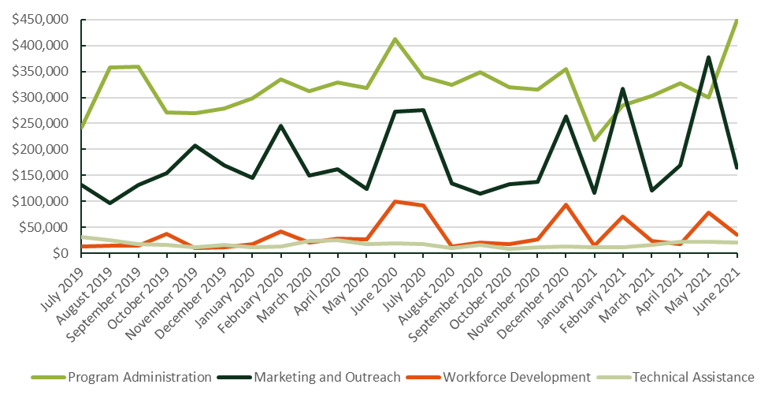
The figures below present the labor and non-labor quarterly spending over the last two years. Trendlines have been added to show how the spending has trended over this period. Notable findings from these tables are the following:
- Program Administration category spending has increased over time for the SOMAH PA (Labor Spending) but declined overtime for the Subcontractors (Non-Labor spending).
- Total quarterly spending on the other three categories (ME&O, TA, and WD) has remained fairly steady over time for the SOMAH PA (Labor Spending), however ME&O and WD subcontractor spending has been trending up over time.
Figure 3-2: Quarterly Spending by Program Category – SOMAH PA Labor vs Non-Labor (SI)
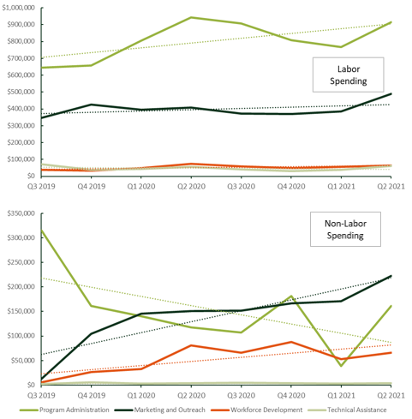

Spending Trends Over Time by SOMAH PA Organization
The next figure shows quarterly spending for each of the four SOMAH PA members and the subcontractors (as a whole) over the last two years. This figure shows that while quarterly spending dropped for CSE and the subcontractors in Q1 of 2021 and for GRID in Q4 of 2020, spending overall across all PA members (except for AEA) and the subcontractors has been on the rise over the last two years.
Figure 3-3: Quarterly Spending by SOMAH PA Member (SI)
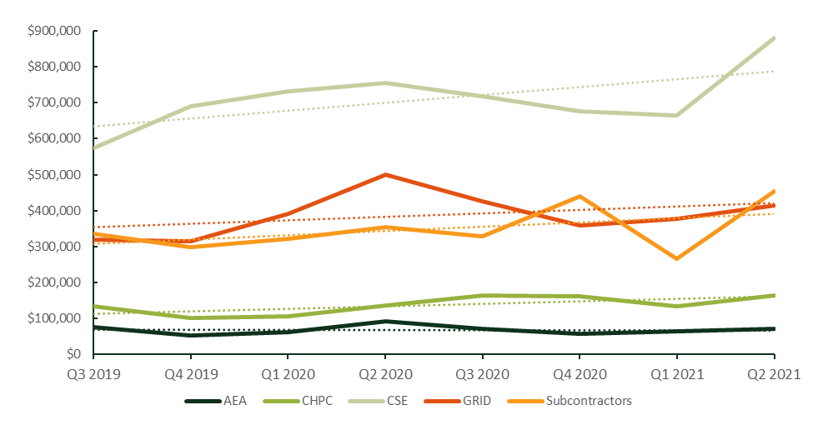

Assessment of SOMAH Forecasting And Invoicing Process
This section presents findings from the assessment of SOMAH’s forecasting and invoicing process.

SOMAH Spending versus Originally Planned Budget
SCE’s Purchase Order (PO) for CSE for the implementation and administration of the SOMAH Program laid out the PA’s projected spending by program year (Table 1 of the Purchase Order). The figure below shows the SOMAH PA’s forecasted Administrative Work Budget for 2018-2030 compared with the spending to date through the end of 2020. As this figure shows, all years to date have been underspent with the underspending through the end of 2020 totaling nearly $5,000,000.
Figure 3-6: Purchase Order Proposed Annual Spending Versus Actual Spending to Date
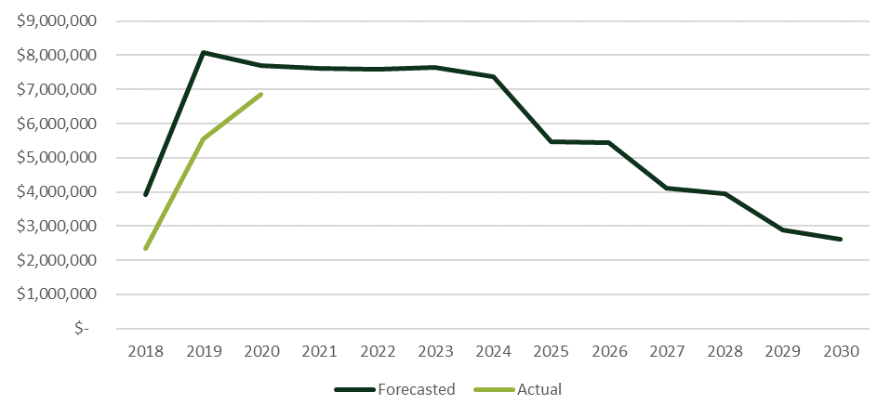

SOMAH Spending versus Quarterly Forecast
Every quarter the SOMAH PA provides the CPUC with an Advance Invoice for the quarter that represents their estimated invoicing for the upcoming quarter. Currently these invoices are developed by each member of the PA on a per month, per staff member, per task basis. Once the forecast is approved the SOMAH PA receives prepayment on their advance invoice, and if the forecasted amount is not spent there is a true up that occurs within the next quarter’s Advance Invoice (i.e., the overpayment from one quarter is subtracted from the advanced payment for the next quarter).
The evaluation team analyzed the forecasted versus actual spending by quarter to see how the forecasts and actuals have varied over time, and whether the forecasts have improved. This analysis was completed on a quarterly basis rather than monthly basis as forecasting is completed by each PA member on a quarterly basis. As Figure 3-7 below shows, both the forecasted spending and actual spending have been trending downwards over time, however the amount of underspending has stayed consistent. The SOMAH PA was asked about the cause of this underspending, and they reported two primary drivers: 1) AEA’s reduced spending due to very limited Track A participation, and 2) a need to increase staff focused on workforce development where there has been a higher level of turnover.

Figure 3-7: Quarterly Forecasted Spending Versus Actual Spending to Date (A)
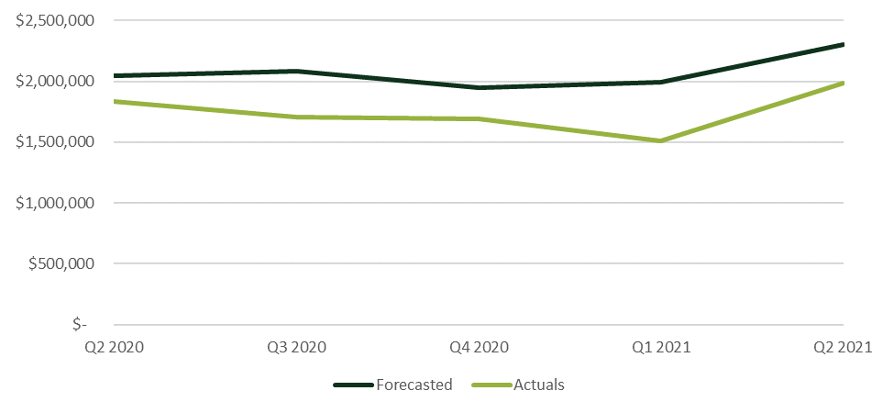

Actual versus Forecast Spending by Program Category
The table below shows that during the analysis period (April 2020 through June 2021, Analytic tab data), the program has been underspent by roughly 17 percent. The biggest absolute dollar difference between forecasted and actual spending is the Program Administration category (~$604k) which had the largest spending forecast (roughly $4.6M over the five quarters). On a percentage basis this category was only underspent by 12 percent. As a percentage of forecast, the largest underspending was in the Workforce Development and Technical Assistance categories which spent only 70 and 33 percent of their forecasted budgets respectively. Across all subcontractors, actual spending was only 8 percent short of forecasted spending. During the SOMAH PA interviews, PA staff were asked if this underspending has led to any delays in deliverables and all reported they did not think that it had.
Table 3-8: Actual versus Forecast Spending by Program Category (A)
Program Category | Forecasted Spending | Actual  Spending | Amount Underspent | % of Forecast  Spent
Program Administration | $4,998,853 | $4,395,257 | $603,597 | 88%
Marketing and Outreach | $2,296,093 | $2,036,903 | $259,190 | 89%
Workforce Development | $486,413 | $341,816 | $144,597 | 70%
Technical Assistance | $735,057 | $244,742 | $490,315 | 33%
Subcontractors | $1,858,159 | $1,707,949 | $150,210 | 92%
Total | $10,374,575 | $8,726,666 | $1,647,909 | 84%

Figure 3-8 below presents the difference between the quarterly forecast and actual spending by quarter for each of the Program Categories. As this figure shows, the difference for all Program Categories except Program Admin (PA) seems to be decreasing. Program Admin Category difference has been increasing since Q3 2020.
Figure 3-8: Difference Between Quarterly Forecast and Actual Spending by Program Category (A)
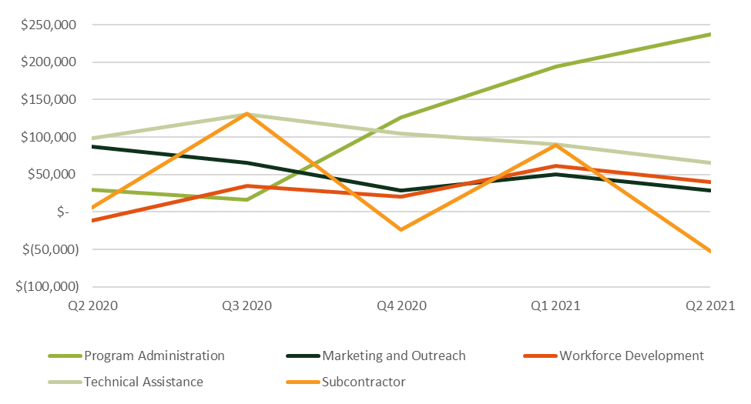
To account for the differences in category sizes, Figure 3-9 below shows the difference between the quarterly forecast and the actual spending as a percentage of the forecasted spending. This figure shows:
- Underspending as a percentage of the forecast was greatest for Technical Assistance (67 percent across the five quarters). This category has been significantly underspent due to the limited number of Track A applications that have been submitted to date.
- In comparison, Workforce Development was underspent by 30 percent and Program Administration and ME&O were underspent by 12 and 11 percent, respectively. Underspending on Workforce Development is likely related to the limited number of projects that have started construction as of the end of Q2 2021.
- According to the SOMAH PA, creating quarterly forecasts on a per month per staff per task level is a very time-consuming task that provides little value at that level of granularity. Reducing the granularity to be only the monthly spending amount ($) by program category would be more manageable.
- As shown in the figure below, the SOMAH PA overall was consistently within 30 percent of their quarterly forecast (a goal set by the CPUC) for the PA and ME&O categories and was close for WD category (with the exception being Q1 2021). The TA category forecast was consistently more than 30 percent higher than their actual spending.
Figure 3-9: Percentage Difference Between Quarterly Forecast and Actual Spending by Category
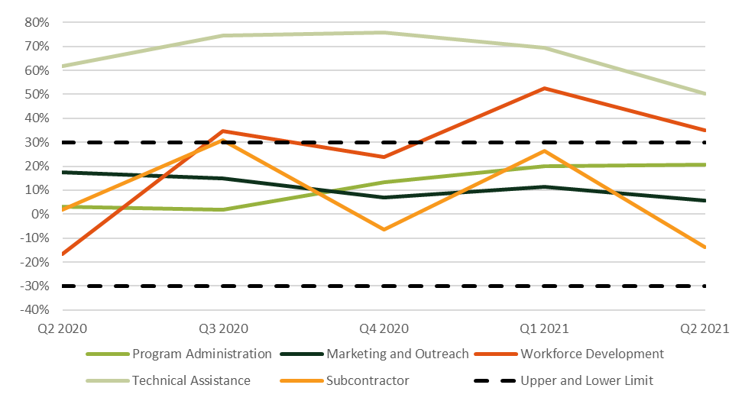

Actual versus Forecast Spending by SOMAH PA Member
Table 3-9 below compares forecasted versus actual spending between April 2020 and June 2021 by SOMAH PA member (excluding their subcontractor spending). As this table shows, the biggest absolute dollar difference between forecasted and actual spending was for AEA which was underspent by $787,194 (68 percent). The smallest absolute dollar difference was for CHPC which was only underspent by $28,990 (4 percent). CSE, who spent more than half of the total PA budget during this period, was only underspent by 6 percent ($228,709). GRID, who had the second highest spending during this period, was underspent by 17 percent ($452,806).
Table 3-9: Actual versus Forecast Spending by SOMAH PA Member (A)
SOMAH PA MEMBER | Forecasted Spending | Actual  Spending | Amount Underspent | % of Forecast  Spent
CSE | $3,958,468 | $3,729,759 | $228,709 | 94%
GRID | $2,600,499 | $2,147,692 | $452,806 | 83%
CHPC | $793,776 | $764,786 | $28,990 | 96%
AEA | $1,163,673 | $376,479 | $787,194 | 32%
Total | $8,516,416 | $7,018,717 | $1,497,699 | 82%

The three PA members with the largest spending have been off by a reasonable amount.
Figure 3-10 below presents the difference between the quarterly forecast and actual spending by quarter for each of the SOMAH PA members. As this figure shows, on a quarterly basis the difference for CSE and CHPC have been much smaller than the differences for GRID and AEA (which aligns with the table above).
Figure 3-10: Difference Between Quarterly Forecast and Actual Spending by SOMAH PA Member (A)
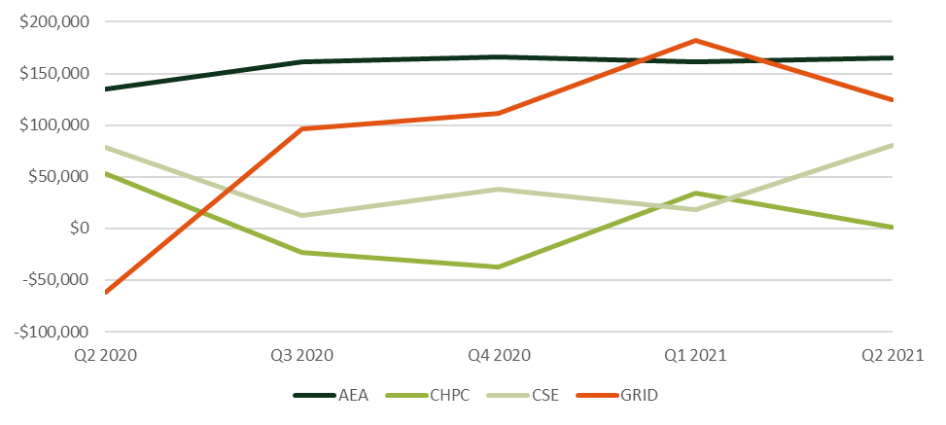
To account for the differences in category sizes, the Figure 3-11 below shows the difference between the quarterly forecast and the actual spending as a percentage of the forecasted spending. This table shows:
- Underspending as a percentage of the forecast was greatest for AEA (68 percent across the five quarters). AEA has been significantly underspent due to the limited amount of Technical Assistance that has been requested by program participants to date which is their primary focus. They acknowledge that their initial forecasts were high as they did not know how much their services would be needed. They now have much more data available, and they look back at the actuals to develop their forecasts, however they note that it is hard to be within 30 percent of their forecast when their forecast is low to start, and they are creating the forecast by as much as six months before the work takes place. Another reason it is difficult for them to forecast as they have one staff member who doesn’t work on the program full-time but is available to be pulled in when highly technical issues come up. Forecasting when these issues will arise is nearly impossible to know in advance.
- GRID’s spending was the second furthest from their forecast, however on a quarterly basis it was nearly always within the 30 percent threshold. CSE and CHPC were always within the 30 percent threshold. Before submitting a quarterly forecast, the SOMAH PA should review at a program category level their forecasted and actual spending in the most recent months, as well as any anticipated program changes that could result in increases or decreases to PA spending, to ensure their forecast is reasonable. Ensuring these types of feedback loops are incorporated into the planning process should help to ensure forecasts that are well within a 30 percent threshold.
Figure 3-11: Percentage Difference between Quarterly Forecast and Actual Spending by PA
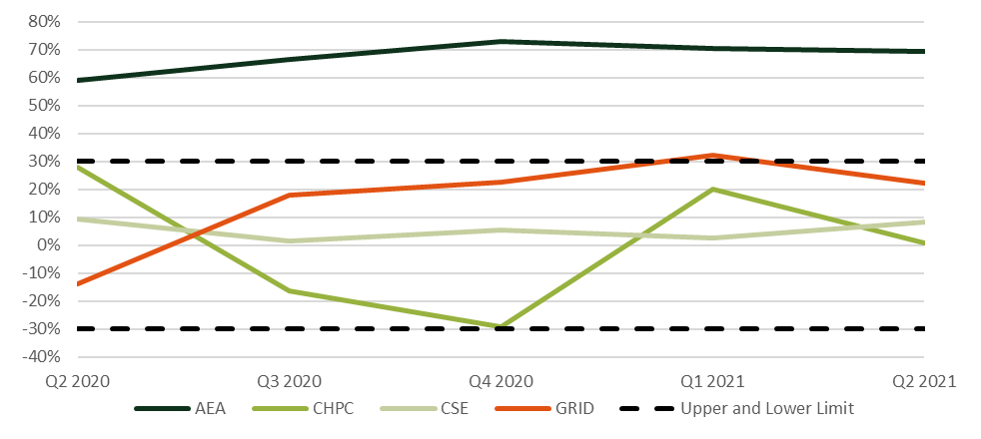

Actual versus Forecast Spending by Program Task
Table 3-10 below shows the top three underspent tasks for each program category. A few notable findings from this table include:
- Marketing, Education, and Outreach: Tenant, Property Owner, and Contractor Engagement are all very important to ensure program participation and to be able to achieve the program’s goal of installing 300 MW of solar. Despite the essential nature of engagement, it is interesting to note that within the ME&O Category, these three tasks were the most significantly underspent tasks (by more than $261k over the last five quarters).
- Program Administration: As the table shows the Financial Tracking Task has been underspent by 21 percent since Q2 of 2020, however it does seem to be improving as the underspending has fallen from 26 percent in 2020 to 12 percent during the first two quarters of 2021. Underspending on the Program Planning and Development Task has gotten worse, increasing from 15 percent in 2020 to 57 percent in 2021. The forecast for Q2 2021 was more than $102k, which was roughly 25 percent higher than the spending on this task during all of 2020. This increase in the forecast appears to have been driven by CSE significantly increasing their monthly forecasts for Q1 and Q2 of 2021 based on their spending in 2020, however after increasing their forecast their spending on this task dropped by about 50 percent in 2021.
- Workforce Development: GRID is the only SOMAH PA member submitting a forecast for the WFD Cooperative Marketing Efforts Task which is underspent by 90 percent. Their quarterly forecasts in 2020 were between $12k and $17k, but their spending never surpassed $3k in a quarter. So, while they dropped their forecasts to around $6K in 2021, their spending also dropped off to less than $1,000 in Q1 and Q2 of 2021 combined.
- Technical Assistance: The underspending on Technical Assistance tasks was significant primarily due to the extremely limited Track A participation to date. According to SOMAH PA staff we spoke with, they are currently looking to revamp the TA offered through the program to make it more accessible and valuable to all program participants rather than primarily Track A participants.
Table 3-10: Top Underspent Tasks
Program Category | Task Description | Forecasted Expenses | Actual Expenses | Amount Underspent | % Underspent
Marketing and Outreach | Tenant Engagement | $142,948 | $49,960 | $92,988 | 65%
 | Property Owner Engagement | $410,218 | $318,988 | $91,229 | 22%
 | Contractor Engagement | $149,804 | $72,461 | $77,343 | 52%
Program Administration | Database Management | $507,632 | $348,992 | $158,640 | 31%
 | Program Planning and Development | $456,468 | $305,408 | $151,060 | 33%
 | Financial Tracking | $532,658 | $419,918 | $112,740 | 21%
Workforce Development | WFD Admin | $218,552 | $158,923 | $59,629 | 27%
 | WFD Cooperative Marketing Efforts | $54,675 | $5,711 | $48,965 | 90%
 | Job Training Portal | $57,364 | $27,135 | $30,229 | 53%
Technical Assistance | Pre-Installation TA | $481,122 | $199,768 | $281,354 | 58%
 | EE and Program Leveraging | $133,383 | $38,856 | $94,527 | 71%
 | Post-Installation TA | $93,977 | $695 | $93,282 | 99%

Table 3-11 below shows the six project tasks that have been overspent by more than $10,000 during the invoicing analysis period. The task that was overspent the most on a percentage basis was Conferences (39 percent overbudget). Most of these hours appear to have been spent prepping for or attending a conference.
Table 3-11: Top Overspent Tasks
Program Category | Task Description | Forecasted Expenses | Actual Expenses | Amount Overspent | %
Marketing and Outreach | Website Development & Enhancements | $172,042 | $229,372 | ($57,330) | -33%
Program Administration | Application Processing | $786,351 | $828,446 | ($42,095) | -5%
Marketing and Outreach | Community Based Organizations | $242,024 | $260,455 | ($18,431) | -8%
Marketing and Outreach | ME&O Plan Development | $68,579 | $87,008 | ($18,429) | -27%
Marketing and Outreach | Conferences | $46,773 | $65,090 | ($18,318) | -39%
Program Administration | Program Reporting | $468,162 | $480,156 | ($11,995) | -3%

Actual versus Forecast Spending by Subcontractor
Table 3-12 below shows the difference between forecasted and actual expenditures by subcontractor. This table shows that overall subcontractors were underspent by 8 percent, however differences from forecast by subcontractor ranged from a high of $90,150 for Energy Solutions to a low of -$103,603 (which represents overspending as compared to their forecast) for Clean Power Research. Most of the subcontractors we spoke with reported their spending was either on track or would be at the end of their contract (a few items had been pushed off so were not billed when they had anticipated). Those that were underspent said some of this was because in-person outreach, which required subcontractor staff travel, as well as food, childcare, translation services, etc., had been cancelled due to COVID.
Table 3-12: Subcontractor Spending Versus Forecast
Subcontractor | Forecasted Spending | Actual  Spending | Under or Overspent $ | Under or Overspent %
Energy Solutions | $423,966 | $333,816 | $90,150 | 21%
Placeholder for new central valley CBO | $75,000 | $- | $75,000 | 100%
Asian Pacific Environmental Network | $225,025 | $163,962 | $61,063 | 27%
Salesforce/IT Matters | $55,500 | $24,229 | $31,271 | 56%
Self-Help Enterprises | $62,500 | $34,042 | $28,458 | 46%
Communities for a Better Environment | $203,931 | $198,809 | $5,122 | 3%
Rising Sun Energy Center | $309,409 | $312,680 | ($3,271) | -1%
California Environmental Justice Alliance | $225,051 | $230,390 | ($5,339) | -2%
Environmental Health Coalition | $191,702 | $220,343 | ($28,641) | -15%
Clean Power Research | $86,075 | $189,678 | ($103,603) | -120%
Total | $1,858,159 | $1,707,949 | $150,210 | 8%

Table 3-13 below groups the subcontractor forecasting and spending by the focus of their activities. As this table shows, subcontractors that were focused on ME&O (namely CBOs) were underspent by the largest amount $135,663 (14 percent) during this period, however this is primarily driven by two CBOs – one of whom is new and was delayed it being brought on board. This is somewhat concerning as one of their primary responsibilities, in addition to tenant engagement, is outreach to non-participating property owners—which can be essential to project pipeline development.
Table 3-13: Subcontractor Spending Versus Forecast by Program Category
Program Category | Forecasted Spending | Actual  Spending | Under or Overspent $ | Under or Overspent %
Program Admin | $565,541 | $547,723 | $17,818 | 3%
Marketing, Education, and Outreach | $983,209 | $847,546 | $135,663 | 14%
Workforce Development | $309,409 | $312,680 | ($3,271) | -1%

Effectiveness of SOMAH PA’s Existing Forecasting and Invoicing Process
Another objective of the SOMAH Vendor Assessment is to evaluate the effectiveness of the SOMAH PA’s current invoicing process to assess the time and cost of producing monthly invoices and quarterly forecasts, the degree to which it provides the CPUC with the information necessary to ensure program funds are being appropriately spent, and to identify opportunities for improvement or streamlining.

Invoicing and Forecasting Costs
Within the Program Administration Category there is a Financial Tracking Task which made up five percent of total program spending since program inception ($907,102). This task appears to include financial related activities such as developing quarterly forecasts, budget tracking, invoicing, and timecard review. The figure below shows the quarterly forecasted and actual spending for the Financial Tracking Task. As this figure shows, spending on this task has been fairly stable around $80k a quarter except for the during last quarter of 2020 and the first quarter of 2021 when it increased to around $100k per quarter.
Figure 3-12: Forecasted versus Actual Quarterly Spending on Financial Tracking Task (A)
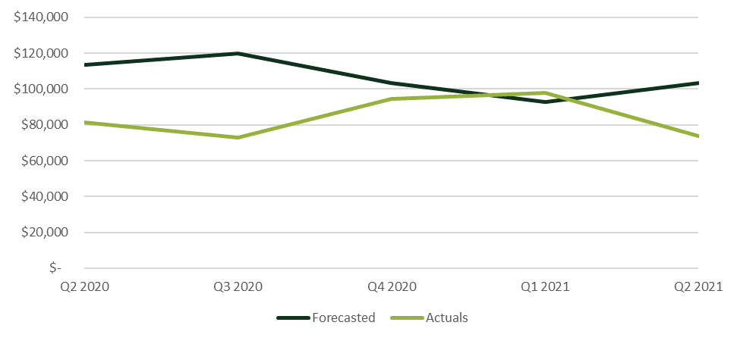
As previously discussed, currently the SOMAH PA creates forecasts of their projected spending on a quarterly basis. These forecasts are required to include the anticipated spending for each staff member, for each month in the quarter, and across the 37 distinct tasks. The current level of quarterly forecast granularity is quite time consuming to create as it requires 111 individual hourly estimates for each staff member billing to the project (3 months x 37 distinct tasks = 111 hourly forecasts). As stated above, across all four SOMAH PA members there has been an average of 75 staff members working on the project monthly which means developing 8,325 hourly spending estimates each quarter (3 months x 37 distinct tasks * 75 staff members = 8,325 hourly forecasts). This process is made even more difficult because these forecasts need to be estimated nearly six months in advance of when the spending will occur. Program priorities and needs can change a lot over a six-month time period. According to an interviewed PA, their organization started their Q1 2022 forecasting process in October of 2021 to ensure sufficient time to create the forecast, have it reviewed internally, get it submitted to CSE to be integrated with the other PA forecasts, and then have it delivered to the CPUC for review and advance payment. All SOMAH PA members interviewed commented that the time required to create such a detailed estimate of program spending is excessive and their estimates are essentially just “educated guesses” of what their staff may be working on six months in the future. One SOMAH PA member described the forecasting process as “complex and onerous” but also said they thought that it provided valuable information. The forecasting process can also lead to additional time being spent by a PA if their category-level forecast is off by more than 30 percent (the threshold set by the CPUC). Actual invoices that do not come within 30 percent of the category level forecast trigger the need to provide a brief written explanation for the deviation and assess future work implications. Significant time could be saved if the quarterly forecasts were completed at the task-level and did not require monthly staff-level estimates of hours spent.
To assess the costs of creating the quarterly forecasts and monthly invoices, the evaluation team analyzed the invoice notes (Detailed Spending Analysis) for the Financial Tracking Task, as well as other program tasks. Notable findings included the following:
- Roughly 17 percent of spending ($115,031) in the Financial Tracking Task was for work completed on forecasting (notes included “forecast”) and 42 percent of spending ($288,122) was for work related to invoicing (notes included “invoice” or “invoicing”).
- Roughly a quarter of forecasting expenditures (78 percent) were billed to the Financial Tracking Task and another 13 percent were billed to the Program Reporting Task. No other task had more than 3 percent of the “forecast” spending.
- For invoicing, 89 percent of the spending fell under the Financial Tracking Task and no other task had more than three percent of the “invoice” spending.
- Additional forecasting and invoicing related activities were found to be included in other program categories besides Program Administration. Table 3-14 below presents the estimated spending on forecasting and invoicing activities across each of the program categories. The table shows that on average across the analysis period (July 2019 to June 2021), the average cost to create a quarterly forecast was $18,330 (135 hours) and the cost to create a monthly invoice was $13,476 per month (110 hours). The spending over time on these activities was found to have been relatively stable.
- Future assessments of the cost to create quarterly forecasts and monthly invoicing would be easier and more accurate if all invoicing and forecasting work was billed to the Financial Tracking Task and included “forecast” or “invoice” in the spending notes.
Table 3-14: Estimated Spending on Quarterly Forecasting and Monthly Invoicing
Program Category | Forecasting Expenses | Invoicing Expenses
Program Administration | $142,587 | $307,348
Marketing and Outreach | $3,723 | $10,380
Workforce Development | $333 | $5,515
Technical Assistance | $0 | $193
Total | $146,643 | $323,436
Quarterly | $18,330 | -
Monthly | - | $13,476

The cost trend to create the quarterly forecasts is presented in Figure 3-13 below. As this exhibit shows, the spending on forecasting increased from Q3 2019 to Q2 2020, before sharply decreasing by about $15,000 in Q3 2020. The greatest spending on forecasting was identified by SOMAH staff in Q2 2021.
Figure 3-13: Estimated Spending on Developing Quarterly Spending Forecasts (SI)
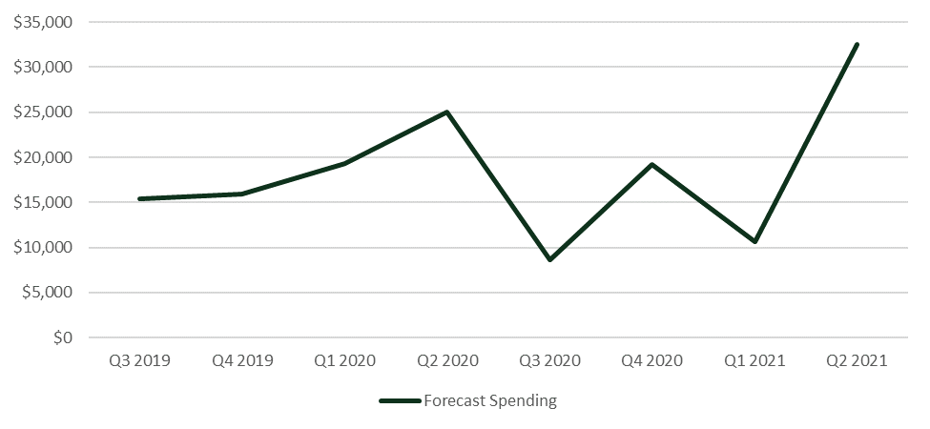
As shown in Figure 3-14 below, spending on invoicing has also varied by month but seems to be trending downwards since a peak in December 2019. A review of the detailed labor reporting notes seemed to indicate that much of the early invoicing spending was related to setting up a process to review and compile invoices. Costs to do this work since January of 2020 have been drastically reduced.
Figure 3-14: Estimated Spending on Monthly Invoicing (SI)
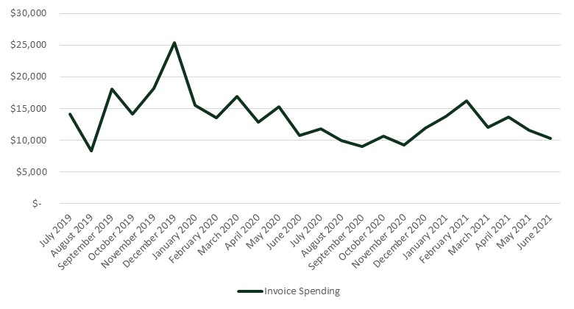

SOMAH Program Spending and Staffing Assessment
As part of the vendor assessment, Verdant analyzed the invoicing data and interviewed SOMAH PA staff to determine whether any spending or staffing appears out of scope in relation to the anticipated output of the task or program objective. The assessment that follows identified several areas where spending or staffing appears to be somewhat out of alignment.
The SOMAH PA members we spoke with all reported that a substantial portion of their spending and time was spent on the Financial Tracking, Timekeeping, and Program Reporting Tasks. They reported that these activities have been one of the biggest hurdles they have experienced to date implementing the program. The CPUC and SCE have many reporting requirements and ironing out that process took significant time and effort. At this time, while still very labor intensive, they reported they have built up a lot of infrastructure that makes it run smoother with less chance of error. In total since the program launch more than $2.3M has been spent on these three tasks (21 percent of the PA category budget and 13 percent of the entire program budget). The SOMAH PA members interviewed were asked about this spending and reported that they felt some of this spending did not yield value commensurate with the cost. Table 3-6 below breaks down the spending on these three tasks by PA member over the 24-month analysis period (July 2019 through June 2021). Our assessment of this spending based on the data analysis and interviews with the SOMAH PA is presented below.
- Program Reporting. More than $1M had been spent on Program Reporting. This was mostly driven by CSE and subcontractor spending which made up 9 percent and 14 percent of their spending to date, respectively. This task accounted for 8 percent of total program spending during the last two years. The subcontractor spending to this task appears to mostly be Energy Solutions. According to Energy Solutions their primary roles implementing the SOMAH Program are to host and maintain weekly SOMAH project updates to the DG Stats website and to host the Online Bidding Tool for Track A projects. It is their DG Stats work that is billed to the Program Reporting Task. The Online Bidding Tool work is billed to the Bidding Resources Task.
- Financial Tracking. Nearly $700k had been spent on Financial Tracking. CSE and GRID spent 7 percent and 8 percent of their time on this task. The SOMAH PA noted that one of the reasons for the high level of spending in this area is due to the PA consisting of four organizations plus subcontractors that all use their own method of tracking staff time. The different tracking methods need to be pulled together to create a single monthly SOMAH PA invoice. Due to the importance of accuracy and the room for human error, significant time is spent to ensure the financial tracking is correct.
- Timekeeping. A total of $328,773 was spent by SOMAH PA staff tracking the time they spent implementing the SOMAH program. Further analysis of timekeeping spending trends and the average percentage of time SOMAH staff spend on timekeeping is provided in Figure 3-15 and Table 3-16 below.
Table 3-15: Spending by SOMAH PA Member on Financial Tracking, Timekeeping, and Program Reporting, 7/2019 - 6/2021 (SI)
Program Task | CSE | GRID | CHPC | AEA | Subcontractors | Total
Program Reporting | $500,526 | $119,933 | $8,854 | $5,976 | $391,572 | $1,026,860
 | 9% | 4% | 1% | 1% | 14% | 8%
Financial Tracking | $380,628 | $243,113 | $47,637 | $20,158 | $0 | $691,536
 | 7% | 8% | 4% | 4% | 0% | 5%
Timekeeping | $135,164 | $134,823 | $37,228 | $21,557 | $0 | $328,773
 | 2% | 4% | 3% | 4% | 0% | 2%
Total Spending | $5,690,541 | $3,098,416 | $1,102,730 | $546,259 | $546,259 | $13,321,745

Effectiveness of Spending To Address Participation Barriers
The SOMAH Phase II evaluation included interviews with participating and nonparticipating contractors and property owners to identify the barriers they face to participation. As part of the Vendor Assessment, we have mapped these identified barriers to the SOMAH PA’s spending in related areas. The goal of this mapping, as well as interviews with the SOMAH PA, is to assess the effectiveness of the spending to date and whether this spending has been sufficient, or if additional spending should be shifted or refocused to help alleviate any identified participation barriers.

Contractor and Property Owner Barriers to Participation
The SOMAH Phase II final report documented the primary barriers that participating and nonparticipating contractors faced to partaking in the SOMAH Program. As stated in the final report, the primary barriers faced by contractors are administrative in nature. The SOMAH Program rules and participation requirements are onerous and present a significant administrative burden to contractors. Participating contractors typically require large, dedicated teams to manage SOMAH projects, including sales, project management, engineering, and construction staff. Filling this multitude of roles can be difficult for small contractors. Non-participating contractors reported difficulty generating project leads, as well as confusion over program requirements and the application process. Contractor barriers also included financial and solar feasibility concerns, such as property owners’ inability to cover up-front costs or secure bridge funding. Contractors also reported difficulties carrying project costs for extended times prior to incentive payment.
The SOMAH Phase II final report also documented the primary barriers property owners faced to participation in the SOMAH Program. Interviews and web surveys with participating and non-participating property owners found that some of the barriers faced were similar to those faced by the contractors, such as a lack of time to deal with a burdensome application and participation process or a perceived inability to finance the project. Additional barriers they reported facing included a lack of contractor or program trust, physical site issues that made solar difficult, and lack of prioritization against other affordable housing priorities.
As part of the Vendor Assessment these contractor and property owner barriers have been grouped into five primary categories (Application Burden, Generating Project Leads, Program/Contractor Distrust, Project Financing, and Job Training Requirements) and program tasks that address these barrier categories have been mapped to them. Table 3-17 below presents this mapping. As it shows, roughly one-third of the budget during the analysis period was to a task supporting these barriers. It is important to note that there are other activities, for example work completed by the SOMAH PA to create the Progress Payment Pathway (which will help to address project financing barriers), that cannot be mapped on a task level as the work was billed to several different tasks (Program Planning and Development, Program Admin, Communications, and Marketing Collateral Development).
Table 3-17: Mapping of Contractor And Property Owner Participation Barriers to Program Spending (SI)
Barriers to Participation | SOMAH Tasks that Support this Barrier | PA Spending  (7/19 – 6/21) | % of Total Spending
Application Burden (Contractor and Property Owner) | Application Processing | $1,148,265 | 9%
 | Pre-Installation TA | $329,862 | 2%
 | Post-Installation TA | $2,229 | 0%
 | Total | $1,480,357 | 11%
Generating Project Leads  (Contractor)  Program/Contractor Distrust (Property Owner) | Bidding Resources | $337,038 | 3%
 | Community Based Organizations | $1,483,637 | 11%
 | Property Owner Engagement | $449,417 | 3%
 | Communications | $186,640 | 1%
 | Cooperative Marketing Efforts | $144,622 | 1%
 | Conferences | $133,139 | 1%
 | Contractor Engagement | $110,802 | 1%
 | Contractor Training | $68,509 | 1%
 | Media | $33,172 | 0%
 | Total | $2,946,977 | 22%
Project Financing (Contractor and Property Owner) | Financial TA | $10,601 | 0%
Job Training Requirements (Contractor) | Regional JTO Task Force | $177,890 | 1%
 | Job Training Portal | $102,666 | 1%
 | WFD Cooperative Marketing Efforts | $66,855 | 1%
 | WFD Workshops and Conferences | $21,382 | 0%
 | Local Hiring Plan Development | $3,336 | 0%
 | Total | $372,129 | 3%
Total |  | $4,810,064 | 36%

While the table above shows significant spending on activities to address contractor and property owner barriers to SOMAH participation, this evaluation team identified the following areas where the SOMAH PA could increase their activities to further alleviate these barriers:
- Application Burden – A significant portion of program spending has been spent on Application Processing, however the SOMAH PA should meet with participating contractors and property owners to identify any additional support they can provide to reduce the application burden placed on these two groups.
- Generating Project Leads – Achieving SOMAH’s aggressive goal of installing 300 MW of solar is going to require the SOMAH PA to increase its efforts to build a robust project pipeline. To date roughly 3 percent of the program budget has been spent on Property Owner Engagement which may not be sufficient to achieve the necessary volume of project leads. Additional engagement of property owners has reportedly been conducted by CBOs, however interviews with these CBOs indicated the number of property owners they have engaged with has been quite limited (~60 in total) and additional CBO training and support may be necessary to ensure these engagements are effective. The SOMAH PA reported plans to begin creating case studies of successfully completed projects and having focused one-on-one meetings with property owners to build additional awareness and trust in the program.
- Project Financing – As shown in the table above program spending to date on Financial TA has been quite low ($10,601 over last two years). The SOMAH PA should consider what additional support can be provided to property owners and contractors to ensure they are aware of the various ownership options (some of which require no out of pocket costs for property owners) and ways in which other upgrades needed prior to installing solar (such as roof repairs or replacement) can be completed at no cost.

Effectiveness of Spending to Address Barriers to Participation
A review of the SOMAH PA’s program spending to date has found they have been moderately effective at addressing the barriers faced by contractors, and the spending to date across the program categories at this time seems appropriate. Our assessment of the spending in each of these areas is provided below.
- Application burden – Despite spending more than $1M on the Application Processing Task in the first two years of the program (which amounts to just over $2,000 per application), the application process is still very time consuming for both contractors and property owners. The number of application cancellations also continues to rise. The SOMAH PA should continue to identify areas where they can provide additional assistance to relieve the application burden felt by participants.
- Generating project leads – Spending on marketing activities directed towards SOMAH project pipeline development has totaled nearly $3M over the course of the last two years. Much of the spending was directed towards ramping up program marketing efforts and raising awareness of the SOMAH Program through CBO partners, webinars, and other outreach efforts. The number of SOMAH projects that have resulted from this spending is hard to accurately determine, however interviews with participating property owners in Phase II of the SOMAH evaluation indicated a large share of applicants at that time stemmed from contractor outreach or relationships. Increasing the pipeline of SOMAH project applications, especially from property owners who contractors are not targeting outreach efforts to, needs to be a central focus of marketing efforts in the coming year to ensure the program is able achieve its goals.
- Program/Contractor distrust – Spending on activities to increase property owners’ trust in the program have primarily been related to increasing program awareness and educational materials. Interviews with the SOMAH PA revealed plans to set up one-on-one meetings with property owners who apply in order to provide neutral third-party support on the SOMAH Program, and ensure they are well informed on program rules, eligibility and the available options (such as project ownership type). The program should additionally consider how it can increase the one-on-one support provided to property owners who have not yet submitted an application to the program. A vast majority of the completed ME&O outreach activities to non-participating property owners have been via email (a high number of which never get opened) or via conferences or webinars (most of which have been remote due to COVID). During interviews with the PA and CBO partners, both mentioned outreach activities working directly with individual property owners, however, to increase the SOMAH project pipeline to the extent needed, the number of these activities will have to increase significantly.
- Project financing – As shown in the table above, few tasks could be directly linked to project financing. Efforts such as creating the Progress Payment Pathway have helped to alleviate this burden, however additional efforts, as called out in the SOMAH Phase II report (such as leveraging unreserved incentives, helping smaller contractors offer PPA to customers, etc.), are needed to fully address this barrier.
- Job training requirements – The spending to meet the program’s job training requirements seems to be sufficient. There has been significant spending on the JTO Taskforce Task, however this taskforce is an important component of ensuring that SOMAH job opportunities are accessible to job seekers and that workforce development activities are effective, and thus the spending on this taskforce is in-line with the value it provides to the program.

Effectiveness of SOMAH PA’s Efforts to Date
The SOMAH Program is large and complex with broad and ambitious goals. Its magnitude (both in terms of incentive dollars and MW of solar installed) is much larger than MASH, its predecessor program. As of the end of Q2 2021, the SOMAH PA has spent $18.3M on program implementation. During that same period, SOMAH participants had installed 50 kW of solar PV and received $126,238 in incentives. The difference between SOMAH’s cumulative implementation costs and the number of interconnected projects as of mid-2021 is significant and could raise questions regarding the effectiveness of the program’s implementation, however it is important to consider a number of other important metrics and factors such as:
- The number of completed projects is expected to ramp up significantly starting in the second half of 2021. According to the SOMAH PA, by the end of 2021 more than two dozen SOMAH projects are expected to be completed, representing roughly 4.5 MW of installed capacity, $8.5 million in incentive payments, and serving more than 2,000 tenant units. Approximately 400 additional projects are currently being actively managed by the SOMAH PA, representing another 79 MW of potential installed capacity and over 30,000 additional beneficiaries. All these pipeline projects, while not complete, have required significant SOMAH PA time and effort to get them to their current project status.
- The lag that exists between the data provided to the SOMAH PA (via PowerClerk) and a project’s status in the field. There may be more solar capacity installed than is known to the program due to an application status not being entirely reflective of the work that has been done to complete the project.
- The significantly longer timelines required to complete multifamily solar projects (months or years) versus single family projects (weeks or months). The scale of MF projects, along with the co-benefits and programmatic requirements put in place to ensure the targeted communities realize the program’s benefits, increase the complexity of projects and lead to projects taking one to two years to be completed. In addition, SOMAH projects are large (approximately 175 kW on average) and working with the affordable housing industry is complex and time intensive.
- The impact of COVID-19 on project timelines (which have been extended) and property owners’ prioritization of efforts and activities in light of COVID.
All the SOMAH PA members and subcontractors interviewed were asked to self-assess the spending of their organization and the SOMAH PA as a whole on program implementation activities to date. Highlights of their responses included:
- A significant portion of the SOMAH PA’s spending to date has been focused on application processing, ME&O, reporting, and trying to build efficiencies into the program to expediate future implementation activities. By the end of 2020 the team and program activities were becoming very cohesive, and a lot of work has been accomplished for the money spent.
- SOMAH spending to date has been reflective of the ramp up activities necessary to get this substantial program off the ground. Over the course of the past year and a half the COVID pandemic added an additional complexity to program implementation activities, and they are now trying to make up for the setbacks caused by COVID.
- They strive to wherever possible be efficient with their budget, which includes trying to “right size” meetings with respect to the number of staff in attendance and the frequency of the meetings.
- They acknowledge the cost to implement SOMAH has been high (and higher than MASH). However, point out that there are key differences between SOMAH and MASH that have increased the cost of SOMAH. These include items such as: MASH projects including much of the “low hanging fruit”, the scale of SOMAH necessitating the need for increased program marketing, program design features such as creating an online bidding tool designed to get more competitive bidding, etc.
- The SOMAH PA team has leaders in their respective areas in the industry. This allows them to provide exceptional value to the program. For example, AEA is very involved with other programs directed towards low-income multifamily properties (such as LIWP), which allows them to help identify synergies and best practices across the programs.
The evaluation team’s overall assessment at this time based on this detailed review of spending, as well as a review of program materials, training activities, and interviews with both the SOMAH PA and subcontractors, is that the program’s administration has been comprehensive and has accomplished a great deal in a relatively short time. Contractors, property owners, and subcontractors (CBO, WD, and PA) all had positive things to say about their interactions with the PA, reporting they were very responsive, detailed oriented, knowledgeable, and have helped them participate or engage with the program. Their ultimate effectiveness achieving the program’s primary goal of installing 300 MW of solar on low-income multifamily properties is still yet to be determined. Their ability over the coming year to increase participation in the program by helping property owners and contractors overcome the barriers they face to program participation and to decrease the number of application cancellations will be essential to their ultimate success.
The evaluation team completed a Detailed Spending Analysis across all Program Categories to identify, based on the invoicing notes, the most common types of activities occurring. The results are provided in Table 3-18 below. As this table shows:
- Meetings and Calls - Roughly one-third of the Program Admin spending was on attending program meetings and calls. Further classifying the topics of these coordination events could not easily be accomplished.
- Review – Nearly $1.3M has been spent on “review” activities. Common types of review activities have been application review, SOMAH materials review, timesheet review, and invoice review.
Table 3-18: Detailed Spending Analysis by Program Category (DLR-R) (7/19 – 6/21)
Most Common Key Words in Invoice Notes | Program Administration |  | Marketing and Outreach |  | Technical Assistance |  | Workforce Development |  | Total
 | $ | % | $ | % | $ | % | $ | % | $ | %
Meetings/Calls | $2,010,040 | 31% | $900,229 | 28% | $123,817 | 32% | $166,545 | 40% | $3,200,632 | 31%
Review | $825,261 | 13% | $320,507 | 10% | $86,014 | 23% | $47,150 | 12% | $1,278,932 | 12%
Application | $1,037,020 | 16% | $26,109 | 1% | $7,464 | 2% | $2,964 | 1% | $1,073,558 | 10%
Management | $669,002 | 10% | $123,270 | 4% | $8,789 | 2% | $13,896 | 3% | $814,957 | 8%
Training/Onboarding¥ | $236,805 | 4% | $145,974 | 5% | $41,772 | 11% | $49,661 | 12% | $474,212 | 5%
¥ In general, the Training and Onboarding within the Program Admin Category is for internal staff training versus the Training and Onboarding within the ME&O category is for external parties.
The remainder of this section examines the effectiveness of SOMAH PA and subcontractor spending, including analysis performed on the detailed project notes (Detailed Spending Analysis), for each of the four Program Categories.

Effectiveness of Program Administration Activities
PA staff were asked to assess the effectiveness of their spending on the Program Administration Category tasks. Overall, they thought the SOMAH PA had been effective, acknowledging the significant scope of work included within this category.

Program Admin Primary Cost Drivers and Detailed Spending Analysis
Table 3-19 below presents the primary cost drivers for the Program Administration Program Category.
Table 3-19: Program Administration Category Task Level Spending Summary (SI)
Program Administration Category Tasks | Total Spending  through 6/21 | % of Category Spending | % of Total Program Spending | Pre-Launch Spending %
Program Admin | $3,110,160 | 28% | 17% | 38%
Program Planning and Development | $1,865,785 | 17% | 10% | 78%
Database Management | $1,251,292 | 11% | 7% | 21%
Application Processing | $1,239,144 | 11% | 7% | 7%
Program Reporting | $1,141,304 | 10% | 6% | 10%
Financial Tracking | $907,102 | 8% | 5% | 24%
Bidding Resources | $393,933 | 4% | 2% | 14%
Timekeeping | $331,345 | 3% | 2% | 1%
Working Group & Public Forums | $269,175 | 2% | 1% | 19%
Program QA/QC | $246,115 | 2% | 1% | 1%
Advisory Council | $220,561 | 2% | 1% | 2%
Worksite Safety Program | $115,030 | 1% | 1% | 4%
On-site Field Inspections | $84,804 | 1% | 0% | 54%
Total | $11,175,749 | 100% | 61% | 31%

Further analysis on the Program Administration Tasks yielded several interesting results:
- Application Processing Task – To date, the processing of program applications has accounted for only seven percent of the total program administration budget. Both the CPUC and the SOMAH PA separately reported that application processing consumes a significant amount the PA’s time, however based on the time billed to this task since the program launched it amounts to roughly $2,100 per application (or less than 20 hours per application based on the average application processing staff rate). It is important to note that this cost per application is an average at this time and thus does not account for the fact that most of these applications are still in progress (so the application processing costs will continue to go up until the project is complete). It also includes applications in this average that may have been cancelled soon after they were submitted and so less PA involvement. As stated in the barriers section above, both contractors and property owners reported in Phase II of the SOMAH evaluation that the SOMAH application process presented a substantial burden to their organization and thus was a barrier to their participation. It was recommended that more of this burden be shifted to the SOMAH PA which would lead to an increase in the PA’s Application Processing Task spending. The figure below maps monthly spending on this task to the number of SOMAH application submissions. As this figure shows little correlation was identified and there were significant swings in monthly spending.
Figure 3-16: Application Processing Task Spending versus SOMAH Application Submissions
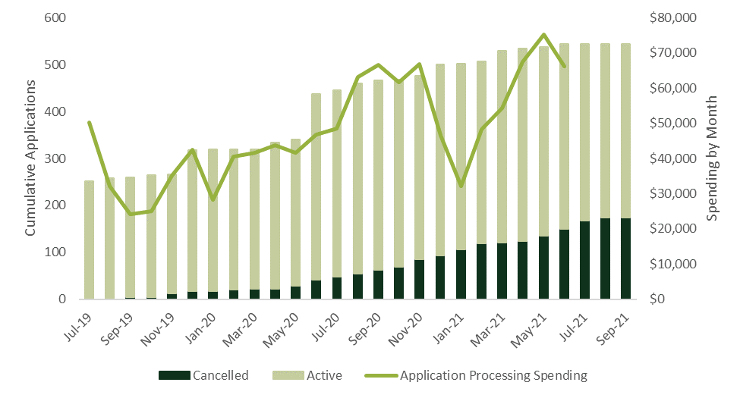
- Working Group & Public Forums and Advisory Council Tasks – Nearly $500,000 has been spent on these two tasks. While this is a significant expenditure, the activities that fall under these tasks are important and ensure community members have a voice in the program’s administration. The SOMAH Advisory Council is made up of key stakeholders, such as CBOs, environmental justice organizations, trade organizations, and affordable housing specialists. This council was formed to advise on matters pertaining to program development and implementation such that community members voices and interests remain central to the program to ensure it maximizes the benefits it provides to low-income housing tenants and disadvantaged communities. PA staff mentioned there is the potential for cost savings related to the SOMAH Public Forums. These forums are currently held quarterly and require significant time to plan and attend. Additionally, historically many SOMAH staff have attended the forums which is not an effective use of and the staff time or program spending as the information conveyed in these forums could be broadly circulated to PA staff by emailing the slide decks presented at the forums. These forums were designed to provide program updates to external stakeholders, not internal PA staff. The PA recommended monitoring the agenda items for these forums send program forum updates as email if there is nothing substantial to report on.
- Analysis of the Program Reporting, Financial Tracking, and Timekeeping Tasks were presented in above in the section on SOMAH Forecasting and Invoicing costs (Section 3.2).

Effectiveness of ME&O Efforts
Annually the SOMAH PA creates a Marketing, Education and Outreach (ME&O) Plan to guide the evaluation team’s outreach activities to SOMAH’s target audiences and to support other program goals and objectives.
As documented in the ME&O Plan, the plan “outlines strategies, objectives and tactics that drive the program toward achieving its goals. In addition to fostering a robust pipeline of program applications, the ME&O strategies focus on prioritizing DAC participation and ensuring geographically and demographically diverse participation from SOMAH audiences—contractors, property owners and job trainees—while educating and engaging tenants about SOMAH’s opportunities and benefits.”
This section of the SOMAH Vendor Assessment report documents the spending to date on key ME&O activities and assesses their effectiveness in achieving the stated ME&O objectives.

ME&O Primary Cost Drivers and Detailed Spending Analysis
Table 3-21 below presents the primary cost drivers for the ME&O Program Category.
Table 3-21: ME&O Task Level Spending Summary (SI)
ME&O Category Program Task | Total Spending  through 6/21 | % of Category Spending | % of Total Program Spending | Pre-Launch Spending %
Community Based Organizations | $1,587,371 | 29% | 9% | 7%
ME&O Admin | $1,093,014 | 20% | 6% | 21%
Website Development & Enhancements | $656,236 | 12% | 4% | 35%
Property Owner Engagement | $516,456 | 9% | 3% | 13%
Tenant Engagement | $300,719 | 5% | 2% | 66%
Cooperative Marketing Efforts | $233,408 | 4% | 1% | 38%
Communications | $230,711 | 4% | 1% | 19%
Contractor Engagement | $222,060 | 4% | 1% | 50%
ME&O Plan Development | $202,813 | 4% | 1% | 14%
Marketing Collateral Development | $167,749 | 3% | 1% | 19%
Conferences | $167,443 | 3% | 1% | 20%
Contractor Training | $117,164 | 2% | 1% | 42%
Media | $40,726 | 1% | 0% | 19%
Total | $5,535,870 | 100% | 30% | 22%

Notable findings from this table include the following:
- Spending on the Community Based Organization Task was the highest - it made up nine percent of total program spending and 29 percent of spending within the ME&O Category. Most of the work performed for this task was completed by subcontractors. A key component of this evaluation is interviewing five subcontractors to better understand their spending, the oversight they receive from the SOMAH PA and the effectiveness of their efforts. A section is included below with the evaluation team’s assessment of the ME&O subcontractors’ efforts.
- Spending on Property Owner Engagement is fourth largest task within the ME&O category, however this task does not represent the totality of the SOMAH PA’s engagement with property owners – Time billed to other ME&O tasks, such as Conferences, may also include time during which the SOMAH PA is engaging with property owners. Interviews conducted with participating property owners during Phase II of the evaluation found they most frequently learned about the SOMAH program through a contractor or prior program participation (MASH or CSI) and that they had little interaction with the SOMAH PA to date. A review of the invoice notes for this task (Detailed Spending Analysis, shown in Table 3-22 below) found a large portion of the spending on this task was on webinars or meetings. The SOMAH PA has conducted surveys with participating and non-participating property owners, however only a portion of that work was billed to this task. The billed task varied by organization with CSE primarily billing to the Program Reporting Task and CHPC splitting the time between the Property Owner Engagement and the ME&O Admin Tasks.
Table 3-22: ME&O Category Property Owner Engagement Task Description (DLR-R)
Property Owner Engagement Detailed Spending Analysis | Spending  (7/19 – 6/21) | Unique Staff Members | ME&O Category Spending (%) | PO Engagement Task Spending (%)
Webinar | $136,514 | 29 | 4% | 31%
Meetings | $124,543 | 28 | 4% | 28%
Outreach | $89,397 | 18 | 3% | 20%
Development | $80,895 | 12 | 3% | 18%
Survey | $11,554 | 6 | 0% | 3%

- Spending on Contractor Engagement has been low ($222k) – Analysis of task level spending versus forecasted spending found this task was roughly 50 percent underspent (Table 3-10 above). As shown in Table 3-23 below, most of the invoicing notes for the Contractor Engagement Task indicated the work performed was focused on webinars, development and meetings. Limited spending appeared to be on direct program outreach (non-webinar outreach) which is somewhat surprising as the July 2021 SAPR reported that as of the end of June 2021 there were 126 SOMAH-eligible contractors in the program, however as of the SOMAH Phase II Evaluation report, only approximately 10 contractors have submitted a program application.
Table 3-23: ME&O Category Contractor Engagement Task Description (DLR-R)
Contractor Engagement Detailed Spending Analysis | Spending  (7/19 – 6/21) | Unique Staff Members | % Spending of ME&O Category | % Spending of Contractor Engagement Task
Webinar | $27,227 | 27 | 1% | 25%
Development | $15,697 | 13 | 1% | 15%
Meeting | $12,340 | 15 | 0% | 11%
Outreach | $5,470 | 10 | 0% | 5%

- The cost to develop annual ME&O Plan is significant – Each year the SOMAH PA creates an ME&O plan reviewing the PA’s ME&O performance over the past year and the documenting the ME&O plans and activities for the following year. Figure 3-17 below shows the monthly spending by organization billed to the ME&O Plan Development Task during the last two years. During this period two ME&O plans were developed for the SOMAH program. The total amount billed during this period was $174,779 (1,497 hours) which equates to an average roughly a cost of $87,500 (750 hours) to create a single ME&O Plan. Most of the work for the 2020 and 2021 annual plans was completed in October and November. No data was readily available to estimate the cost of the 2019 ME&O Plan, however it does appear that the 2021 plan cost slightly less than the 2020 plan to develop (spending between July 2019 and June 2020 was $20,000 more than the spending for that period in the following year. CSE and GRID accounted for most of the spending to this task (43 percent and 40 percent, respectively). GRID also accounted for the largest share of hours spent on the plan development (696 hours, 47 percent of all hours), followed by CSE (627 hours, 42 percent). A review of invoicing notes (Detailed Spending Analysis) found that additional spending on the ME&O Plan development may have been billed to other project tasks. Moving forward, the SOMAH PA should ensure all hours spent working on the ME&O Plan are billed to the correct ME&O Plan Development Task. A review of the hours and expenditures forecast for this task found it exceeded the forecasted budget by roughly 27 percent (31 percent over the forecasted staff hours).
Figure 3-17: Spending on ME&O Plan Development Task by Organization and Overall (DLR)
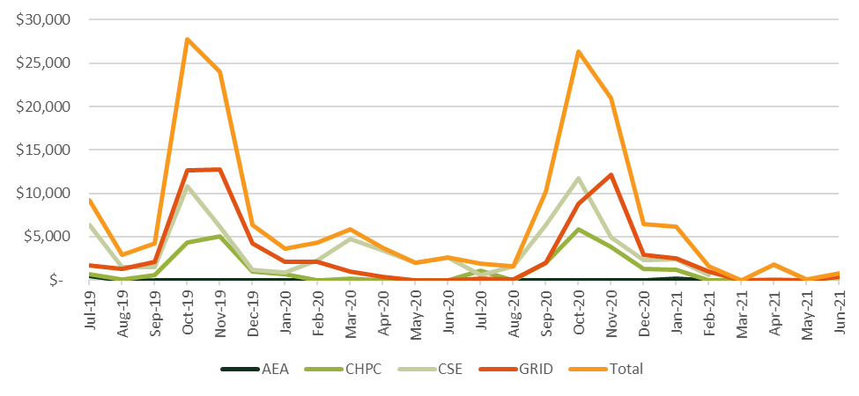

Project Pipeline Development
Figure 3-18 below presents the monthly spending on ME&O versus the number of active and cancelled applications since July of 2019. The spending in this table looks to be erratic as the CBO subcontractors’ invoice only once per quarter. As this figure shows, the majority of the application submittals occurred at program launch (July 2019), and it is hard to tie the ME&O spending since then to any increase in application submittals. After the program’s opening day there have been two additional big waves of applications submitted. They occurred right before the Year 2 and Year 3 incentive step downs. While the ME&O activities may have helped to encourage these participants to submit an application, it is difficult to show a direct correlation.
Figure 3-18: ME&O Category Spending versus SOMAH Application Submissions
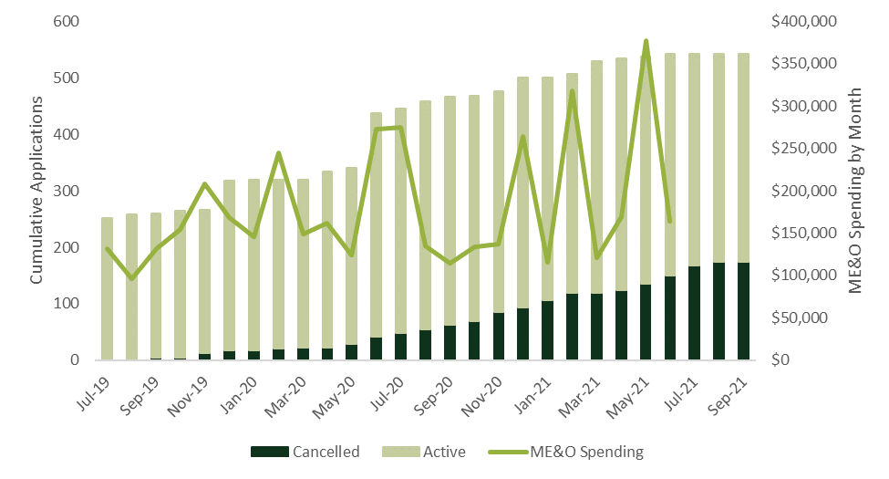

As part of this assessment, we requested and reviewed materials created and distributed by the SOMAH PA using numerous methods of distribution (email, social media, conferences, webinars, etc.). These materials appear to be clear and informative. SOMAH’s CBO partners reported they are often involved in reviewing the materials developed to ensure they are culturally relevant and accessible. While these materials are helping to raise awareness of the SOMAH Program, interviews with contractors, property owners, CBO partners, and the SOMAH PA, increasing participation in this program is going to require significantly more direct engagement with properties owners. Affordable housing property owners often need multiple touchpoints before they will consider participation. One PA member reported it is likely too soon to determine the effective the ME&O efforts to date. They emphasized the impact COVID had on many affordable housing properties, often significantly shifting their priorities away from SOMAH. For some properties this meant the PA had to effectively restart their engagement with the property.
The evaluation team attempted to assess whether the balance of spending on different marketing channels (such as web, social media, conferences, etc.) is aligned with ME&O goals but found it difficult to assess due to the lack of data tracking spending on that level (except for Conferences which had their own task). We attempted to assess the spending across these channels via a Detailed Spending Analysis of invoicing notes. To do this we created the flag for "Web", "Internet", "Facebook", "Twitter", and "Social Media". Of the spending identified ($537,300) by this analysis, 72 percent was web focused, 22 percent was for conferences, and 6 percent was for social media. To successfully assess spending on this detailed level, KPIs for this type of outreach would need to capture both the number of stakeholders engaged by the activity and the itemized spending on the activity. If the CPUC is interested in this level of analysis it should be added to ME&O data tracking requirements.

Eligible Properties Map
One of the assessment research questions was “What was the approximate cost of developing the property eligibilities map?” Because there is not a Program Task that can be used to answer this question, we analyzed the program notes (detailed spending analysis) trying to find staff hours spent working on the development of this map (this map was originally developed by another vendor but was brought in house and is now maintained and updated by the SOMAH PA). When we flagged "Map" in the notes, we identified many entries that were not related to the property eligibilities map. Thus, we changed the code to search for note entries that included "Map" and either "Property", "Properties", "Eligibility", or "Eligibilities". The total spending that this analysis identified was $18,959 although we are not able to determine if this represents all or most of the spending on this activity. The usefulness of this map and its effectiveness leading to future projects is best assessed by program contractors. We interviewed several contractors during Phase II of the SOMAH evaluation and they reported that they were aware of the eligible properties map and some reported they had used the map in addition to other sources, such as affordable housing lists, to determine property eligibility. One contractor noted that in some cases they have found that the map is out of date (i.e., including properties that have installed solar and are thus ineligible for SOMAH).
During interviews conducted with members of the SOMAH PA for this assessment we asked about recent spending on updates to this map (specifically the additions of filters such as legislative districts). The SOMAH PA reported these filters were added to assist with the outreach meetings they are having with local government entities. Being able to drill down in these meetings to the properties in their districts have been of great interest to the officials.

SOMAH Training Events
Figure 3-19 presents a timeline documenting the number of workshops, webinars, or conferences targeting the various stakeholder groups since Q2 2019. This event data was pulled from the SOMAH Program website and annual ME&O Plans. Many of these events target several different stakeholders and thus the far dark green category indicates how many unique distinct events occurred each quarter. As this figure shows, the largest consistent number of events were directed to contractors and property owners. There was a spike in events for property owners in Q2 of 2021, which is when the Solar 101 workshops were held, and a spike for JTOs and Job Seekers in Q3 of 2020 which is when a three-part solar careers workshop was held.
Figure 3-19: Number of Events by Quarter and Event Type

The evaluation team attempted to assess the spending for materials and activities targeting different SOMAH Program population segments (properties and contractors located in DACs, small or diverse contractors, property owners with single or small numbers of properties, potential job trainees that are tenants at SOMAH project sites) and the cost to develop individual SOMAH educational materials, however currently data is not readily available to make these assessments. If future analysis is desired at this level of granularity the SOMAH PA will need to determine a means of efficiently tracking spending on this level.

Effectiveness of Technical Assistance Efforts
SOMAH was designed to have two primary participation tracks: Track A and Track B. Track A was designed for property owners who would like to receive no-cost technical assistance services from the SOMAH PA to help them assess the solar potential at their property and to identify eligible contractors for their project. Track B was designed for applicants who do not require technical assistance to submit a project reservation. As shown above in Table 3-10, the Technical Assistance Category is the only Program Category that has been significantly underspent to date (spending has been only one-third of forecasted spending). This is primarily the result of extremely low Track A participation. As reported on during Phase II of the evaluation, the majority of participating property owner learned about the program from their contractor and so were participating in Track B. Therefore, this underspending has been in alignment with Track A participation levels.
SOMAH PA members interviewed as part of this assessment reported they are currently working on redesigning and reallocating their Technical Assistance offerings in light of the limited uptake and in response to the Phase II SOMAH report that indicated that both non-participating property owners (who have yet to submit an application) and those participating in Track B could use additional assistance.

Technical Assistance Primary Cost Drivers and Detailed Spending Analysis
Table 3-24 below presents the primary cost drivers for the Technical Assistance Program Category. As this table shows only three percent of total program spending during the evaluated period (July 2019 to June 2021) was billed to the Technical Assistance Category. The majority of this spending fell under the Pre-Installation TA Task (80 percent) or the Energy Efficiency and Program Leveraging Task (17 percent). Very little was spent on the Financial TA or Post-Installation TA Tasks.
Table 3-24: Technical Assistance Category Task Level Spending Summary (SI)
Technical Assistance Category Tasks | Total Spending  through 6/21 | % of Category Spending | % of Total Program Spending | Pre-Launch Spending %
Pre-Installation TA | $421,505 | 80% | 2% | 22%
EE and Program Leveraging | $70,438 | 13% | 0% | 3%
Financial TA | $30,692 | 6% | 0% | 65%
Post-Installation TA | $2,229 | 0% | 0% | 0%
Total | $524,864 | 100% | 3% | 22%

Detailed Spending Analysis performed on the Technical Assistance Category notes found most of the TA spending has been on meetings or calls (Table 3-25). The evaluation team found that tracking spending to a specific project is currently being done in a limited fashion within the Technical Assistance Category. As shown in the table below, roughly 14 percent of the detailed labor report timekeeping notes included a specific project name or project number being worked on during the recorded hours. The spending on the two largest named projects have been broken out (shown as Project #1 and #2) and the remaining named projects are collapsed under “Other Named Projects.” A row has also been included corresponding to work that was conducted for a specific project that was not named. The majority of the “named” project spending was completed by AEA (Table 3-26 below). During our interview with AEA they indicated they have tried to include a project name or number within their timekeeping notes and that they recently transitioned to a new tracking system that will allow them to do this more efficiently moving forward. We also attempted to estimate the cost of creating Track A work products (namely Solar Feasibility Reports – standard or lite), however the detailed Spending Analysis found very few mentions of such reports ($6,487) and so it is likely that most staff working on these do not include this type of detail in their notes.
Table 3-25: Technical Assistance Category Description (DLR-R)
TA Category Detailed Spending Analysis | Spending  (7/19 – 6/21) | Unique Staff Members | TA Category Spending (%)
Meetings/Calls | $123,817 | 29 | 32%
Projects | $72,910 | 10 | 19%
- Project #1 | $14,261 | 3 | 4%
- Project #2 | $10,028 | 4 | 3%
- Other Named Projects | $29,462 | 6 | 8%
- Unnamed Projects | $19,159 | 8 | 5%
Training/Onboarding | $41,772 | 14 | 11%
Storage/Self Generation Incentive Program | $30,871 | 15 | 8%
Energy Efficiency Compliance Milestone | $22,889 | 3 | 6%
Electric Vehicle Charging | $14,593 | 3 | 4%
Track A | $13,580 | 8 | 4%
Solar Feasibility Report | $6,487 | 2 | 2%

Table 3-26 below shows the distribution of spending based on the invoice notes (Detailed Spending Analysis). As this table shows most of AEA and CHPC’s spending was on meetings or calls and AEA was much more likely to mention a SOMAH project name or number in their notes than either of the other two SOMAH PA members.
Table 3-26: Technical Assistance Category Spending by PA Member (DLR-R)
TA Detailed Spending Analysis | GRID |  | AEA |  | CHPC
 | Spending | % | Spending | % | Spending | %
Meetings/Calls | $32,286 | 18% | $68,755 | 42% | $22,776 | 53%
Projects | $5,010 | 3% | $62,722 | 38% | $5,178 | 12%
Training/Onboarding | $35,604 | 20% | $5,156 | 3% | $1,012 | 2%
Total | $174,571 | 100% | $165,417 | 100% | $42,831 | 100%

Table 3-27 below shows the distribution of the Technical Assistance task-level spending by SOMAH PA Member. As this table shows, over the last two years nearly 90 percent of Technical Assistance Spending has been split between GRID and AEA. CHPC has also had some a small amount TA spending, all of which has been on either Pre-Installation TA or Financial TA. CSE had no Technical Assistance spending. During the PA interviews AEA reported they had spoken with many property owners about SOMAH, however much of that time was billed to another program as it was part of their job providing TA for other programs to educate the property owners about all programs they are eligible for.
Table 3-27: Distribution of Technical Assistance Spending by SOMAH PA Member
SOMAH PA Member | GRID |  | AEA |  | CHPC |  | Total
 | Spending | % | Spending | % | Spending | %
Pre-Installation TA | $129,840 | 43% | $130,890 | 43% | $40,621 | 13% | $301,351
Energy Efficiency and Program Leveraging | $38,777 | 56% | $29,860 | 43% | $0 | 0% | $69,637
Financial TA | $5,954 | 56% | $2,437 | 23% | $2,209 | 21% | $10,601
Post-Installation TA | $0 | 0% | $2,229 | 100% | $0 | 0% | $2,229
Total | $174,571 | 46% | 165,417 | 43% | $42,831 | 11% | $382,819

Figure 3-20 below shows the monthly spending on the Pre-Installation Task. As this figure demonstrates, there was significant spending that occurred on this task prior to any Track A applications being submitted. Detailed Spending Analysis of the Pre-Installation TA notes for this period found most of the work corresponded to outside meetings and trainings, working with Helioscopes, learning about EV charging, and Solar Sizing Tool (SST) development.
Figure 3-20: Monthly Spending on Pre-Installation TA Task vs. Track A Application Submissions
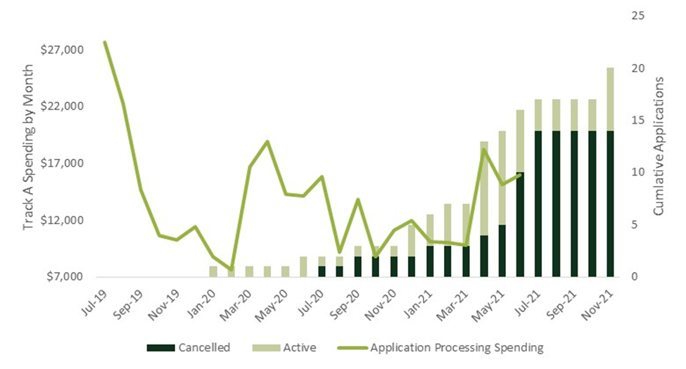

Effectiveness of Workforce Development Efforts

Workforce Development Primary Cost Drivers and Detailed Spending Analysis
As noted earlier, the Workforce Development category has been underspent by 30 percent to date. This underspending is likely related to the limited number of projects that have started construction as of the end of Q2 2021. Table 3-28 below presents the primary cost drivers for the Workforce Development Program Category.
Table 3-28: Workforce Development Category Task Level Spending Summary (SI)
Workforce Development Category Tasks | Total Spending  through 6/21 | % of Category Spending | % of Total Program Spending | Pre-Launch Spending %
WFD Admin | $466,560 | 45% | 3% | 21%
Regional JTO Task Force | $182,822 | 18% | 1% | 3%
Job Training Portal | $164,638 | 16% | 1% | 38%
WFD Resource and Content Creation | $115,172 | 11% | 1% | 13%
WFD Cooperative Marketing Efforts | $83,728 | 8% | 0% | 20%
WFD Workshops and Conferences | $22,805 | 2% | 0% | 6%
Local Hiring Plan Development | $4,227 | 0% | 0% | 21%
Total | $1,039,953 | 100% | 6% | 19%

Recommendations for Program Improvement or Streamlining
Below we offer some recommendations for program improvement or streamlining that could help to decrease program implementation costs or improve the tracking of program spending.
- Increase spending on areas that address Contractor and Property Owner Barriers. Areas identified where the SOMAH PA could do more to address barriers faced to participation include:
- Application Burden – Increase the support provided to contractors and property owners to minimize the application burden they currently experience.
- Generating Project Leads – Increase engagement with property owners to help build a robust pipeline of future projects.
- Project Financing – Provide additional support to property owners and contractors to ensure they are aware of all available ownership options, including those that facilitate the installation of solar at no cost to the affordable housing property owner.
- Increase focus on one-on-one outreach to non-participating property owners. Although CSE (who is responsible for “for-profit” outreach) and CHPC (responsible for “non-profit” outreach) are on target with their spending to date (they are only underspent by 6 percent and 4 percent, respectively), there currently does not appear to be sufficient effort or handholding to help many property owners (primarily smaller organizations) participate in the program. Increasing the level of individual property owner outreach, as well as assistance provided to CBOs to strengthen their outreach activities, can help to ensure the ME&O activities are effectively working to build a project pipeline. Care must be taken to ensure the increased property owner outreach is right-sized and does not leave property owners feeling overwhelmed or harassed by the program.
- Increase training to CBOs on property owner engagement. CBOs typically engage with community members and so while they are comfortable and familiar engaging with tenants, the skills required to engage with property owners could use further development and training support from the SOMAH PA. The CBOs reported that most of the properties they contact have not previously engaged with an eligible SOMAH contractor.
- Optimize project staffing levels. To date 162 individual PA staff have billed time to the SOMAH Program, however 90 percent of SOMAH spending has been conducted by 48 staff members (30 percent). Increased number of staff working on a project increases the level of coordination needed which leads to increased program spending. The SOMAH PA should ensure the “core” staffing is appropriate for the current stage of the program and that the use of subject matter experts who are brought into the program’s implementation add appropriate value.
- Review of program meetings and requirements to ensure they are providing intended value for their cost. A bi-annual review all program meetings and requirements should be conducted to ensure they continue to be necessary, the frequency with which they occur continues to be appropriate, and they are providing the outcomes desired. This includes check-in meetings with CBOs which should be aligned program activities reporting and management.
- Reduce cost of Public Forums. In quarters where there is little of substance to report on consider transitioning the Public Forum meeting to an email to reduce the costs associated with these quarterly updates. This would lower the cost of creating the meeting presentation materials, as well as reduce the time staff spend attending the meetings.
- Reduce quarterly forecasting granularity. Reduce the level of granularity required for the quarterly forecasts. Estimating the quarterly forecasts on a per person, per month, per task basis is difficult, time consuming, overly tedious and is not necessarily leading to improved forecasts at that level. Eliminating the need for forecasts to be developed at the staff level (so by month and task only) would make forecasting a much more manageable activity, reducing the time and cost to create the forecast, and would still allow for tracking of forecasted to actuals on a program category and task level. It would likely also improve the task level forecasts as they could more manageably focus on their past and future spending without becoming overwhelmed by the staffing aspect. For some PA’s with more limited roles on the SOMAH PA (namely AEA and CHPC), it may be sufficient to utilize the previous quarters’ forecast and only provided updates if the past forecasts have been consistently off in one direction or another—or if work is anticipated to ramp up or drop off.
- Compare quarterly forecasts to historical spending prior to submittal. The SOMAH PA should review at a program category level their forecasted spending to actual spending during recent months, as well as any anticipated program changes that could result in increases or decreases to PA spending, to ensure their forecast is reasonable. Ensuring these types of feedback loops are incorporated into the planning process should help to ensure forecasts are within 30 percent of actuals.
- Increase engagement between Workforce Development program staff and program contractors. Increasing interaction between SOMAH PA staff focused on workforce development and contractors can help them to better understand typical hiring practices for SOMAH job opportunities and timing of future job opportunities.
- Expand timekeeping notes to include SOMAH application numbers and ensure staff hours are billed to the appropriate tasks. Currently it is not possible to track the level of effort and time spent working on an individual SOMAH applications. AEA is the only SOMAH PA member regularly including project application numbers or name within their timekeeping notes. Including this level of detail in SOMAH invoices would allow future assessment to better estimate the costs of processing applications. Additionally, accurately assessing spending requires that staff bill their time to a correct task, which was not always the case based on our detailed review of timekeeping notes.
The overall conclusion from this Vendor Assessment is that the SOMAH PA currently is on track to be under its 10 percent administrative cap by the program’s end in 2030. While PA spending at this time appears to be a bit out of alignment with completed projects and incentives paid to participants, the administrative expenses of the SOMAH Program were front loaded to get the program up and running and projects have taken longer to complete than originally anticipated (in part due to COVID). By late 2023 or mid-2024 we expect the percent of spending on SOMAH administrative activities will start to decrease as large numbers of SOMAH projects are completed and incentives paid out.

https://www.cpuc.ca.gov/-/media/cpuc-website/divisions/energy-division/documents/somah/somah_phaseii_report_20211013_final.pdf
California AB 693. Multifamily Affordable Housing Solar Roofs Program. Eggman, 2015. https://leginfo.legislature.ca.gov/faces/billTextClient.xhtml?bill_id=201520160AB693
This program is funded by Pacific Gas and Electric Company (PG&E), Southern California Edison Company (SCE), San Diego Gas and Electric (SDG&E), Liberty Utilities, and PacifiCorp, collectively known as the investor‐owned utilities or IOUs.
The SOMAH handbook currently outlines 3 types of project ownership: Power Purchase Agreement (PPA), Host Customer Ownership (HCO) and a Solar Lease.
Two tax credits can be used in conjunction with the SOMAH program incentives. These include the Federal Investment Tax Credit (ITC) and the Low-Income Housing Tax Credit (LIHTC).
Most notably these programs include the Energy Savings Assistance Program (ESA) that provides qualified customers with energy-savings improvements at no charge and the Self-Generation Incentive Program (SGIP) the offers incentives on behind-the-meter battery storage.
It should be noted that the Analytic tab was not added to the invoicing files until Q2 of 2020, and thus the forecasted versus actual results shown below exclude the months prior to April 2020.
This does not include the number of hours worked by subcontractors.
SCE holds the SOMAH contract. A single invoice is submitted by CSE to SCE on behalf of all four organizations that make up the PA.
D.19-03-015 Ordering Paragraph 1.
Semi-annual Expense Report: July 1, 2019 – June 30, 2021. https://www.californiadgstats.ca.gov/static/documents/somah/SOMAH_Semiannual_Expense_Report_July_2021.xlsx
The invoicing process and SAER are on two different timelines and thus there may be small discrepancy between the invoices and the SAER for months have not been finalized until the SAER has been submitted. When the timelines do not match up it is part of the PA process to reconcile the previous 6 months reported.
According to the SOMAH PA, Clean Power Research sent their invoice in earlier than expected (in Q2 vs. Q3) which was the reason for this difference from forecast.
https://www.cpuc.ca.gov/-/media/cpuc-website/divisions/energy-division/documents/somah/somah_phaseii_report_20211013_final.pdf
During the mapping exercise it became apparent that many tasks that address lead generation for contractors also align with the barrier of program or contractor distrust felt by property owners.
The Detailed Labor Report notes had $123,929 in spending that included the phrase “Progress Payment.”
Most of the “development” seemed to involve developing webinar material for contractors and the Solar Sizing Tool or developing contractor marketing collateral.
An additional plan was developed prior to program launch and so the spending is not shown in the table below as we lacked monthly spending data for that pre-launch period.
According to 2021 ME&O Plan, the paid social media was used for targeted marketing to property owners and managers with eligible properties located in a DAC.
https://calsomah.org/eligible-somah-properties-map
There were an additional 6 Track A applications submitted and waitlisted that have been excluded from this exhibit as they never came off the waitlist before they eventually were cancelled.

