 | Water-Energy Calculator 2.0 User’s Guide
Submitted to | California Public Utility Commission  505 Van Ness Avenue  San Francisco, CA 94102
Submitted by | SBW Consulting, Inc.  2820 Northup Way, Suite 230  Bellevue, WA 98004
In association with | Pacific Institute  344 20th St  Oakland, CA 94612
 | December 6, 2021

Table of Contents
List of Figures iv
List of Tables v
1 Introduction 1
2 Overview 1
2.1 Methodology 2
2.1.1 Regional Analysis 3
2.1.2 Water-System Components by Sector 4
2.1.2.1 Urban Sector 4
2.1.2.2 Agricultural Sector 5
2.1.3 Resource Balance Year 5
2.1.4 Marginal Water Supply 5
2.1.5 Historical Water Supply Mix 7
2.2 Relationship to Other CPUC Tools 7
3 Step-by-Step Instructions 9
3.1 Getting Started 9
3.2 Model Inputs 10
3.2.1 Measure Inputs Tab 11
3.2.2 Water System Inputs Tab 11
3.3 Model Outputs 12
3.3.1 Calculations Tab 12
3.3.2 Output Table Tab 13
4 References 14
Appendices 16
A. Short- and Long-term Solutions for Integrating Embedded Energy Savings into CEDARS 17
B. Default Values Used in the Water-Energy Calculator 2.0 19
Glossary of Terms 22

List of Figures
Figure 1: Conceptual Framework of the W-E Calculator 2.0 3
Figure 2: California’s Ten Hydrologic Regions 4
Figure 3: Short-term Relationship Between the W-E Calculator 2.0, eTRM, CEDARS, and CET 8
Figure 4: Long-term Relationship Between the W-E Calculator 2.0, eTRM, CEDARS, and CET 8
Figure 5: The Information Tab 10
Figure 6: The Measure Inputs Tab 11
Figure 7: The Water System Inputs Tab 12
Figure 8: The Calculations Tab Showing a Summary of the Measure Information 13
Figure 9: The Calculations Tab Showing the Historical and Marginal Embedded Energy Calculations and Annualized Embedded Energy Savings 13
Figure 10: The Output Table Tab 14

List of Tables
Table 1: Embedded Water Energy Intensities 17
Table 2: Total Electric Energy Intensity of Extraction and Conveyance for Each Hydrologic Region (kWh/AF) 18
Table 3: Total Electric Energy Intensity of Water Treatment (kWh/AF) 18
Table 4: Total Electric Energy Intensity of Water Distribution (kWh/AF) 19
Table 5: Total Electric Energy Intensity of Wastewater Collection and Treatment (kWh/AF). 19
Table 6: Fraction of Energy Provided by an IOU for Each Water-Supply Component and Type 19
Table 7: Water-Supply Mix, 2006-2015, by Hydrologic Region. 20

Introduction
This user’s guide provides basic information and guidance on using the Water-Energy (W-E) Calculator 2.0, a tool intended to help Project Administrators (PAs) calculate the embedded energy savings of water-efficiency measures. The Overview section describes the basic methodological framework underlying the calculator and its relationship to other California Public Utilities Commission (CPUC) tools. The Step-by-Step Instructions section provides detailed instructions on how to use the calculator. The Appendices provide the short- and long-term solutions for integrating embedded energy savings into the California Energy Data and Reporting System (CEDARS), as well as the default values used in the calculator. More detailed information about the W-E Calculator 2.0 can be found in the final project report on the CPUC’s Water-Energy Nexus homepage (posted Jan. 2022). This guide may periodically be updated by CPUC staff.

Overview
Extracting, moving, treating, and using water requires a substantial amount of energy, especially in California where large amounts of water are pumped over long distances and steep terrain. As a result, water-efficiency measures that save water also save energy and can help investor-owned energy utilities (IOUs) meet energy-efficiency and greenhouse-gas-reduction goals. Water-efficiency measures can be implemented in residential, commercial, industrial, and agricultural settings and include, for example, low-flow showerheads, efficient clothes washers, high-efficiency toilets, weather-based irrigation controllers, turf removal, drip irrigation, and dry-vacuum pumps. Existing water efficiency measures, sometimes referred to as Water-Energy Nexus (WEN) measures, and their related information can be found in the electronic Technical Reference Manual (eTRM).
Water-related energy is often divided into two categories.
- Direct energy is the energy used on the customer side of the meter by, for example, reducing on-site pumping and hot water usage. These energy savings are also sometimes referred to as end-use energy savings.
- Embedded energy is the energy used to extract, convey, treat, and distribute water to end users, and energy used to collect and transport wastewater for treatment prior to safe discharge of the effluent in accordance with regulations.
Historically, energy-efficiency tools only accounted for the direct energy savings associated with reduced water use. In 2015, the CPUC approved use of the Water-Energy Calculator 1.0 to estimate embedded energy savings associated with water-efficiency measures so that these savings could be incorporated into evaluations of measure cost effectiveness.
Like its predecessor, the W-E Calculator 2.0 estimates the embedded energy savings (in kWh) of water-efficiency measures. However, while the previous calculator also estimated the avoided embedded energy cost and the avoided water-capacity cost, all cost-effectiveness functions have been removed from the W-E Calculator 2.0. Instead, the estimated embedded energy savings from the W-E Calculator 2.0 can be entered into CEDARS for cost-effectiveness evaluations using the Cost Effectiveness Tool (CET).

Methodology
Fundamentally, the W-E Calculator 2.0 estimates embedded energy savings by multiplying the annual water savings of an efficiency measure by the energy intensity of relevant water-system components. The energy intensities of the water-system components depend on several factors, including the source of the water saved and its geographic location. Defaults are provided throughout the model; however, the user can adjust these defaults as appropriate for the measures evaluated.
Figure 1 illustrates the underlying methodology used in the W-E Calculator 2.0 to estimate embedded energy savings. Calculating embedded energy savings follows these four steps:

- The user enters basic information about the measure(s) being evaluated. This includes the installation year, annual water savings per device, number of devices installed, measure application, and the zip code where the measure was installed. The zip code determines the hydrologic region for the analysis.
- Based on the hydrologic region, the calculator provides a default marginal water supply that represents the source of the water saved. The default can be adjusted as needed. The water supply selected, combined with the measure application, determine the water-system components included in the analysis.
- Based on the hydrologic region and marginal supply, the calculator provides default energy-intensity values (in kilowatt-hours per acre-foot) for each water-system component included in the analysis. The calculator also provides default values for the percent of the energy provided by an IOU. The default values can be adjusted as appropriate for the measures included in the analysis. However, per D.15-09-023, where PAs depart from default values, they bear the burden of proving the departure is reasonable in all documents submitted to CPUC staff.
- The calculator estimates the total embedded energy savings (including IOU and non-IOU energy, in kWh) by multiplying annual water savings by the sum of the energy-intensity values of the water-system components. It then estimates IOU embedded energy savings by multiplying the annual water savings by the sum of the product of the water-system-component energy-intensity value and the fraction of IOU energy for each component. Subtracting IOU embedded energy savings from the total embedded energy savings yields the non-IOU portion of embedded energy savings.
The project report includes a more detailed description of the underlying methodology and default assumptions provided in the calculator.
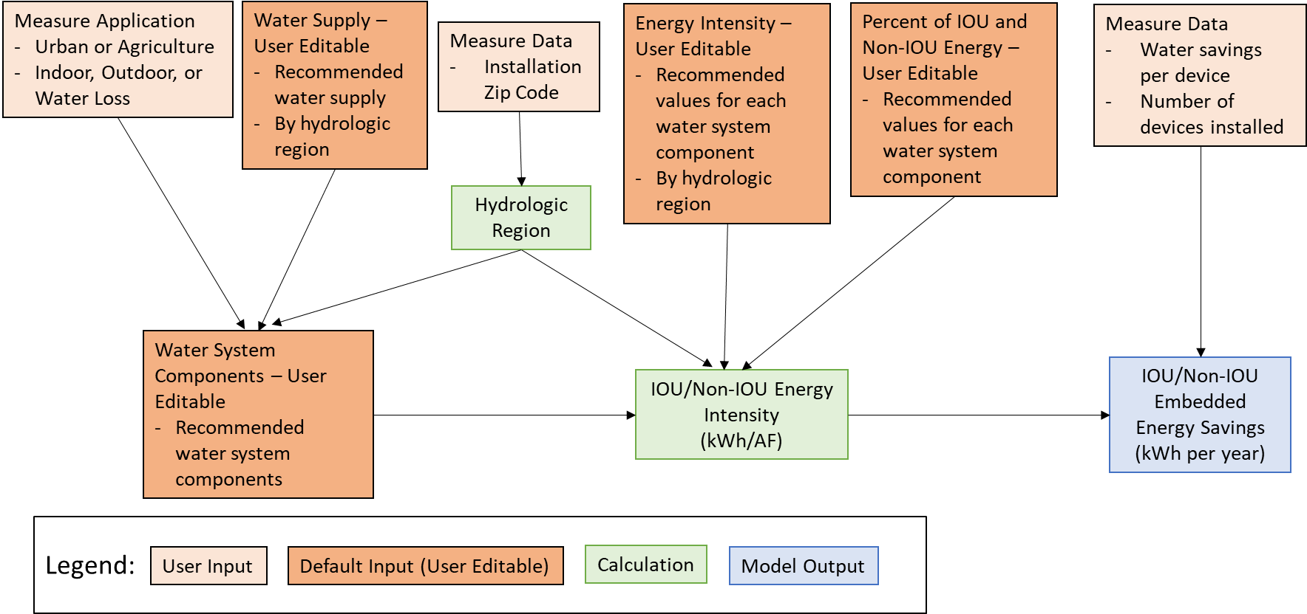
This is a simplified version of the underlying conceptual framework for the W-E Calculator. Although not depicted here, the installation year, measure life, and resource-balance year determine whether the marginal or historical water-supply mix are used to estimate embedded energy savings. This is described in more detail in sections 2.1.3, 2.1.4, and 2.1.5.
Figure 1: Conceptual Framework of the W-E Calculator 2.0

Regional Analysis
The available water supplies and their associated energy intensities can vary across California. To account for this variability, the W-E Calculator 2.0 operates at a regional level, using the ten hydrologic regions of the California Department of Water Resources (DWR). These ten hydrologic regions (Figure 2) generally correspond to the state’s major drainage basins. This is consistent with the approach taken in the W-E Calculator 1.0, as well as CPUC Decision D.15-09-23.
The W-E Calculator 2.0 uses zip code as the common locator, consistent with how energy-efficiency measures are assigned to climate zones within cost-effectiveness evaluations. We conducted an analysis in GIS to assign each zip code to a hydrologic region. In cases where a zip code straddled two or more hydrologic regions, we followed a “majority rules” approach, assigning the zip code to the hydrologic region that contained the largest area of the zip code. This approach is consistent with how evaluators assign energy-efficiency measures to climate zones and reduces the complexity within the eTRM for deemed measures. The W-E Calculator 2.0 contains a look-up function that automatically selects the hydrologic region based on the user-entered installation zip code.
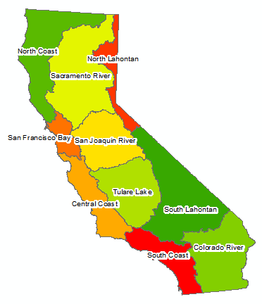
Source: https://indicators.ucdavis.edu/water/regions
Figure 2: California’s Ten Hydrologic Regions

Water-System Components by Sector
The W-E Calculator 2.0 requires the user to specify whether the measure applies to the urban or agricultural sector. These specifications determine which water-system components are included in the analysis.

Urban Sector
In the urban sector, water for indoor use is subject to water extraction and conveyance, water treatment, water distribution, wastewater collection, and wastewater treatment. So, when the user selects “urban” for the measure-application sector and “indoor” for the water-use type, the calculator provides default assumptions for each of those water-system components. By contrast, water for outdoor uses and water losses in the distribution system are only subject to water extraction and conveyance, water treatment, and water distribution, so default assumptions apply only to these components.

Agricultural Sector
In most cases, water for agricultural applications is not subject to water treatment, i.e., raw water, and the wastewater is not collected or treated prior to discharge. Thus, when the user selects “agriculture” for the measure-application sector, default assumptions are only provided for water extraction and conveyance, water treatment (when the marginal water supply is recycled water or desalination), and water distribution. Defaults are not provided for water treatment (when the marginal supply is not recycled water or desalination), wastewater collection, and wastewater treatment; however, the user can override this and provide energy-intensity values for these water-system components if appropriate.
In some instances, especially in an agricultural or industrial setting, the end user may extract water from a groundwater aquifer or nearby stream for their own use. In these instances, the estimates of on-site direct energy savings may include embedded energy savings so be sure to avoid double counting these savings.

Resource Balance Year
The Resource Balance Year represents the year in which new capacity will be required to meet water demand. Consistent with both D.15-09-023 and the Water-Energy Calculator 1.0, the W-E Calculator 2.0 uses 2016 as the default Resource Balance Year (RBY). According to D.15-09-23, however, the user can select a different RBY “to account for a particular water supplier’s planning, resource, and other needs.” Accordingly, the W-E Calculator 2.0 lets the user override the default RBY and select a year up through 2050.
Within the W-E Calculator 2.0, the RBY determines whether the embedded energy savings are based on the marginal water supply or the historical water-supply mix. Prior to the RBY, the calculator uses the historical water-supply mix to calculate a “historical” embedded energy savings. In the RBY and beyond, the calculator uses the marginal water supply to calculate a “marginal” embedded energy savings. If some of the water savings from a water-efficiency measure occur both before and after the RBY, the calculator uses the historical embedded energy savings for the years preceding the RBY and the marginal embedded energy savings for the RBY and subsequent years. Summing the annual embedded energy savings and dividing by the measure life yields an annualized embedded energy savings.

Marginal Water Supply
The marginal water supply represents the next unit of water supply that would need to be developed within a region to meet demand in the absence of water conservation and efficiency. In support of the W-E Calculator 1.0, the Navigant team consulted publicly available documents, including state and regional planning studies, and consulted with experts and stakeholders to identify the long-run marginal supply in each of California’s ten hydrologic regions. Based on this consultation, the Navigant team identified a proxy marginal supply of non-potable recycled water, i.e., wastewater treated to tertiary, unrestricted standards, for all hydrologic regions in California. According to McDonald et al. (2014):
“Using recycled wastewater as the default proxy marginal supply is reasonable for several reasons. All regions currently are developing and have available recycled water supplies. Although the predominant use of these supplies currently is irrigation, these supplies are approved for numerous other uses. Many utilities include recycled wastewater as a key element of their future supply portfolios. Recycled water is a more conservative supply option than ocean water, which addresses concerns raised by some stakeholders who question the availability of treated ocean supplies to more inland coastal agencies. Lastly, recycling of wastewater is consistent with the SWRCB goals, which encourage water agencies to significantly increase development and use of these supplies.
When recycled water is used for non-potable end uses, it can displace potable or raw water that was previously serving that end use. The displaced potable water can be used to increase supply available to potable end uses; the displaced raw water could be treated further for potable uses. Thus, developing a recycled water supply can still increase the amount of supply available for potable end uses.”
CPUC D.15-09-23 supported use of the long-run marginal supply in the W-E Calculator 1.0. The decision stated that “It is the margin—the next water resource we do not have to develop or procure—that matters, and so the W-E calculator correctly considers costs for the marginal supply (e.g., recycled water) rather than average supply.” D.15-09-23 further notes that while the user can override the default marginal supply to reflect local circumstances, the user should continue to use values for a marginal supply rather than for historical or existing supplies.
Additionally, D.15-09-23 supports the calculator’s use of the long-run marginal supply, rather than the short-run marginal supply, for several reasons. “The first is that data on short-run supplies remain hard to come by. The second is that imports continue to involve much energy that is not from jurisdictional energy companies. A third is that short-run supply options can vary enormously in cost from period to period, and from place to place.”
The W-E Calculator 2.0 follows both the W-E Calculator 1.0 and D.15-09-23 in its use of the long-run marginal water supply. It uses non-potable recycled water as the default marginal water supply for each of the ten hydrologic regions and allows the user to adjust the default according to local circumstances.

Historical Water Supply Mix
To plan for and manage water supplies over time, water suppliers evaluate their available supplies using a portfolio approach. The water-supply portfolio for the state varies across time and space, and each hydrologic region has a unique mix of water supplies available, ranging from imported water sources like the Colorado River to more local sources like groundwater. While the type of water supplies available within a hydrologic region is subject to little interannual availability, the amount of water available from each supply often changes from year to year due to weather and other factors.
As described in section 2.1.3, if a measure is installed before the RBY, the W-E Calculator 2.0 uses the historical water-supply mix for each hydrologic region to estimate the “historical” embedded energy savings. The historical supply mix for each hydrologic region was based on water-balance data from the California Department of Water Resources’ 2018 Water Plan Update for the ten-year period preceding the Resource Balance Year of 2016, i.e., 2006 to 2015.

Relationship to Other CPUC Tools
The W-E Calculator 2.0 allows PAs to estimate embedded energy savings associated with water-efficiency measures. Integrating embedded energy savings into CEDARS allows the PAs to count those savings toward their energy-efficiency goals and to incorporate them into cost-effectiveness evaluations. Integrating the embedded energy savings expeditiously, however, requires a short-term and a long-term solution, which we summarize. Appendix A contains additional detail on these approaches.
Figure 3 shows the short-term solution for integrating embedded energy savings into CEDARS. Here, the W-E Calculator 2.0 was run using default assumptions to estimate embedded energy intensities (in units of kWh per 1,000 gallons, or kWh/kgal). Embedded energy savings can then be determined by dividing the number of gallons saved by a measure by 1,000 (to put the water savings in kgal) and multiplying the result by the embedded energy intensity. Within the eTRM, the embedded energy savings are automatically added to the direct energy savings of the measure (per D.17-12-010), You can enter the combined value, along with other site-specific savings values, into the CET to calculate the measure’s cost-effectiveness. PAs can also use the combined value if they submit a claim for this measure. This approach is only suitable for measures that use the default marginal water supply, i.e., recycled non-potable water. PAs can only claim measures that do not use the default as their marginal supply using the long-term solution, and so must wait until that solution is implemented. Additionally, per D.15-09-023, where PAs depart from default values, they must show that the departure is reasonable in all documents submitted to CPUC staff.
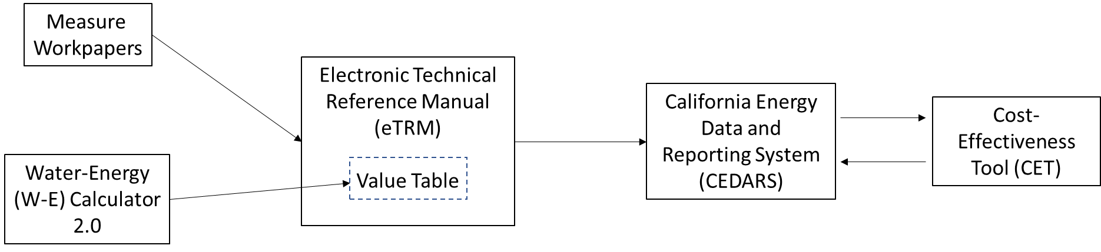
Figure 3: Short-term Relationship Between the W-E Calculator 2.0, eTRM, CEDARS, and CET
Figure 4 shows the long-term solution for integrating embedded energy savings into CEDARS. Here, PAs will use the new CET functionality to enter the direct energy savings and IOU embedded energy savings separately into the CET through CEDARS. The direct energy savings will be calculated using the measure-package methodology. The IOU embedded-water-energy savings will be calculated following the same methodology as used in the short-term solution, but this value will be stored independently within the eTRM and CEDARS to facilitate reporting and cost-effectiveness calculations. The PA will still receive the same credit for both the direct and embedded energy savings as they received using the short-term solution, but for accounting purposes the two types of savings will be entered into the CET and claims separately. Once finalized by the CPUC, this will replace the short-term solution.
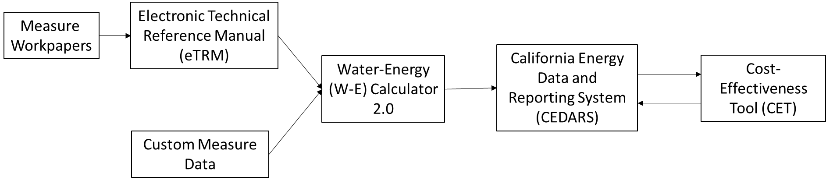
Figure 4: Long-term Relationship Between the W-E Calculator 2.0, eTRM, CEDARS, and CET
For example, assume low-flow showerheads were installed in a hotel in San Francisco, consistent with the deemed measure “Low-flow Showerhead – Commercial” (SWWH020). The measure’s permutations in the eTRM indicate that the annual water savings are 2,979 gallons per showerhead. The water savings, along with the measure life, can be entered into the W-E Calculator 2.0. The default water supply and energy intensity for the SF Bay hydrologic region produce an estimated annual IOU embedded energy savings of 16.2 kWh per showerhead. The embedded energy savings can then be entered into CEDARS alongside the claimed direct energy savings to get the water-related energy savings. CEDARS then interfaces with the CET to determine the measure’s cost effectiveness.

Step-by-Step Instructions

Getting Started
The W-E Calculator 2.0 opens to the Information tab, shown in Figure 5. This tab describes the purpose of the tool, as well as its uses and limitations. Scroll down the page to find instructions on how to use the calculator and a legend for tab colors and cell formatting. After reviewing the Information tab, select the Measure Inputs tab to begin entering information about the water-efficiency measures to be evaluated.
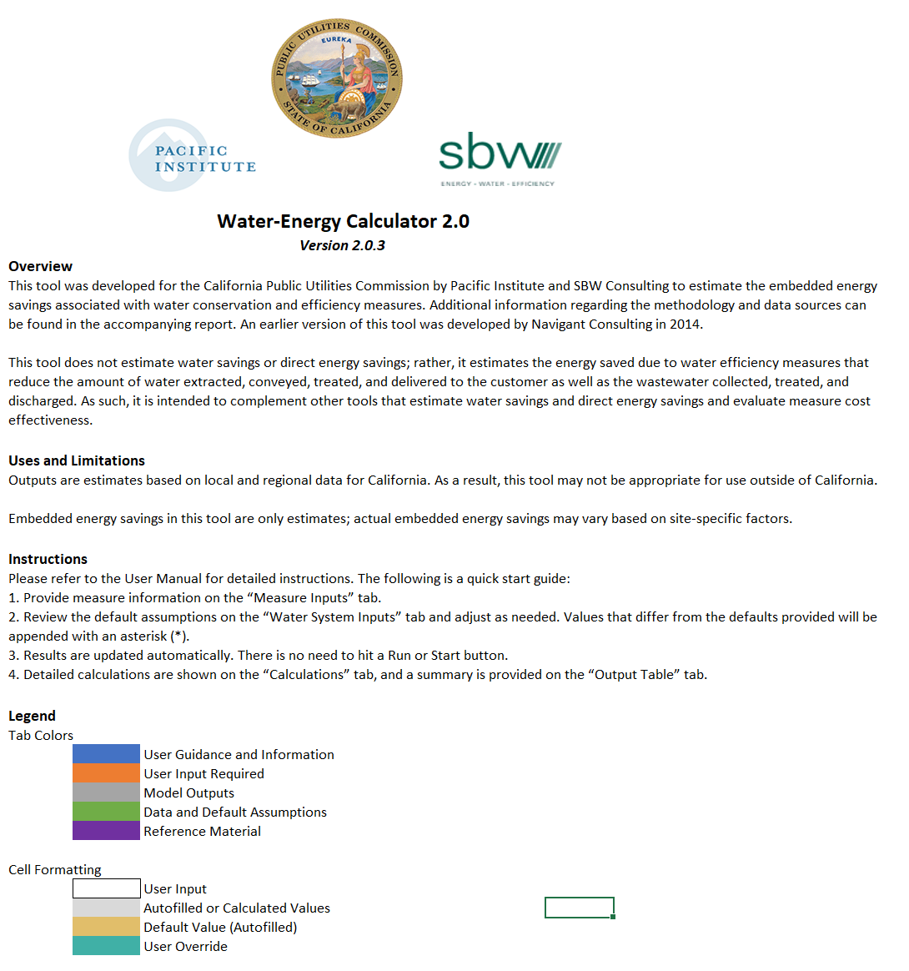
Figure 5: The Information Tab

Model Inputs
Enter model inputs on the Measure Inputs and Water System Inputs tabs.

Measure Inputs Tab
On the Measure Inputs tab, provide a description of the project (Figure 6). Note that this field is for reference purposes only.
Scroll down to enter basic information about the measure(s) to be evaluated. For each measure, enter the measure name and the zip code where it was installed. Based on the zip code provided, the hydrologic region is automatically filled in. For each measure evaluated, enter the installation year, measure life, sector (i.e., urban or agriculture), type of water use evaluated (i.e., indoor, outdoor, or system leaks), annual water savings per device or normalization unit, and the number of devices installed. Based on the annual water savings per device and the number of devices installed, the total annual water savings are automatically filled in. You can enter inputs directly into cells or use the drop-down lists for the Installation Zip Code, Installation Year, Sector, and Water Use Type.
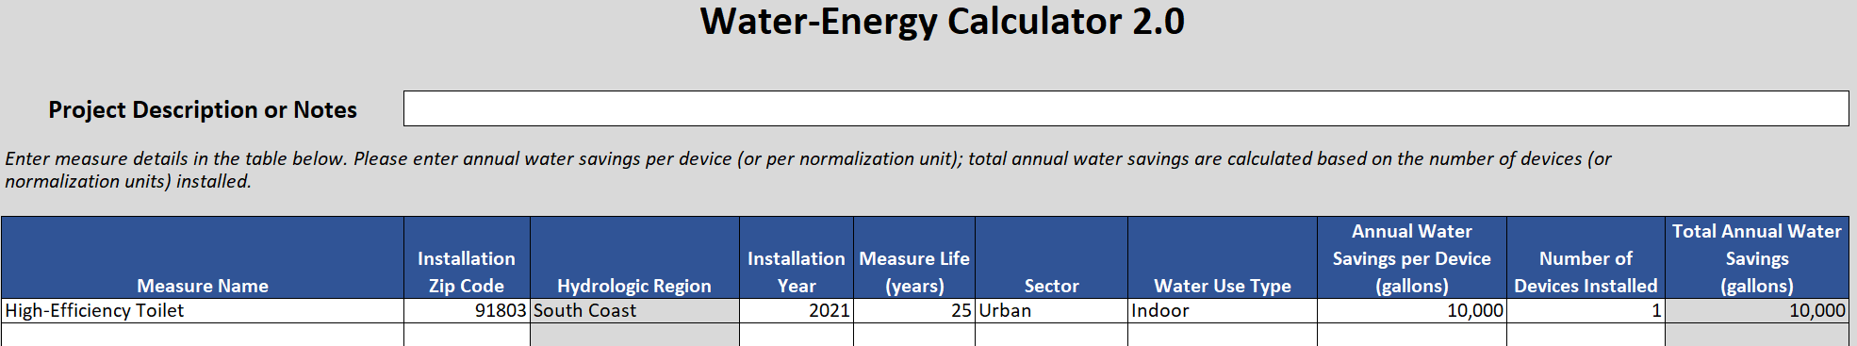
Figure 6: The Measure Inputs Tab

Water System Inputs Tab
On the Water System Inputs tab (Figure 7), select the marginal water supply for the hydrologic regions identified on the Measure Inputs tab (Figure 6). The defaults for the marginal water supply and each water-system component are based on the marginal water supply selected, sector, and water use type. Default values are also provided for the energy intensity of each of the water-system components and the fraction of embedded energy provided by an IOU. You can override the default selections, as appropriate for the measures evaluated. Appendix B contains the default values and data sources for water-system components, the historical water-supply mix, and the fraction of embedded energy provided by an IOU.
The defaults on the Water System Inputs tab for the relevant hydrologic regions are based on the installation zip codes entered on the Measure Inputs tab. You can select the marginal supply, water-system components, and energy-intensity values for each of the relevant hydrologic regions. Scroll down the page to review these values and modify as appropriate. Review the urban and the agricultural assumptions for measures installed in an urbanized and agricultural area, respectively.
For the example shown in Figure 7, the user overrode the default marginal water supply for the South Coast hydrologic region and selected potable recycled water as the marginal supply. Additionally, the user overrode the distribution-system topography, selecting a hilly terrain.
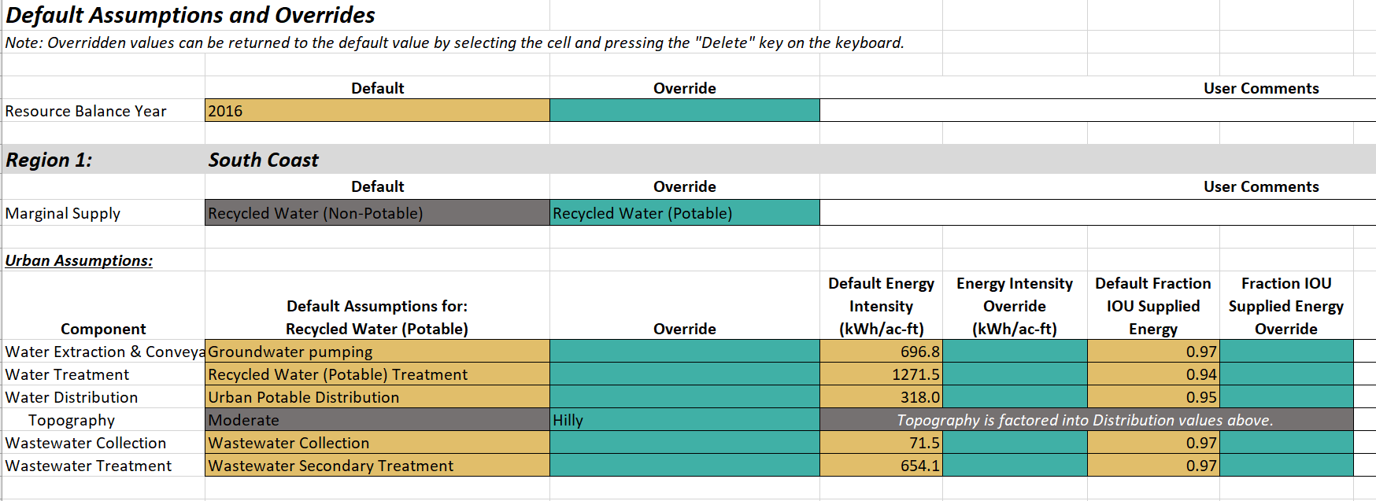
Figure 7: The Water System Inputs Tab
Agricultural water-efficiency measures are assumed to have no effect on wastewater collection and treatment and thus no wastewater-related embedded energy savings. However, should an agricultural water-efficiency measure reduce wastewater collection and treatment, you can override this assumption and insert the appropriate energy-intensity values for wastewater collection and treatment.
Additionally, as noted in section 2.1.2, the end user, especially in agricultural and some industrial settings, may extract water from a groundwater aquifer or nearby stream for their own use. In these instances, the embedded energy savings associated with pumping less groundwater may already be captured in the estimates of on-site direct energy savings. If so, the user should be careful to count those energy savings one time, i.e., as either embedded or direct energy savings.
After you enter information on the Measure Inputs and Water System Inputs tabs, the Calculations and Output Table tabs are automatically populated with calculation results; there is no “Run” or “Calculate” button to press.

Model Outputs

Calculations Tab
The Calculations tab (Figure 8) summarizes the calculator inputs, including the measure name, installation zip code, annual water savings, and the marginal supply. An asterisk (*) indicates any selection that differs from the default value.
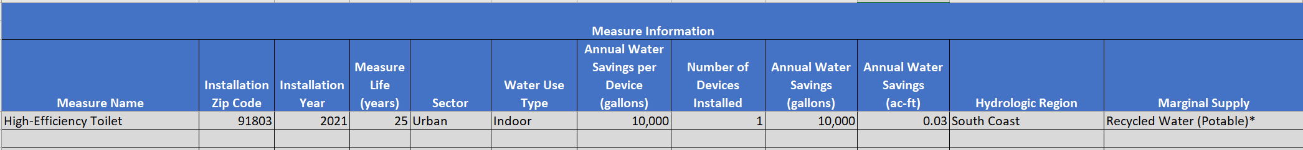
Figure 8: The Calculations Tab Showing a Summary of the Measure Information
Scroll to the right to view the historical and marginal embedded energy calculations and the annualized embedded energy savings (Figure 9). Click the “+” sign above columns W and AP to view detailed information on the energy intensity and fraction IOU-supplied energy for each water-system component for the historical and marginal embedded energy calculations, respectively. To hide this information, click the “–” sign above columns W and AP.
When a measure is installed after the RBY, the annualized embedded energy savings are equal to the marginal embedded energy savings. When the measure is installed before the RBY, the historical embedded energy savings are used for the years preceding the RBY and the marginal embedded energy savings are used for the RBY and subsequent years. Summing the annual embedded energy savings and dividing by the measure life produces an annualized embedded energy savings.
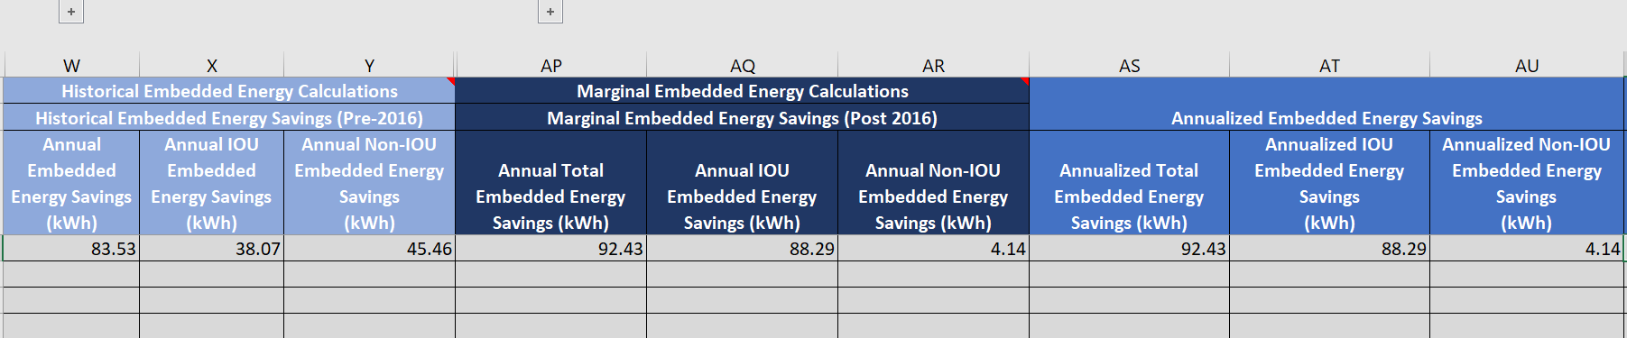
Figure 9: The Calculations Tab Showing the Historical and Marginal Embedded Energy Calculations and Annualized Embedded Energy Savings

Output Table Tab
The Output Table tab (Figure 10) summarizes outputs generated by the W-E Calculator 2.0. These include the measure name, hydrologic region, sector, water-use type, water savings, the annualized IOU and non-IOU embedded energy savings (in kWh), and the annualized IOU and non-IOU energy intensity (in kWh/kgal).
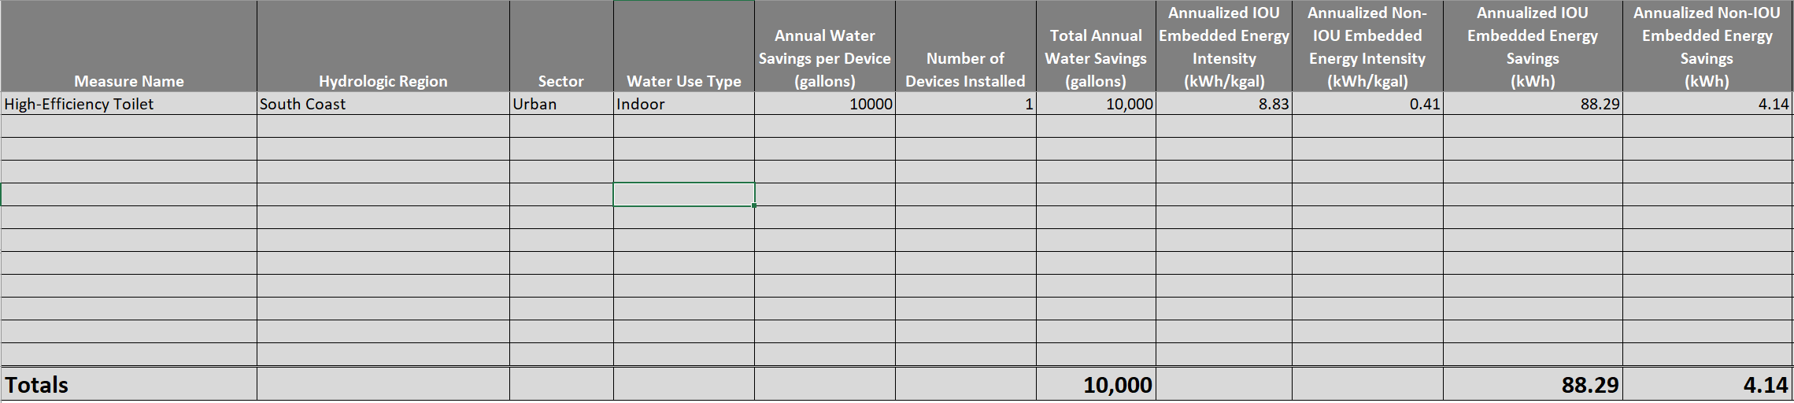
Figure 10: The Output Table Tab

References
California Department of Water Resources (DWR). "California Water Plan Update 2018." 2018.
Cooley, H., Wilkinson, R. “Implications of Future Water Supply Sources on Energy Demands.” WateReuse Foundation, Pacific Institute, UC Santa Barbara for California Energy Commission. July 2012. Available at: https://‌pacinst.org/‌publication/‌wesim/
EPRI. Water & Sustainability (Volume 4): U.S. Electricity Consumption for Water Supply & Treatment - The Next Half Century. 1006787, 2002. Available at: https://www.circleofblue.org/wp-content/uploads/2010/08/EPRI-Volume-4.pdf
GEI Consultants/Navigant Consulting. “Embedded Energy in Water Studies Study 1: Statewide and Regional Water-Energy Relationship.” Prepared for California Public Utilities Commission. August 2010a. Available at: https://‌waterenergyinnovations.com/‌wp-content/ uploads/2020/03/Embedded-Energy-in-Water-Studies-Study-1-FINAL.pdf
GEI Consultants/Navigant Consulting. “Embedded Energy in Water Studies Study 2: Water Agency and Function Component Study and Embedded Energy-Water Load Profiles.” Prepared for California Public Utilities Commission. August 2010b. Available at: https://waterenergyinnovations.com/wp-content/uploads/2020/03/Embedded-Energy-in-Water-Studies-Study-2-FINAL.pdf
Klein, G., Krebs, M., Hall, V., O’Brien, T., Blevins, B.B. “California’s Water – Energy Relationship (No. CEC-700-2005-011-SF).” California Energy Commission. November 2005. Available at: http://‌large.stanford.edu/‌courses/‌2012/‌ph240/‌spearrin1/‌docs/CEC-700-2005-011-SF.PDF
Liu, Qinqin, et al. Connecting the Dots between Water, Energy, Food, and Ecosystems Issues for Integrated Water Management in a Changing Climate. Climate Change Program, California Department of Water Resources, Feb. 2017. Available at: https://cawaterlibrary.net/wp-content/‌uploads/‌2017/‌10/‌QLf2017FinalWhitePaper_jta_edits_fk_format_2.pdf
McDonald, Craig, et al. Water/Energy Cost-Effectiveness Analysis. Navigant Reference No.: 169145, Prepared for California Public Utilities Commission, Oct. 2014. Available at: https://‌www.cpuc.ca.gov/‌WorkArea/‌DownloadAsset. aspx?id=5360
Plappally, A.K., Lienhard V, J.H., 2012. Energy requirements for water production, treatment, end use, reclamation, and disposal. Renewable and Sustainable Energy Reviews 16, 4818–4848. Available at: https://‌doi.org/‌10.1016/‌j.rser.2012.05.022
Stokes-Draut, J., Taptich, M., Kavvada, O., Horvath, A. “Evaluating the electricity intensity of evolving water supply mixes: the case of California’s water network.” Environ. Res. Lett. 12, 114005. October 2017. Available at: https://‌doi.org/‌10.1088/‌1748-9326/‌aa8c86
Tarroja, Brian, et al. “Evaluating Options for Balancing the Water-Electricity Nexus in California: Part 1 – Securing Water Availability.” Science of The Total Environment, vol. 497–498, Nov. 2014, pp. 697–710. ScienceDirect. Available at: https://‌doi.org/‌10.1016/‌j.scitotenv.2014.06.060
Tidwell, Vincent C., et al. “Geographic Footprint of Electricity Use for Water Services in the Western U.S.” Environmental Science & Technology, vol. 48, no. 15, Aug. 2014, pp. 8897–904. ACS Publications, Available at: https://www.osti.gov/servlets/purl/1182984.
Wilkinson, Robert C. “Analysis of the energy intensity of water supplies for West Basin Municipal Water District White Paper.” 2007. Carson, CA. Available at

Appendices
Appendix A contains detailed descriptions of the short- and long-term solutions for integrating W-E Calculator 2.0 outputs into CEDARS.
Appendix B contains the default values and data sources for water-system components, the historical water-supply mix, and the fraction of embedded energy provided by an IOU.
- Short- and Long-term Solutions for Integrating Embedded Energy Savings into CEDARS
On December 20, 2020, the California Public Utilities Commission (CPUC) published the final version of the Water-Energy Calculator 2.0 (W-E Calculator 2.0). The W-E Calculator 2.0 replaces the first version of the Water-Energy Calculator, and Program Administrators (PAs) will use its values going forward to calculate the embedded energy savings of Water-Energy Nexus (WEN) measures. PAs can now use the embedded energy savings from these WEN measures to claim incentives and they will count towards PAs’ energy efficiency goals.
The two solutions described below detail how PAs will calculate the embedded energy savings using the California electronic Technical Reference Manual (eTRM).
Short-term Solution
Until the CPUC implements the Long-term Solution, existing and new WEN-measure packages will use the following method to calculate the embedded energy savings produced by a water-efficiency measure and add it to the direct (site) energy savings generated by that measure.
The measure or measure update will add the energy-intensity values in Table 1 to eTRM. The embedded energy savings for the measure will be the result of dividing the number of gallons saved by the measure by 1000 and multiplying that result by the “Total IOU Embedded Water Energy Intensity” value in Table 1, based on whether the measure is an indoor or outdoor measure. For IOUs, the embedded-water-energy intensity is 5.44 kWh/kgal for indoor measures, and 3.28 kWh/kgal for outdoor measures. Once the embedded energy savings have been calculated, they will be automatically added in eTRM to the direct energy savings of the measure (per D.17-12-010). That combined value, along with other site-specific savings values, will then be input into the Cost-Effectiveness Tool (CET) through California Energy and Data Reporting System (CEDARS) to calculate the measure’s cost effectiveness. Program Administrators (PAs) will also use the combined value if they submit a claim for this measure.
As the embedded energy savings are present regardless of whether the measure uses hot or cold water, the total annual water savings including both hot and cold water will be multiplied by the appropriate “Total IOU Embedded Water Energy Intensity” value in Table 1. The calculation of direct energy savings will be unchanged.
This approach is only suitable for measures that use the default marginal water supply—recycled water (non-potable). PAs may claim measures that use a different marginal supply only if they use the Long-term Solution, and thus must wait until that solution is implemented. Additionally, per D.15-09-023, where PAs depart from default values, they must show that the departure is reasonable in all documents submitted to CPUC.
Table 1: Embedded Water Energy Intensities
Climate Zone | Sector | Water Use Type | Marginal Supply | Total IOU Embedded Water Energy Intensity  (kWh/kgal) | Total Non-IOU Embedded Water Energy Intensity  (kWh/kgal)
Any | Urban | Indoor | Recycled Water (Non-Potable) | 5.44 | 0.25
Any | Urban | Outdoor | Recycled Water (Non-Potable) | 3.28 | 0.10

Long-term Solution
Once CPUC finalizes this solution, it will replace the Short-term Solution for the measure. When the CPUC informs the relevant PAs of this transition, the PAs will create a Measure Log Entry that includes a Measure Package Plan (MPP). The MPP will describe the administrative change to the measure package that will incorporate the long-term solution used to calculate the total energy savings as well as when the change will take effect. This administrative change will not trigger a new version of the measure package since impacts (including savings, cost, and measure life) have not changed. It is expected that total energy savings will be broken out in this long-term approach so that direct energy savings can be distinguished from IOU embedded-water-energy savings and stored separately in permutation data fields.
The measure or measure update will use the new CET functionality to accept the direct energy savings and IOU embedded energy savings separately into the CET. The direct energy savings will be calculated using the measure-package methodology. The IOU embedded-water-energy savings will be calculated following the same methodology described in the Short-term Solution but will be stored independently within the eTRM to facilitate reporting and cost-effectiveness calculations. The PA will still receive the same credit for both the direct and embedded energy savings as they received using the Short-term Solution, but for accounting purposes the two types of savings will be entered into the CET separately through CEDARS.
- Default Values Used in the Water-Energy Calculator 2.0
Table 2: Total Electric Energy Intensity of Extraction and Conveyance for Each Hydrologic Region (kWh/AF)
Component | NC | SF | CC | SC | SR | SJ | TL | NL | SL | CR
Seawater Desalination Conveyance | 197 | 197 | 197 | 197 | 197 | 197 | 197 | 197 | 197 | 197
Brackish Desalination -Groundwater Pumping | 383 | 491 | 506 | 697 | 294 | 301 | 347 | 381 | 401 | 532
Brackish Desalination - Local Surface Water | 89 | 89 | 89 | 89 | 89 | 89 | 89 | 89 | 89 | 89
Groundwater Pumping | 383 | 491 | 506 | 697 | 294 | 301 | 347 | 381 | 401 | 532
Central Valley Project Conveyance | 225 | 478 | 696 | 225 | 120 | 327 | 241 | N/A | N/A | N/A
Colorado River Conveyance | N/A | N/A | N/A | 2,111 | N/A | N/A | N/A | N/A | N/A | 116
State Water Project Conveyance | NA | 1,062 | 2,056 | 3,306 | 241 | 527 | 2,603 | NA | 3,600 | 4,000
Recycled Water (Non-Potable) Conveyance | 107 | 107 | 107 | 107 | 107 | 107 | 107 | 107 | 107 | 107
Recycled Water (Potable) – Groundwater Pumping | 383 | 491 | 506 | 697 | 294 | 301 | 347 | 381 | 401 | 532
Recycled Water (Potable) – Local Surface Water | 89 | 89 | 89 | 89 | 89 | 89 | 89 | 89 | 89 | 89
Local Surface Water | 89 | 89 | 89 | 89 | 89 | 89 | 89 | 89 | 89 | 89
Local Imported Water | 89 | 112 | N/A | 33 | N/A | N/A | N/A | N/A | N/A | N/A
NC = North Coast, SF = San Francisco Bay, CC = Central Coast, SC = South Coast, SR = Sacramento River, SJ = San Joaquin, TL = Tulare Lake, NL = North Lahontan, SL = South Lahontan, CR = Colorado River
The default energy intensity of extraction and conveyance for brackish desalination and potable reuse is assumed to be the same as for groundwater because most brackish water and potable recycled water are drawn from groundwater basins; however, the user can select “local surface water” if the brackish water or potable recycled water is drawn from a local surface water body.
Data Sources: Data Sources: EPRI 2002, Klein et al. 2005, Wilkinson 2007, GEI Consultants/Navigant Consulting 2010a, GEI Consultants/Navigant Consulting 2010b, Cooley et al. 2012, Plappally 2012, Tarroja et al. 2014, Liu et al. 2017, and Stokes-Draut et al. 2017
Table 3: Total Electric Energy Intensity of Water Treatment (kWh/AF)
Treatment Type | Energy Intensity (kWh/AF)
Seawater Desalination | 4,497
Brackish Desalination | 1,407
Conventional Drinking Water Treatment | 205
Chlorination | 63
Recycled Water – Urban Potable Treatment | 1,272
Recycled Water – Ag Potable Treatment | 1,066
Recycled Water - Non-Potable Treatment | 607
Data Sources: Klein et al. 2005, Cooley et al. 2012, GEI Consultants/Navigant Consulting 2010a, GEI Consultants/Navigant Consulting 2010b, Stokes-Draut et al. 2017, Tarroja et al. 2014, and Tidwell et al. 2014.
Table 4: Total Electric Energy Intensity of Water Distribution (kWh/AF)
Component | NC | SF | CC | SC | SR | SJ | TL | NL | SL | CR
Urban Potable (Flat) |  |  |  |  | 18 | 18 | 18 | 18 |  | 18
Urban Potable (Moderate) | 163 |  | 163 | 163 |  |  |  |  | 163
Urban Potable (Hilly) |  | 318
Recycled Water (Non-Potable) | 416 | 416 | 416 | 416 | 416 | 416 | 416 | 416 | 416 | 416
Agriculture | 144 | 144 | 144 | 488 | 19 | 19 | 389 | 144 | 389 | 488
NC = North Coast, SF = San Francisco Bay, CC = Central Coast, SC = South Coast, SR = Sacramento River, SJ = San Joaquin, TL = Tulare Lake, NL = North Lahontan, SL = South Lahontan, CR = Colorado River
Distribution energy intensity for urban potable water was calculated by topography, i.e., flat, moderate, and hilly, and a default topography was assigned to each hydrologic region.
Data Sources: Klein et al. 2005, GEI Consultants/Navigant Consulting 2010b, Cooley et al. 2012, McDonald et al. 2014, Tidwell et al. 2014, and Liu et al. 2017.
Table 5: Total Electric Energy Intensity of Wastewater Collection and Treatment (kWh/AF).
Technology | Energy Intensity (kWh/AF)
Wastewater Collection | 72
Wastewater Secondary Treatment | 654
Wastewater Tertiary Treatment | 999
Data Sources: EPRI 2002, Klein et al. 2005, GEI Consultants/Navigant Consulting 2010b, Cooley et al. 2012, Tarroja et al. 2014, Tidwell et al. 2014, and Liu et al. 2017.
Table 6: Fraction of Energy Provided by an IOU for Each Water-Supply Component and Type
Water-Supply Component | Water-Supply Type | Fraction of IOU Energy
Extraction and Conveyance | Seawater | 0.94
 | Brackish Water | 0.94
 | Recycled Water (Non-Potable) | 0.97
 | Recycled Water (Potable) | 0.97
 | Groundwater | 0.59
 | Local Surface Water | 0.27
 | Local Imported Water | 0.27
 | Colorado River Deliveries | 0
 | Central Valley Project | 0
 | State Water Project | 0
Water Treatment |  | 0.94
Water Distribution |  | 0.95
Wastewater Collection |  | 0.97
Wastewater Treatment |  | 0.97
Data Source: McDonald et al. 2014
Table 7: Water-Supply Mix, 2006-2015, by Hydrologic Region.
Water-Supply Type | NC | SF | CC | SC | SR | SJ | TL | NL | SL | CR
Seawater | 0.0% | 0.1% | 0.0% | 0.0% | 0.0% | 0.0% | 0.0% | 0.0% | 0.0% | 0.0%
Brackish Water | 0.0% | 0.0% | 0.0% | 0.0% | 0.0% | 0.0% | 0.0% | 0.0% | 0.0% | 0.0%
Recycled Water (Non-Potable) | 0.0% | 2.9% | 0.47% | 4.14% | 0.0% | 0.0% | 0.0% | 0.0% | 0.1% | 0.3%
Recycled Water (Potable) | 0.0% | 0.0% | 0.03% | 0.36% | 0.0% | 0.0% | 0.0% | 0.0% | 0.0% | 0.0%
Groundwater | 2.1% | 20.3% | 88.5% | 36.9% | 21.6% | 42.1% | 62.8% | 23.6% | 70.6% | 7.8%
Local Surface Water | 96.4% | 21.1% | 2.2% | 4.5% | 54.3% | 41.1% | 16.9% | 76.4% | 15.9% | 0.1%
Local Imported Water | 0.1% | 35.7% | 0.0% | 4.4% | 0.3% | 0.1% | 0.0% | 0.0% | 0.0% | 0.0%
Colorado River | 0.0% | 0.0% | 0.0% | 26.5% | 0.0% | 0.0% | 0.0% | 0.0% | 0.0% | 89.6%
Central Valley Project | 1.4% | 11.6% | 7.0% | 0.0% | 23.6% | 16.4% | 12.9% | 0.0% | 0.0% | 0.0%
State Water Project | 0.0% | 8.4% | 1.8% | 23.2% | 0.2% | 0.3% | 7.4% | 0.0% | 13.4% | 2.2%
Total | 100% | 100% | 100% | 100% | 100% | 100% | 100% | 100% | 100% | 100%
NC = North Coast, SF = San Francisco Bay, CC = Central Coast, SC = South Coast, SR = Sacramento River, SJ = San Joaquin, TL = Tulare Lake, NL = North Lahontan, SL = South Lahontan, CR = Colorado River
Data Source: Based on data from California Department of Water Resources 2018.

Glossary of Terms
Term | Definition
Acre-Foot | The volume of water that would cover one acre to a depth of one foot (equivalent to 325,851 gallons).
Brackish Water | Water with a salinity ranging from 0.5 to 30 parts per thousand (ppt), which exceeds normally acceptable standards for municipal, domestic, and irrigation uses but is less than that of ocean water.
California Energy Data and Reporting System (CEDARS) | Data and reporting system that maintains California Energy Efficiency Program data reported by Investor-Owned Utilities, Regional Energy Networks, and certain Community Choice Aggregators.
Central Valley Project and Other Federal Deliveries | The delivery of water to Central Valley Project contractors and to other federal water projects.
Colorado River Aqueduct | Water diverted from the Colorado River by the Metropolitan Water District of Southern California.
Cost Effectiveness Tool (CET) | An online tool designed for the California Public Utilities Commission to determine the cost effectiveness and examine other properties of energy efficiency programs and portfolios.
Desalination | Water treatment process for the removal of salt from water for beneficial use. Source water can be brackish or ocean water.
Distribution | The transport of treated water (both potable and non-potable) to the customer.
Electronic Technical Reference Manual (eTRM) | A statewide repository of California’s deemed measures, including supporting values and documentation.
Embedded Energy | The energy used to extract, convey, treat, and distribute water to end users, and energy used to collect and transport wastewater for treatment prior to safe discharge of the effluent in accordance with regulatory rules.
Embedded Energy Savings | The energy saved due to reductions in the amount of water extracted, conveyed, treated, and delivered as well as the wastewater collected, treated, and discharged.
Entergy Intensity | The amount of energy used to extract, convey, treat, and distribute water and to collect and treat wastewater on a per-unit basis, e.g., kilowatt-hours per acre-foot of water (kWh/AF) or kWh per 1,000 gallons (kWh/kgal)
Energy Load Profile | The hourly variation in energy use over the course of a day.
Extraction and Conveyance | The transport of untreated or partially treated water from its source through aqueducts, canals, and pipelines to a water treatment facility, or directly to the end user if using untreated water.
Groundwater | Water beneath the Earth’s surface in soil pore space and in the fractures of rock formations.
Hydrologic Region | A geographical division of the state based on the local hydrological basins. The Department of Water Resources divides California into ten hydrologic regions, correspond to the state’s major water drainage basins.
IOU Energy | Energy provided by an investor-owned utility.
Local Surface Water | Water delivered by local water agencies and individuals. It includes direct deliveries of water from stream flows, as well as local water storage facilities.
Local Imported Water | Water transferred by local agencies from other regions of the state.
Marginal Water Supply | The next increment or unit of water supply developed within a region to meet demand in the absence of water conservation and efficiency.
Measure Life | An estimate of the median number of years that the measure installed will remain in place and operable.
Non-IOU Energy | Energy that is not provided by an investor-owned utility
Recycled Water (Non-Potable) | Municipal wastewater that is treated to meet a non-potable beneficial use.
Recycled Water (Potable) | Municipal wastewater that is treated to meet a potable beneficial use.
Resource Balance Year (RBY) | The year in which new capacity will be required to meet water demand.
State Water Project | A collection of canals, pipelines, reservoirs, and hydroelectric power facilities that extends more than 700 miles and is managed by the California Department of Water Resources.
Water Treatment | Processes and technologies that treat water prior to its distribution to the end user.
Wastewater Collection | Movement of untreated wastewater from the end user to a wastewater treatment facility.
Wastewater Treatment | Application of biological, physical, and/or chemical processes to bring wastewater to discharge standards.

As described in Section 2.1.4, a default marginal supply of non-potable recycled water, i.e., wastewater treated to tertiary, unrestricted standards, is assumed for all hydrologic regions in California.
The measure application indicates whether the measure is applied in an urban or agricultural setting and whether it reduces indoor water use, outdoor water use, or losses in the water distribution system.
Water-system components include water extraction and conveyance, water treatment, water distribution, wastewater collection, and wastewater treatment.
Decision (D.) 15-09-23, at 28.
Decision (D.) 15-09-23, at 27.
Decision (D.) 15-09-23, at 27.
Decision (D.) 15-09-23, at 23.
Decision (D.) 15-09-23, at 24.
Decision (D.) 15-09-23, at 25.

