2013 Ex-post Efficiency Savings and Performance Incentive (ESPI)
Performance Statement Report

June 15, 2015

- Introduction
This Draft Performance Statement report provides Commission Staff’s proposed earnings amounts for the 2013 Efficiency Savings and Performance Incentive. Interested parties will have an opportunity to provide comments on this draft report and the proposed values by July 13, 2015. Commission Staff will finalize the report and earnings amount and the IOUs will use these final values in an advice letter filing by September 1, 2015 at the latest. The actual award will come in the form of a resolution from the CPUC in response to the advice letter.
- Regulatory Background
D.13-09-023 adopted the Efficiency Savings and Performance Incentive (ESPI) and ordered Commission Staff to submit 2013 ex-post results by December 31, 2014. On December 24, 2014, Interim Executive Director Timothy Sullivan granted Commission Staff’s extension request to submit draft evaluation results by March 31, 2015. Commission staff is working on process improvements to continue to streamline the outputs for the ESPI deliverables and the transparency and accessibility of the deliverables.
Commission Staff posted the 2013 ESPI memos on March 9, 2015 and held a public stakeholder workshop on March 25, 2015. On April 21, 2015, Pacific Gas and Electric Company (PG&E) and Southern California Edison Company (SCE) filed joint comments, while San Diego Gas and Electric Company (SDG&E) and Southern California Gas Company (SCG) filed individual comments. Commission Staff and its evaluation consultants reviewed the technical comments and made edits to the memos and data where necessary, and posted the final memos and 2013 ESPI database to the CPUC web site on May 7, 2015.
- Earnings
Based on the values from the 2013 ESPI database and the earnings coefficients established in D.13-09-023, Commission staff recommends the following earnings amounts for utility performance of 2013 energy efficiency program activity:
Table 1 – Proposed 2013 Ex-Post Earnings by Utility
 | kWh Earnings | kW Earnings | Therms Earnings | Total
PG&E | $8,157,248 | $3,731,710 | $2,287,886 | $14,176,845
SCE | $7,033,712 | $2,907,608 |  | $9,941,320
SCG |  |  | $1,988,692 | $1,988,692
SDG&E | $1,857,525 | $834,859 | $8,750 | $2,701,134
Total Statewide | $17,048,486 | $7,474,177 | $4,285,328 | $28,807,991

The earnings are based on the lifecycle net electric, demand, and natural gas savings for both deemed and custom measures. In Table 2 the ex-post lifecycle net savings values for both deemed and custom measures are shown along with how the savings translates to the proposed earnings amounts in Table 1.

Table 2 - 2013 Ex-Post Savings for Custom and Deemed by Utility
 | Electric (GWh) | Demand (MW) | Natural Gas (MM Therms) | Total
PG&E
ExPost (LC Net) Deemed | 1,072 | 266 | -5
ExPost (LC Net) Custom | 2,158 | 336 | 113
Total ExPost LC Net | 3,231 | 602 | 107
Earnings Rate | $2,525 | $6,200 | $21,331
Payment | $8,157,248 | $3,731,710 | $2,287,886 | $14,176,845
SCE
ExPost (LC Net) Deemed | 1,417 | 230 | -17
ExPost (LC Net) Custom | 1,369 | 239 | 3
Total ExPost LC Net | 2,786 | 469 | 0
Earnings Rate | $2,525 | $6,200 | $21,331
Payment | $7,033,712 | $2,907,608 | N/A | $9,941,320
SCG
ExPost (LC Net) Deemed | 0 | 0 | 18
ExPost (LC Net) Custom | 13 | 13 | 76
Total ExPost LC Net | 13 | 13 | 93
Earnings Rate | $2,525 | $6,200 | $21,331
Payment | N/A | N/A | $1,988,692 | $1,988,692
SDG&E
ExPost (LC Net) Deemed | 421 | 82 | -4
ExPost (LC Net) Custom | 315 | 53 | 4
Total ExPost LC Net | 736 | 135 | 0.4
Earnings Rate | $2,525 | $6,200 | $21,331
Payment | $1,857,525 | $834,859 | $8,750 | $2,701,134

- Components of the Earnings Calculation
Earnings Coefficients
D.13-09-023 established the earnings coefficient to apply to each unit of savings each IOU achieved in 2013, on an ex-post basis:
Electricity ($/MWh) $2,525
Peak Demand ($/MW – Yr) $6,200
Natural Gas ($/MMTh) $21,331

Commission staff applies these coefficients to the net lifecycle ex-post values per IOU for kWh, kW, and therms.

Lifecycle Savings

To estimate lifecycle kWh, kW, and therms savings, Commission Staff applied the ex-post parameters from the final 2013 ESPI memos. Per Attachment 2 of D.13-09-023, the following parameters may be updated for purposes of determining performance:

- Measure Installations/Measure Count
- Unit Energy Savings
- Gross Energy Savings (product of 1 and 2)
- Net-To-Gross Ratios by Program Strategy and/or Measure
- Net Energy Savings (product of 3 and 4)
- Effective Useful Life
- Load Factor or Daily Load Shape used to transform annual electricity savings estimates into peak savings estimates
- For custom projects, all components of the projects will be subject to review. An evaluation based estimate of the savings claim for custom projects in the defined program year will be applied

Ex-Post Results

Commission staff’s evaluation contractors produced 2013 ex-post ESPI memos (hereafter 2013 ESPI memos) for “uncertain measures” as identified in D.13-09-023. The evaluation results are discussed in detail in the following memo:
http://www.cpuc.ca.gov/NR/rdonlyres/3F9E5EF6-E399-47AB-80D3-821FB3C9FB76/0/2013ESPIMemosFinal.docx.

Table 3 shows which uncertain measures received ex-post parameter updates based on field work or best available information. Section 5 shows the decision-tree for when Commission staff applied ex-post results or passed through reported values.

Table 3 - Measures that Received Ex-Post Updates
Applied results from field work | Used best available information
Behavior | HVAC quality maintenance
Custom projects | HVAC mini-split
Non-res new construction | Residential lighting (CFLs)
Sprinklers (Net-to-Gross only) | Home upgrade program
Pipe insulation Sprinklers (Net-to-Gross only) | Water kits
Non-res downstream lighting | Pool pump

- Creation of Ex-Post Dataset
Commission staff utilized the detailed quarterly tracking data for 2013 as the foundation for prioritizing evaluation activities and applying updates from evaluation work. The ex-post 2013 ESPI memos carried out Commission staff’s guidance to make updates to the claims on a parameter basis. Commission staff and evaluation contractors utilized the following options in making updates to the utility savings claims for the aforementioned parameters:
1. Pass through: Accept reported savings values for claims that do not fall within the frame of an impact evaluation (no change); or
2. Leverage results from a 2013 ESPI memo: Apply stratum-level results to records included in the frame of an impact evaluation. These data are considered “evaluated results” and are used in the context of this report.

Evaluation Decision Tree
The decision tree in the following figure illustrates how Commission Staff updated IOU claims with evaluation results from the 2013 ESPI memos.

More detailed information regarding how the ex-post dataset was created can be found in Appendix C.
Figure 1: Evaluation Framework Decision Tree 2013 ESPI

- Biggest Drivers of Change in Earnings
This section provides three different looks at the portfolio based on the 2013 ESPI process.
The first subsection presents the relative effect that updates to each of the parameters has on the overall claimed savings. These graphs illustrate how the evaluated parameters change the life cycle savings first from gross ex-ante to gross ex-post and then to net ex-post. These graphs allow the reader to see which parameters had the biggest impact on evaluated net savings (i.e. was it the installation rate, or UES, or the EUL, or the NTG).
The next subsection shows how much of the net lifecycle savings values were “Passed Through vs. Evaluated” so the reader can see what percent of the portfolio savings were “touched” or updated based on an evaluation result.
Finally, the last section presents the distribution of savings by ESPI measure group for those measures that make up the 2013 ESPI Deemed Uncertain measures. This allows the reader to see which measures had the largest contribution to savings.
  - Key Drivers of Evaluation Updates – Parameter Updates
The following graphics provide an illustration of the relative influence of each parameter update. Several caveats are necessary to appreciate the limitations and value of these graphics, and in fact their calculation is pathway-dependent. First, more than one parameter update may have been applied to a measure (e.g. unit energy savings and installation rate were updated for an installed light bulb). Hence the influence of each parameter cannot be completely isolated but they interact. Second, the parameter may have multiple factors within its calculation that could influence the value (e.g. hours of use within the unit energy savings) and this break down is at the highest parameter level. Third, the parameter gauging program influence (the net to gross ratio) is estimated in the program plans, and in many cases updated with evaluated results. The graphics show the program attribution in its two constituent parts to illustrate the additional net adjustments from evaluation relative to the already assumed net adjustment. The following parameter adjustments in the graphics are defined as follows:
- Installation Rate – the units were verified as installed and operating
- Unit Energy Savings & Realization Rate Adjustment
  - Unit Energy Savings (UES) – savings per unit installed (primarily for deemed measures)
  - Realization Rate (RR) – savings achieved versus expected (ratio used primarily for custom projects)
- Effective Useful Life/Remaining Useful Life Adjustment – adjustments made to EUL and RUL
- Program Influence Expected Adjustment (reported) – planning assumption of program influence
- Program Influence Evaluation Adjustment – incremental difference in program influence found through field evaluation

The statewide results are provided in the following series of graphics, while the utility specific results are presented in the attached appendix.

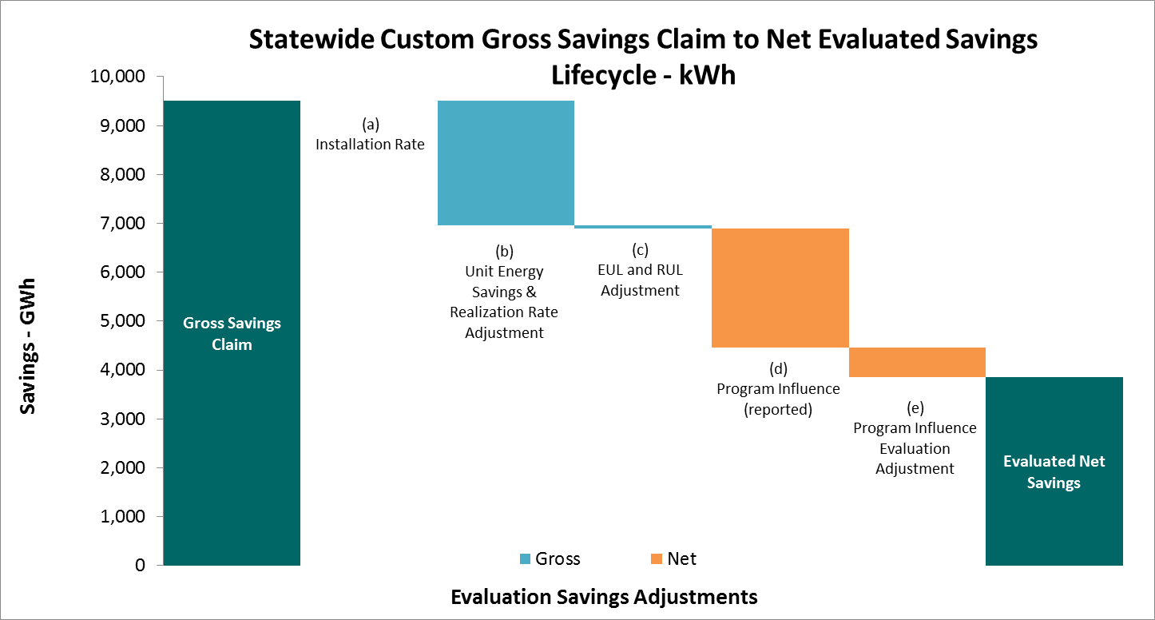
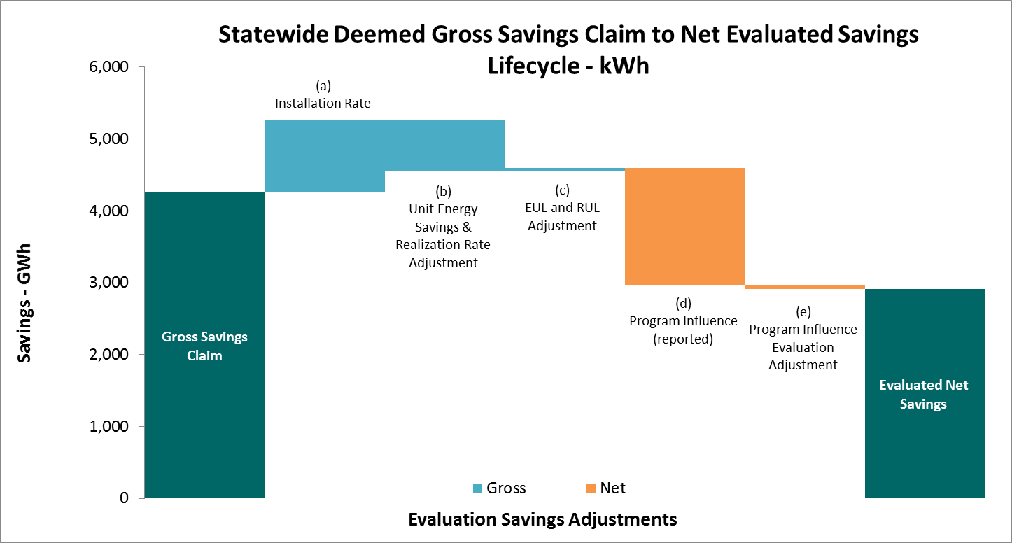

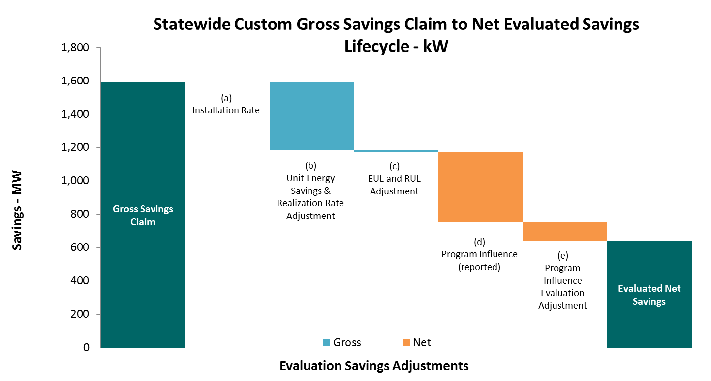
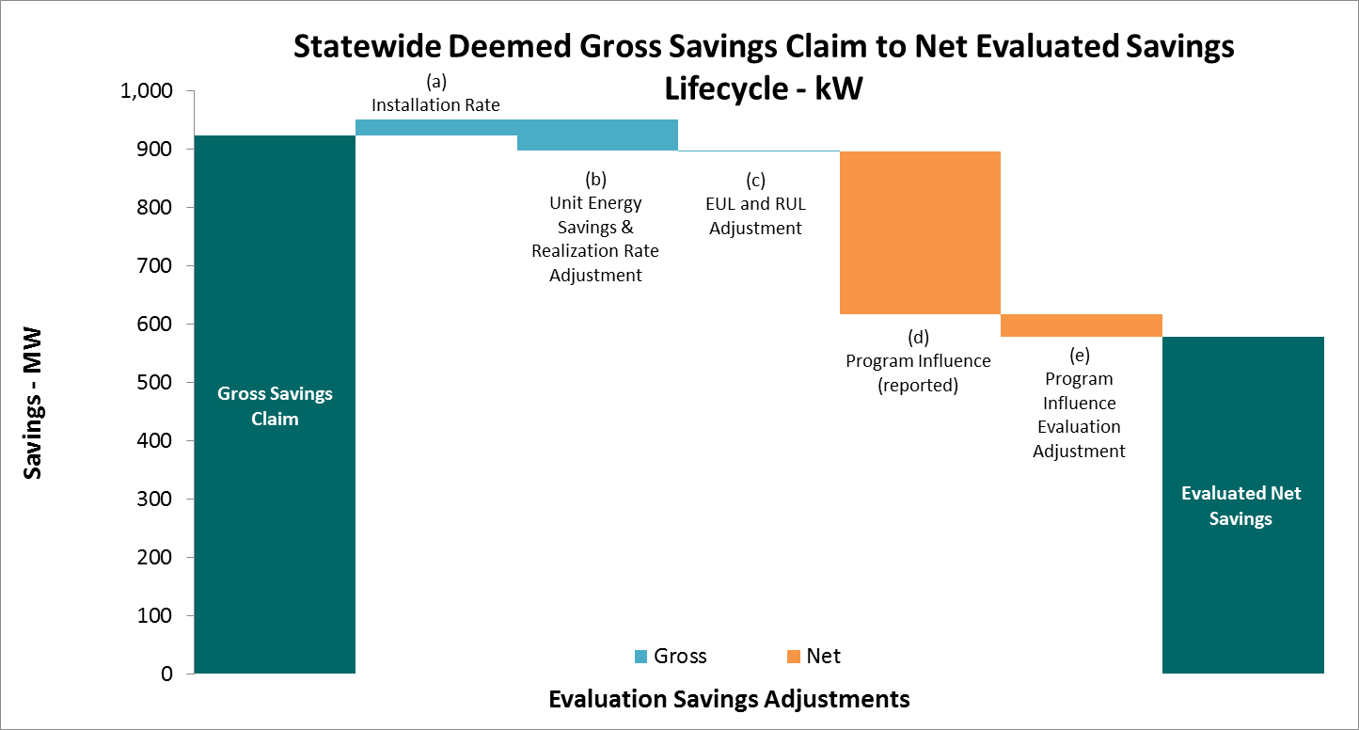

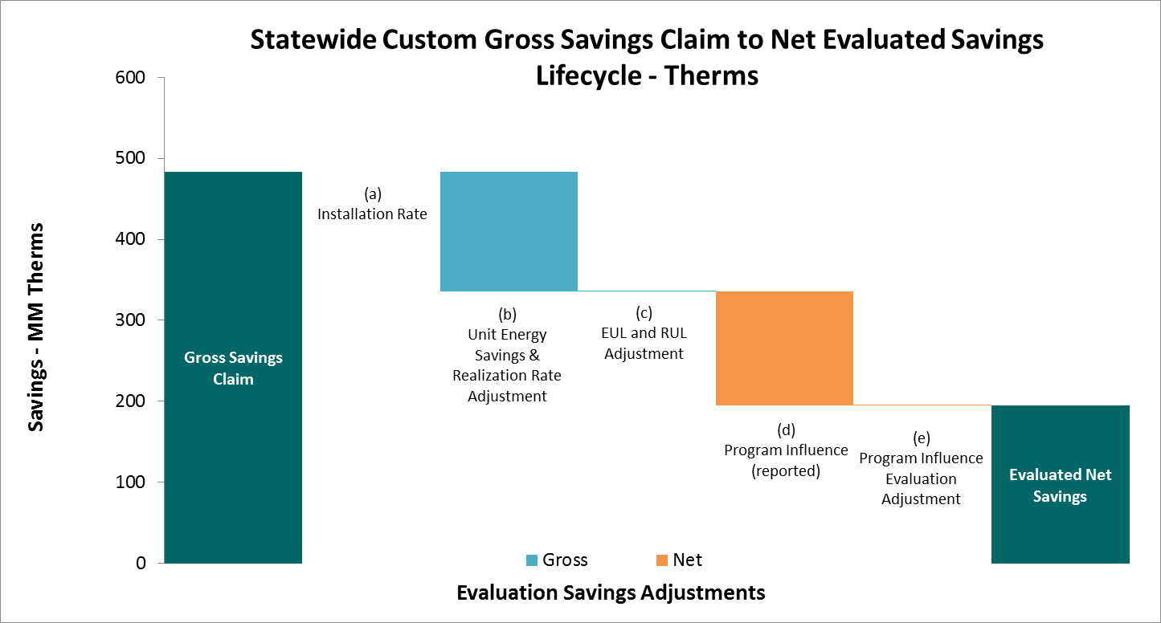

  - Key Drivers of Evaluation Updates – Pass-Through versus Evaluated Records
These charts show the evaluation lifecycle savings and what percent received an evaluation update for each parameter. The 2013 ESPI memos only covered a portion of the portfolio, with 31% of the deemed lifecycle kWh savings and 54% of the lifecycle therm savings being passed through. However, for custom measures, 94% of lifecycle kWh savings and 96% of lifecycle therm savings received some evaluation update. Notably, for custom and deemed measures, the EUL parameter was the least evaluated. The lifecycle therms chart is included, but please note that in order to calculate a percentage of savings that were passed through, an absolute value of the savings was taken.

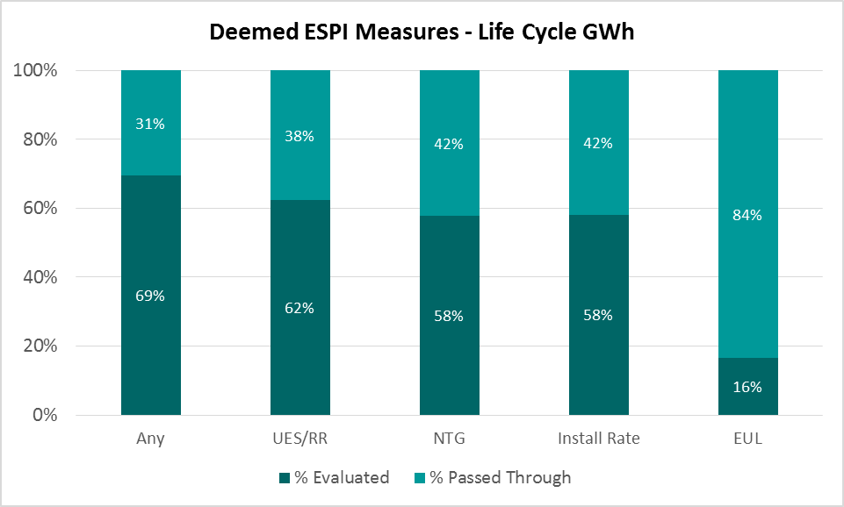

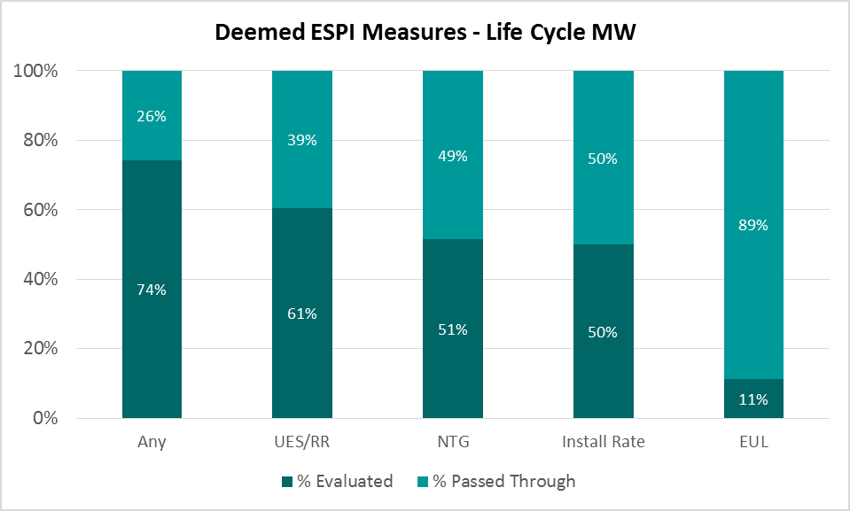
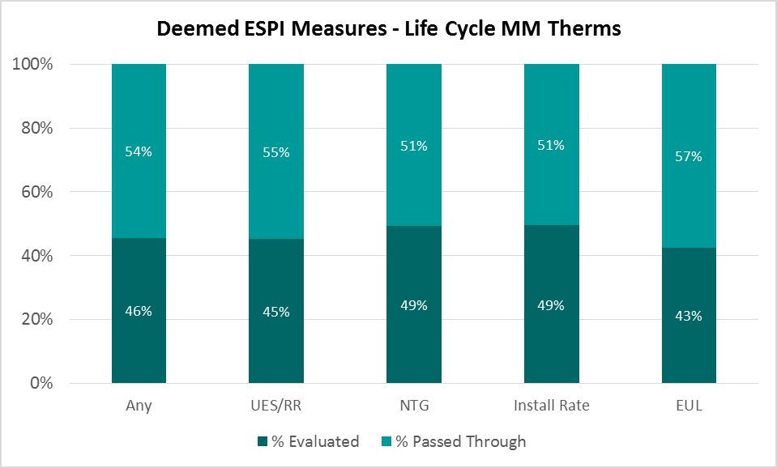

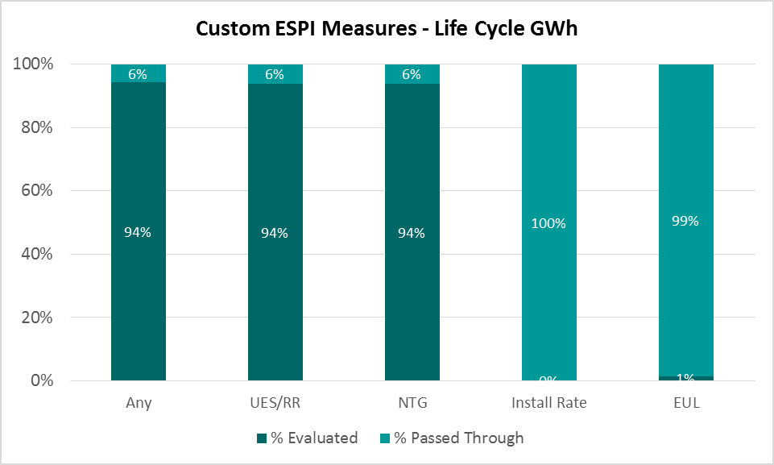

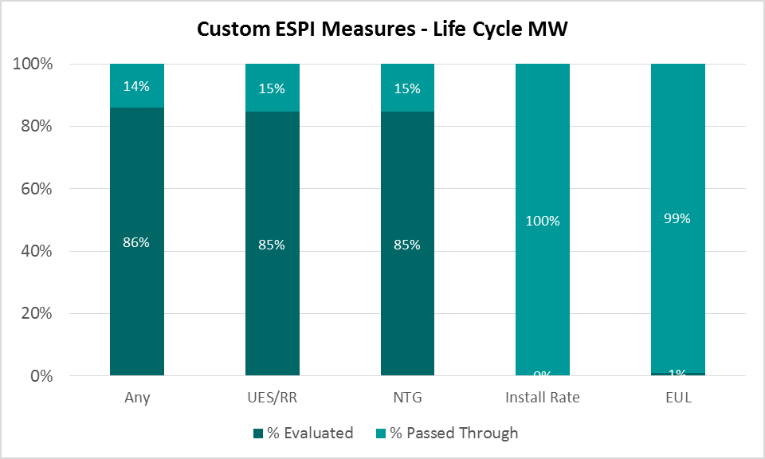
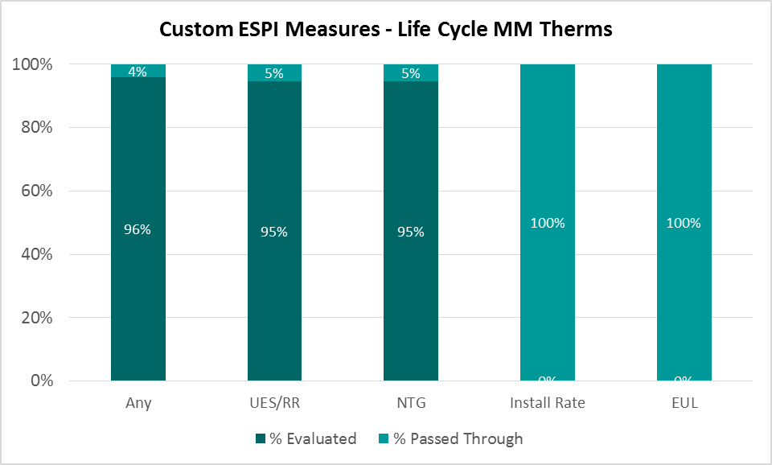

  - Key Drivers of Evaluation Updates – Largest ESPI Deemed Measures
These charts rank the deemed uncertain measures and their contribution to statewide lifecycle electric, demand, and natural gas ex-post savings. CFLs continue to be a significant portion of the portfolio in 2013, contributing the most to lifecycle GWh and MW for 2013 ESPI purposes. Water Kits were the largest contributor for lifecycle therm savings (again, this is within the 2013 ESPI Deemed uncertain measure savings and does not include therm savings from Codes & Standards, ESPI Custom or ESPI Deemed – ExAnte review).

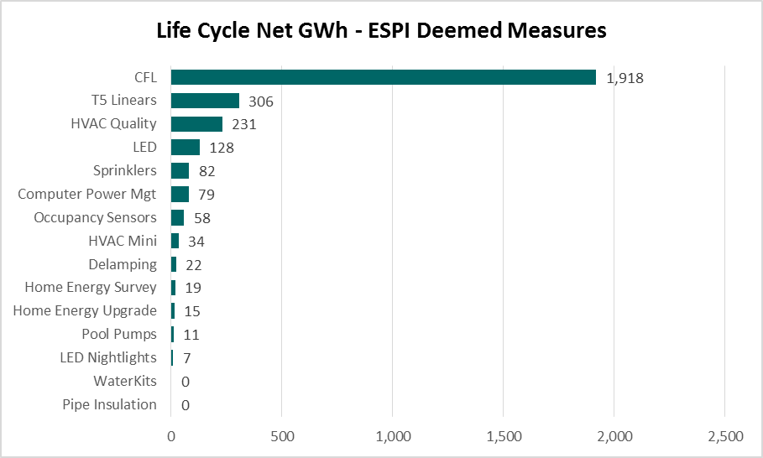
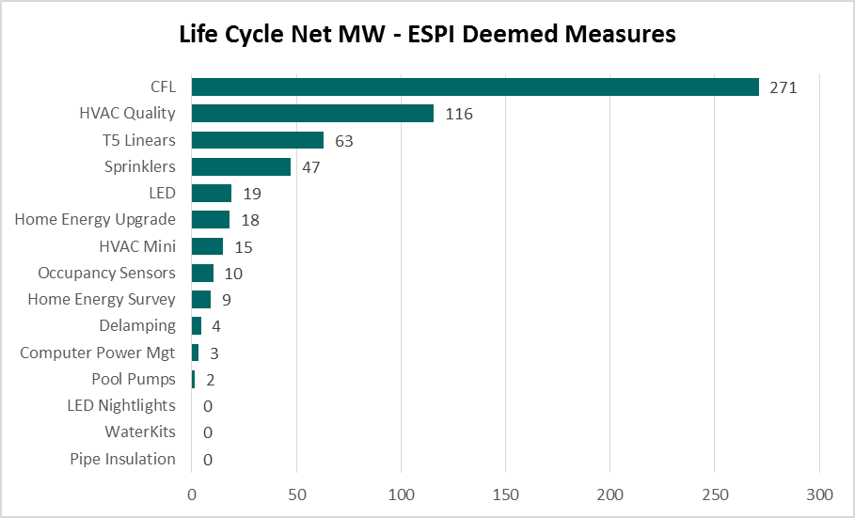
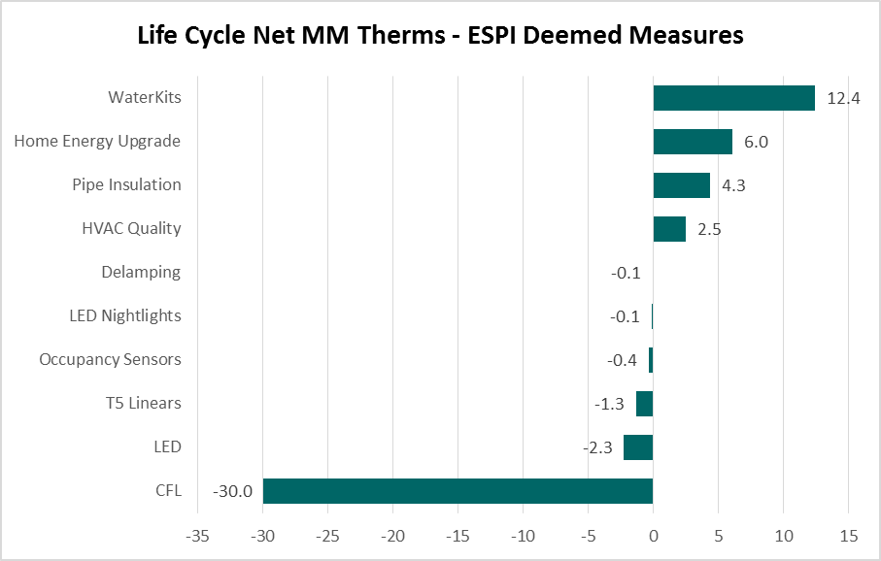
- Appendices
All the tables and charts used in this report can be found in the Appendix A. In addition, Appendix A also includes the IOU specific workbooks. All the measure level data and queries used to build the tables in Appendix A can be found in Appendix B. Appendix C includes more detail on how the final dataset was developed.
  - 2013 Performance Statement Workbook
  - 2013 ESPI Database
  - Creation of Ex-Post Dataset

2013 Ex-post Efficiency Savings and Performance Incentive (ESPI) Mechanism
Appendix A: 2013 Performance Statement Workbooks
The 2013 ESPI workbooks can be found at:
http://www.cpuc.ca.gov/PUC/energy/Energy+Efficiency/Shareholder+Incentive+Mechanism.htm
The embedded workbook below was used to create all results tables and graphs presented in this report. This embedded workbook includes the statewide results. These are presented separately from IOU-specific results (available via the link above), giving rise to five workbooks in total. Each workbook contains results data by Scenario, PA, ESPI Group, ESPI Category, Uncertain Measure, having Evaluation Results, Measure Group, and RoadMap ID. The results include Record Counts, Quantities, and Gross and Net First Year and Life Cycle Savings. The subsequent tables and charts are derived from this data.
The workbooks contain tables and graphs not available in the report. These are provided to allow the reader to interpret the results at a finer level of detail.

2013 Ex-post Efficiency Savings and Performance Incentive (ESPI) Mechanism
Appendix B: 2013 ESPI Database
The 2013 ESPI database can be found at: http://www.cpuc.ca.gov/PUC/energy/Energy+Efficiency/Shareholder+Incentive+Mechanism.htm
This database includes a table with the detailed claim level data for the four IOUs. For each record, the ExAnte and ExPost savings values (including gross and net, first year and life cycle) are available. In addition, the parameter level data is also included (including ExAnte and ExPost values). This database table is the basis for this report and the aggregated data presented in the Excel files in Appendix A.
The queries included in this database were developed to verify that the data in the database match the aggregated data in the Excel file (included in Appendix A) which was then used to produce all tables and graphs in this report. The ReadMe file below provides information detailing the contents of each query and identifies the Excel tables each is intended to match.

2013 Ex-post Efficiency Savings and Performance Incentive (ESPI) Mechanism
Appendix C: Creation of Ex-Post Dataset
Claim Data
The utility energy efficiency program tracking data forms the basis for critical program reporting functions and for evaluation sampling and execution. The cumulative 2013 Q1 – 2014 Q4 quarterly tracking claim data subset for 2013 is the foundation for the values in this report.

Claim Submission Processing
The following steps were followed to process the program tracking data in preparation for ESPI 2013:

1. Receive FTP link to download data from IOUs
2. Write IOU data together into standardized tables
3. Clean data and create “EDFilled” table
4. Quality check the data submission
5. Post IOU data submissions and “EDFilled” table onto ED Central Server (EDCS) and into SQL Server database

Data Cleaning
Although the IOU claims have continuously improved from quarter-to-quarter and cycle-to-cycle, the central data set still required some level of data cleaning to enable processing through the cost effectiveness tool. Data elements necessary for evaluation were cleaned by the CPUC evaluation contractors in conjunction with IOU staff. Throughout the cycle, the amount of data cleaning necessary was continuously reduced as IOUs improved their reporting capabilities. The result of the data cleaning process was a table named “EDFilled,” which contains all cleaned ex-ante IOU data necessary for evaluation teams.

Validation and Quality Control
The main component of the Energy Division’s data cleaning process was a quality control algorithm. All quality control algorithms were communicated to the IOUs via the Data Transfer Tool, an Access file that the PAs use to transfer their quarterly tracking data to the ED and QC their own data before transferring. The end product was a clean, consistent data set of claims which were ready for evaluation sampling and update.

Evaluation Data
Evaluation data provided in the final 2013 ESPI memos forms the basis for ex-post updates for this report. Evaluation data is reported by evaluation teams, and each evaluation team provides stratum-level results for each parameter being evaluated. The evaluation results are discussed in detail in the ESPI memorandums.

Evaluation Data Processing
The following steps were followed to process the evaluation data in preparation for ESPI 2013:

1. Evaluation team posts evaluation data submission database to Smartfile
2. Bring evaluation data into SQL Server database
3. Write evaluation data together into the Evaluation table
4. Quality check the data submission

Figure 1: Claims Processing
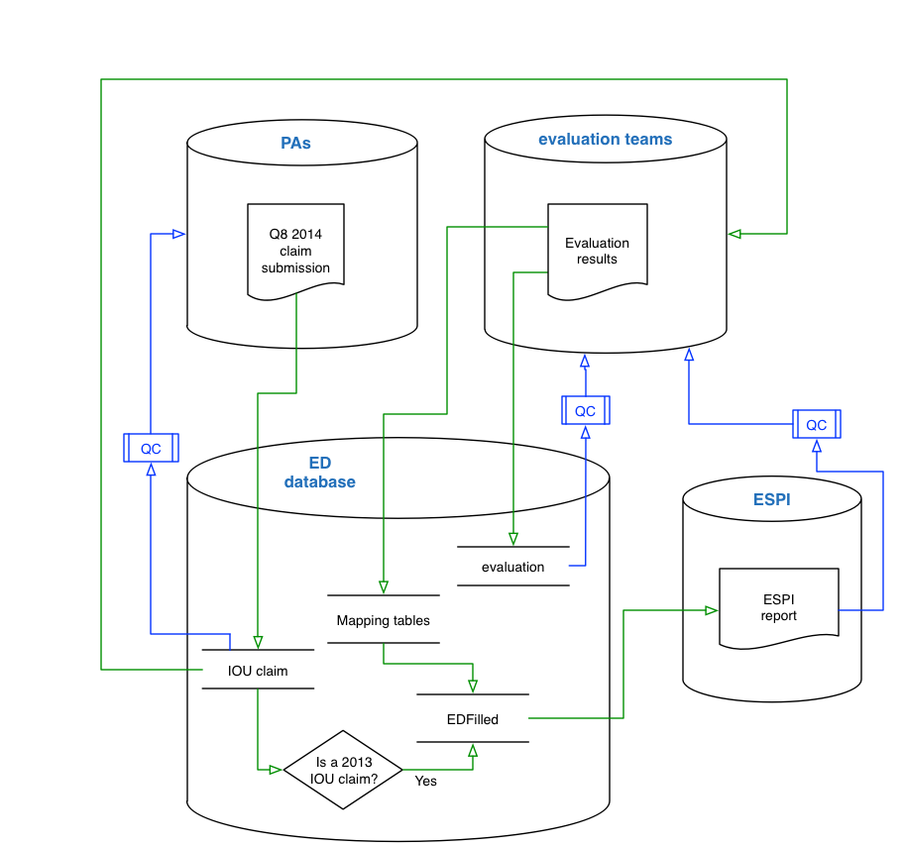

Evaluation Decision Framework
Commission staff utilized the detailed quarterly tracking data, described in the prior section, as the foundation for prioritizing evaluation activities and applying updates from evaluation work. The detailed evaluation plans carried out Commission staff’s guidance to make updates to the claims on a parameter basis in addition to meeting other evaluation objectives.
Commission staff and evaluation contractors utilized the following options in making updates to the utility savings claims for the aforementioned parameters:
1. Pass through: Accept reported savings values for claims that do not fall within the frame of an impact evaluation (no change); or
2. Leverage results from an evaluation study: Apply stratum-level results to records included in the frame of an impact evaluation. These data are considered “evaluated results” and are used in the context of this report.
Evaluation Decision Tree
The decision tree in the following figure illustrates how IOU claims were updated with evaluation results for ESPI 2013 and applies to all parameter updates.
Figure 2: Evaluation Framework Decision Tree

ESPI 2013 evaluation results were submitted by the evaluation teams in the form of memos. Each ESPI memo was reviewed and vetted via the public review process, and the final numbers were provided to the data reporting team. Evaluation results were downloaded and processed into the SQL Server database on the Energy Division Central Server (EDCS), an internal server (not publicly available) used to manage the data in a secure environment. Evaluation results are reported in two phases: the first phase is to deliver the data required to apply evaluation results to the final ESPI 2013 claim. In the second phase the evaluation contractors provided the logic which assigns ESPI 2013 claims into strata. A visual of this process is provided in the following figure.
Figure 3: Reporting of Evaluation Results: Phase 1 and Phase 2
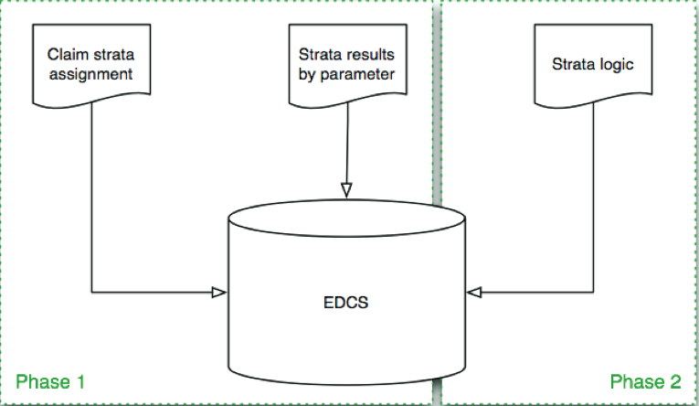

Following phases one and two is the third and final phase of evaluation data reporting. Phase three covers submission of all raw and processed evaluation data.

Phase 1 Data Specification

The data specification for evaluation results submitted by evaluation contractors consists of two primary components: record assignments to strata (the blue table in the middle of the following figure), and evaluation parameter results by strata (the five other black tables of the following figure). The two components are linked to assign evaluation parameter results to claim records in a transparent relationship. The connection and resulting data is designed to be consistent with the field evaluation sample structure.

Phase 1 Data Elements

- Parameter by Strata (PbS) - evaluation parameter results for each strata
- Strata by ClaimID (SbC) - assignment of claim lines to strata. These two data elements are brought together to assign evaluation results to the claim data.

Figure 5: Evaluation Phase 1 Data Specification
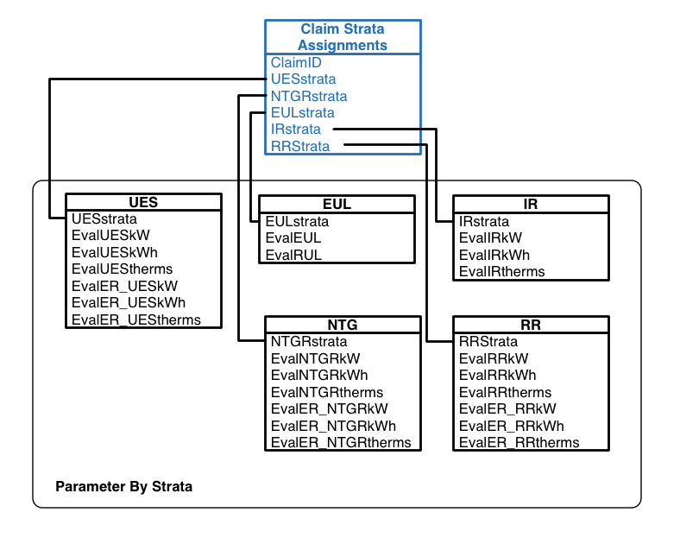

All comments are located here: http://www.energydataweb.com/cpuc/comment.aspx?did=1253
http://www.cpuc.ca.gov/PUC/energy/Energy+Efficiency/Shareholder+Incentive+Mechanism.htm
Commission staff and its evaluation consultants are performing a reconciliation to ensure the ex-ante payment categorizations and ex-post payment categorizations are aligned.
The lifecycle therm savings for deemed measures graph is not included in this report, intentionally, due to difficulties graphically displaying the negative therm values.
Note that the ExPost values for ESPI Deemed ExAnte Review and Codes & Standards records are only pass through values at this time.
http://www.cpuc.ca.gov/PUC/energy/Energy+Efficiency/Shareholder+Incentive+Mechanism.htm

