VGI Communications Protocol Working Group
June 12, 2017 in-person meeting, CEC Sacramento
Summary
For presentations visit: http://www.cpuc.ca.gov/vgi/

Attendance: 28 non-agency stakeholders in person and 50+ online.

Dean Taylor, SCE, dean.taylor@sce.com presented on Definitions. The definitions list has now grown to 27 pages with 60 new terms having just been added. There are still some terms that need to be fully defined. The first sub-group focus call will be held the week of June 19th, more details will come soon regarding the meeting. The definition presentation focused on a proposed framework from a paper by Eric Cutter, Director of DER at E3. Eric presented the framework, which was drawn from energy storage, electric vehicle and smart grid work for CPUC, in order to emphasize mutually exclusive definitions, focus on high value benefits and different approaches to quantifying and categorizing benefits. Planning and Capacity chart shows that there are 8 potential ways of defining capacity and each of the color coding refers to a different modeling techniques. The framework could apply for quantifying the grid or energy provider benefits for both V1G and V2G and the related use cases. There are some cases that have yet to be defined such as ramping, load following and hour-to-hour ramp.
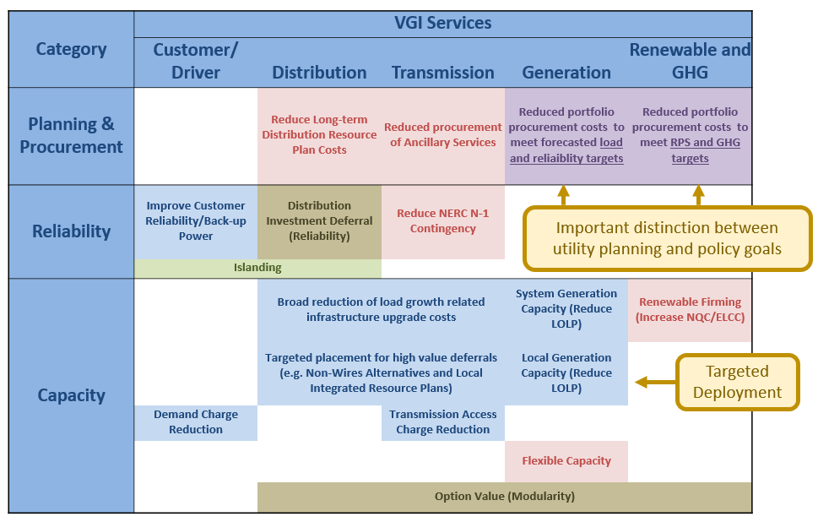
Mike Bourton, Kitu Systems, mbourton@kitu.io, presented on the use-case sub group. Meetings are regularly held Tuesday and Thursday 7:30am – 9:00am (PST). Currently there have been 78 use cases submitted to be reviewed, each meeting 4 use cases will be discussed. In order to better categorize the use cases into proper buckets, the sub-group has decided to tag each of the use cases. The tags are V1G, V2G, Aggregated, Non-Aggregated, Fragmented, Unified and other. Please contact Mike if you wish to join the sub-group or share some use-cases. Additional use cases need elaboration including the consolidated ones listed under OVGIP and ISO 15118, for example.
Noel Crisostomo, CEC, noel.crisostomo@energy.ca.gov, explained an exercise that the state agencies would like the stake holders to complete in order to answer the Deliverable 1 questions. This entailed examining an individual use case to determine where and which standards could be used to complete the objective of the use case successfully. Specifically, Deliverable 1 tasks the parties to identify the standards that would be used in the 4 given domain areas. Noel presented an example for what standards could be used in the EVSEEV domain to complete demand charge management. Discussion ensued on whether or not this is the right approach to the desired result. Several ideas where given about different methodology to achieve the same answer. One suggestion was to identify the actors, extract the requirements for their roles in completing the use-case. Subsequently, then see at what point along the line of communication line did each of the required standards sit (e.g. ISO 15118, IEEE 2030.5 and OpenADR).
Upon returning from lunch, a proposal was put forth by some stakeholders to adopt within the EVSE ISO 15118 and IEEE 2030.5. Discussion occurred on if that idea was a good one. Sponsoring agencies reiterated the need for evidence to back up the decision of adoption of a single standard between the EV and EVSE. After several rounds of comments, questions and clarification the group agreed that the need for discussion on use cases was still necessary and to focus on the previously proposed exercise. The room was polled on the proposal of adopting a standard and the result was about 1/3 of the room was on board with the idea.

The exercise that was initially proposed by state agencies was modified at the suggestion of stakeholders. For the use case of V1G to manage demand in a public space, the stakeholders identified the actors, requirements and steps necessary to complete the charge. Due to time constraints the activity was not completed in the group meeting. The sponsoring agencies encourage this type of analysis on each of the use cases and promised to provide further instruction on the tasks needed for Deliverable 1. See photos of the easel drawings of the exercise, below.

Detailed Comments
Presentations
- Dean Taylor– Draft VGI Glossary
  - May 30th meeting have 90 new terms
  - New section of explaining standards
  - Fully defined 60 new terms, expectation will be living document
  - Sub-group call June 19th
  - 27 pages currently and other glossaries are longer than this document, unique to have all three industries to be talking together
  - Possible frameworks – VGI white paper, Adam Langton June 8th call, E3 framework to be discussed
  - Eric Cutter Director of DER at E3, draws from storage, and grid modernization
    - Typically 80% of value comes from about 2-3 use cases which are huge. 20% comes from smaller use cases.
    - Meeting policy goals is hard to define in a $ value
    - It is easier to define procurement information $ value
    - Resource planning could happen better, if they know certain type of generation will occur / as well as how they would like to curtain certain aspects
    - Slide 5 – for capacity there are 8 ways of defining capacity and the color coding is the difference in the modeling
    - Also slide 6 – for customer / driver there are 4 ways of defining the value and the color is the difference in modeling
    - Q: Jennifer Kalafut: Are these cases V1G or V2G?
      - A: Seems to be V1G benefits framework. V1G can give most of the benefits of V2G if it is fast. V2G gives additional kWhs to complete the use caess.
    - Calls out frequency regulation- inertial, primary and secondary market response, these all are different speeds in response to change in voltage / frequency on the system
    - There are cases that have not been defined yet: ramp, load following and hour to hour ramp. Each of these can use CAISO – flexiramp product, (similar yet distinct ways to get the same quality of service and can be used on different intervals),
    - Slow ramp is what CAISO deals with right now which gives us good prices right now. The faster ramp cases, do not have a good $ value attached at the moment
    - Start with 80% - 20% rule, before trying to dig too deeply into smaller chuncks
    - What framework and models work to convert these models and framework to $value
    - Slide 9 – describes benefit groupings and may add the utility markets, 5 different buckets, utilities describe these as foundational groupings as the quickest way to grab the most amount of value
    - Q: Jeremy Whaling – have utilities looked at what is existing in the market today and who are the current actors in these spaces? Are these people located in the matrix?
      - A: Value is often defined of what is currently available such as capacity that is currently in the RA market $40 kWh/ year, this is the market that E3 expects cars to be bidding into – new markets should offer flexibility instead of standard one-off.
    - Comment: Peter Klauer – CAISO will require an aggregator to pull all vehicles into one signal, how would someone in the field take that signal and distribute it to the many cars?
    - Comment: Jeremy Whaling - $3kW/month equivalent RA price, compared to SCE tier 4 EV rate $15 kW/month, regarding value that is available today.
    - Comment: Hank McGlynn – V2G as bi-directional September of this year, CA has eliminated bi-directional flow, requirement is 4 quadrant give, generate, take and spin, Rule 21. This is all due to the inverter to manage voltage at night even no sun. This applies to storage. Not going to get all of the services with V1G.
      - A: Need to examine the effect of Rule 21 on EV.
    - Q: Noel Crisostomo: does storage not have any benefit, if fast V1G could do the same things as V2G?
      - A: V2G doubles capacity to import and export onto the grid, able to do more but not qualitatively different,
    - Q: Noel Crisostomo: Is the 80-20 rule generalization looking retrospectively or prospectively?
      - A: gross generalization, for a particular use case for a particular resource, a few key benefits provide the most amount of value (simple reducing the customer’s bill), the additional final layers in the stack have extra value, yet diminished magnitude.
    - Comment: Peter Klauer– it is not V1G or V2G, it is a combination of both, virtual power plant concept
    - Dean Taylor –V1G is not really needed due to rate design benefits
    - Justin Regnier – In running Monte Carlo analysis to determine value, how many values (“anchor tenants”)?
      - A: Values do have 2-3 anchor tenants, but not the same anchors, almost always seeing a better value for storage instead of another approach
E3’s value framework could help start the discussion of use-cases and assign $ value
- Mike Bourton – Use Case Subgroup
  - Adopted a tag which will allow the use – cases that fall into the different buckets to easier to read
  - Tags have reached consensus! Yay
  - Each meetings are now 730am – 9am, have a schedule for which use-cases are to be discussed
  - Tags!! – V1G (charging), V2G (include V2H and V2B, discharging), Aggregated, Non-aggregated, Unified (where each of the elements or actors in the use case is managed by a single entity or are managed as a single entity, EX fleet) , Fragmented (where the elements are not managed by a single entity), Other (parking lot)
  - 73 use cases submitted in 38 documents, 16 placeholders for ANSI for ISO 15118
  - 35 use cases tagged by submitters, 2 use cases completed review
  - 8 use cases scheduled for review this week
  - Adam submitted use-cases are going to be used as gap analysis
  - Actors, sequence of events that will get this to complete, overall task
  - Use cases may not have any monetary value but need to define
  - Comment: Oleg Logvinov – What is value and who will get this value? He thinks consumer should get value, and the value is cheaper than what they are getting now, and that their car can be full when they need it. Electric mobility is going to be IOT, charging will be crossing 5+ domains and we need to make sure that everything works in harmony
  - Discussion of use case – non-functional requirement is a price outside from CAISO that will affect how the customer may or may not charge.
- Noel Crisostomo – Breakout Exercise
  - (See presentation)
  - Questions & Comments:
    - Oleg Logvinov – This process cannot stall the market.
    - Hank McGlynn – Explain in more detail the EVSE. Whether it is onboard the PEV and supplying AC or DC, or off-board the PEV and the standard it uses (ChaDeMo or SAE/ISO).
    - Mike Bourton – Missing a connection link, the Network Service Provider to the Building Energy Management System
    - Barry Sole – Agrees with NSP to BEMS link because if the BEMS does not have the ability to complete demand response among other loads, the EV “is always the loser.”
    - Bill Boyce – Where is the customer?
    - Oleg Logvinov – The framework uses conventional wisdom. Thinking forward, with large penetration of renewables, storage, and electric vehicles a NSP would have the decision to interface across multiple downstream actors (BEMS, EVSE, EV). For example in a cluster of vehicles or microgrid, the EV might be “invisible.” Consider an offboard charger that is a combination device responsible for power factor control.
    - Nikki DeLeon – Consider all 78 use cases identified in the morning
    - Oleg Logvinov – Warns against survey design bias. Consider and focus what is in development in the ecosystem.
    - Vincent Chen – Value add from balancing top down and bottom up examination. Thinks there is value in the simplification of the architecture since many use cases create complexity.
    - Stephan Voit – ChaDeMo is DC FC only. In CCS, a combined connector is enabled through 15118 and additional processes.
    - Dean Taylor – Requests clarity about Mike Bourton’s requests for “technical, functional, non-functional, and business” requirements.
    - Dave McReadie – Supports Mike in looking at requirements but also respects agencies’ effort to “find the holes.” Proposes to examine: Use Cases, Requirements, Focus Areas and Protocols.
    - Jeremy Whaling – High level communications could provide better information but, you could achieve the DR by 1) adjusting the pilot signal, 2) assume that the driver doesn’t need the vehicle immediately, 2) ask, Does it impact the customer?
    - Vincent Chen + Adrian Gomez – Look at focus areas first and include NSP to BEMS.
  - Consider during lunch: how to task the participants’ activity from use cases into developing network architecture? We agreed that the discussion should only be on one VGI use case and each group will walk through all four sections of identified use cases.
Discussions
- How to spend time in breakout exercise? Discussion and general feedback.
  - Barry Sole – What is the goal of the working group? What is the nature of the recommendation – is it a standard? Where is it in the charging ecosystem? Is it ISO 15118 between the EV and EVSE? The two main options are ISO 15118 and SEP 2. During lunch he discussed with others and there seems to be a stalemate between the parties. Proposes a compromise, and recommends that the CPUC recommend both ISO and SEP are included on the EVSE and the OEM chooses vehicle-side implementation. End the working group’s effort on protocols now and spend the rest of the time discussing the VGI Roadmap. We need to achieve mass interoperability.
  - Lisa McGee – Avoid being “loosey goosey” by using standards. Limitations of OBD to diagnose vehicles and support charging. Wants electronic logging data in commercial vehicles to log duty cycles and getting the data from OEMs is hard.
  - Oleg Logvinov – Merging ecosystem of energy and transportation requires multi-stakeholder interoperability between cars and chargers. ISO 15118 has been examined through 4 years of interoperability testing and 6 years of consensus built through a Standards Development Organization. Agrees with Barry on need for standardization. “Passive” VGI is short term goal, but not a long term goal. Nothing we do should negatively impact the trajectory of EV growth.
  - Lance Atkins- Notes that DC and AC EVSE have differences. And CHAdeMO has some differences than the CCS.
  - Adam Langton – No decisions until use case value is determined and access to contracts. iChargeForward is using OpenADR to vehicle OEM cloud. Standards are only important for charging away from home since the owner of the vehicle does not own the EVSE. Mike suggests to list all the grid services that the utilities want to run. How do we facilitate mapping from utilities to the EVSE.
  - Jeremy Whaling - Need rates and ISO requirements for aggregation.
  - Barry Sole – Interoperability requires standards. Unless the OEMs open their telematics, we will be back in the same place. OEMs can plan for standards or not but something that could take 5-10 years with regulatory clarity could take 15 years without.
  - Jennifer Kalafut – Is it worth [the functionality] to add technological capability beyond telematics?
  - Oleg Logvinov – Frame the question: We need to achieve EV adoption. Interoperability will enable unconstrained innovation.
  - Stephan Voit- Vehicle could get grid pricing signal using telematics, but there is a possibility of a losing connection. Smart charging interoperability is needed, even at home, because it would allow to gather more information from the user in order to avoid distribution constraints. Intelligence in curbside charging could be useful for Plug N Charge. EVSE has a stronger relation to the grid because it is stationary (this relationship is not enabled through telemetry). In Germany distribution utilities would have needed to spend 16x more money into upgrades to help facilitate the new EVs coming onto the grid without standards. Oxygen Initiative is translating OpenADR to ISO 15118.
  - Adam Langton – Technology is already available right now for the telematics approach. Implementation will not happen until value is defined and quantified. Highest value is from Load shifting across time and location. Commission and utilities need to set value of x$ per kW year for grid outcome.
  - Judy Brunson – Diamler uses ISO 15118 for smart charging. Preserving the customer customer experience is the primary value.
  - Bill Boyce – The value to SMUD is $100 per car for the lifetime of the vehicle, therefore they prefer an extremely low cost solution. Otherwise it would be better to do grid hardening. Estimates that telematics costs $200/car-year. Worried that picking a standard increases the cost of the EVSE, hindering customer adoption, and negatively affecting ratepayers. It won’t be cost effective for the grid to install high cost charging infrastructure
  - Dean Taylor- Some value in time load shifting, but there is more value and cost savings in just updating the grid and lowering the rate of charging to Level 1. Consider MW-level parking garages.
  - Barry Sole – ISO 15118 is coming into Volkswagen Group’s vehicles. Regarding low power as a solution for VGI, disagrees. If we want adoption we need flexibility.
  - Jeremy Whaling – Consider how many EVs that can be serviced with a given amount of load. Decrease the capacity upgrade needed by power shifting according to need.
  - Oleg Logvinov – The appeal of an EV is comfort for the customer. The standards allow for a composite value of better customer experience including Plug N Charge.
  - Lisa McGee – There is value in building-level curtailment because of demand charge mitigation. The operator must control the C rate to meet the duty cycle, and there may be limited flexibility given operations.
  - Abigail Tinker – Questions benefit of near term implementation. Wants to examine the level of complexity implied to the customer.
  - Hank McGlynn – SEP 2.0b needs to be translated to ISO 15118 in order for the grid information to be sent to the EVSE.
  - Mike Bourton – SEP and ISO use the same Home Plug Green PHY protocols. The additional memory to implement 2 protocols is $0.02.
  - Justin Regnier – Question to parties: What if the mandate was a hardware layer that were to allow for ISO 15118 and IEEE 2030.5?
  - Adam – We don’t know what the value is. Suggests a large scale pilot to implement both standards to then choose which works better.
  - Barry Sole – Physical hardware supports both standards but needs software. Without it, it is useless. UC San Diego has a large pilot project already.
  - Jeremy – What is the cost of implementation for the EVSE?
  - Oleg - $110 per integrated circuit board (which includes metering and 2 contacts) + levelized cost of developed software compliant with all standards. Shipping today. Clarification: If the EVSE has an application layer processor, there is no additional cost.
  - Mike Ferry – To clarify Oleg’s point, $110 represents an intelligent L2 EVSE. It costs $20 or less for the expansion board carrying the PLC modem to be added into an existing L2 EVSE.
  - Mike Bourton – Concurs with the cost experience of Oleg and Mike.
  - Dean Taylor – Hardware cost is not high but the software cost to the customer is high.
  - Oleg Logvinov – About $10 /month for commercial sites. Higher cost potential if a cellular modem is needed for a single remote station. Every Building management system has an IP connection. Could set up sites to have gateway EVSEs collecting aggregations of EVSE arrays. Site could be around $200 /year.
  - UC Berkley – Does this work apply to Heavy Duty Vehicles?
  - Stephen Voit – HPGP factory chip set is less than $2/unit at a volume of 100,000 units. Providers include Qualcomm, SD Micro, and a Chinese company. Software, developed over 3-6 months, is divided by the number of charging stations. Suggests de minimis costs. Maturity horizon for ISO 15118 and IEEE 2030.5 10 + years at the moment.
Breakout Exercise
Identify Use case, actors involved, and their respective requirements. These requirements will inform the formation of the network architecture.
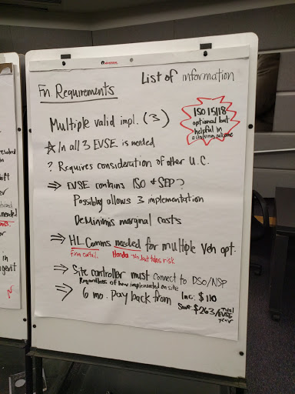
Next steps – Use case meetings to occur tomorrow and later this week
- Mike will continue to head up the use cases
- Agencies need to sit down and come to an agreement about everything that has been said here
- Mike asking for a second work group that works in parallel with the use case groups that will be extracting the requirements from each of the use cases that have been discussed

