2016 Filing Guide for System, Local and Flexible Resource Adequacy (RA) Compliance Filings
Issued: August 14, 2015

1. Purpose and Overview of Resource Adequacy Guides and Templates 2
2. New for 2016 RA Compliance Year 2
3. Major Components of the RA Templates 4
4. The Filing Process 5
5. Using the Templates – 2016 System and Local RA compliance 8
6. Net Qualifying Capacity 9
7. Flexible Capacity Framework 11
7.1 Flexible Need and Allocation 11
7.2 Flexible Capacity Requirements Study 12
7.3 Effective Flexible Capacity (EFC) Counting Conventions and EFC List 12
7.4 RA Showings and Validation 14
7.5 Sale and Purchase of Flexible Capacity 14
7.6 Use-Limited Flexible Resources 15
8. Capacity Allocation Mechanism and Combined Heat and Power Contracts Accounting Process 16
9. Local and Flexible RA Reallocation Process for 2016 Compliance Year 18
10. Confidentiality and RA Filings 19
11. Load Forecast Adjustments 20
12. Maximum Cumulative Capacity and Resource Categories 22
13. Demand Response Resources and the Demand Response Tab 23
14. Export Commitments Made with RA Resources 24
15. Outages 24
16. Import Capacity Allocation Process for 2016 25
17. Zonal RA: Constraint on Flows Across Path 26 28
18. Certification of LSE Resource Adequacy Compliance Filing 30
19. Submission of RA Filings – Secure FTP 30
20. Correction of Errors: Minor or Substantial 32
21. RA Penalty Structure 32
Appendix A: Submission of RA Compliance Filings 33
Appendix B: CAISO Import Allocation Process for 2016 35
CAISO Business Practice Manual Exhibit A-3: Import Capability Posting and Submittal Dates 35
Appendix C: Frequently Asked Questions and Clarifications to the Filing Instructions 38
Appendix D: Directions for Use of Secure FTP 40

Purpose and Overview of Resource Adequacy Guides and Templates
This 2016 Resource Adequacy (RA) Compliance Guide (Guide) is meant to inform Load Serving Entities (LSEs) in demonstrating compliance with the CPUC’s RA) program. Along with the RA System and Local/Flexible Reporting Templates (Templates) LSEs are to use this Guide as reference material. To the extent that this Guide is incomplete or does not address a particular issue that the LSE may discover, the LSE is strongly requested to contact Energy Division staff (RAFiling@cpuc.ca.gov) immediately and request direction. Although this Guide is organized for quick reference, the LSE is strongly encouraged to read the entire Guide and become familiar with its contents. More specific line item instructions are provided in the templates on the instruction tab.

New for 2016 RA Compliance Year
For the 2016 RA Compliance Year, the CPUC is issuing this Guide to specify how to fill out the Templates. A webinar workshop was held on July 23rd to cover the 2016 Templates and Guide. The Local and Flexible RA Template includes a tab for showing flexible RA procured to meet Year-ahead RA targets. Both templates have been modified to include a category selection for flexible capacity. The specific changes made to the templates are discussed below. LSEs are encouraged to read this Guide and the instructions included in the Templates carefully and to contact Energy Division with any questions at: RAFiling@cpuc.ca.gov .
D.15-06-063 made several changes to the RA program rules and implementation. Those changes for 2016 RA compliance year, among others, are summarized below:
- Dates were revised to reflect 2016 dates, and some other minor rewording was made to clarify directions. The schedule of filing deadlines included in section 2 of this guide are based on current rules regarding when RA filings are due; please visit our online RA Filing calendar for a current calendar.
- DR program totals are grossed up for transmission and distribution (T&D) line loss assumptions from the Long-Term Procurement Plans proceeding (currently Rulemaking 13-12-010) rather than utility rate cases.
- Technology factors for solar powered generators have been split into solar thermal factors and photovoltaic factors. Staff calculated these factors and will report them in the 2016 Net Qualifying Capacity (NQC) List.
- Qualifying Capacity (QC) for resources that come online in phases shall be based on a MW weighted combination of historical production and technology factors until the full MW of the facility reaches their Commercial Operation Date (COD).
- For 2016 Resource Adequacy compliance year only, Energy Division will not calculate proxy data for generators whose performance history may be affected by scheduled or forced outages. Instead QC for non-dispatchable resources will be based on the entire three years of production data, regardless of outage history.
- QF cogeneration facilities that are utility prescheduled will receive QC calculated from bid and schedule history instead of settlement data.
- Energy Division has provided LSEs with twelve monthly Cost Allocation Mechanism (CAM) values as part of its annual year-ahead allocation.
- Each LSE’s local capacity requirement shall be capped at that LSE’s system requirement in the monthly resource adequacy process.
- Local Resource Adequacy requirements shall be capped at monthly system Resource Adequacy requirements.
- Energy Division shall publish information on the CEC’s load forecasting methodology, including key dates and times of CAISO system peaks.
Timeline for Year Ahead Load Forecasts for 2016 Compliance Year:
LSEs file Historical load info | Mar 20, 2015
LSEs file 2016 Year-Ahead Load Forecast | Apr 24, 2015
LSEs receive 2016 Year-Ahead RA obligations | July 31, 2015
Final date to file revised forecasts for 2016 | Aug 19, 2015
LSEs receive revised 2016 RA obligations | Sep 18, 2015

Load Forecast and Month-Ahead filing dates for 2016 RA Compliance (Includes the due date for the Local RA True up Filing pursuant to D.14.06-050)
RA filing month | Load Forecast month | Due Date
Final 2016 Year-Ahead |  | Oct 30, 2015
January | February | Nov 16, 2015
February | March- June | Dec 17, 2015
March | April | Jan 15, 2016
April | May | Feb 15, 2016
May | June-December | Mar 16, 2016
June | July | Apr 18, 2016
July (with Local & Flex true up) | August | May 16, 2016
August (with Local & Flex true up) | September- December | Jun 16, 2016
September (with Local & Flex true up) | October | Jul 18, 2016
October (with Local & Flex true up) | November | Aug 16, 2016
November (with Local & Flex true up) | December-March | Sep 16, 2016
December (with Local & Flex true up) | January 2017 Compliance Year | Oct 17, 2016

Major Components of the RA Templates
The Templates are comprised of a number of individual tabs including the following:
- ID and Local Areas tab listing resources available for use in the RA Filings. Information is taken from the CAISO NQC list
- LSE Specific Allocations of Demand Response, CAM, RMR, Path 26, and load forecasts are inserted into the LSE Allocations tab so as to minimize manual error and paperwork The allocations in this tab now include monthly flexible RA procurement requirements
- The System RA Template includes both the Year Ahead and Month Ahead Summary Sheets that sum resources and compute LSE compliance. The Month Ahead summary sheet also includes a check for Local RA adjustments and a check for flexible RA capacity requirements by category.
- The Physical Resource and Import tab of the System template now includes a flexible capacity column and a flexible capacity category drop down list in which LSEs are to report flexible MW capacity procured by category. MCC buckets are to now to be specified on the resource tabs using a pull down list in lieu of the previous four MCC columns.
- The Local and Flexible RA template includes a reporting tab for year-ahead flexibility RA requirements and a summary table on the summary tab of the workbook.
- Demand Response Resource worksheet for reporting DR allocations and all other DR programs not part of the DR allocations; DR allocation information is drawn from the LSE allocations tab, but LSEs can also enter information for programs that are not allocated. The DR tab draws DR allocations into the DR tab; this information then flows through into the Summary pages where a 15% PRM is added on to its value.

The Filing Process
Decision (D.) 05-10-042 established a Year-Ahead and Month Ahead System RAR for LSEs under the jurisdiction of the CPUC. D. 06-06-064 expanded the RA program to include a Year-Ahead Local RAR, and D10-12-038 adopted a Local RA True-up Process for compliance year 2012 and onward. D.13-06-024 and D.14-06-050 adopted an interim Flexible RA Framework and Flexible RA requirements for 2015-2017. Below is a breakdown of the year ahead and month ahead RA requirements.
- Due October 30, 2015: LSEs are required to make a 2016 Year-Ahead System, Local and Flexible RAR compliance showing that demonstrates Year Ahead compliance with the following obligations:
    - For YA System compliance LSEs must demonstrate they have procured 90% of the total forecasted load plus planning reserves for the five summer months of May through September of the applicable compliance year.
    - For YA Local compliance LSEs must demonstrate they have procured 100% of the Local RAR for all 12 months of the applicable compliance year. LSEs must show all units they have under contract that are Local RA units and included in the CAISO NQC list, although units in excess of Local RA obligations may be listed on the Additional Local Resources tab.
    - For YA Flexible compliance LSEs must demonstrate they have procured 90% of each month’s allocated flexible RAR.
- 45 days prior to the compliance month (due dates specified in the RA calendar above) LSEs are required to file:
    - Monthly forecasts adjustments that track load migration. LSEs are allowed to update their month ahead load forecasts up to 25 days before the RA compliance filing due date for that month, pursuant to CEC approval.
      - Pursuant to D.10-12-038 and revised by D.14-06-050 LSEs must make only one revised August load forecast (to inform the local reallocation process) in March of each year. In addition to the August revised forecast LSEs must provide revised forecast from July through December in order to inform the incremental flexible reallocation process.
      - Pursuant to the quarterly CAM allocation process adopted in D.14-06-050, LSEs must include, with their revised monthly load forecast adjustments, updated values for all months in the upcoming CAM quarter. Since these quarterly allocations occur four times a year, they should be included in the following monthly load forecast submissions to the CEC: March, June, September and December (this information is included in the calendar above).
    - Monthly Flexible and System RAR showings that demonstrate 100% compliance with an LSE’s Flexible and system RAR.
    - Incremental Flexible and Local RAR showing that demonstrates compliance with the incremental Flexible and Local RAR from July-December. The incremental Flexible and Local RAR are based on the revised August forecasts filed in March.
    - .
4.1 Templates
The Guide herein and the accompanying Templates (System RA template and Local-Flexible RA template) provide the means for LSEs to demonstrate compliance with the System, Local and Flexible RAR Program:
- For 2016 Year Ahead System RAR – LSEs are required to make a showing for May September using the 2016 System RA Template. The Year Ahead Summary sheet is automated to perform the Year Ahead RA requirement checks.
- For 2016 Year Ahead Flexible and Local RAR – LSEs are required to use the Local and Flexible RA Template to demonstrate compliance with the Local and Flexible RAR for all 12 months of 2016. Local RA resources procured in excess of Local RA obligations may be listed on the Additional Local Resource tab.
- For 2016 Monthly RAR - LSEs are required to make a showing using the 2016 System RA template. The Month Ahead Summary sheet is automated to perform the Month Ahead RA requirement checks.
- For 2016 Local RA Reallocations: LSEs are required to use the CEC 2015 MA load forecast template to revise their forecasts through August 2016 once in March. Please consult the schedule in Section 2 of this guide.
4.2 Notification of LSE RA Requirements and Allocations
Each LSE will be notified by the CEC/CPUC Energy Division of its System, Local and Flexible RAR, as well as its DR and CAM allocations. This notification process consists of four parts.
- For Year ahead System RAR – LSEs were notified on August 13th, 2015 via Secure FTP of the following: annual monthly peak load forecasts, Local RARs, Flexible RARs, DR Allocations, and 12 monthly CAM Allocations for use in the Year Ahead System RA Filing. The CAM allocations will include the CAM accounting process adopted in D.14-06-050. For non-IOU LSEs CAM allocations will be allocated as they have in the past. For IOUs these allocations will be a negative value in an amount equal to what the non-IOUs were credited. LSEs are to consider these RA obligations and allocations preliminary. LSEs will receive Final 2016 RA obligations and allocations on or around September 18th, 2015 after LSEs have filed adjusted annual load forecasts. Barring change to RMR contracting, LSEs are to consider those allocations final. Beginning with the 2016 compliance year LSEs will receive 12 monthly CAM allocation values in their year-ahead allocations for use in the year ahead RA filings. On a separate timeline, each LSE will receive notification of their Import Allocations and Path 26 Allocations for use in their System RAR filing. See Sections 12 and 13 for more details regarding Path 26 and Import Allocation.
- For Year Ahead Local RAR – LSEs were notified of their 2016 Local RA requirements. For non-IOU LSEs these Local RARs will be net of CAM and RMR amounts for use in the Year Ahead Local RA Filing. Local RA obligations are not net of DR. DR is automatically taken off in the year-ahead Local and Flexible RA template. LSEs are to consider these RA obligations preliminary, as LSEs will receive Final 2016 RA obligations on or around September 18th, 2015 after LSEs have filed adjusted forecasts.
- For Year ahead Flexible RAR– LSEs were notified of flexible RA requirements. For non-IOU LSEs, these Flexible RARs will be net of CAM and RMR amounts for use in the Year Ahead Flexible RA Filing. For IOUs these Flexible RARs will not be net of CAM resources, since IOUs will be able to show the CAM resources in filings. Instead the IOU’s Flexible RARs are adjusted upwards in an amount equal to what the non-IOU LSEs are adjusted downwards. For Monthly System RAR – LSEs will be issued their System RAR for all months of 2016 alongside the annual obligations. LSEs are required to comply with the Monthly Load Forecast Adjustment process throughout 2016 as done in past years. LSEs are to continue using the Import Allocations and Path 26 Allocations they receive in August 2015 for all 2016 Month Ahead RA Filings. CPUC Energy Division will notify LSEs via Secure FTP of any change to Condition 2 RMR allocations and CAM Allocations as they occur throughout compliance year 2016 for use in subsequent Monthly RA Filings.
- For Local and Flexible RA Reallocation Requirements- LSEs will receive notification of adjustments to their Local and Flexible RA obligations concurrent with their CAM and RMR allocation letters via Secure FTP. The Local and Flexible RA adjustments will apply to the July through December compliance months and will be sent in March with the July CAM/RMR allocation letters. Pursuant to D.14-06-050 there is only one local and flexible true up cycle for 2015 and beyond.

Using the Templates – 2016 System and Local RA compliance
For 2016 RA compliance year, some minor changes were made, either adopted explicitly by Commission decision or implemented by Energy Division staff consistent with adopted CPUC policy. LSEs are encouraged to pay close attention during RA workshops and to contact Energy Division staff for more direction.
LSEs use the templates to report contracts they have signed with qualifying generators in order to verify compliance with RA obligations. LSEs notice their RA obligations on the summary page, and begin listing contracts to meet their RA obligations on the appropriate resource tab. For unit specific RA resources, either internal to CAISO or imported into CAISO, the LSE is to use the Phys_RES_Import_RES tab.
LSEs begin by entering a contract identifier in the first column, then selecting a Scheduling ID in the second column. The Local and Zonal Area designation will be automatically propagated. From there, the LSE is to enter the applicable System, Local and Flexible MW amounts in the appropriate columns, along with the associated bucket and category, so the LSE can demonstrate compliance with the System, Local and Flexible RA obligations.
The MW capacity values will be totaled and flow into the summary pages where they compare against the yearly and monthly requirements. LSEs are to use the appropriate summary tabs (year ahead or month ahead) to verify they are in compliance before filing. CPUC staff will then perform compliance review on the templates and notify LSEs of any corrections or errors found.
Pursuant to D.14-06-050, LSEs are now required to show Flexible RA capacity to meet the 2016 Flexible RAR. Two columns have been added to the Physical Resource page of the System template for LSEs to report their monthly flexible RA capacity by category. The claimed flexible capacity is tabulated in Table 6 and Table 7 of the Month-ahead summary tab and compared against the monthly allocated flexible RA target.
For year ahead flexible RA and Local RA showings, use the “Local and Flexible RA template”. The Local resource tab is to be used for reporting year-ahead local resources committed to meet Local RA obligations. The Committed Flexible Capacity tab is to be used for reporting flexible resources that are committed to meeting flexible capacity obligations. The summary tab includes summary tables for both Local and Flexible YA compliance.
Pursuant to D.10-06-036, LSEs are able to list additional Local RA resources that they have contracted for but are not committed for RA. That way, LSEs can list resources under contract for possible backstop designations but not commit them to availability penalties in the event of forced outage. The Local RA template has a tab for Additional Local Resources controlled by LSEs but not committed as RA resources.
Listing all Local resources that LSEs control is mandatory, meaning that LSEs are not able to avoid informing CPUC and CAISO as to which Local resources are under contract to LSEs, but it is no longer mandatory that all Local resources that LSEs control must be committed for RA and subject to the RA Must Offer Obligation.

Net Qualifying Capacity
D. 05-10-042 requires all LSEs to fulfill their System RAR through purchase of NQC. D. 10-06-036 adopted a Qualifying Capacity Manual that describes the methodologies used to calculate NQC values for all resources. D.15-06-063 made some modification to the QC calculations and definitions. The decision directed Energy Division is to revise the QC manual to incorporate all of these changes and reissue it on the Commission website for parties to reference as soon as is possible after approval of this decision. This manual will be made available on the RA compliance website. D.15-06-063 adopted the following changes related to QC methodologies:
- DR resources QC values will be grossed up for T&D line losses based on the most recently adopted LTPP assumptions of T&D line loss factors.
- Technology factors for solar have been split into thermal solar factors and photovoltaic factors. These factors are to be used for the 2016 NQC list.
- For the 2016 Resource Adequacy compliance year only, QC for resources that come online in phases shall be based on historical production after the phase reaches commercial operation excluding test data. Remaining phases under construction will be assessed using technology factors and a megawatt-weighted average of each part shall comprise the total QC of the facility.
- For 2016 Resource Adequacy compliance year only, Energy Division will not calculate proxy data for generators whose performance history may be affected by scheduled or forced outages. Instead QC for non-dispatchable resources will be based on the entire three years of production data, regardless of outage history.
QF cogeneration facilities that are utility prescheduled will receive QC calculated from bid and schedule history instead of settlement data. D.14-06-050 adopted a QC (and EFC) methodology pertaining to Energy Storage and Supply-Side Demand Response Resources for compliance years 2015-2017. The adopted methodologies can be found in appendix B of D.14-06-050.
The Final 2016 CAISO NQC List will be available and posted under “Current Net Qualifying Capacity (NQC)” on the CAISO website at: http://www.caiso.com/planning/Pages/ReliabilityRequirements/Default.aspx as well as on the CPUC website at: http://www.cpuc.ca.gov/PUC/energy/Procurement/RA/ra_compliance_materials.htm
Every resource has a resource name (“RES Name”) and associated resource identification number (“Scheduling Resource ID”). Each unit also has a Path 26 and Local Area designation. Resources not located in Local Areas are labeled as “CAISO system” and can only count toward the System RAR. There are also other import resources not listed on the NQC list that can count for RA, provided the LSE has import allocation on the applicable path allocated by CAISO or obtained from someone who received the allocation from the CAISO. Please check that you have an Import Allocation applicable to these resources and that these resources are added to the ID and Local Area sheet of the RA template. It is the responsibility of the LSE to ensure that information is entered correctly.
A list of Scheduling IDs and their Zonal and Local designations is included in the RA template, for purposes of making the compliance workbook more automated for LSEs. New resources that are added as they come online in 2016 or that change their Scheduling Resource ID can be added to the bottom of the list until the new units are reflected in an update that is posted on the CPUC website. It is the responsibility of the LSE to ensure that information is entered correctly.
Resources under construction are listed on a separate tab of the NQC List, and the resources on this list are available for listing by an LSE in their Year Ahead RA Filing on the “Under Construction” tab provided that the current projected date of commercial operation (COD) for the resource is on or before the first date of the compliance month in which the LSE wishes to count the resource towards their RA obligation. Information on the 2016 NQC List will not be changed except for data maintenance and correction of errors, and addition of new resources that come online during the course of 2016. Any revisions made by the CAISO after it is published will be evaluated by the CPUC before being added to the list posted on the CPUC website. Revisions can raise a given unit’s NQC or add units to the NQC list, but CAISO revisions cannot lower the resource’s NQC or remove units for purposes of RA. In instances where more than one Local Regulatory Authority seeks to determine NQC values for a given Scheduling ID, the CPUC will post NQC values consistent with CPUC adopted QC calculation methodologies and CPUC jurisdictional LSEs are required to use the values posted on the CPUC website for subsequent compliance filings.
NQC and Local RA Compliance
D.06-06-064 adopted a program of Local RAR for LSEs that are under the jurisdiction of the CPUC, while D.15-06-063 adopted Local RA totals for 2016 compliance year. These decisions require all LSEs to procure physical resources to meet the Local RARs. These units are to be located in the ten LCR areas identified in the CAISO NQC list. For purposes of RA compliance, the ten LCR areas have been aggregated into five Local Areas (LA Basin, Big Creek/Ventura, San Diego-IV, Other PG&E Local Areas, and the Greater Bay Area). The Other PG&E Local Areas include the Local Areas of Fresno, Humboldt, Kern, North Coast/North Bay, Sierra, and Stockton. The LSE is responsible for verification of the Local Area Designation of the unit, as well as the NQC value and the Scheduling Resource ID. To report a contract with a unit located within a Local Area on the Local Template, LSEs select the correct Scheduling ID from a drop down list in Column C of the Reporting Template, and upon selection, the Local Area designation is filled in for the LSE.
In the case of DR resources, the template will utilize the August DR values (located in the LSE allocation tab) for each Local Area for each of the 12 months of the year.
During the 2016 compliance year, LSEs are to make RA showings demonstrating compliance with the Local RA obligations as adjusted by the Local RA True-up methodology adopted in D.10-12-038 and modified by D.14-06-050. A Local RA column was added to the Physical Resource worksheet and the Demand Response worksheet to allow LSEs to demonstrate monthly Local RA compliance on the same template as System RA compliance.
The Physical Resource tab has a column called “Local RA MW” (Column E) where the LSE is to enter the amount in MW that is meant to satisfy Local RA obligations from that unit. This amount is to be the same MW amount the LSE has listed in their Year Ahead Local RA filing for the appropriate month, which means that this value will be different from the System RA MW for that month for two reasons. First, the LSE that showed the local resource in the year-ahead showing sold the capacity to another LSE due to load migration, and thus the MW value of the resource is listed by another LSE or LSEs for the same aggregate amount. Second, this value will be different from the System RA MW for the appropriate month in the event that the resource has a monthly NQC which differs by month. In that event, the LSE would list the correct applicable month’s NQC in as a System MW but list the August NQC value in the Local RA MW column.

Flexible Capacity Framework

7.1 Flexible Need and Allocation
D.13-06-024 recognized a need for flexible capacity in the RA fleet and defined flexible capacity need: “Flexible capacity need” is defined as the quantity of economically dispatched resources needed by the California ISO to manage grid reliability during the greatest three-hour continuous ramp in each month. Resources will be considered as “flexible capacity” if they can sustain or increase output, or reduce ramping needs, during the hours of “flexible need.” (D. 13-06-024, p2). The Decision adopted the following formula to calculate system flexibility requirement:

Flexibility NeedMTHy= Max [(3RRHRx) MTHy]+ Max(MSSC, 3.5%*E(PLMTHy)) + ε

Where,
Max [(3RRHRx) MTHy] = Largest three hour continuous ramp starting in hour x for month y
E(PL) = Expected peak load
MTHy= Month y
MSSC = Most Severe Single Contingency
ε = annually adjustable error term to account for uncertainties such as load following. This term is zero for 2015.D.15-06-063 adopted 2016 Flexible RA procurement obligations for LSEs that serve load within the CAISO Balancing Authority. ED staff will use peak load- ratio share to allocate flexibility among LSEs. In the future, ED intends to explore other methods of allocation based on causation through the RA proceeding, potentially in conjunction with staff’s analysis of reliability needs. D.15-06-063 stated that it would be more appropriate to address the allocation of flexible capacity requirements in Phase 2 of R.14-10-010, following or in conjunction with the development of a durable flexible capacity product. Additionally, LSEs can request allocations from ED that follow the CAISO’s method of cost causation. These allocations will be provided (if requested) for information purposes only.
An LSE’s flexible procurement obligation is calculated as follows, consistent with how system and local RA requirements are allocated.

LSE monthly flexible capacity procurement obligation = [(LSE monthly coincident peak load)/ (ISO monthly coincident peak load)]* Cumulative monthly flexible capacity requirement

7.2 Flexible Capacity Requirements Study
By May 1 of each year (or as soon as practical), the ISO will complete and file in the RA proceeding, a flexible capacity requirements (“FCR”) study together with the Local Capacity Requirements (“LCR”) study, which lists flexible capacity needs for each month of the following year. Parties to the RA proceeding will vet the studies and submit comments to the CPUC. The annual RA decision will then adopt final study results, which consist of total monthly flexible obligations for CPUC LSEs along with the LCR. The timeline of this study process will mirror that of the current LCR schedule.

Effective Flexible Capacity (EFC) Counting Conventions and EFC List
In order to qualify as a flexible resource, the resource must meet the following criteria:
- A resource must qualify as an RA resource and have a qualifying capacity (“QC”) in order to have an EFC
- A resource must be able to ramp and sustain energy output for a minimum of three hours
Specific counting conventions apply to determine the EFC of resources relative to a resource’s NQC. The EFC reflects the flexibility of a resource that can be counted towards an LSE’s flexible RA obligations.
Counting conventions for EFC applicable in 2016 are listed below:
Dispatchable thermal resources
- If start-up time of resource is greater than 90 minutes then EFC is limited to the MW range between Pmin and NQC as limited by ramp rate.
EFC= minimum of (NQC-Pmin) or (180 min * RRavg)
Where: RRavg = average between Pmin and NQC.
If start-up time of resource is less than or equal to 90 minutes then EFC is limited to the MW range between zero and NQC as limited by start-up time and ramp rate.
EFC = minimum of (NQC) or (Pmin + (180 min – SUT) * RRavg)
Where: SUT = Longest (cold) RDT start-up time in minutes.
Cold start-up time is the highest value in the startup time segments for the resource.
RRavg = average ramp rate between Pmin and NQC.
Hydro resources
A hydro resource will qualify as flexible if it has the physical storage capacity to provide energy for up to Pmax for six hours. A hydro resource will be permitted to designate an EFC value annually for each month of a counting year. The proposed EFC shall not exceed the NQC or the Pmax of the hydro resource.
Combined Heat and Power Facilities
A Combined Heat and Power (“CHP”) resource will be permitted to designate an EFC value annually for each month of a counting year to reflect its unique operating requirements related to industrial host obligations or CHP contract limitations. EFC of a CHP resource is capped at the lesser of the NQC or Pmax minus Pmin.
Energy Storage and Supply side Demand Response
Please see Appendix B of D.14-06-050.
D.15-06-063 modified Appendix B, to eliminate the prohibition on non-zero transition times, and to allow up to 45 minutes transition times that will not count towards either the one-and-a-half hour charge or discharge.

The CPUC and ISO will develop and post a draft listing the effective flexible capacity amount for each participating dispatchable resource (“EFC list”). Its EFC is calculated using the relevant counting conventions. Additionally, to accommodate the CHP settlement, which allows existing CHP resources to convert to dispatchable (referred to in the settlement as “Utility Prescheduled Facilities),” CHP resources that change their operations as specified in the CHP settlement will be able to request an EFC value from the CAISO without having a history of economic bids.

Mirroring the current NQC list process, the ISO is expected to issue a draft EFC list in August. Generators may request modifications or additions to these lists and by sending these requests to the CPUC and ISO. Generators may refer to the CPUC for further details. The ISO and CPUC will issue the final EFC list for CPUC jurisdictional LSEs by September.

RA Showings and Validation
CPUC Staff will send each LSE its flexible capacity obligation along with the system and local RA requirements in July of 2015 for the 2016 compliance year. Demand response programs are not listed on the EFC list but will be allocated to the LSE by the ED. LSEs must use NQC to satisfy system and local RA obligations. The EFC and NQC of a resource are distinct numbers, and may not be used interchangeably. Each LSE shall make a 1) year-ahead, and 2) month-ahead showing of flexible capacity for each month of the compliance year. In the showing an LSE must submit the committed flexible capacity it has contracted for the compliance period to meet its flexible RA obligation. The LSE is not required to commit additional flexible capacity beyond its flexible RA obligation. A committed flexible resource is a qualified flexible resource under contract to perform under the applicable flexible must-offer obligation. In order to verify the committed flexible capacity that is being shown in the RA filing, staff will compare LSE RA filings against the generator’s corresponding supply plan filed with the ISO. Validation of each LSE’s flexible capacity obligation supplements the validation of RA filings against local and system RA obligations. Year-ahead compliance filings should demonstrate that 90% of flexible capacity obligation is met for January to December. Month-ahead filings need to demonstrate that 100% of flexible capacity obligation is met for the month.

A megawatt of capacity counts only once – as flexible or generic. A resource may have flexible megawatts and generic megawatts based on its start-up time and how it was contracted to the LSE. Flexible megawatt and generic megawatt count towards system RA obligation. Only flexible megawatts count towards meeting flexible RA obligation. If the resource is in a local area, the combined total MW contracted from the facility count towards system and local RA requirements. For example, an LSE contracts with a resource with an NQC of 200 MW, a Pmin of 50 MW, and an EFC of 150 MW in a local area. The LSE can make the following RA showing if it contracts all the capacity within a resource including both flexible and generic.

System RA | Local RA | Flexible RA
200 MW | 200 MW | 150 MW

For RA showing purposes the EFC of a resource committed by an LSE may be greater than, equal to, or less than the NQC committed for that resource. The committed EFC will bear obligations under the flexible must-offer obligation as specified by the ISO tariff. The NQC of a resource will bear obligations under the resource adequacy must-offer obligations as specified by the ISO tariffs for generic capacity.

Sale and Purchase of Flexible Capacity
The sale of flexible capacity will entail an enhanced must-offer obligation and a potentially higher cost to a resource owner due to potential increases in wear and tear on a facility due to cycling. Therefore, a resource owner will have discretion in the sale of generic and flexible capacity. A resource must submit economic bids into the ISO’s day- ahead and real time markets for the committed flexible portion of the facility’s operating range. A megawatt may be sold only once as either flexible or inflexible. A resource owner may sell the flexible and inflexible capacity in separate transactions and to different purchasers. A resource owner may elect to sell any portion of qualified flexible capacity as inflexible. A resource owner with a resource consisting of both “generic” capacity (below Pmin) and “flexible” capacity, may elect to, or not to, sell the generic capacity prior to selling the flexible portion capacity.
For example an LSE contracts with a resource with an NQC of 200 MW and a Pmin of
50 MW. The resource owner could sell quantities with the same freedom as they can purchase, similar to the example described above.
An LSE’s generic and flexible obligations will be examined separately. Each generic RA MW committed by an LSE in its RA showing as generic RA counts toward that LSE’s generic RA obligation, and each flexible RA MW of a resource committed by an LSE in its RA showing as flexible RA counts toward its flexible RA obligation. We expect LSEs to employ procurement and showing practices that maximize efficiency and avoid any excess procurement.

Use-Limited Flexible Resources
D.13-06-024 directed staff and parties to develop rules regarding use-limited resources. Staff organized a workshop on October 15, 2013, which among other things included a discussion on use-limited resources.
Use-limited resources can be classified as resources that can run in all or most hours, but are limited in the total starts or hours they can run; or resources that cannot offer in certain hours (excluding outages). This includes but is not limited to, thermal units limited by starts or emissions, demand response, hydro resources, storage, and variable energy resources (“VERs”). Flexible use-limited resources must be operationally capable of ramping or sustaining output for three continuous hours.
Interim Approach
Due to developments in the Reliability Services Initiative as well as the Commission’s OIR regarding multi year RA requirements, the CPUC instituted an interim approach through December 31, 2017.
This interim approach requires LSEs to procure flexible resources in accordance with flexible categories based on varying must-offer obligations and energy limitations. There is a three- category approach with fixed monthly percentage limits.
The LSEs shall procure and show their flexible resources according to the characteristics defined in Table-1.
Table -2 Categories of must-offer
 | Category 1 | Category 2 | Category 3
Must-offer obligation | 17 Hours | 5 Hours | 5 Hours
 | 5 AM- 10 PM Daily  For the whole year | 12 PM to 5 PM for  May – September | 12 PM to 5 PM for  May – September
 | 5 AM- 10 PM Daily  For the whole year | 3 PM- 8 PM for  January- April and  October-December | 3 PM- 8 PM for January- April and  October-December
 | Daily | Daily | Non-holiday weekdays
Energy limitation | At least 6 Hours | At least 3 Hours | At least 3 Hours
Starts | The minimum of two starts per day or the number of starts feasible with minimum up and down time | At least one start per day | Minimum 5 starts a month
Percentage of LSE portfolio of flexible resources | At least 68 % for  May – September | Up to 32% for categories 2 and 3 combined | Up to 5%
 | At least 74 % for January- April and October-December | Up to 26% for categories 2 and 3 combined | Up to 5%

If the ISO observes a collective deficiency in these categories, it might backstop to meet the requirements. In case of such a shortfall, backstop costs will be allocated to LSEs based on their respective load ratio shares. The categories will be assessed annually and the percentages for flexible categories may change accordingly. The ISO is expected to issue monthly advisory targets to the CPUC for flexible categories in the FCR study.
Long Term Approach
The Commission will design a long-term approach based on experience following implementation of this proposal, which may include a revision of percentage or timing limitations on all flexible categories.3

Capacity Allocation Mechanism and Combined Heat and Power Contracts Accounting Process
D.06-07-029 adopted the CAM. CAM allows the IOUs to allocate the capacity costs and benefits of certain new generation resources, to all benefiting customers within their service areas. System reliability need identified in the LTPP proceedings is specific to the service area of each IOU. Each IOU is tasked with maintaining reliable operation within their service area, although they do not serve all retail customers in their service area.
Similar to the CAM process, D.10-12-035 QF/CHP settlement established a cost treatment to be used to share the benefits and costs associated with meeting the CHP and greenhouse gas goals. This adopted cost treatment is almost identical to what was adopted in the LTPP decision for CAM resources. Under the QF/CHP settlement framework, the costs and the RA benefits are also allocated to all benefiting customers.
The IOU responsible for procurement of the CAM or CHP resources will act as the Scheduling Coordinator and show the entire CAM and CHP resources on its RA filings to count towards its RARs.
As the Scheduling coordinator, the IOUs must manage the resources for scheduled outages. The IOUs have the authority to recover scheduled outage replacement costs through a balancing account mechanism. For scheduled outages that are approved after the compliance filing due date, the SC of the resource will be responsible for outage replacement as specified in the CAISOs replacement rule.
IOUs are required to manage their CAM and CHP scheduled outage replacement costs consistent with least-cost-best fit evaluation. The recoverable cost of replacement capacity for CAM and CHP resources shall be as follows:
- For replacement with IOU portfolio resources (resources already under contract or owned by the IOU), the weighted average RA capacity price by zone and month from the most recent Energy Division Resource Adequacy report shall be used to determine the recoverable costs. These prices can be found on page 28 of the 2012 RA report in Figure 7.
- For replacement with capacity procured in the market, the actual capacity price paid shall be used to determine the recoverable costs.
- For replacement capacity that is unavailable in the market and for which CAISO exercises backstop authority using its capacity procurement mechanism (CPM), the CPM price shall be used to determine the recoverable costs.
For non-IOU LSEs, the CPUC will provide a CAM and CHP credit that will count towards their System RA requirements. The CPUC will also provide the IOUs with a CAM and CHP debit. The CAM and CHP debit will be a negative value (meaning an addition to the IOU’s RA obligation) equal to the amount of CAM and CHP credits provided to non-utility LSEs serving load in each TAC area.
For example, assume that an IOU has a 90% load ratio share in its TAC and has procured a CAM resource with a NQC of 100 MW. The IOU would show the 100 MW CAM resource (or a replacement if the resource is on a planned outage) in its RA showing, all LSEs serving load in the TAC area would receive 10 MW RA CAM credit, and the IOU would receive 10 MW CAM debit (negative value). In this case, the IOU would receive a higher RA requirement equal to the credit the other LSEs are receiving. The CAM resource, or replacement, would be shown in the IOU’s RA filing as a physical resource which would count for a 100MW towards its RA requirement (higher by 10 MW).
The process of allocating the Local RA benefit associated with the CAM and CHP resources is similar to the System RA process. For non-IOU LSEs the RA requirement for each local area will first be reduced by the RA value of all the CAM and CHP resources in the local area. LSEs will then be assigned their Local RA requirements net of all CAM and CHP local benefits. For IOUs, the Local RARs will be allocated NOT considering the RA benefit of CAM and CHP resources. Instead, the IOUs will receive higher local RA requirement equal to the amount of local CAM and CHP benefits subtracted off the non-utility LSEs serving load in each TAC. The IOUs will then show the whole local value of the CAM and CHP resource or that of replacement units on its RA showing, to meet its Local RA requirement.
For Flexible RA benefits the same process outlined above for allocation of Local RA benefits would apply. Flexible capacity benefits will be allocated consistent with the flexible categories adopted in D.14-06-050. All three IOUs are required to submit a list of its CAM and CHP resources with contracted system and flexible capacity benefits of each resource to Energy Division prior to the allocation timeline laid out for local RA in the RA Compliance Guide.
Pursuant to the allocation timeline adopted in D.14-06-050, Energy Division will allocate the Capacity benefits of CAM, CHP & RMR resource as follows:
- For System RA benefits - Energy Division staff will allocate system credits/debits quarterly. The first quarterly allocation will be sent in January 2016.
- For Local and Flexible benefits, Energy Division will conduct one incremental Local RAR and Flexible RAR reallocation annually. This incremental reallocation will adjust Local RAR and Flexible RAR for July compliance month through the end of the compliance year.
In order to implement the quarterly CAM allocation process, LSEs need to provide an adjusted load forecast that includes the months covered by the allocation. For example the quarter one CAM allocation uses the revised December forecast, filed in mid-September. The December load forecast needs to include December – March so that the quarter one CAM allocation can be based on the associated month’s forecast.
Following the quarterly CAM allocations ED will post a list of CAM resources that were included in the quarterly CAM allocation.
The IOUs are to submit the CAM and CHP scheduled outage replacement costs to Energy Division quarterly in the CAM template sent by Energy Division prior to each allocation.
Pursuant to D.15-06-063, Energy Division shall provide twelve distinct forecast values, one per month, for the full year-ahead CAM-related capacity allocation forecasts. Energy Division shall provide LSEs with twelve monthly CAM values as part of its annual year-ahead allocation.

Local and Flexible RA Reallocation Process for 2016 Compliance Year
D.10-12-038 adopted a local RA reallocation process for the 2012 compliance year and beyond. D.14-06-050 modified that process, to have only one incremental reallocation cycle, and extended the reallocation process to flexible capacity.
The Local and Flexible RA reallocation process requires the use of the two existing templates, the load migration forecast template and the System RA compliance template.
The Local and Flexible RA reallocation process includes one adjustment cycle, occurring in the second quarter (April) of the year to apply for filings in the third and fourth quarters (July- December) of the year. LSEs file adjusted load migration forecasts in March with their May MA RA filing and receive incremental Local RA adjustments in April. For the Flexible true up, the adjusted load migration forecast filed in March needs to include June forecast through December so that the monthly flexible capacity requirements can be trued up accurately for each month from July-December. (The June forecast is used for month ahead RA compliance)
The Local and Flexible RA reallocation cycle requires LSEs to file load forecast adjustments through the August compliance month and submit those forecasts with the June load forecast adjustments. LSEs will have approximately five days to make any corrections to their load forecasts. Energy Division staff will notify LSEs of incremental adjustments to Local and Flexible RARs for July through December and send these to LSEs 45 days before the July MA filing compliance due date with the July CAM-RMR allocation letter. The adjusted Local Flexible RARs will then be used for July through December Month Ahead RA filings. The incremental Local RA adjustments must be inserted into the LSE Allocations tab of the RA Compliance Template in Table 5. Table 5 in the month-ahead summary tab will calculate any needed or extra local capacity for the month-ahead RAR. The incremental Flexible RARs must be inserted into the LSE Allocations tab of the RA Compliance Template. Table 7 in the month-ahead summary tab will calculate any needed or extra flexible capacity for the month-ahead RAR.
LSEs will receive its incremental Local and Flexible RA obligations through the Secure FTP. LSEs may request these allocations to be inserted into the System RA template, or LSEs can insert the allocations themselves.
Pursuant to the Local RA Reallocation process adopted in D.10-12-038, incremental Local RARs may be aggregated by TAC area. To implement this provision, LSEs will receive incremental adjustments to their Local RA obligations (either a positive or a negative number) for each Local Area. LSEs may enter the allocation in any Local Area in the same Transmission Access Charge (TAC) Area. For example, if an LSE receives a two MW incremental Local RA adjustment in LA Basin, the LSE could enter zero MW in Big Creek/Ventura and procure a two MW resource in Big Creek-Ventura instead. The LSE could also enter a MW in each LA Basin and Big Creek-Ventura. The template will draw the allocations entered by LSEs into the Summary Tab and calculate any needed or extra local capacity for the Month Ahead-RA showing.

Confidentiality and RA Filings
We start with a presumption that information should be publicly disclosed and that any party seeking confidentiality bears a strong burden of proof. However, in some instances (such as "market sensitive" information relating to electric procurement that passes a materiality standard), confidential treatment of data may not only be allowed, but may be required in order to carry out our statutory and constitutional duties.
Parties or persons submitting RA Filings for which they claim a right to confidential treatment shall attach a declaration under penalty of perjury certifying that they are only claiming confidentiality for data included in the D.06-06-066 Matrices. Pursuant to D.08-04-023, an LSE need not seek confidential treatment every time it makes a compliance filing of a repetitive nature. Rather, on making subsequent compliance filings, the LSE may cite the earlier declaration for confidentiality. Thus the LSE is instructed to file a declaration accompanying the 2015 Year Ahead System and Local RA Filing and refer to that declaration by date and subject in the cover letter submitted with subsequent Month Ahead RA Filings.
The LSE is required to send a signed electronic version of the declaration in pdf format via the Secure FTP application accompanying the 2015 Year Ahead Filing templates and cover letter, and to include a reference to this declaration by date and summary of content in the cover letter accompanying each future Month Ahead RA Filing. LSEs also may use the initial declaration submitted with the 2015 Year Ahead Filing to request protection for the annual and month ahead load forecast information submitted to the CEC; the LSE is to refer to the initial declaration filed with the 2015 year ahead filings in the cover letter to the Load Forecast submittals.
RA Filing or Data Requests Related to RA Filings
Situation: An LSE files a RA Filing and seeks confidential treatment for data of the type addressed in the Matrices to D.06-06-066. In this situation, the following procedure applies:
A declaration under penalty of perjury will accompany the filing, establishing the five factors required by D.06-06-066, Ordering Paragraph 2, listed below but no motion is initially required.
- That the material constitutes a particular type of data listed in the Matrix;
- The category or categories in the Matrix to which the data correspond;
- That the submitting party is complying with the limitations on confidentiality specified in the Matrix for that type of data;
- That the information is not already public; and
- That the data cannot be aggregated, redacted, summarized, masked or otherwise protected in a way that allows partial disclosure.
If another person asks to see the confidential data, the filer and the requesting person shall meet and confer to resolve the dispute informally, consistent with the intent of new Rule 11.3 of Commission Decision D.06-06-066. If they cannot resolve the dispute, the filer and the requesting person shall present the dispute to the assigned ALJ. The confidentiality claim and dispute will be resolved consistent with the Commission’s procedures for addressing confidentiality claims and requests for information in the context of Public Record Act requests.

Load Forecast Adjustments
D.05-10-042 stated “[w]e require that month-ahead compliance filings include adjustments for positive and negative load growth due to migration. Apart from load changes due to load migration, load forecasts should not be updated from LSE’s Year-Ahead filing.” LSEs submit historical load data and year ahead load forecasts in March and April of the year before the RA compliance year. CEC staff complete analysis on the LSE submitted information and together with overall statewide forecasts that CEC staff produce annually, LSEs are sent updated year ahead RA obligations based on load forecast information. LSEs receive this information in July of each year. Before 2012 compliance year, LSEs were unable to revise or change their forecasts between April and the October RA filing deadline. This proved to be a significant period of time, and some LSEs requested the ability to revise their year ahead information closer to the RA Filing. D.11-06-022 created a process for LSEs who wish to adjust their year ahead forecasts to do so up until August 17. This will ensure that RA obligations LSEs procure to meet are as accurate as possible. The decision adopted a schedule for doing that, and it is integrated into the schedule in Section 2.
On August 13th, 2015 the CPUC will send each LSE the preliminary month specific RA obligation for January-December 2016. Because the Year-Ahead forecasts will make assumptions about direct access load, the Year-Ahead forecasts are revised to account for actual direct access customer migration to date, and expected additional load migration prior to the obligation period. On August 17, 2015, LSEs are able to submit revised forecasts to account for load migration or revised assumptions that occur between April and August. This is to improve accuracy of the RA obligations that LSEs are required to procure and that are to be met with the year ahead filing in October. All LSEs will receive Final RA obligations and allocations on or about September 18th, 2015; all LSEs will receive adjustments even if each LSE does not individually file adjustments to their year ahead load forecasts. IOUs should adjust their forecast to account both for customers who are known to have returned to bundled service and for those that have notified the IOU that they intend to return to bundled service prior to the filing Month. ESPs should account for contracted load and a reasonable expectation for the rate of contract renewals of non-firm load or load with expiring contracts. If the CEC determines that the assumptions made are not plausible, the CEC may make a plausibility adjustment to account for a more plausible rate of customer retention. The CPUC requires LSEs to procure to meet RAR based on the load forecasts that are submitted to the CEC and adjusted by the CEC.
After the Year Ahead RA compliance filings, an LSE with migrating direct access customers is responsible for adjusting its monthly load forecast and monthly RA obligation and reflect those changes on the monthly RA Template, which is currently due along the same schedule as the Month Ahead RA Filings. IOUs should adjust their forecast to account both for customers who are known to have returned to bundled service and for those that have notified the IOU that they intend to return to bundled service prior to the Filing Month. ESPs should account for contracted load and a reasonable expectation for the rate of contract renewals of non-firm load or load with expiring contracts. If the CEC determines that the assumptions made are not plausible, the CEC may make a plausibility adjustment to account for a more plausible rate of customer retention. The CPUC requires LSEs to procure to meet RAR based on the load forecasts that are submitted to the CEC and adjusted by the CEC. The CEC will communicate these monthly adjusted forecasts to the CPUC for compliance validation purposes.
Pursuant to D.10-06-036 (OP 6e) LSEs may, at the discretion of CEC staff, file changes to their load forecasts up to 25 days before the due date of any 2015 month-ahead compliance filings. LSEs are not to submit revisions after the filing due dates laid out in Section 2 of this Guide, unless approved by CEC staff, and any revisions made after the filing date without CEC approval or any revisions made less than 25 days before the RA compliance filing will be ignored by CEC and CPUC staff for RA compliance purposes.
The CEC has provided a separate template to facilitate the forecast revision process and verify that migrating load is correctly accounted. LSEs which have gained or lost customers since their Year-Ahead forecast will enter the amount of monthly peak load associated with the change in customers, and the template will make the appropriate adjustments, including coincidence. LSEs are to submit complete load forecast adjustments each month to the CEC. This required submission shall include the certification sheet signed by an officer of the company, as well as the electronic template and all supporting data. LSEs are asked not to send this information to the CPUC or the CAISO as they do not need to receive this submission. Guidelines for submission of load information are provided by the CEC. The Load forecast template for 2016 can be found on the CPUC compliance website: http://www.cpuc.ca.gov/PUC/energy/Procurement/RA/ra_compliance_materials.htm
To implement D.10-12-038 and D.14-06-050, LSEs need to submit load migration estimates through December with their June MA load migration filing to recalculate local and flexible capacity allocations. To implement the quarterly CAM allocation process, LSEs need to provide adjusted load forecasts that include the months covered by the quarterly CAM allocation. For example, the Q1 CAM allocation uses the revised December forecast, filed in mid-September. The December load forecast needs to include December – March so that the quarter one CAM allocation can be based on the associated month’s forecast. LSEs are to continue using the “best estimate” approach, which requires LSEs to make a forecast of anticipated customer retention as well as new customers coming to the LSE. As the “best estimate” approach requires LSEs to forecast load migration in advance of final Direct Access Service Request (DASR)/Community Choice Aggregator Service Request (CCASR) approval, the CEC will expect LSEs to be as accurate and complete as possible and may adjust or correct load migration filings before reallocating Local RA obligations. LSEs are to account for the impacts of Load Migration via the LSE Allocation tab in the Month Ahead RA Filing. LSEs are to enter the Net Change in Load plus Trans. Losses & UFE for each service territory into Table 4 of the LSE Allocations tab for the appropriate month. Summary Table 1 in the Month Ahead Summary Page will sum the Year Ahead forecast for each service territory and the Net Change in Load for each service territory for that month to determine the LSE’s RA obligation. The data for Table 4 is the data from Column 7 (Q-S) of the LSE’s most recent Load Forecast adjustments submitted to the CEC.

Maximum Cumulative Capacity and Resource Categories
Maximum Cumulative Capacity categories (the so called “MCC buckets”) were designed in 2005 to limit LSE’s reliance on resources to meet RA that are contractually limited in their hours of availability. Since 2005, standard energy contracts no longer count towards RA and LSEs are shifting more and more to meeting RA obligations with resources that are not contractually limited. There remain other concerns related to physical availability of the facility due to emissions limits or intermittency of production, which are not dealt with by the MCC buckets structure, forming part of the reason why Energy Division proposed to redesign the buckets in the 2013 RA proceeding. D.12-06-025 revised the percentages applicable to the buckets to reference more updated load shapes, from 2009-2011, and also added a bucket for Demand Response resources. The hour limits for all the existing buckets remain the same, and the hour limit for the DR bucket was chosen in light of the fact that all DR programs are available a minimum of 24 hours in a month. Energy Division intended to allow all current DR programs to continue to count for RA even within the new DR bucket construct. For 2016 RA compliance year, there is no MCC percentage limit on the DR bucket. The chart below outlines the different buckets applicable for 2016 compliance year. As in past years, the MCC restrictions will apply and be based on the total RA obligation not the year ahead 90% RA obligation.
Summary of Resource Categories
Category | Resources may be categorized into one of the five categories shown below, according to their planned availability as expressed in hours available to run or operate per month (hours/month):
DR | Demand Response resources available for “Greater than or equal to” 24 hours per month.
1 | “Greater than or equal to” the ULR [Use Limited Resource] monthly hours as shown in the Phase 1 Workshop Report, Table “Number Hours ISO Load Greater than 90% of the Monthly Peak,” p.24-25, last line of table, titled “RA Obligation,” http://www.cpuc.ca.gov/word_pdf/REPORT/37456.pdf  These ULR hours for May through September are, respectively: 30, 40, 40, 60, and 40, which total 210 hour and have been referred to as “the 210 hours.”
2 | “Greater than or equal to” 160 hours per month.
3 | “Greater than or equal to” 384 hours per month.
4 | All Hours (planned availability is unrestricted)

Demand Response Resources and the Demand Response Tab
In the past LSEs received an allocation of Demand Response (DR) credit for programs that were administered by the utilities. These allocations have been listed on the LSE allocation tab of the compliance spreadsheet and have directly debited from the LSE’s RA obligation. LSEs have not needed to do anything or list any additional information to receive credit for these programs.
The DR allocations do not include the 15% planning reserve margin. The 15% planning reserve margin is added to the DR resources in the Summary sheets to reflect that DR programs directly reduce the load that the system is required to support, and thus that load does not need planning reserves.
Most LSEs other than the utilities have not themselves developed DR programs. Although the DR tab of the compliance template has been available for this purpose, no LSE has used it.
Pursuant to D.12-06-025, a new MCC bucket has been created for DR resources, and the percentages used for MCC buckets has been updated to reflect a more current load shape.
To implement the new bucket, the summary page has been updated to draw data from the DR tab instead of the LSE allocation tab. This DR tab will be where LSEs list all the DR allocations they receive, for each Local Area, as well as any programs that they themselves run or are not allocated. The DR tab is automated, and DR allocation information is drawn directly into the DR tab and on to the Summary tabs. There would be an indication of which cells to avoid, preserving the automation.
Several other rules have been adopted in recent DR decisions so as to conform DR programs to other RA resources more fully and they are repeated below.
The NQC for DR resources will be grossed up to add back the effects of distribution and transmission line losses. The formula adopted in D.10-06-036 as adjusted by D.15-06-063:
DR RA Value= 1.15*DR Load Impact * T&D line loss factors
 | PG&E | SCE | SDG&E
Peak, transmission and distribution losses | 1.097 | 1.076 | 1.096
Line loss factors are updated based on the most recently adopted LTPP T&D line loss assumptions.
Pursuant to D.11-06-022, the rules adopted in D.05-01-042 are superseded and no longer effective. All DR resources are required to be available a minimum of four hours per day and three days in a row to be available as RA credit. This is to harmonize rules for DR RA resources with non-DR conventional RA resources.
In DR D.14-03-026, DR programs were bifurcated into Supply Resources and Load Modifying Resources. No changes have yet been made in how Supply Resource DR and Load Modifying Resource DR are treated by the CPUC in the RA context. However, in its California Energy Demand Forecasts, the CEC has treated the IOUs’ Permanent Load Shifting programs and Time-of-Use rates as load modifiers (i.e., reducing the load forecast). Beginning in the CEC’s 2014-2024 California Energy Demand Forecast, the CEC has begun treating IOU Critical Peak Pricing and Peak-Time Rebate programs as load modifiers as well.
D.14-06-050 established a QC and EFC methodology for supply side DR resources. The QC methodology continues to rely on the load impacts protocols but also includes a testing requirement and compliance with the CAISO’s must-offer obligations. D.15-06-063 exempted DR resources, contracted through the Demand Response Auction Mechanism (DRAM) Pilot, from the load impacts for compliance year 2016. QC values for the DR resources procured though the DRAM pilot will be based on the programs design (contracted MW amount).

Export Commitments Made with RA Resources
Some LSEs have export commitments that they seek to fulfill with RA Resources. The Reporting template formalizes a method for the LSE to accomplish this end while maintaining the level of proper RA resources to meet the LSE’s RA obligation within CAISO. This is done via the Physical Resource worksheet. LSEs are to list the amount of Export Commitment into which they have entered with a negative value of MW capacity in the proper Maximum Cumulative Capacity resource category. All other information is also entered, such as contract start date and contract end date and contract identifier. The LSE is directed to add the export commitment as if it was a new generator. On the ID and Local Area tab the LSE is to create a Scheduling ID that includes an abbreviation of the name of counterparty. The LSE is to enter a Zonal Designation for the export commitment in the ID and Local Area tab also. For Export Commitments that exit the CAISO via an intertie in SP26, the export commitment has a Zonal Designation of SP26 and for commitments that exit the CAISO via an intertie in NP26, the export commitment would be designated as NP26. Since a negative number is listed, and a zonal designation is given for the resource, the template is able to debit the export commitment from resources in that zone to ensure that the amount of the LSE’s RA obligation is still met with an appropriate amount of resources within that zone.

Outages
Scheduled Outages:
Beginning in 2013 compliance year, the CPUC no longer has a scheduled outage replacement rule. This CPUC’s scheduled outage replacement rule has been replaced by the CAISO’s replacement requirement for scheduled generation outages. http://www.caiso.com/planning/Pages/ReliabilityRequirements/Default.aspx
Forced Outages:
Forced outage of any RA resource occurring during a month does not change the RA compliance established for that LSE for that month. If the forced outage continues into succeeding months, the resource may still be counted towards the LSE's RA compliance.

Import Capacity Allocation Process for 2016
Note: Please refer to the CAISO Tariff, Section 40 for the express language on this topic and Appendix B of this Guide for a quick reference guide as to the timelines and tasks that are codified in this section of the CAISO Tariff.
In summary, import capacity will be assigned to entities that serve load in the CAISO Control Area in 2016 per the following steps:
- Posting of Maximum Import Capability on Interties -For 2016, the CAISO will establish for each branch group the total import capacity values into the CAISO Control Area and publish these values on its website by July 1, 2015. The information can be found on the CAISO website at: http://www.caiso.com/Pages/documentsbygroup.aspx?GroupID=0EF1490E-D98D-4051-8FED-F037CB9DD34A
- Determination of Available Import Capability by Accounting for Existing Contracts and Transmission Ownership Rights Held by Out-of-Balancing Authority Area LSEs: For each branch group, the CAISO will determine the Available Import Capability into the CAISO by taking the Total Import values from Step 1 and deducting the import capacity associated with (i) Existing Transmission Contracts and (ii) Encumbrances and Transmission Ownership Rights.
- Determination of Existing Contract Import Capability by Accounting for Existing Contracts and Transmission Ownership Rights Held by CAISO Balancing Authority Area LSEs - The import capability associated with ETCs and TORs in Step 2 will be reserved for the holders of such commitments, and will not be reduced subsequent to the following process.
- Assignment of Pre-RA Import Commitments - The LSEs submitted their existing commitments from resources outside CAISO Control Area entered into before March 10, 2006 and with a term lasting into the year 2016 as part of the 2016 Compliance Year Import Allocation Process. The CAISO will use this information to determine Import Capability reserved for Pre-RA Commitments. Previously, LSEs selected particular branch groups based on the primary branch group that energy or capacity from each particular import resource commitment had historically been scheduled. For resources that did not have deliveries into 2016 or were not included in the Compliance Year 2016 Import Allocation process, the CAISO will assign capacity based on which branch group the energy or capacity was anticipated to be scheduled. This is the Pre-RA Import Capability.
To the extent a particular branch group is over requested due to Pre-RA commitments not included in the Compliance Year 2016 Import Allocation process or changes to system conditions that affect total import capability into the CAISO, the requested Pre-RA Import Capability will be allocated based on the Import Capacity Load Share ratio of each LSE that submitted such resource commitments. However, to the extent this initial allocation has not fully assigned the total import capacity of a particular branch group to the requested resource commitments, the remaining capacity will be allocated until fully exhausted based on the Import Capacity Load Share ratio of each LSE whose quantity of submitted resource commitment have not been fully satisfied. Import Capacity Load Share is each LSELSE’s proportionate share of the forecasted 2016 coincident peak load for the CAISO Control Area relative to the total coincident peak load of all LSEs that have not had their request for import capacity for a resource commitment on a particular branch group fully satisfied. The proportionate share of the forecasted 2016 peak load for the CAISO Control Area for each LSE is the “Coincident Load Share” as determined by the CEC.
- Assignment of Remaining Import Capability Limited by Load Share Quantity- The Total Import Capability remaining after Step 4 will be assigned only to LSEs serving Load within the CAISO Balancing Authority Area that have not received Existing Contract Import Capability and Pre-RA Import Commitment Capability under Steps 3 and 4, that exceed the LSE’s Load Share Quantity. Only the MW quantity of any Pre-RA Import Commitment Capability assigned to Existing Contract Import Capability under Step 4 that exceeds the Existing Contract Import Capability on the particular Intertie will be counted for purposes of this Step 5. This Total Import Capability will be assigned until fully exhausted to those LSEs eligible to receive an assignment under this Step based on each LSE’s Import Capability Load Share Ratio up to, but not in excess of, its Load Share Quantity. The quantity of Total Import Capability assigned to the LSE under this Step is the LSE’s Remaining Import Capability. This Step 5 does not assign Remaining Import Capability on a specific Intertie.
- Posting of Assigned and Unassigned Capability -By July 9, 2015 the CAISO will publish on their website (http://www.caiso.com/Pages/documentsbygroup.aspx?GroupID=0EF1490E-D98D-4051-8FED-F037CB9DD34A) the following information:
  - Total Import Capability;
  - Quantity in MW of ETCs and TORs assigned to each branch group, distinguishing between ETCs held by LSEs within the CAISO and those held by LSEs outside the CAISO;
  - The aggregate quantity in MW, the holders, of Pre-RA Import Commitments assigned to each branch group;
  - Remaining aggregate import capacity, the identity of the branch groups with available capacity, and the MW quantity remaining on each such branch group.
- Notification of LSE Assignment Information- By July 9, 2015 the CAISO will notify the Scheduling Coordinators of each LSE of the following information:
  - LSE’s Import Capability Load Share;
  - LSE’s Load Share Quantity
  - Amount and branch group on which the LSE’s Contract Import and Pre-RA Import Capability has been assigned;
  - LSE’s Remaining Import Capability
- Transfer of Import Capability- LSEs will be allowed to trade some or all of their remaining import capability to any other LSE or market participant. The CAISO will accept trades among LSEs and market participants only to the extent such trades are reported to the CAISO as outlined in a CAISO Market Notice. LSEs must report their trades to the CAISO by July 20, 2015 and include the following:
  - Name of counterparty
  - MW quantity
  - Term of transfer
  - Price per MW
- Request to assign Remaining Import Capability- By July 20, 2015, Scheduling Coordinators for LSEs and other market participants shall report to the CAISO requests to allocate post-trading Remainder Import Capacity on a MW per available branch group basis. The CAISO will honor the requests to the extent a branch group has not been over-requested. If a branch group is over requested, the requests for Remainder Import Capacity on that branch group will be allocated based on the ratio of each LSE’s Import Capacity Load Share, as used in Step 4. A market participant without an Import Capacity Load Share will be assigned the Import Capacity Load Share equal to the average Import Capacity Load Share of those LSEs from which it received Remainder Import Capacity.
- CAISO Notification of Initial Remaining Import Capability Assignments and Unassigned Capability- ISO Notification of Initial Remaining Import Capability Assignments and Unassigned Capability By July 27, 2015 the CAISO will notify each Scheduling Coordinator for LSEs of their accepted allocations and publish on its website remaining aggregate import capacity, the identity of the branch groups with available capacity, and the MW quantity remaining on each branch group.
- Secondary Scheduling Coordinator Request to Assign Remaining Import Capability by Intertie- To the extent import capacity remains unallocated pursuant to Step 10, all LSEs will notify the CAISO by August 3, 2015 of their request to allocate any Remainder Import Capacity on a MW per available branch group basis. The CAISO will honor the requests to the extent a branch group has not been over requested. If a branch group is over requested, the requests on that branch group will be allocated based on the ratio of each LSE or market participant’s Import Capacity Load Share, as used in steps 3 and 6.
- Posting of Assigned and Unassigned aggregate Import Capability - By August 10, 2015 the CAISO will notify each Scheduling Coordinator for a LSE of the LSE’s accepted allocation under this Step 12 and publish on its website the quantity and branch group identity of Remaining Import Capability that has not been assigned pursuant to the steps above.
- Requests for Unassigned Available Import Capability- To the extent total Available Import Capability remains unassigned pursuant to Step 12, Scheduling Coordinators for LSEs shall notify the CAISO pursuant to limitations discussed below, of a request to assign the Remaining Import Capability on a branch group. The CAISO will accept two (2) requests per calendar week from any Scheduling Coordinator on behalf of a single LSE or market participant. The CAISO will honor requests on a first come first served basis and without regards to the LSE’s Load Share Quantity. Requests will be honored and assigned for the balance of the Compliance Year, however requests honored by the CAISO and notified to the LSE after the 20th day of the month cannot be included in the Monthly RA Filing submitted at the end of that month, but may be used for subsequent RA Filings.
This multi-step allocation of import capacity does not guarantee or result in any actual transmission service being allocated and is only used for determining the maximum import capacity that can be credited towards satisfying a LSE’s planning reserve margin, or appropriate Resource Adequacy Obligation. Upon the request of the CAISO, Scheduling Coordinators must provide the CAISO with information on existing import contracts and any trades or sales of their load share allocation. The CAISO will inform the CPUC or other Local Regulatory Authority of any Resource Adequacy Plan submitted by a Scheduling Coordinator for a LSE under their respective jurisdiction that exceeds its allocation of import capacity.
Please refer to Appendix B of this Guide for a quick reference guide as to the timelines and tasks that are codified in Section 40of the CAISO’s Tariff.

Zonal RA: Constraint on Flows Across Path 26
The Path 26 Counting Constraint was adopted in D.07-06-029 and will continue into 2016 compliance year. LSEs are still required to balance their loads and resources so as to provide the CAISO with enough resources north of Path 26 (between Midway and Vincent substations) and south of Path 26 to meet load while at the same time observing the transfer limits in both directions.
The reporting and offer requirements of resources listed in the Preliminary Path 26 submittals is the same as with a standard RA resource. There is the binding obligation that a resource listed in the Preliminary Path 26 submittals also be used to satisfy an LSE’s RAR and thus be offered to the CAISO under an RA MOO in the subsequent System RA Filing and in all applicable Monthly RA Filings.
Each LSE is required to forecast load and specify customer count separately by TAC Area (PG&E, SCE, and SDG&E) in a template submitted to the CEC in April 2015. The CEC then verifies the submitted information, benchmarks the information against the CEC forecast and adjusts each LSE’s forecast for plausibility. Energy Division includes this information in the LSE Allocation spreadsheet that is now included in the System RA reporting template. The LSE then verifies that each resource they list to provide RA is listed with the correct Zonal Designation in the appropriate Resource Worksheet and that the total of their commitments both north of Path 26 and south of Path 26 do not require transfers across Path 26 in either direction that exceed their Path 26 Allocation.
The System and Monthly templates implement this Path 26 transfer constraint by splitting the System RA obligation into Zonal RA obligations, and measuring resources procured against the Zonal RA obligations. LSE load for each TAC Area is drawn from the LSE Allocation spreadsheet; physical resources, along with imports, portfolio resources, units under construction, and demand response resources are designated according to zone.
The template subtracts the amount of demand response resources located in the zone from the load within the zone, computes a RA obligation with the required Planning Reserve Margin, tallies the resources listed to meet that RA obligation, and computes a necessary flow across Path 26 to meet their zonal RA obligation. The LSE then enters their appropriate Path 26 allocation received at the conclusion of this process to accommodate those necessary flows.
Imports delivered across a particular import branch and then traveling across Path 26 must be accommodated by both an import allocation and a Path 26 allocation. Additionally, contracts that do not specify either a particular generating unit or a specific zone of delivery will not be included as resources in the zone to serve load, and are unavailable to offset necessary flows across Path 26. The template assumes that resources delivered to the CAISO are in either SP26 or NP26, so in simple terms that capacity is always assumed to be transferred over Path 26 to meet zonal RA obligations.

Pursuant to D.14-06-050, two changes were made to the Path 26 netting process: (1) IOUs are required to submit all existing contracts for CAM and CHP resources located outside of the utility’s service area into the Path 26 netting process, and (2) the Path 26 capacity adjustments resulting from the netting process will be based upon the LSE’s netting participation-ratio share (not the LSE’s load-ratio). Aside from those two changes, the Path 26 netting process remains the same.

Pursuant to D.14-06-050, CAM and CHP resources procured outside of the IOUs north or south zone are required to be included in the Path 26 netting process. The IOU responsible for the procurement of the CHP resource must submit the resource/contract information to the CAISO as an existing contract in step three of the Path 26 netting process adopted in D.07-06-029 and detailed below.

These submitted CHP contracts will get net against each other, and the overlapping amounts will supplement the “available” transfer capacity of Path 26, since in reality no actual flows will occur. The additional available Path 26 capacity created by netting of these CHP contracts will be allocated to all LSEs based on the LSEs netting participation-ratio share and no longer on LSEs load-ratio.

The IOU responsible for procuring the CHP resource(s) will receive the netting Path 26 benefit associated with CHP resource(s) and therefore be able to use that benefit to aid in showing the resource on the RA plans for compliance. Other LSEs paying for the costs of the CHP resource(s) would be allocated the RA system benefit of the CHP resource consistent with the zone/TAC they serve load in.
Schedule for 2016 Path 26 Allocation process
Step 1 – July 20th, 2015. The CAISO will determine the amount of Path 26 transfer capacity available for RA counting purposes after accounting for Existing Transmission Contracts (ETCs) and loop flow. The CAISO will notify the LSEs via their Scheduling Coordinators.
Step 2 – July 20th, 2015. The CAISO will allocate a baseline “Path 26 transfer capability” to each LSE, and notify them via their Scheduling Coordinator. The baseline allocation is the higher of (1) their Load Share Ratio of load in the zone into which capacity is being transferred, or (2) the sum of the LSE’s existing commitments including ETCs, TORs, and RA Commitments executed prior to March 22nd, 2007. Any LSE with a baseline allocation in excess of Load Ratio Share due to existing commitments will receive Path 26 transfer capability to cover those commitments, which will be taken out of other LSE’s baseline allocations.
Step 3 – August 3rd, 2015. Once the baseline quantities are determined, LSEs will have an opportunity, but not an obligation, to submit RA resource contract commitments (Preliminary Path 26 Submittals) that exist as of July 31st, 2007, including Grandfathered RA Commitments, that need to use Path 26 to deliver to the LSE’s loads (Existing RA Commitments). IOUs are required to submit CHP contract information for resources procured outside the IOUs north or south zone to be included in the netting. The CAISO will use these Preliminary Path 26 Submittals to “net” the north-to-south and south-to-north Path 26 RA counting impacts associated with the Existing RA Commitments. An LSE’s Preliminary Path 26 Submittal cannot exceed its baseline Path 26 RA counting capacity. Once submitted, the Preliminary Path 26 Submittals will create a binding obligation on the LSE to include the Existing RA Commitments in its Year-Ahead and month-ahead RA compliance filings, and make them subject to the CAISO Tariff regarding RA Resources.
Step 4 – August 9th, 2015. The CAISO will allocate the additional Path 26 RA counting capacity that was made available due to netting of existing commitments. This additional counting capacity will be allocated to LSEs based on the netting participation-ratio share, and will be additive to the LSEs’ baseline allocations.
Step 5 - August 9th, 2015. The CAISO will notify LSEs of the final results of the Path 26 RA counting capacity process. This final notification can add to the baseline allocation in Step 2 but cannot decrease it.

Certification of LSE Resource Adequacy Compliance Filing
As confirmed in D. 06-07-031, all RA Filings shall be filed under the following certification; a certification sheet signed by an officer of the company must accompany each template. Electronic signatures inserted into the appropriate cell of the sheet are acceptable as binding.
Consistent with Rules 1 and 2.4 of the CPUC Rules of Practice and Procedure, this Resource Adequacy compliance filing has been verified by an officer of the corporation who shall expressly certify, under penalty of perjury, the following:
- I have responsibility for the activities reflected in this filing;
- I have reviewed, or have caused to be reviewed, this compliance filing;
- Based on my knowledge, information, or belief, this filing does not contain any untrue statement of a material fact or omit to state a material fact necessary to make the statements true; and
- Based on my knowledge, information, or belief, this [filing] contains all of the information required to be provided by Commission orders, rules, and regulations.

Submission of RA Filings – Secure FTP
RA Filings are now all done in Excel 2007 format. Please do not save the templates in 2003 format, as that will disable several formulas and compliance checks built into the templates. Appendices A and D instruct LSEs how to electronically submit RA Filings. LSEs are encouraged to contact Energy Division immediately for any questions or issues relating to the Secure FTP application. LSEs may need to reregister periodically, as the Secure FTP system may purge users after a period of inactivity. Additionally, in the case of unforeseen system failures, Energy Division will notify LSEs with alternate arrangements.
In light of the electronic nature of the submissions, LSEs are required to use the following naming convention when submitting compliance filings to the CPUC, CEC, and CAISO as follows:
[1-10 character name of LSE][first three letters of month or LOC for Year Ahead Local][YA for year ahead, or MA for month ahead][last 2 digits of the year][.xlsx] For example, ACMELSE’s Year Ahead template for August 2015 would be named as follows: ACMELSEAugYA15.xls. Filenames are not case sensitive.
LSEs will use the Secure FTP client available at the url below to transmit the following three files: https://cpucftp.cpuc.ca.gov/courier/1000@/mail_user_login.html?
- Completed workbooks covering the applicable compliance months; Month Ahead System RA Filings cover the next compliance month, while Year Ahead System RA Filings cover the summer months of May through September and the Local RA Filing covers all months of 2016.
- A pdf of the signed certification sheet or an electronic signature in the certification page of the template.
- Confidentiality Declaration covering the filing or reference in the cover letter and Summary Sheet to the date and content of the original confidentiality declaration meant to cover the filing.
The Commission’s SFTP application is undergoing upgrades. Directions for use of this upgraded SFTP application are attached as Appendix D.
LSEs are to submit files directly to the Energy Division via the Secure FTP application, and are requested to submit the filings to the CEC and CAISO at the email addresses below. In the event that an LSE fails to do so or is unwilling to submit the filings via email to the CEC and CAISO, Energy Division will forward all files to the CEC and CAISO at COB on the filing due date.
CPUC Energy Division  email: RAFiling@cpuc.ca.gov | California Energy Commission  email: RAFiling@energy.state.ca.us | CAISO  email: reliabilityrequirements@caiso.com
The RA Filings are due according to the schedule listed in Section 2 of this Guide.
LSEs will receive a letter via electronic mail that confirms approval of the filing from Energy Division. For this reason, the LSE must provide an email address to which the Energy Division will email the approval letter.
CPUC staff has included a set number of rows for each worksheet of the template. If more rows are needed, the LSE is to add rows to the Excel spreadsheet. All formulas are locked to prevent accidental overwriting, but LSEs may unlock the formulas to add rows or if they need to make changes. It is the responsibility of the LSE to ensure that all information is integrated into the formulas correctly. The Summary worksheets of the template are completely automated. Please do not print out and mail any of this information, as paper copies are not useful to Energy Division. Electronic copies of all documents and delivery receipts will be retained by Energy Division for record keeping.

Correction of Errors: Minor or Substantial
There are two classes of corrections, minor or substantial:
- Minor errors are: typos and numerical errors that do not affect compliance or require the LSE to procure additional capacity. Minor errors must be corrected through the filing of accurate replacement sheets.
- Substantive errors require the LSE to procure and demonstrate additional capacity. Substantive errors must be corrected through a complete refiling, including a new certification sheet and cover letter. The LSE must clearly explain the corrections and list extra procurement. The LSE may be subject to enforcement action for substantive errors.
The CPUC has discretion over classifying errors, and ordering corrections. LSEs are to use Secure FTP for all submissions of information and for all error correction. Energy Division will communicate correction notices to the LSE via email.

RA Penalty Structure
D.11-06-022 modified the penalty structure of the RA program, changing both the penalties applicable under Resolution E-4195 as well as the other penalties of the program. D.11-06-022 eliminated the penalty for small procurement deficiencies, and instead created a Specified Violation for any procurement deficiency remedied within five business days. For those deficiencies not cured within five business days, the other penalties adopted in D.10-06-036 continue to apply. D.14-06-050 extended the Local RA penalty structure to flexible RA deficiencies. The penalty structure follows:
 | Deficiency in either System or Local RA Filing (Modifying Appendix A in Resolution E-4195)
 | System RA Penalty | Local & Flexible RA Penalty
Deficiency cured within five business days from the date of notification by the Energy Division | $5,000 per incident if the deficiency is 10MW or smaller, $10,000 for a deficiency larger than 10 MW. For the second and each subsequent deficiency in any calendar year, penalties will be $10,000 per incident if the deficiency is 10 MW or smaller, $20,000 for a deficiency larger than 10 MW. | $5,000 per incident if the deficiency is 10MW or smaller, $10,000 for a deficiency larger than 10 MW. For the second and each subsequent deficiency in any calendar year, penalties will be $10,000 per incident if the deficiency is 10 MW or smaller, $20,000 for a deficiency larger than 10 MW
Replaced after five-business days from the date of notification or not replaced | $6.66/kW-month | $3.33/kW-month

Appendix A: Submission of RA Compliance Filings
1. Applicability
D.08-06-031 allows Energy Division staff to determine that RA Filings may be submitted via means other than an Advice Letter. These guidelines seek to give direction to LSEs as to how to make RA Filings under the new rules.
1.1 Code of Ethics
Rule 1 (“Code of Ethics”) of the Commission’s Rules of Practice and Procedure (California Code of Regulations, Title 20, Division 1, Chapter 1) shall apply to all RA Filings.
1.2 Computation of Time
As used in these rules, “day” means a calendar day, and “business day” means a calendar day except for Saturdays, Sundays, and weekdays when the Commission’s offices are closed, due either to a State holiday or to an unscheduled closure (e.g., an emergency or natural disaster). The Commission’s Internet site (www.cpuc.ca.gov, under “About CPUC”) will maintain a list of State holidays for the current calendar year and a list for the following calendar year as soon as that list is available.
When these rules set a time limit for performance of an act, the time is computed by excluding the first day (i.e., the day of the act or event from which the designated time begins to run) and including the last day. If the last day does not fall on a business day, the time limit is extended to include the first business day thereafter.
2. RA Filing format
The RA Filings (Cover Letter with Summary Sheet and all RA Templates) shall include a Cover Letter, which shall state the person to contact for questions, and the date when the LSE expects the RA Filing to be received by the CPUC. The Cover Letter shall summarize the contents as follows:
- Note the correct compliance period covered by this Filing
- Show contact person, telephone number, and e-mail address for additional information regarding the RA Filing and the person to whom the approval letter is to be sent.
If an RA Filing does not include a complete submission as described above, the Energy Division may reject the RA Filing and require a new submission by the LSE.
4. Submitting RA Filings and Related Documents
The RA filing (RA Templates and Confidentiality declaration if needed) shall be submitted to the CPUC Energy Division, CEC, and CAISO. The method of filing is summarized in Section 20 of the RA Guide, along with the exact email addresses to be used at the CPUC, CEC, and CAISO.
5. Service to Other Parties
RA filings are compliance filings and not subject to protest. Therefore, service beyond the parties listed in Section 20 of the RA Guide (CPUC, CEC, and CAISO) is not required.
6. Correction of Errors made in RA Filings
Minor typographical or numerical inaccuracies that do not affect compliance and do not require the procurement of additional capacity can be made by submitting a corrected template to replace the original, with the changes described in the cover letter. The LSE must type REVISED at the top of all Resource Worksheets (not Summary Pages) and highlight any changed cells in the Resource Worksheets (not Summary Pages). Since the Summary Pages are protected and unable to be edited, the LSE is not required to highlight any information on them. Errors that do affect compliance and require the LSE to procure additional capacity must be submitted via a complete refiling of the templates with a new cover letter, new Certification Sheet, and must be received by Energy Division within the time frame indicated in the correction notice. The Cover Letter must state the reason for the refiling, and indicate any additional procurement performed. Energy Division Staff reserves the discretion to classify errors as one of the two classes, and to order corrections. Corrections made to RA Filings that affect compliance may also be referred to the Commission’s enforcement staff.
- Minor Typographical and Numerical Errors:
Simple typographical or numerical errors that do not affect compliance or do not invalidate resources sufficient to drop the LSE below RAR can be corrected by the LSE by submitting a corrected template to replace the original in its entirety; specific revisions must be noted in a cover letter. In the case of a supply plan mismatch or a scheduled outage that invalidates a portion of the LSE’s capacity, if the supplier has submitted replacement capacity via a supply plan as of the RA Filing due date, the LSE may submit corrections to list the correct source of capacity via correction sheets. Submission of revised templates and cover letters is done via the same method as the original filing and to the same addresses. LSEs must type REVISED at the top of any page that contains corrections (except for Summary pages) and must highlight cells that have been altered. Corrections must arrive in Energy Division within five business days after notification by the CPUC.
- Substantive Errors that May Affect Compliance
Errors that are substantive and affect compliance, when removal of the capacity in question would leave the LSE without sufficient capacity committed to the CAISO (even in the event that the LSE otherwise controls the capacity but did not make it available to the CAISO via a RA Filing) to meet RAR. Substantive errors must be corrected via a complete refilling of the RA Filing (with cover letter that explains the errors and a new certification sheet). Additional procurement (even if the LSE already controls the capacity but not has made it available to CAISO via an RA filing) must be demonstrated via a corrected template and the LSE is to ensure that a revised supply plan documenting that additional procurement is filed with the CAISO by the supplier.
Procurement deficiencies occur when LSEs do not make sufficient RA capacity available to the CAISO via an RA Filing or supply plan confirmation by the RA Filing due date. If additional RA capacity is made available to the CAISO on behalf of the LSE by suppliers, that amount will be debited against any deficiency even if the LSE does not list it in their RA Filing. Corrections and additional procurement must be clearly explained in the Cover Sheet and noted in the certification sheet. Corrections to an original RA Filing must include the date of submission of the original RA Filing.
Refiled RA Filings are evaluated similarly to original RA Filings, and are subject to the same filing provisions. Examples of errors that may affect compliance include omitting resource availability, filing a resource under an incorrect tab (recording an import as a Physical Resource), and any typographical or numerical error that would change an LSE’s compliance status. Energy Division must receive corrections or refilings within five business days of LSE receipt of the correction notice.

Appendix B: CAISO Import Allocation Process for 2016

CAISO Business Practice Manual Exhibit A-3: Import Capability Posting and Submittal Dates
Item | Posting Date | Submittal Date | Frequency
Market Notice requesting Import Commitment Data and contact person |  | 1st week in June | Annual
LSE to submit Data requested |  | 2 weeks after previous Market Notice | Annual
Step 1: Posting of Maximum Import Capability on Interties | 1st of July or next business day if 1st falls on a weekend |  | Annual
Step 6: Posting of Assigned and Unassigned Capability | 9th of July or next business day if 9th falls on a weekend
Step 7: Notification of LSE Assignment Information | 9th of July or next business day if 9th falls on a weekend |  | Annual
Step 8: Transfer of Import Capability |  | 18th of July, or next business day if 18th falls on a weekend | Annual
Step 9: Request to assign Remaining Import Capability |  | 19th of July, or next business day if 19th falls on a weekend | Annual
Step 10: ISO Notification of Initial Remaining Import Capability Assignments and Unassigned Capability | 26th of July, or next business day if 26th falls on a weekend. The ISO will begin accepting requests for Step 11 at the date and time indicated in the market notice published after Step 10. |  | Annual
Step 11: Secondary request to assign Remaining Import Capability |  | 1st of August, or next business day if 1st falls on a weekend. The ISO will begin accepting requests for Step 11 at the date and time indicated in the market notice published after Step 10. | Annual
Step 12: Posting of Assigned and Unassigned aggregate Import Capability | 8th of August or next business day if 8th falls on a weekend. The ISO will begin accepting requests for Step 13 at the date and time indicated in the market notice published after Step 12. |  | Annual
Step 13:  Requests for Unassigned Available Import Capability |  | 9th of August, or next business day if 9th falls on a weekend. The ISO will begin accepting requests for Step 13 at the date and time indicated in the market notice published after Step 12. | Annual
Step 13:  Publish list of Unassigned Available Import Capability | 5th day of September, or next business day if 5th falls on a weekend |  | Annual
Registration for Bilateral Import Capability Transfers |  | Anytime | One time
Reporting Bilateral Import Capability Transfers occurring outside of Step 8 |  | Anytime.  To be counted on an RA Plan, must be submitted on or before the 20th of the Month, two months prior to the Compliance Month (ie: 9/20/2008 to count on Nov 2008 RA Plan) | Upon transfer of Import Capability
Posting of Eligible Import Capability Trading Parties | 5th day of each month, or next business day if 5th falls on a weekend |  | Monthly
Posting of Import Capability Transfers | Within 5 business days of receiving a transfer request. |  | On Event
Posting of Interties and holders of Import Allocation per Intertie | 5th day of each month, or next business day if 5th falls on a weekend |  | Monthly
Posting of Import Allocation usage on Annual RA Plans | 15 business days after Annual RA Plans are due |  | Annual

Appendix C: Frequently Asked Questions and Clarifications to the Filing Instructions
1. Question: What if I have more than one contract with facilities under the same Scheduling Resource ID such as a set of QFs or maybe there is a baseload contract with a generator for part of the capacity, but also peak capacity contract for the rest? How should I file that in the RA template; should I include all that information in one line with one contract ID?
Answer: For multiple QF units under one aggregate ID that are all for as available capacity, please roll them all up under one Scheduling Resource ID and report the total capacity in one line of the template with the same hours of availability. For multiple contracts with the same Scheduling Resource ID that have different hours of availability, please list each separate contract on separate lines consecutively in the RA template. The Scheduling Resource ID (column C) will remain the same, but the Capacity Contract Identifier (column B) will be different. Please list all information for each contract to the extent that functionally they are different contracts.
- Question: What if I have one contract for peak capacity for 15 MW and a second contract for off-peak capacity for 5 MW? How should I report these contracts in the RA template; should I include all that information in one line with one Contract Identifier (Column B)?
Answer: If the peak and off peak contracts combine to cover a 24 x 7 period, split the peak contract into two components; 5 MW to match with the off-peak contract and 10 MW that remain peak. Then, on one line report the 5 MW peak and 5 MW off peak contracts as a single resource in Bucket 4 with unrestricted availability (all hours). On a second line report a 10 MW peak contract. On the line with two contracts, both contract numbers should appear in the contract ID cells.
- Question: What if I have one contract with a facility that includes different components? For example 100 MW 7x24, and 15 MW 7x16? How should I report that in the RA template; should I include all that information in one line with one contract ID?
Answer: If a single resource contract has separate components that qualify in different resource categories, the contract should be entered in the RA Template in multiple lines. Using the example, one line should be completed using the 100 MW 7x24 component and a separate line should be completed using the 15 MW 7x16 component. Each line should include all information.
4. Question: What does it mean in the instructions for Minimum Hours in Month, where the directions refer to “during peak load hours?”
“Minimum Hours in Month - The minimum number of hours in the RA month that the RA resource is contractually or physically available and capable of operating at its Qualifying Capacity during peak load hours to meet the LSE’s RAR.”
Answer: The minimum hours in a month are the minimum hours that a resource is available. For example a 5x4 contract is available for 80 hours a month. To count, those hours must be peak hours. A 5x4 contract that is available between 2 and 6 am would not deliver RA benefits. Different programs have different definitions of peak hours, so for this template peak hours are counted in accordance with program rules. For example, solar and wind resources define peak as noon to 6pm per D 05-10-042.

5. Question: Do firm import LD contracts signed after October 27, 2005 still count towards RA requirements, or are they subject to the same sunset date and phase out percentages as in-area LD contracts are pursuant to page 65 of D. 05-10-042?
Answer: Firm import LD contracts do not fall under the sunset and phase out provisions because they do not present the same deliverability and reliability issues as in-area LD contracts. Thus Firm import LD contracts with specific intertie agreements do not fall under the same phase out schedule.
6. Question: What is the difference between Scheduling Resource ID in Column C and the Contract Identifier in column B in Worksheets I through III in the RA Template?
Answer: Scheduling Resource ID – The CAISO-assigned Scheduling Resource ID that identifies the unit in the CAISO NQC list and by which the unit is scheduled into CAISO markets.
Contract Identifier – LSE specified number that identifies the relevant contract(s) in the LSE’s internal recordkeeping. This information will be used to identify supporting documentation during compliance verification.
If there are two contracts with the same unit, then Contract Identifier (column B) would be different, but the Scheduling Resource ID (Column C) would be the same. Please refer to Question 1 above.
7. Question: What if I have a contract with a unit that lasts for only part of the month?
Answer: Please pair up the resource with another resource that can fill out the month as done for peak/off peak pairings in question 2 above. If that is impossible, a contract for part of a month will not count for RA and should not be listed.

Appendix D: Directions for Use of Secure FTP
Summary

This article explains how to set up an account for the CPUC Secure File Transfer Protocol (SFTP) that will enable you to send large files securely throughout the CPUC. The article will also detail steps to exchange large files with an external entity. You can send files up to 2GB in size. Please note that external users can ONLY send files to internal users within CPUC.

NOTE: This user Guide is for External Users. All blacked out parts of images are to protect the confidentiality of user information.

Getting Started: Setting up Account

- Go to: https://cpucftp.cpuc.ca.gov/
- There are two ways to gain access to the CPUC Secure File Transfer Protocol:
  - If you are a non CPUC employee, register as a new user (See Figure 1)
  - You received an invite via Email (See Figure 7)

2. When you are on the login page, click on “I don’t have an account yet.” (See Figure 1)

Accessing CPUC Secure File Transfer as a new user (Non-CPUC employee)

Figure 1
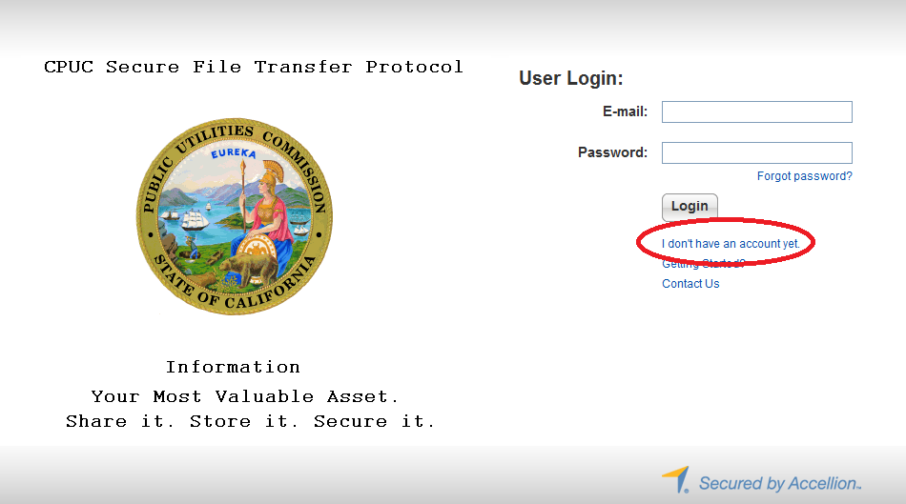

- To complete the registration process, enter your email address. (See Figure 2 )
Figure 2
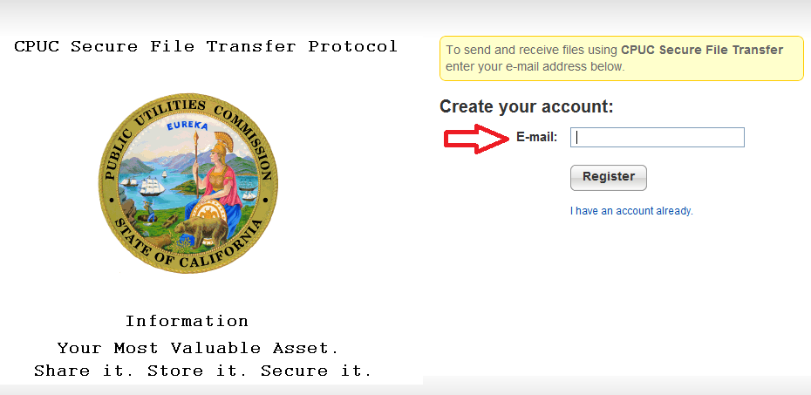

- A verification code will be sent via email. (See Figure 3)

Figure 3
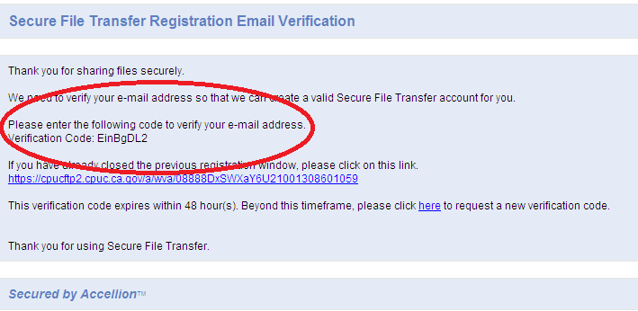

- To verify your account, enter the verification code. Click “Verify.” (See Figure 4)

Figure 4
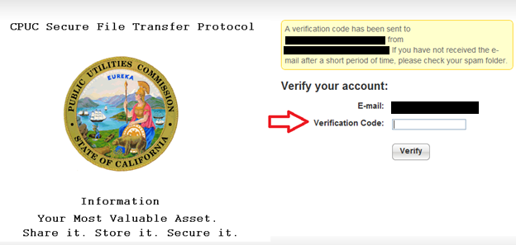

- The setup process will ask you to create a password and to re-type it. Click “Register” upon completion. (See Figure 5)

Figure 5
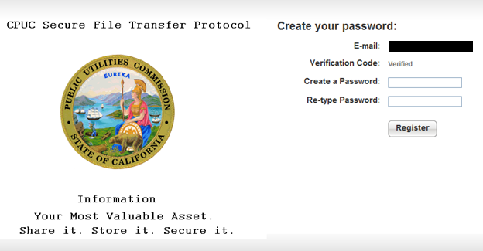

- Upon successful registration, this message should appear, and immediately forward you to the home page of the application (See Figure 6)
Figure 6
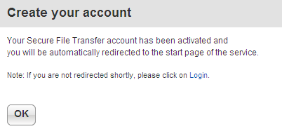

Access CPUC Secure File Transfer via Email invitation

1. If you were invited to use the program, an email was sent to you from the inviter. Click on the link that is provided. (See Figure 7)

Figure 7
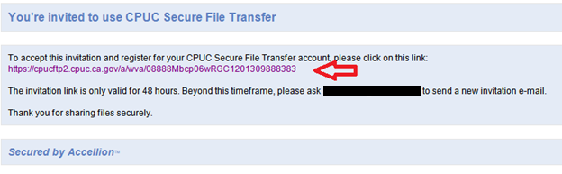

2. After you click the link, create your password. Click “Register” and following successful registration; it will direct you to the main page. Note: it has to contain at least 6 characters with one uppercase and one number. (See Figure 8)

Figure 8
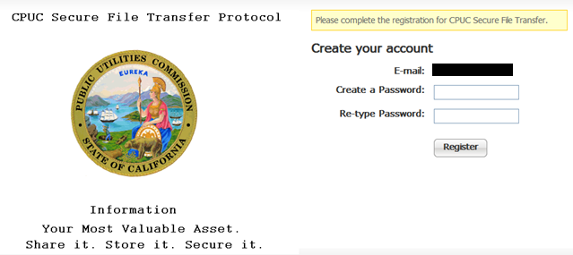

Sending Files

Follow steps below to send files. This applies to both internal and external users:
- Enter recipient’s email address
  - External users may only send files to recipients within CPUC. Please contact Help Desk for special circumstances.
- Enter Subject

1. To attach files to the email message, click on “Choose File/Folder.” If you have files already uploaded into the File Manager, then click on “Choose from File Manager.” (See Figure 9)

Figure 9
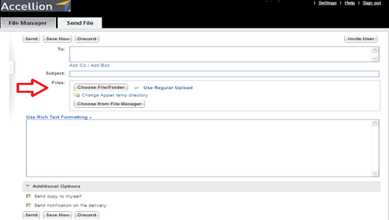

2. Select the folder/file you want to attach and click “Attach.” (See Figure 10)

Figure 10
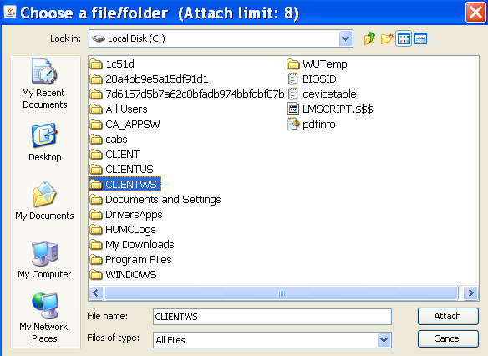

4. The attachments will upload and appear on top of your message. Click “Send.” (See Figure 11)

Figure 11
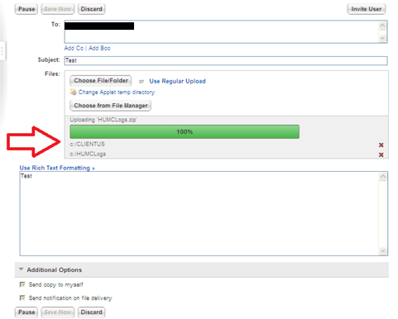

5. Following a successful sent email, a notification page will appear (See Figure 12)
- Note: Folders are converted into zip files.

Figure 12
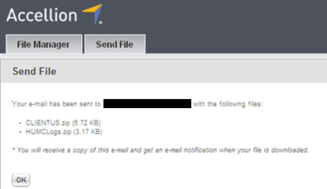
Confirming files that were sent or uploaded to the File Manager
1. Click on “File Manager” on top of the page, and it shows all the files you have sent or uploaded in the File Manager (See Figure 13)

- The file manager is for you to store files, so you can easily select them to send later. You can add files to the cabinet by clicking “Add Files.”

Figure 13
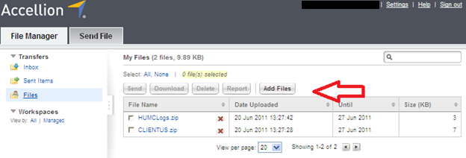

Receiving files

1. You will be notified via email when you have received a file. Click on the “Download File” link (indicated by the red arrow in Figure 14)

Figure 14
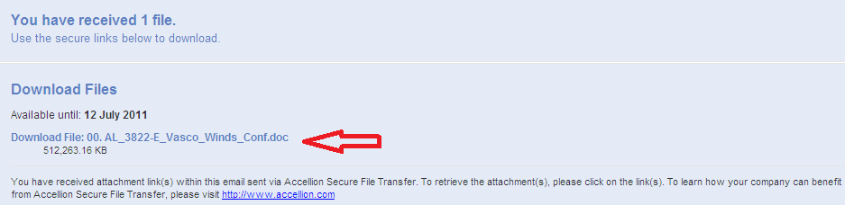

2. You will be directed to a download page. If your browser blocks downloads, click on the blue highlighted bar, and click “Download File.” Otherwise your download will automatically begin. (See Figure 15)

Figure 15
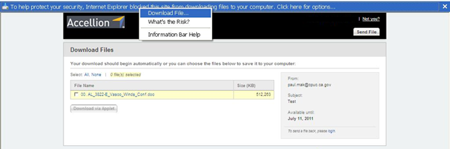

RA compliance materials site is linked here: http://www.cpuc.ca.gov/PUC/energy/Procurement/RA/ra_compliance_materials.htm
Section 4.3.5 and OP 6(f), link here: http://docs.cpuc.ca.gov/PUBLISHED/FINAL_DECISION/119856.htm
http://docs.cpuc.ca.gov/SearchRes.aspx?DocFormat=ALL&DocID=97619935
D.05-10-042, section 7.9
http://delaps1.cpuc.ca.gov/CPUCProceedingLookup/f?p=401:59:3813823951043::NO
3 In the case of demand response resources, the Commission will design future programs to meet CAISO and CPUC RA criteria, for flexible, system and local, as they exist in this proposal and as these criteria are modified in the future.
D.08-04-023, Section 4.2.6
The transfer capacity on Path 26 must be de-rated to accommodate ETCs that are used to serve load outside the CAISO control area. “Loop flow” is common to large electric power systems and must be accommodated to prevent overloading of lines.

