Energy Division Straw Proposal on Limited Integration of Demand Response and Energy Efficiency Activities
under Energy Efficiency Applications (A.17-01-013 et al.) and Demand Response Applications (A.17-01-012 et al.)

California Public Utilities Commission

June 2017

Table of Contents
Proposal for Limited Integration of Demand Response and Energy Efficiency Activities 3
1. Summary 3
2. Introduction 3
3. Background & Policy History 3
4. History of Integrated Demand-side Management Policy 4
5. Proposal Description 9
6. Proposed Budget Framework 13
7. Coordination across Application Proceedings 16
Appendix A: EE-DR Integration through TOU-friendly Energy Management Technologies 19
Appendix B: Strategies for Deploying DR-Enabled EE Measures in the Non-Residential Sector 33
Appendix C: Energy Efficiency and Demand Response Retrofits: Technical Attributes and Cost Estimates 39

Proposal for Limited Integration of Demand Response and Energy Efficiency Activities

Summary

In this three-pronged proposal, Energy Division recommends a limited integration of Energy Efficiency (EE) and Demand Response (DR) through 1) residential HVAC controls and 2) non-residential HVAC and lighting controls. We propose repurposing the Integrated Demand-side Management (IDSM) budget to fund this limited integration and to ensure the cost-effectiveness of integrated EE programs are not negatively affected. Though IDSM is a statewide program approved through the EE application proceeding, nearly its entire budget derives from DR funds authorized in that proceeding.

We also propose: 3) integration of the DR and EE potential studies to support analysis under the Integrated Resource Planning (IRP) process. This third element would be funded through reauthorized DR research funds and existing EE Evaluation, Measurement and Verification (EM&V) funds.

Introduction

This is a critical time for distributed energy resource (DER) optimization to ensure ratepayer and customer capital investment matches the grid’s dynamic needs rather than simply providing static electricity demand (kW) or annual electricity consumption (kWh) reductions. The bulk power and distribution system needs are rapidly changing as increasing amounts of variable renewable energy resources are introduced onto the grid. This change creates a need for flexible energy management technologies that are not limited to only decreasing energy consumption (kWh), but that can optimize energy consumption on a time variant basis, by reducing load in the evening through efficiency and by shifting loads to daytime periods when renewable supply is plentiful. Automated energy management technologies that integrate EE and DR have the potential to manage energy consumption on a time-of-day basis, as well as geographically, with little or no customer disruption.

The short-term objective of this proposal is to spur a robust discussion among stakeholders of the EE and DR proceedings at a joint workshop on June 26, which could inform party comments in the two proceedings in the weeks that follow. Given the coincident timing of the two proceedings, decisions approving the 2018 EE and DR applications could be coordinated to adopt budgets and high level concepts for limited DR and EE integration at least through 2022.The details of most integration proposals could be addressed in 2018 through advice letter filings in the EE proceeding.

Background & Policy History

In January 2017, the IOUs filed applications for DR budgets (2018-2022) and EE business plans (2018-2025). Staff believes this presents a unique opportunity to jointly develop EE/DR policy integration in both proceedings. In past years, the timing of the DR and EE applications has not been synchronized, which one study found to be a barrier to EE/DR integration. Scoping memos for both application proceedings included limited EE/DR integration as a distinct topic to consider. The March 15, 2017 DR scoping memo for consolidated Application (A.)17-01-012 included the following topic:

Should the Commission explore joint activities in demand response and energy efficiency by integrating funding and program implementation in a limited-manner, e.g. targeting specific controls, conducting necessary studies?

Four DR parties have commented on the subject of integrating DR and EE. As discussed below, SCE proposed broad integration in its 2018 application and reaffirmed this in its March 9, 2017 response to party protests. PG&E, in its March 9, 2017 reply to party protests, said that ALJ Atamturk’s mention of limited integration of EE and DR at a pre-hearing conference should be out of scope for A.17-01-012. PG&E further commented that it seeks a clear line between what DR programs incentivize and incentives from programs such as EE that are involved with distributed energy resources. In its February 27, 2017 protest of IOU DR applications, the California Large Energy Consumers Association (CLECA) objected to SCE’s proposal to consolidate EE & DR at this time, while DR programs are in transition to greater integration of DR into CAISO markets and new models of DR to meet grid needs. CLECA added that, because of the size of EE budgets and staff, there is a risk of losing focus on DR and its unique issues if the two are combined.

In their February 27, 2017 protest of DR applications, the Joint Demand Response Parties commented in support of combining EE rebates & DR incentives, as discussed by SDG&E in its portfolio application. The Joint Parties noted that this synchronizing of investment in DR and EE is increasingly important as third party DER providers offer a broader suite of options to customers and streamline distributed energy resources investments for customers. Stakeholder testimony filed May 11 on the 2018 DR applications included similar comments.

In the EE Application (A.17-01-013), the April 14th scoping memo included the following topic:

12. Coordination between energy efficiency and demand response portfolios (also being evaluated concurrently by the Commission in separate applications)

Parties did not comment substantially on the subject of integrating DR and EE in reply to the EE scoping memo, beyond outlining existing IDSM programs within the EE Business Plans.

History of Integrated Demand-side Management Policy

Integrating demand-side program offerings has been an objective of the Commission for decades, and in the most recent interation since 2007. The Commission has provided extensive guidance to the utilities for promoting integrated program offerings of EE, DR, and distributed generation (DG) programs. In D.07-10-032, the Commission required the utilities to “integrate customer demand-side programs, such as energy efficiency, self-generation, advanced metering, and demand response in a coherent and efficient manner.” The intent of integrating DSM programs described in that decision was to achieve maximum savings while avoiding duplication of efforts, reducing transaction costs, and diminishing customer confusion.

Per D.07-10-032, integration would address the full range of comprehensive consumer demand-side options, promote a systems integration approach within RD&D, design, hardware, controls, codes and standards, and installation and maintenance, and would include a process to engage external subject matter experts.

California’s Long-Term Energy Efficiency Strategic Plan adopted by the Commission in September 2008, includes a chapter dedicated to Integrated Demand-Side Management goals and objectives that the utilities were to reference for their 2010–12 program. Additional Integrated Demand-Side Management related guidance in D.09-09-047 established a joint utility Integrated Demand-Side Management taskforce. The Commission provided guidance on the issue of integrating demand-side energy programs and resources in, among other things, D.07-10-032, the April 2008 Assigned Commissioner Ruling, the October 2008 Assigned Commissioner Ruling, and D.09-09-047.

An August 2010 Ruling on guidance for the 2012-2014 DR applications directed that future authority and funding for the DR portion of statewide IDSM program activities be considered in EE proceedings starting with the 2013-2015 EE portfolio. Although considered in the EE proceeding, joint funding of IDSM-related programs is accomplished through a combination of EE funding and DR funding, authorized most recently in D.12-11-015 and extended in D.14-10-046.

The Order Instituting Rulemaking for the Integrated Distributed Energy Resources (IDER) proceeding (R.14-10-003), formerly called the IDSM proceeding, highlights Commission and State of California policy dating to 2005 that calls for utilities to integrate demand-side customer resources. The OIR notes that to fulfill AB 32 and other state energy policy mandates without duplication of efforts, “the Commission recognizes the need to integrate planning and programs across energy technologies and activities which impact load on the customer-side of the meter.’’ Among the list of functions and policies that the R.14-10-003 OIR aims to unify includes goals and potential, and funding levels and sources. Although EE/DR program integration objectives were envisioned in the IDER OIR, the proceeding took a different direction (to pursue DER competitive solicitations and other sourcing mechanisms in concert with the Distributed Resource Plans proceeding, R.14-08-003). In light of that, Energy Division staff believes the best near-term opportunity to pursue EE/DR integration is through a limited scope of joint activity in the 2018 EE and DR applications.

Research Supporting Integration
The CPUC’s Omnibus IDSM evaluation report found that the different timing of EE, DR, and distributed generation program cycles is a barrier to integration, while on the customer level, completing multiple applications with differing review times and funding cycles discourages sites from completing integrated projects.

On March 1, 2017, the CPUC published the 2025 California Demand Response Potential Study. Study findings underscored the emerging importance of shifting loads to periods of high renewable generation to facilitate integration of renewables onto the grid and avoid excess generation and curtailment. This shift, or increase, includes a commensurate load decrease during times when demand and energy prices could be high and renewable resources are less prevalent. The study found that on a system-wide basis, a shallow, frequent load shifting, which may not be noticeable to the customer, was the single biggest benefit DR will be able to provide to the grid in 2025 and beyond.

The study findings support proposals here, such as the TOU-enabled thermostat proposal in Appendix A.

The DR potential study found the following potential for load shifting in 2025. The “load shifting’’ product listed first could, according to the study, be accomplished through a dispatchable supply-side product, or more simply and cost-effectively through rates. The “load shaping’’ refers to load modifying demand response accomplished through rates.

- Load Shifting: The study found potential for 10-20 GWh of this shallow daily load shifting DR are cost competitive in 2025 if the automation technology is paid for both with site-level services (“co-benefits’’ including EE, discussed below) and through revenue (CAISO energy markets, etc.) or other incentives reflecting the value of “Shift” resources to the system. Resources that shift load into high-curtailment hours, the study found, can offer significant capital investment and operational cost savings by reducing renewable over-generation, and preventing the need to overbuild renewables capacity to meet clean energy goals. Using a demand curve framework simulated by E3 Consulting’s RESOLVE model, the study found up to some $700 million a year in system-level value from dispatchable daily energy shifts enabled with advanced control technology.

- Load Shaping: The study also found that load modifying TOU rates could at almost no cost contribute to supporting grid needs, albeit not on a dispatchable basis. The study found TOU rates could provide approximately 1 GW of load shedding. The study also found TOU rate could provide 1.8 GWh of load shifting per day for 2025 – indicating that significant load can be shifted throughout the day with price signals from retail rates. In 2025 this shift resource would represent approximately 0.3 percent of load.

The figures below illustrate the potential for load shedding (first table) and load shifting (second table) through rates, including an event-based DR rate program called Critical Peak Pricing (CPP). The potential study examined three scenarios of TOU and CPP rate design and participation levels. For more information on the rate mixes and scenarios modeled, see Section 5 of the study, which is linked above. Importantly, these potential projections do not assume automation of controls which we have proposed here and which we would expect to heighten this potential.

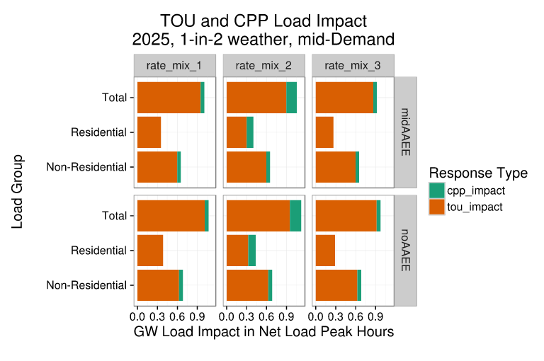

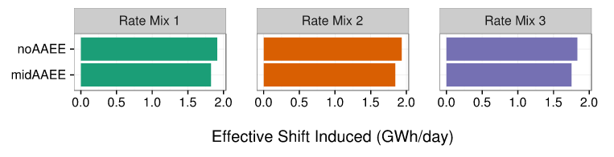

One of the most emphatic recommendations of the DR potential study is to integrate demand side resources, most especially those that combine EE and DR. The study comes at this from a number of approaches. They center on three types of high-DR-opportunity controls:

- residential HVAC controls (smart thermostats)
- commercial HVAC controls (energy management systems)
- commercial lighting controls

The DR potential study uses the concept of “co-benefits” for certain end uses, where the same technologies or device upgrades that enable DR (e.g. smart thermostats, building energy management systems (EMS), or lighting controls), produce other benefits by allowing a building to operate more efficiently. The study modeled these economic benefits as a percentage of DR enabling technology costs by which the upfront cost attributed to DR would be reduced. The study includes co-benefits for lighting (luminaire-level, zone level) controls, refrigerated warehouses, residential AC (smart thermostat), commercial HVAC (EMS), EV chargers, and batteries. For more information, see Appendix I-3.3 of the DR potential study (link provided above in a footnote on Page 5)

Initial Technology Cost Reduction from Co-Benefit (EE and kW reduction)

    - Commercial and residential HVAC controls: 30%
    - Lighting controls (non-residential) 75%

This cost reduction is reflected as increased DR potential throughout the study and is presented as an alternate scenario for DR services potential. For the most part, the increase in DR potential due to co-benefits is significant.

While the potential study findings on co-benefits are presented under the framework of DR potential and cost, Energy Division staff note that they inherently represent savings to the customer through more efficient EE and DR site improvements, and to the ratepayer, through more efficient EE and DR programs (e.g. without duplication of outreach, marketing, site visits, etc.) The potential study highlights these themes in other recommendations, below.

OpenADR
Is an open and standardized way for electricity providers and system operators to communicate DR signals with each other and with their customers using a common language over any existing IP-based communications network, such as the Internet. Its use is widespread in the DR industry. http://www.openadr.org/overview
For more information, see Appendix C.

The study also makes integration recommendations tied to site-level energy management. Section 9.3 of the study talks about the inefficiency and customer confusion caused by the separate planning, management and evaluation of utility EE and DR goals. Further, it notes that customer engagement would be more cost-effective if the technology costs for EE and DR were integrated. The study cites an example from the Sacramento Municipal Utility District (SMUD.) When new building HVAC automation or lighting controls are incentivized with EE funds, SMUD requires the incented EE technology to support OpenADR (See Box 1).

Ensuring that incentivized EE technologies support OpenADR “future-proofs’’ the building, the study says, so it will be less expensive for the building to join a DR program in the future. The study also notes the importance of jointly completing the design, installation, building commissioning, and incentives for EE and DR measures. Finally, the study discusses the site-level energy management optimization that comes from integration: “Enabling a building or end use with the control and communication systems necessary to provide DR often presents an opportunity to simultaneously upgrade equipment with energy efficiency measures, improve the operation and scheduling of a load to better serve site needs, and ultimately reduce energy service costs for building owners.’’

In Section 9.1, the study highlights a tremendous lost opportunity that integration of DR building controls could address. The report notes that the California Energy Commission has developed requirements to install DR automation technology as part of Title 24. These requirements’ success could greatly reduce the new DR systems’ first cost. Not only can the Title 24 requirements reduce the cost for automated DR in new buildings, they could also help to disseminate key information to control companies about the commitment to formal communication standards for DR automation. “For large building control systems, the DR automation cost could be extremely low if the DR automation was available in conventional building automation system controls.’’ Further, the majority of large commercial and industrial DR is installed with gateway boxes. Unfortunately, the report notes, there is great confusion about the current DR requirements in Title 24, and code officials and key market players have received little to no education on the intent of these DR requirements.

Southern California Edison IDSM Proposal
We also note here that in its 2018 DR portfolio application, Southern California Edison (SCE) proposed a sweeping demand-side management consolidation. In its policy overview, SCE recommends that the Commission consider consolidating planning and funding for DR, EE and distributed generation. SCE recommends procedural paths to allow this change to take effect in January of 2018, which SCE notes coincides with the start of the new EE Business Plan period and the 2018-2022 DR funding period. SCE also recommends a workshop so stakeholders can develop a planning and funding proposal for Commission consideration and adoption. The procedural path SCE recommends is to establish demand-side management goals in the IRP proceeding. IOUs, SCE says, could request resulting demand-side management program funding in a combined proceeding.

Proposal Description

The staff straw proposal focuses on three elements. The first two address how to encourage inclusion of DR-enabled HVAC and lighting controls or energy management systems in EE programs. These are further detailed in Appendices A and B. The third element proposes integrating the EE and DR potential studies in future planning studies.

- Integration Element 1: Residential (and Small Commercial) Control Technologies that Facilitate TOU and Dynamic Rate Participation
This is a cohesive five-part proposal addressing mostly the residential sector, but is also applicable to small commercial customers. The premise is that customer acceptance and increased adoption of TOU and dynamic rates (such as CPP) can be facilitated through energy management technologies (EMTs) that can automatically respond to price signals and maximize bill savings in a “set it and forget it” mode. These same technologies can facilitate participation in DR programs that dispatch loads into CAISO markets.

The Commission plans to place all residential customers on default time of use rates in 2019. In preparation for that, the Commission has authorized various activities to promote price-responsive devices and facilitate customer adoption of time-varying rates and residential DR programs. These include residential opt-in and default TOU pilots authorized under D.15-07-001, marketing education, and outreach (ME&O) activities regarding TOU, and AB 793 activities to encourage adoption of EMTs. In addition, rate reform ME&O activities are being coordinated with the statewide Energy Upgrade California campaign. This proposal is not meant to duplicate these activities. Rather, it is a targeted set of activities intended to complement them.

The proposal in Appendix A capitalizes on the 2019 default residential TOU plans, and could maximize TOU load shifting impacts of small businesses. The Appendix A proposal is built around the concept of a thermostat pre-programmed to be TOU ready, including an inexpensive non-communicating version that could be accessible to low income customers. According to the proposal, “many are concerned about the effects that default TOU rates might have on low-income and other at-risk customers. While those with relatively flat loads have little to fear from a switch to TOU, customers with high peak loads (e.g. homes in the central valley) would perhaps benefit more than most from improved insulation, education, and TOU-friendly EMTs, all of which can be provided at no cost to low-income customers.”

The proposal is composed of the following five activities:
- Coordinate TOU-related outreach efforts within EE, DR, and AB 793 marketing, energy and outreach (ME&0) ;
- Market and evaluate price-responsive thermostats within PG&E’s SmartRate (a residential Critical Peak Pricing rate);
- Collect standard usability scale scores for energy management technologies (EMT) being used or considered for use by IOUs;
- Work with industry and marketing experts to settle on standard customer-friendly TOU and DR terminology and language; and
- Work with vendors to develop and manufacture a cost-effective TOU-friendly thermostat, focusing on usability and effectiveness for low-income homes.

Implementation: The activities would be implemented through the IOUs, in consultation with Energy Division staff, or possibly in some instances directly by Energy Division staff and its consultants. Staff proposes these activities specifically for IOUs, and not all program administrators, because we propose these activities be funded from the IDSM budgets, which are IOU-specific funding. However, we welcome comments from parties regarding whether / how these or similar proposals could be structured for non-IOU program administrators.

The details of the proposal would be developed through an advice letter process, wherein the IOUs actively consult with Energy Division staff on the contents of the advice letter (AL) in advance of filing, and Energy Division staff may direct the IOUs to seek stakeholder input in advance of filing. Staff recommends some flexibility be granted to modify or augment the specific activities proposed for adoption in the advice filing.

Budget and funding: As discussed further below and in Appendix A, the estimated budget for this proposal is $690,000. Staff proposes a funding allocation up to $1 million for this proposal to be funded out of the statewide IDSM program budget, and potentially complemented with ED EM&V funding for select sub-activities such as coordination of TOU-related outreach. This allows for a funding margin if the final proposal submitted by advice letter requires additional funding. Staff seeks comment from stakeholders on whether this funding is necessary and sufficient for the proposed activities.

- Integration Element 2: Incentives and Installation Support for DR-enabled HVAC + Lighting Controls and Other Technologies in the Non-Residential Sector

Provided below is a suite of potential strategies involving mostly non-residential HVAC and lighting controls. The basic premise is that when installing EE measures that receive an incentive paid by ratepayer-funded EE programs, there are many cost-effective opportunities to ensure those measures have automated DR capabilities and link those customers to utility or third-party administered DR programs. Appendix C provides some background information on the OpenADR architecture, and some data on associated hardware, software, and labor costs.

Staff provides these proposals as a starting point for discussion, recognizing that, upon further review, some of these ideas may be found to better than others and additional ideas may surface.

- Automated DR-ready Energy Management Systems – Use DR funds for incentives to cover the cost of making energy management systems OpenADR-compliant or for any needed training of control vendors, etc. Consider requiring program participants to agree to allow the utility to share their contact information with DR aggregators in exchange for an incentive.
- Automated DR-ready Air Conditioners – Encourage manufacturers participating in upstream incentive programs to configure embedded controls to receive a signal from the IOU or a third-party.
- New Construction – Savings by Design and Performance by Design – Use DR funds to incentivize energy management system vendors to enable and program equipment to be Open-ADR ready. Require lighting control systems to possess OpenADR capability, in coordination with title 24 requirements. Also, fund training of vendors and installers, as well as training or marketing needed to reach progressive design firms.
- DR-enabled Ballasts and Lighting Control Systems – Use DR funds for incentives to cover the incremental cost of DR-enabled ballasts. Incorporate wireless-controlled tubular LEDs into lighting programs, as a replacement technology for T8 fluorescent lamps. Incentivize and provide training and education to vendors and contractors for automated DR-enabled lighting controls.
- Demonstration Projects to Add Efficient Fan Controls to DR- and Web-Enabled Thermostats for Small Business – Demonstrate the benefits and costs of adding efficient fan controls on rooftop AC units for small commercial buildings, which typically have stand-alone controls.

- Variable Frequency Pumps and Drives for Industrial and Agricultural Customers – Pilot the use of variable frequency drives in commercial HVAC to test scalability, interconnection and performance for distribution and transmission services. Facilitate agricultural customers adding variable frequency pumping with internet access to their irrigation pumps.

Appendix B provides additional information regarding these strategies.

Wise Use of Ratepayer Funds
In developing and implementing strategies, it will be critical to insure wise use of this upfront investment of ratepayer funds. Key questions include:

- Does the DR program uptake from this upfront investment warrant the associated costs?
- How much more efficient and cost-effective is it to make these changes upfront, considering the uptake?
- Would a third-party DRP have made the investment in these autoDR capabilities for their customers anyway, or would the customer have done it themselves?

These questions will need to be addressed in the design and evaluation of any integration strategy. We solicit stakeholder input on these questions.

Implementation: Staff believes that, given the current guidance in the EE proceeding towards expanding the role of third-party implemented programs (D.16-08-019), a likely vehicle for deployment of these strategies would be competitively bid programs specifically dedicated to pursuing integrated EE-DR strategies. These strategies span a range of non-residential market segments, end-use technologies, and retrofit versus new construction, each having their own characteristics which may impart unique program design and go-to-market considerations. Staff does not presume to have all these answers, but we anticipate the third-party market entities are in a good place to design such programs. Therefore, staff recommends that a specific tranche of funding be established to pursue third-party implemented, competitively bid delivery mechanisms.

To the extent that the IOUs remain as implementers of certain programs where these integration strategies could be made to happen, then staff propose that the IOUs be required to make proposals for how these strategies would integrated into the programs they implement. Alternatively, if the IOUs themselves propose to incorporate these or similar strategies into their own IOU-run programs, staff believe those proposals should be considered as well. Thus, staff recommends that flexibility be granted to the IOUs, in consultation with ED staff and stakeholders, to determine which strategies are most amenable to IOU- versus third-party implemented approaches. These considerations should include how best to scope and solicit innovative proposals from the third-party market in specific market segments.

The IOUs should be required to make an advice filing providing the details of which strategies, and through which implementation mechanism (IOU or third-party run), the IOUs will pursue integration in the non-residential sector. The IOUs should be required to actively consult with Energy Division staff on the contents of the advice letter in advance of filing, and Energy Division staff may direct the IOUs to seek stakeholder input in advance of filing.

Budget and funding: As discussed further below, the proposed budget for this proposal is
$ 18.93 million annually, funded from a reauthorized IDSM budget in A.17-01-013. Staff seeks comment from stakeholders on whether this funding is necessary and sufficient for the proposed activities.

Integration Element 3: Joint Funding of a Joint EE-DR Potential Study to Inform the 2019 IRP
Energy Division proposes to incorporate or combine the methodology used in the CPUC’s first DR potential study – the 2025 California Demand Response Potential Study - into the EE potential study scheduled to publish in May 1, 2019. The results of the current DR potential study are being used as inputs to the 2017 IRP modeling, and we anticipate this need to continue in future IRP cycles. There is an opportunity, in 2019, for an updated DR potential analysis to synch up with the 2019 EE potential study, required by May 1, 2019, pursuant to D.15-10-028. This timing would coincide well with the expected timing for the 2019 IRP process.

The current DR potential study recognized that, in some case, EE measures can reduce DR potential because a more efficient unit has less load to drop in a DR event. However, as noted above, the DR potential study also recognized great potential for synergies in program delivery and so-called “co-benefits,” which could in fact increase cost-effective potential when EE and DR measures and strategies are assessed in aggregate. Study integration could focus on areas in which end uses and controls straddle both EE and DR and offer high potential, as well as on integration of methods.

Thus, staff believes there is great merit in updating the DR potential study so that refreshed data is made available for the next IRP cycle, and in conducting the study in combination with the EE study. The specific details of how to orchestrate this vision can be worked out by staff and its consultants.

Proposed Budget Framework

Budget Summary
In summary, staff proposes the following minimum budgets and funding sources for the three integration elements:
- Integration Element 1: Up to $1 million one-time, funded from a reauthorized IDSM budget in A.17-01-013.
- Integration Element 2: Up to $18.93 million annually, funded from a reauthorized IDSM budget in A.17-01-013.
- Integration Element 3: Up to $1 million annually, funded from a reauthorized DR research budget in A.17-01-012.
We solicit stakeholder input on how much funding is needed to accomplish this work over the next five years (the duration of the DR portfolio cycle) and approaches to allocating funding contributions from EE and DR sources.

We discuss the rationale for the funding levels and approach in more detail below.

Conceptual Approach
This staff proposal has a three-part conceptual approach which informs the proposed funding structure for Integration Elements 1 and 2:

- EE programs are the locus of integration – The proposed activities (especially Integration Element 2) will occur through the vehicle of an EE retrofit or new construction program. This is because EE programs already provide incentives for efficient HVAC and lighting technologies, and associated controls, and therefore the customer touchpoint and opportunity to “tag on” DR capabilities is a natural fit. These programs often include marketing and outreach to customers, vendor and contractor trainings, and audits. In order to capture the efficiency of combining EE and DR, Staff believes it makes sense to add the relatively small DR “add on” activity to the existing EE program infrastructure.

- DR-enabling controls – The proposals involve embedding DR enabling functions into EE end use or building controls (e.g., to allow pre-programmed or automated response to TOU or dynamic rates - event-based or hourly - or dispatch into the CAISO markets, etc.)

- Leveraging EE & DR – The integration work will enable customers to gain EE benefits – but also to more fully benefit from TOU rates, dynamic rates, and if they choose, dispatchable supply-side DR programs, while supporting the operations of the bulk power and distribution systems.

For Integration Element 3 (the combined EE and DR potential study), the conceptual approach is to cost-share among funding sources, as appropriate, given the scope of work required for new EE and DR modeling, research, and analysis, and attributable to each resource area.

Funding Sources: Integration Elements 1 & 2

For Integration Elements 1 and 2 we propose utilizing the existing statewide IDSM funds. Pursuant to D.12-11-015, IDSM-related activities are funded through a combination of EE and DR funds authorized in the EE application proceedings. DR funds make up the bulk of the IDSM budgets (See Table below). The EE IDSM program is a non –resource program, meaning it provides supporting activities such as research, tools, and coordination process. However, pursuant to D.12-05-015, the IDSM program does not provide funding for incentives to promote integrated projects. Historically, these funds were used to develop an integrated audit tool, conducted studies on integrated cost-effectiveness and evaluation methods, and coordinated marketing and outreach activities across DER program.

The 2017 authorized funding by IOU for the IDSM program is shown in the table below.

2017 IDSM Authorized Funding
 | EE IDSM Funds (SW) | DR IDSM Funds | Total IDSM Funding
PG&E | $559,000 | $3,264,000 | $3,823,000
SCE | $136,999 | $10,137,000 | $10,273,999
SDG&E | $391,814 | $4,639,999 | $5,031,813
Total | $1,087,813 | $18,040,999 | $19,128,812

To staff’s knowledge, the EE IDSM funds currently support internal coordination efforts among IOU programs, as well as the continuing reporting and compliance requirements that were established when the IDSM program was more active. Staff has submitted data requests to the IOUs to determine how the DR IDSM funds are currently spent. Staff believes the greater integration impact can be had by using these funds to facilitate actual installations of DR-enabled EE measures, rather than coordination and reporting efforts alone.

Staff proposes that some or all of the proposed activities in Integration Elements 1 and 2 be funded from the (roughly $20M) IDSM budget. We propose to substantially replace the currently funded activities with those proposed herein, although we seek comment from the IOUs and parties as to whether any currently funded activities should continue. Because we expect the funding to mostly be spent on encouraging installation and adoption of DR-enabling platforms and controls, we find it appropriate that the DR funds contribute the lion’s share. We find it reasonable to maintain the current cost-sharing proportions for that reason, but we seek stakeholder comment on whether this is the right allocation, given the specific activities proposed.

Staff envisions two ways in which funding could be appropriately distributed to ensure that the costs and benefits attributable to each resource are aligned with each funding source. The first centers on incentive costs related to the incremental cost of controls and automated DR. The second addresses non-incentive program related costs that could be incurred.

- Incremental cost of DR enabling technology – Use the funds to pay for (a) the incremental cost of adding a DR-enabling function to a control system or (b) the full cost of a control system less some estimate of the EE benefits. This could be an upstream incentive to a manufacturer, an incentive to a vendor programming controls for a large commercial building, or to a customer, to support their choosing a more complete control that might have an incentive paid.
  - See Appendix C for information on incremental cost from the LBNL.

- Enhancing Cost-Effectiveness of Relevant EE Programs – Recognizing that EE programs are the most likely vehicle for these efforts, funds could be targeted to cover the costs of including DR in any non-incentive activities such as customer outreach, installation of related equipment (such as the cost of dimmable ballasts in conjunction with a lighting control upgrade (above)), and contractor and customer education about DR controls, TOU rates, and other DR programs.

D.12-11-015 placed some restrictions on how IDSM funding could be used, namely that funds should not be used to pay for incentives. Thus, staff recommends the Commission relax this restriction to enable these funds (which will mostly be DR funds) to pay for incentives to cover the incremental cost of DR-enabling platforms or controls, as described above.

Funding Sources: Integration Element 3

For Integration Element 3 we recommend reauthorization of DR research funding (currently $1 million annually) in A.17-01-012. The EE portion of the proposed EE-DR integrated potential study is already funded under EE EM&V funds, most recently authorized in EE decision D.12-11-015 and extended in D.14-10-046. Staff sees no need for further Commission action to provide necessary EE funds for this.

A funding source for DR research studies, directed by Commission staff, was first authorized in D.12-04-045 was since reauthorized. The large majority of those funds were spent on the DR potential study ordered in D.14-12-024. In order to update the DR potential study so that refreshed inputs can be made available for IRP modeling, staff recommends replenishing these funds with a new authorization at the same $1 million annually level.

Staff does not expect the update to DR potential to expend the entire requested budget. However, several DR research projects which were originally planned had to be set aside in order to prioritize the 2017 DR potential study. New research projects have also surfaced since the 2017 study was completed and these require additional funding. Staff believes that reauthorizing the DR research budget at the current $1 million annual level will provide sufficient funding for the DR portion of the proposed integrated EE-DR potential study, as well as additional research projects. The EE portion of the proposed integrated study would come from already authorized EE EM&V funding.

Coordination across Application Proceedings

This integration proposal requires action in both proceedings. The table below provides a proposed list of actions that could be taken in each proceeding to implement this proposal.

Staff Proposed Action for EE Proceeding | Staff Proposed Action for DR Proceeding
Direct proposed Integration Elements 1 and 2, including related implementation and advice letter process | Address proposed integration Elements 1 and 2, and determine whether any guidance or funding authorization is needed.
Authorized continuation of existing IDSM funds for Program Integration Elements 1 and 2.

Maintain current EE / DR funding proportions for IDSM budget

Augment EE funds, if necessary.

Repurpose EE / DR funds from existing IDSM activities to proposed Program Integration Elements 1 and 2
Increase the DR portion of the IDSM budgets, if necessary. | Authorize additional DR funds, if necessary.
Provide more flexibility for use of IDSM funds (e.g. allow them to be used as incentives to pay the incremental cost of adding DR capability) | Address impacts of proposed integration elements on DR program cost-effectiveness
If necessary, authorize expenditure of EM&V funds for joint evaluation studies of the pilot integration efforts proposed here.
 | Authorize $1 million annually for five years for continued DR potential research, including an updated DR potential study expanded to integrate with the EE potential study scheduled for May 1, 2019
Sanction a combined EE-DR potential study, to the extent feasible. Identify IRP inputs as an objective. | Sanction a combined EE-DR potential study, to the extent feasible. Identify IRP inputs as an objective.

Next Steps

Energy Division seeks stakeholder input to modify or augment this proposal with new ideas presented at the June 26 workshop and in formal comments. If time permits, staff intends to update and recirculate this proposal after the workshop.

Major milestone dates in the DR application proceeding, according to the March 15, 2017 scoping memo include:
- Closing briefs – July 14
- Reply Briefs/Record submitted – July 28
- Proposed Decision – October 2017

The schedule for the energy efficiency proceeding is currently under development and will be established in a forthcoming ruling.

Thus, record development on this proposal would most likely occur in the July 2017 timeframe to inform proposed decisions in Fall 2017.

Attachments:

Appendix A: EE-DR Integration through TOU-friendly Energy Management Technologies

Appendix B: Strategies for Deploying DR-enabled EE Measures in the Non-residential Sector

Appendix C: Incremental cost of adding DR to EE controls – from LBNL

APPENDIX A

Appendix A: EE-DR Integration through TOU-friendly Energy Management Technologies
A proposal to facilitate the integration of energy efficiency (EE) and demand response (DR) into California’s time-of-use (TOU) implementation effort.

Karen Herter, Herter Energy Research Solutions, Consultant to Energy Division staff
June 1, 2017

  - Overview
Beginning in 2019, roughly 10 million homes in California are anticipated to be placed on time-of-use (TOU) electricity pricing, according to the CPUC’s goal set forth in Decision (D.)15-07-001. Meanwhile, the IOUs have opt-in TOU rates are available to residential customers, but participation is generally low. Ongoing statewide pilots are now underway to test opt-in and default TOU rate design and their customer acceptance, billing impacts, and load impacts.

In recent years, small commercial customers were transitioned onto mandatory TOU rates and the transition to default critical peak pricing (CPP), a dynamic rate, is complete or underway at various stages in the IOUs service territories. While load impact evaluations of the small commercial sector have shown that these time-varying rates have resulted in an overall conservation effect, thus far, they have shown little time-differentiated load impacts.

The statewide effort to encourage TOU price response for these customers provides an opportunity to increase both energy efficiency (EE) and demand response (DR) resources in several ways. For example, utilities can educate and encourage customers to improve the efficiency of their building envelope and air conditioning (AC) to prevent high cooling loads during peak hours. Other loads likely to run on peak can similarly be targeted for improved efficiency. As the peak hours move towards the evening in the coming years, EE education might shift focus also, to lighting, television sets, and electric cooking.

Since time-varying rates are designed to motivate customers to shift loads out of peak periods, the residential default TOU implementation effort can be used as a gateway to (1) educate customers about the benefits of automating TOU response and (2) recommend appropriate energy management technologies (EMTs). Customers who choose to install Internet-connected EMTs, such as WiFi thermostats, can then take advantage of further bill savings through automated DR. Studies indicate that empowering customers to respond to TOU prices encourages EE purchases and behavior [1], bringing the EE-TOU-DR effort full circle.

EMTs need not be internet-connected to respond to TOU prices – they need only have programmable schedules designed to reflect the current TOU rate periods, and ideally, preset defaults ready to respond to the existing TOU schedule as installed. Internet-connected EMTs can respond not only to TOU, but also to dynamic rates like critical peak pricing (CPP) or real-time pricing (RTP), by pulling information from websites where hourly rates are posted.

This paper proposes a series of steps to attain the following goals:
- widespread automated TOU response via standalone EMTs (not internet-connected)
- increased energy efficiency (EE) via more involved and better educated customers
- increased dynamic price response (DPR) via internet-connected EMTs
- increased opportunity for direct load control (DLC), along with a reduced need to use it

  - Current Approach: No TOU – Siloed EE – Utility-controlled DR
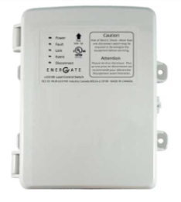
As an example of conventional DR, one might consider direct load control (DLC) of air-conditioning, implemented through utility-controlled thermostats or switches. The goal of these programs is to allow control of end-uses by the utility during DR events, and to discourage (or at least not encourage) interaction by the customer. This strategy is effective for DR, but does little or nothing to promote EE or TOU response [2]. In addition, participation in DR programs is limited to customers willing to allow the utility to control their appliances, leaving a large untapped resource of those who would participate if they could control their own response.
DLC switch: Tamper-proof and definitely not customer-friendly

Imagine instead EMTs that customers want installed and working because they provide the ability to save money through automated TOU response. Under this scenario, EMTs become desirable consumer products in the sense that their main purpose is to provide services to the occupant, not to the service provider.

  - Near-term Objective: Customer-friendly EE-TOU-DR Automation
A single EMT device can integrate EE, TOU and DR for small customers by (1) automating efficient operation of appliances, (2) avoiding TOU peak rates, and (3) offering the opportunity to participate in dynamic pricing (e.g. CPP) or direct load control programs. Combined with integration of customer outreach efforts and improved insulation, EMTs provide the state with the opportunity to vastly expand the EE-TOU-DR potential in California.
- EE Automation. Many EMTs are already designed to optimize the energy use of appliances through operational timing and intensity. Examples include thermostats that learn customer schedules and power strips that automatically shut down when they sense the attached equipment is not being used. As technologies evolve, EE optimization algorithms and routines are expected to expand and improve.
- TOU Automation. In addition, a variety of EMTs enable customers to schedule their appliances to avoid operation during peak TOU rates. Unfortunately, this functionality is not always user-friendly. Many electric vehicle chargers can be considered TOU-friendly, because they can easily be programmed to charge during off-peak hours using TOU terminology and graphical interfaces. In contrast, thermostats are generally poorly designed for TOU response, often providing only time and temperature settings in cumbersome text menus. Most also limit users to just four time periods per day, insufficiently covering customer schedules plus precooling and TOU needs.
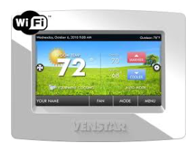
- DR Automation. Finally, EMTs that are connected to the Internet can be programmed to respond not only to TOU rates, but also to pricing and load control signals. Customers who choose to install Internet-connected EMTs to help them respond to the new TOU rates in 2019 can then be offered participation in these programs.
Internet-connected smart thermostat: enables interaction
Together, these efforts will support more educated and engaged customers, energy efficiency and conservation, and flexible system demand resources. In the longer term, EMT automation has the potential to optimize needs between the customer and the grid, opening the possibility to a higher penetration of renewable resources and real‐time supply‐demand balancing.

  - A Word on At-Risk Customers and TOU Rates
Many are concerned about the affects that default TOU rates might have on low-income and other at-risk customers. While those with relatively flat loads have little to fear from a switch to TOU, customers with high peak loads (e.g. homes in the central valley) would perhaps benefit more than most from improved insulation, education, and TOU-friendly EMTs, all of which can be provided at no cost to low-income customers through Section 2790 of the Public Utilities Code.

Any device with a programmable schedule, including those without Internet connections, can be considered a TOU-ready EMT. Without Internet access, such devices can be made inexpensively while providing significant bill savings, and so might be an ideal fit for low-income homes. Unfortunately, these devices are generally not designed to be particularly user friendly – a feature that is particularly important in this demographic.

Going forward, policies might target the development of more TOU-friendly devices, i.e. those designed specifically to help customers respond to TOU rates. Such devices might use standard terminology and approaches to time periods so that customers can easily move from one device to the next to program TOU automation without learning an entirely different set of words and menu options.

One example of an existing TOU-friendly device is the Chevy Volt charging system, which allows the user to define separate time periods for peak, mid-peak, and off-peak TOU rates in the charging menu. For at-risk customers, devices like non-communicating thermostats and electric water heater controls might be more appropriate targets for simplified TOU programming. Efforts to develop more TOU-friendly thermostats and other controls might look to existing TOU-friendly programming, like the charging menu on the Chevy Volt, and perhaps work towards industry standards.
Current Approach
- No TOU
- Separate EE & DR programs & measures
- Utilities control DR, customers control EE
Objectives
- EMT automation enhances EE, TOU response, and (optionally) DR
- TOU-friendly devices made available to at-risk customers to lower bills
  - Research Findings
Multiple studies have shown significant EE, TOU, and DR savings in programs that combine EMTs with time-varying TOU or TOU-CPP rates. For example SMUD’s series of "Summer Solutions” pilots for small businesses, single-family, and multifamily homes used thermostats with price response capability. Given the training, technology, and TOU motivation, Summer Solutions customers easily automated precooling, peak offsets, and event response to lower their bills and benefit the system (Table 1).
Table 1. Single-family EE, TOU and DR impacts in Sacramento (average kWh/hour)
Rate + Technology | N | Overall EE | TOU peak | DR event
Tiered rate | 56 | -0.00 (-0.0%) | -0.09 (-3.8%) | -0.26 (-8.2%)
Tiered rate + AC load control | 78 | 0.02 (1.3%) | -0.01 (-0.2%) | -0.88 (-30%)
TOU-CPP + AC price response | 83 | -0.06 (-4.1%) | -0.71 (-32%) | -1.71 (-58%)
TOU-CPP + AC load control | 96 | -0.07 (-5.3%) | -0.64 (-29%) | -1.71 (-57%)
Notes: TOU peak and DR events occurred from 4 to 7 pm. Values in bold are statistically significant (p<0.05)
Source: SMUD’s Single-family Summer Solutions Pilot [1]

Recommendations provided here are drawn from findings from the 10 Consumer Behavior Studies completed for the U.S. Department of Energy under ARRA funding and 11 other smart grid studies completed by the Sacramento Municipal Utility District. These 21 pilots investigated combinations of customer smart grid offerings, with the following results.
- Electric vehicles (EVs) are the sweethearts of the TOU-friendly EMT family. Many EVs are equipped with TOU-friendly programming, and research shows that nearly all EV owners on TOU rates program their cars to charge off-peak, discounting or even eliminating the need for EV load control or EV-only dynamic pricing [11].
- Price-responsive thermostats enhance EE, TOU and DR in:
  - Single-family homes [1]
  - Small businesses [3]
  - Multi-family homes [4]
- Precooling – is one of the best candidates for making use of the midday solar generation surplus. Long, shallow precooling (2°F for 6 hours) was shown to reduce peak demand, save energy, and lower bills in well-insulated homes [6].
- On average, low-income customers
  - … on TOU rates save more than do standard rate customers [7]
  - … without TOU might not benefit from existing EMTs (Nest, IHD) [5]
- TOU-CPP rates are more effective for EE, TOU, and DR than is load control [2]
- In-home energy data displays are not (yet) effective for EE, TOU or DR [8], but these technologies are evolving quickly
- Usability testing indicates that about half of commonly used smart thermostats do not meet the minimum recommended usability score (SUS) of 50%, potentially jeopardizing the cost-effectiveness of smart thermostat rebate programs [9][10].

  - Recommendations

  - 1. Integrate EE and DR into default TOU education and outreach
The first step in accomplishing the objectives of this proposal is to develop an integrated approach to educating customers about how they can minimize TOU bills using EMTs, through improved energy efficiency, peak avoidance, and precooling. (Project 1)

For example, ensuring sufficient insulation should be part of any outreach effort or program that makes use of precooling. Research indicates that a higher level of ceiling insulation can make the difference between energy use increasing or decreasing as a result of precooling. On average, customers in Sacramento homes saved 6% on their energy bills by setting their thermostats 2 degrees cooler than normal for 6 hours prior to the TOU peak period every weekday – not just on event days. This effect was enhanced for those with higher levels of ceiling insulation, who saved energy and money while maintaining occupant comfort [6].
Project 1: Coordinate TOU outreach efforts with EE, DR, and AB793 efforts.
Goal: Provide a complete and integrated package of EE-TOU-DR options for customers to respond to TOU rates by 2019.

Other ideas for integrating marketing and education taken from the 21 pilots include:
- Use non-technical, consistent language to educate customers about EE, TOU, and DR.
- Use EMT installation visits as an opportunity to offer brief audits and recommendations for basic EE-TOU-DR opportunities, like improved weatherization, more efficient equipment, additional EMTs, or programs.
- Educate customers on the importance of:
  - Scheduling thermostats and other large loads to avoid the peak price
  - Scheduling thermostats to precool prior to TOU or CPP peaks
  - Weatherizing to optimize comfort and the effects of precooling
  - 2. Enable automated TOU response by posting electricity prices
In 2008 the CPUC, CEC, and CAISO collaborated to develop the California Demand Response Vision: “California electricity consumers will have the opportunity and capability to adjust their electricity usage in response to time-varying signals reflecting economic, reliability or environmental conditions.” Around the same time, an open standard for communicating pricing and demand response information called Open Automated Demand Response, or OpenADR, was being developed to facilitate the technology needed to make the Vision a reality.
What is OpenADR?

OpenADR is a data model used to communicate price schedules, DR events, and grid stability information from utilities to ADR-compatible devices over the Internet, using encrypted connections for privacy and security. OpenADR is an open standard, which means that anyone can freely implement the standard without a license [16].

The California IOUs currently maintain OpenADR servers to communicate commercial and industrial TOU rates and DR signals, allowing large customers to automate response and optimize bill savings. With default residential TOU prices on the horizon, customers will benefit if the CPUC and IOUs prioritize the effort to publicly post the new TOU rates on existing IOU OpenADR servers, allowing residential customers to program their EMTs to automatically respond to daily TOU prices. This effort will help integrate large and small customer DR efforts. Perhaps more importantly, IOU-posted prices would reduce or eliminate the need for customers to reprogram their price-responsive EMTs every time utility rates change.

This is particularly important given the CAISO’s near-term system load forecasts showing high midday solar surpluses – a.k.a. “the belly of the duck.” Each time IOUs post updated TOU prices reflecting higher midday supply, customer EMTs programmed to respond to price (rather that time) will immediately shift to operate during the new low-priced midday hours, taking advantage of the generation surplus and helping to fill the duck’s belly.
Project 2: Market and evaluate price-responsive thermostats within PG&E’s SmartRate program, allowing participants to automate response to TOU rates and CPP events.
Goal: Determine customer uptake and incremental EE-TOU-DR load impacts of EMTs under an existing TOU-CPP rate.

Intuitively, price-responsive EMTs would be highly desired by participants of TOU-CPP tariffs, so as a first step, price responsive OpenADR devices might be marketed to – or at least pilot tested within – the 140,000 customers on PG&E’s TOU-CPP SmartRate. (Project 2)

  - 3. Encourage user-friendly EMTs to enhance EE-TOU-DR automation
Of the 21 pilots reviewed for this paper, every one that investigated smart thermostats found that the automation of air-conditioning for TOU peaks and DR event response enabled demand reductions 2 to 3 times higher than manual response, and price responsive thermostats consistently outperformed load control thermostats. Following these findings, we recommend the CPUC support the development and marketing of user-friendly smart thermostats and other EMTs with the following functions.
- Required features – communications not needed
Project 3: Collect Standard Usability Scale (SUS) scores for EMTs being used or considered for use at IOUs.
Goal – Begin a database of SUS scores for available EMTs to allow informed IOU procurement choices.
  - Default schedules avoid TOU peak rates
  - Default precooling or preheating (as appropriate)
  - Industry-standard terminology
  - Usability score of at least 50% (Project 3)
- Optional features – communications needed
  - Open-ADR compliant
  - TOU and CPP price response
  - Utility-controlled DR
  - Whole-house energy data display

Smart thermostats are considered the obvious low-hanging fruit for TOU response during hot California summers, but a wider variety of strategies must be considered for load management in other seasons, particularly spring and fall, when solar production is high and customer demand for electricity is relatively low. A few examples of large end-uses that could be automated using EMTs to contribute to seasonal energy management are shown in Table 2. Under CPUC Resolution-4820, IOU customers will be able to review and purchase EMTs through the California IOU’s online energy technology marketplaces.
Table 2. Opportunities for automated peak load shifting using EMTs
End use | kW | Spring | Summer | Fall | Winter
Electric vehicle | 3-20 | ○ | ○ | ○ | ○
Electric water heater | 10 | ○ | ○ | ○ | ○
Hot tub | 6 | ○ | • | ○ | ○
Heat pump | 6 | • | ○ | • | ○
Air conditioner | 3 | • | ○ | •
Electric space heater | 2 | • |  | • | ○
Swimming pool | 1 | ○ | ○ | ○ | ○
Lighting | 1 | ○ | • | ○ | ○

  - 4. Encourage industry standard terminology for EE-TOU-DR scheduling
As California prepares for the implementation of default TOU pricing in all sectors, policy-makers should take the lead in facilitating the development of user-friendly EMTs by organizing the industry around standard terminology for EE, TOU, and DR scheduling. This can be accomplished through a review of the terms currently in use – peak, mid-peak, off-peak, shoulder, discount period, super peak, etc. – as well as the research already completed in this area, and then supplement the current knowledge through new research (e.g. focus groups) to fill any remaining gaps. (Project 4)
Project 4: Work with industry and marketing experts to agree on standard customer-friendly EE, TOU and DR terminology.
Goal: Encourage the development of more user-friendly EMTs through consistency of user-interface language and logic.

  - 5. Work with vendors to develop and pilot a cost-effective TOU-friendly thermostat, focusing on usability and effectiveness for low-income homes
Under Section 2790 of the Public Utilities Code, EMTs and improved insulation are provided to low-income customers through the IOU’s low-income weatherization programs. This provides a remarkable opportunity to help at-risk customers manage their bills through integrated EE-TOU-DR.

Low-income customers can respond to and benefit from TOU rates, but they might need special consideration. For example, the Nest Learning Thermostat did not reduce energy or peak demand in low-income homes in the central valley as expected, but instead increased their electricity bills by 10% - without a rate change. This does not imply that smart thermostats are not useful for low-income homes. Rather, it indicates that the usability and features of this particular thermostat were not compatible with the needs of low-income homes. Before recommending or providing EMTs to customers, especially low-income customers, California IOUs should test their usability and effectiveness with like customers in advance. (See Project 3.)
Project 5: Work with vendors to develop and pilot a cost-effective TOU-friendly thermostat, focusing on usability and effectiveness for low-income homes.
Goal – Manufacture a thermostat that pays for itself in two years by shifting energy use away from the TOU peak period, featuring:
- SUS score of at least 50%
- Industry-standard TOU terminology
- Default schedule avoids TOU peak
- Default precooling prior to peak

In addition, the majority of low-income customers in California have central air conditioning, meaning there are potentially large bill benefits of precooling and TOU peak avoidance. Providing low-income customers with increased insulation and a low cost, TOU-friendly thermostat would help them cost-effectively manage their bills under the new TOU rates. (Project 5)

  - Summary
Based on a review of 21 pilots completed over the past 5 years, the following course of action is proposed to prepare residential and small commercial customers for TOU rates while enhancing opportunities for energy efficiency (EE) and demand response (DR).

 | Recommendations |  | Projects | Cost*
1 | Integrate EE and DR into default TOU education and outreach |  | Coordinate TOU marketing, education and outreach efforts with EE, DR, and AB793 efforts | $50k
2 | Enable automated TOU response by posting electricity prices |  | Market and pilot test price-responsive thermostats within PG&E’s SmartRate program, allowing participants to automate response to TOU rates and CPP events. | $250k
3 | Encourage user-friendly EMTs to enhance EE-TOU-DR automation |  | Collect Standard Usability Scale (SUS) scores for EMTs being used or considered for use at California IOUs | $80k
4 | Develop industry standard terminology for EE-TOU-DR scheduling |  | Work with industry and marketing experts to settle on standard customer-friendly EE, TOU and DR terminology | $135k
5 | Address the TOU needs of low-income and other at-risk customers |  | Work with vendors to develop and pilot a cost-effective TOU-friendly thermostat, focusing on usability and effectiveness for low-income homes | $175k
*Estimated consulting, equipment and marketing fees

For a more detailed explanation of each Project and its associated costs, see Attachment 1.

  - References
[1] Herter, Karen and Jenya Okuneva. SMUD’s Residential Summer Solutions Study: 2011-2012. Prepared for SMUD. January 2014.
[2] Herter, Karen and Jenya Okuneva. SMUD’s 2013 PowerStat and Pricing Study – Load Impact Evaluation. Prepared for SMUD. March 2014.
[3] Small Business Demand Response with Communicating Thermostats: SMUD’s Summer Solutions Research Pilot, with S. Wayland, and J. Rasin. LBNL-2742E, September 2009.
[4] Sutter, M., S. Wayland, and K. Zhou. 2014. Public Interest Energy Research (PIER) Energy Savings through Smart Controls in Multifamily Housing Study. Prepared by Opinion Dynamics for the Sacramento Municipal Utility District.
[5] Herter, Karen and Jenya Okuneva. SMUD’s Low Income Weatherization & Energy Management Pilot – Load Impact Evaluation. Prepared for SMUD. December 2014
[6] Herter, Karen and Jenya Okuneva. SMUD’s 2012 Residential Precooling Study Load Impact Evaluation. Prepared for SMUD. June 2013.
[7] Herter, Karen and Jenya Okuneva. SMUD’s Load Impact Calculator (SLIC) for Smart Grid Cross-Pilot Evaluation. Prepared for SMUD. December 2014.
[8] S Potter, J., S. George, and L. Jimenez. 2014. SmartPricing Options Final Evaluation. Prepared by the Sacramento Municipal Utility District for the U.S. Department of Energy.
[9] Herter, Karen and Jenya Okuneva. SMUD’s Communicating Thermostat Usability Study: A simultaneous, multi-user, paired comparison test of communicating thermostats for task efficiency, preference, and perceived usefulness of advanced features. Prepared for SMUD. February 2014.
[10] Herter, Karen and Jenya Okuneva. SMUD's 2015 Smart Thermostat Usability Study. Prepared for SMUD. January 2016‬‬.
[11] Herter, Karen and Jenya Okuneva. SMUD’s EV Innovators Pilot – Load Impact Evaluation. Prepared for SMUD. December 2014
[12] Herter, Karen and Jenya Okuneva. SMUD’s IHD Checkout Pilot – Load Impact Evaluation. Prepared for SMUD. December 2014
[13] Herter, Karen and Jenya Okuneva. SMUD’s Smart Thermostat Pilot – Load Impact Evaluation. Prepared for SMUD. December 2014.
[14] Herter, K. R. Levy, J. Wilson, and A. Rosenfeld. Rates and Technologies for Mass Market Demand Response. LBNL-50626. ACEEE Summer Study on Energy Efficiency in Buildings, August 2002.
[15] Cappers, P., and R Scheer. Final Report on Customer Acceptance, Retention, and Response to Time-Based Rates from Consumer Behavior Studies. November 2016.
[16] Herter, Karen, Josh Rasin, and Tim Perry. Development And Demonstration Of The Open Automated Demand Response Standard For The Residential Sector. December 2009.

  - Attachment 1. Estimated Project Costs

- Coordinate TOU outreach efforts with EE, DR, and AB793 outreach efforts
Project 1 could be completed internally at the CPUC. If outside help coordinating these efforts is desired, 20 months of light coordination effort by a consultant (~10 hours per month) is likely to cost about $50,000. The costs of increased, improved, and integrated marketing, education and outreach – for example, marketing of and within the IOU marketplace websites required by Resolution 4820 – is difficult to quantify at this time, but is expected to be in the millions of dollars.
Project 1. Integration of EE-TOU-DR Marketing, Education and Outreach
Schedule | Deliverables | Estimated Cost
Summer 2017 – Fall 2018 | Consulting | $50k
 | Total project cost | $50k

- Market and evaluate price-responsive thermostats within PG&E’s SmartRate
Studies to date have unanimously shown that customers on CPP rates perform better with price-responsive thermostats – shedding 2 to 3 times as much load as customers without them. Project 2 would involve the implementation of a Randomized Encouragement Design (RED) with price-responsive thermostats on PG&E’s 140,000 existing SmartRate customers to automate AC control and boost their response during CPP events. Under an RED, half of the SmartRate customers would be randomly chosen to be marketed a thermostat, while the other half would serve as the random control.

Using this approach, there would be no equipment costs for thermostats beyond marketing and existing rebates, as the equipment and installation would be the responsibility of the customer under an RED. If desired, separate treatments could be incorporated to include a variety of thermostat offerings, still at no additional equipment cost to the IOUs.
Project 2. Price-responsive Thermostats for SmartRate customers
Schedule | Deliverables | Estimated Cost
Summer 2017 | Find/prepare OpenADR-capable thermostats | $20k
Fall 2017 | Beta-test, usability surveys, choose pilot thermostat(s) | $20k
Winter 2018 | Randomized Encouragement Design (RED) | $20k
Summer 2018 | Collect and clean/organize data; Process reporting | $10k
Fall 2018 | Analyze data and write report | $30k
 | Total consulting fees  Equipment costs  Marketing (offer thermostat to 70,000 customers) | $100k  none  $150k
 | Total project cost | $250k

- Collect Standard Usability Scale scores for EMTs being used or considered for use at IOUs
The main recommendation of the 2015 Smart Thermostat study is that prior to procurement, simplified usability testing using the SUS survey should be conducted with at least 22 participants stratified by age and self-reported tech savvy, and that the EMT must receive a usability score of at least 50% to be considered for implementation. Project 3 would collect SUS scores for any previously untested thermostat (or other EMT) that is being considered for use in California IOU pilots and programs.
Project 3. Usability testing for thermostats and EMTs implemented at IOUs
Schedule | Deliverables | Estimated Cost
Spring 2018 | Investigate, choose, and procure 10 thermostats, EMTs | $10k
Summer 2018 | Usability testing | $25k
Fall 2018 | Analyze data and write report | $15k
 | Consulting fees  Equipment costs (thermostats)  Marketing costs (recruit and pay 120 customers) | $50k  $ 2k  $28k
 | Total project cost | $80k

- Work with industry and marketing experts to settle on standard customer-friendly TOU and DR terminology and language
Since TOU and DR are relatively new concepts to many residential and small commercial customers, success of program marketing and operation would be enhanced by customer-tested terminology and language.
Project 4. Standardize customer-facing TOU and DR language
Schedule | Deliverables | Estimated Cost
Summer 2017 | Review existing knowledge and identify stakeholders | $5k
Fall 2017 | Work with stakeholder group to create potential TOU-friendly language for testing with customers | $10k
Winter 2018 | Customer focus groups to refine TOU-friendly language | $30k
Spring 2018 | Field test marketing materials with surveys | $30k
Summer 2018 | Collect and clean/organize data; Process reporting | $10k
Fall 2018 | Analyze data and write report | $25k
 | Consulting fees  Equipment costs (focus group facility)  Marketing costs (recruit 30 customers) | $110k  $15k  $10k
 | Total project cost | $135k

- Develop and manufacture a cost-effective TOU-friendly thermostat, focusing on usability and effectiveness for low-income homes.
The majority of low-income customers in California have central air conditioning, meaning there are potentially large bill benefits of precooling and TOU peak avoidance. Providing low-income customers with increased insulation and a low cost, TOU-friendly thermostat would enable them to cost-effectively manage their bills under the new TOU rates. A similar process with similar costs could be followed to design TOU-friendly controls for other high-demand appliances commonly found in low-income homes.
Project 5. TOU-friendly Thermostat Pilot Schedule and Cost
Schedule | Deliverables | Estimated Cost
Summer 2017 | Work with vendor(s) to design TOU-friendly thermostat | $20k
Fall 2017 | Beta-test prototype thermostat, modify as needed | $20k
Winter 2018 | Random Control Trial experimental design | $10k
Spring 2018 | Coordinate installation of thermostats and insulation | $10k
Summer 2018 | Collect and clean/organize data; Process reporting | $10k
Fall 2018 | Analyze data and write report | $30k
Winter 2018 | Develop plan to distribute thermostats to at-risk customers | $10k
 | Consulting fees  Equipment costs + installation  Marketing costs (Recruit 150 homes, 50 offices) | $110k  $45k  $20k
 | Total project cost | $175k

APPENDIX B

Appendix B: Strategies for Deploying DR-Enabled EE Measures in the Non-Residential Sector

  - Introduction

This appendix provides a preliminary set of strategies or activities for integrating EE and DR in the non-residential sector. The basic premise is that when installing EE measures that receive an incentive paid for through ratepayer-funded EE programs, there are many opportunities to ensure those measures have automated DR capabilities and link those customers to utility or third-party administered DR programs. Staff provides these proposals as a starting point for discussion, recognizing that some of these ideas may (upon further review) be found to better than others, and additional ideas may surface.

Staff believes that, given the current guidance in the EE proceeding towards expanding the role of third-party implemented programs (D.16-08-019), a likely vehicle for deployment of these strategies would be a competitively bid program(s) specifically dedicated to pursuing integrated EE-DR strategies. These strategies span a range of non-residential market segments, end-use technologies, and retrofit versus new construction; each having their own characteristics which may impart unique program design and go-to-market considerations. Staff does not presume to have all these answers, but we do expect the third-party market entities are in a good place to design such programs. Therefore, staff recommends that a specific tranche of funding be established to pursue third-party implemented, competitively bid delivery mechanisms.

To the extent that the IOUs remain as implementers of certain programs where these integration strategies could be made to happen, then staff propose that the IOUs be required to make proposals for how these strategies would integrated into the programs they implement. Alternatively, if the IOUs themselves propose to incorporate these or similar strategies into their own IOU-run programs, staff believe those proposals should be considered as well. Thus, staff recommends that flexibility be granted to the IOUs, in consultation with ED staff and stakeholders, to determine which strategies are most amenable to IOU- versus third-party implemented approaches. These considerations should include how best to scope and solicit innovative proposals from the third-party market in specific market segments.

The IOUs should be required to make an advice filing providing the details of which strategies, and through which implementation mechanism (IOU or third-party run), the IOUs will pursue integration in the non-residential sector. The IOUs should be required to actively consult with Energy Division staff on the contents of the advice letter (AL) in advance of filing, and Energy Division staff may direct the IOUs to seek stakeholder input in advance of filing. Energy Division staff recognize that IOU advice filings on integration will need to be coordinated with any related activities proposed in the IOU AB 793 advice filings.

- Automated DR-ready Energy Management Systems
IOU EE programs could require energy management systems (EMS) to be DR-ready with the most recent open-source automated DR abilities (OpenADR) in order to receive an incentive. Commercial building energy management systems are one of the most important sources of DR in large commercial buildings. These controls occur through the Building Automation System (BAS) or Energy Management Control System (EMCS). Automation can be installed during retro-commissioning or controls retrofit, under EE programs that retro-commission existing buildings, or commission new buildings. Further, the IOU large commercial and industrial custom calculated retrofit incentive programs incentive EMS systems. These incented EMS should be OpenADR compliant.

Further, AB 802 energy use baseline approaches could make it more cost-effective to require OpenADR compliant control systems in these programs. Supporting this work could entail demonstration projects, and additional training for EMS vendors to ensure vendors understand the DR enablement controls aspect. Also, an enhanced savings (value stream) analysis tool would accelerate market adoption and help overcome numerous market barriers and serve to streamline project M&V.

DR funding could fund an incremental incentive to cover the cost of making EMS OpenADR compliant, and fund any needed training of control vendors or others. The DR funds could improve the cost-effectiveness of the EE program and provide an incentive for utility EE program administrators to include DR.

In addition, program participants could be required in return for receiving incentives to allow their utility to share their contact and project information with DR aggregators. The aggregators could contact them with opportunities for cost-savings from DR programs.

- Automated DR-ready Air Conditioners
Upstream EE incentive programs could encourage manufacturers to configure the controls embedded inside the high-efficiency air conditioner to receive a signal from the IOU or third party. This would apply to 4.5-ton residential and 5-6 ton small commercial units. This could be simpler and more cost effective for some consumers than buying an air conditioner and a smart thermostat. This idea could work in this duct-less model of air conditioner, too.

- New Construction – Savings by Design or Performance by Design
An incremental incentive from DR funds could be offered to encourage energy management system vendors to enable and program the unit to be OpenADR-ready. Further incentives could be provided for intelligent lighting controls that enable dynamically responsive lighting systems. Many of today’s lighting control systems are OpenADR compliant. A requirement that the lighting controls possess Open ADR capability would be a fundamental program component. These efforts would need to be coordinated with Title 24 and DR Auto-DR program efforts. Significant training for vendors and installers would be needed. DR funds could be spent any training or marketing needed to reach progressive design firms working with high-technology new buildings.

We note that an earlier version of the Savings by Design program – Performance by Design – envisioned an incentive that was time-based rather than the current annualized incentive structure. Providing both incentives would promote buildings that consume energy in a manner that supports renewable generation growth and adoption of electric vehicles, etc. rather than exacerbating grid issues, as can happen with EE performed on its own. The Performance by Design approach would also complement the move toward outcome-based energy codes and standards that leverage expanding municipal energy benchmarking in buildings and reflect the developing marketplace for smart buildings.

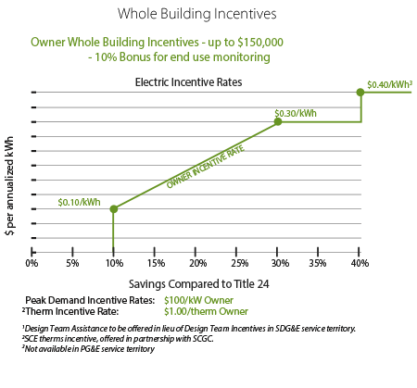
Figure 2: Current Savings by Design (SBD) Incentive Mechanism
Figure 2 shows the static nature of the current SBD incentive mechanism. Reverting to Performance by Design (PBD), which is time-based and more dynamic, bases the incentives on when the savings are achieved in order to better match the near-term needs of the grid and complement the move toward outcome-based energy codes and standards.
- DR-enabled ballasts & Lighting Control Systems

  - Add DR-enabled ballasts to light fixtures when retrofitting lighting. DR funds could cover the incremental cost of the new ballast to allow diming either manually or in response to daylight via a light sensor in the room. If the ballasts are under the control of a wireless control, they could dim in response to a signal from the IOU or aggregator, if the customer chooses to participate in such a rate or program. This could work in any size building that is occupied and lit during the day and spaces where the installed lighting power density is relatively high (e.g. not in warehouses). Occupants often don’t notice the lights dimming.

  - Replace T8 flourescent lamps with wireless controlled TLEDs (tubular LEDs) for customers that would like LEDs. These work with standard instant-start electronic ballasts and easily interoperate with various control devices. These provide significantly improved efficiency to lower the base energy load, controllability, and length of operation before replacement. Further, LED fixture replacements have achieved commodity pricing and the cost for installation in many instances is less expensive than re-wiring old, existing fixtures with questionable optical characteristics for modern environments, with new dimming ballasts and the requisite re-lamping with compatible fluorescent lamps. Operation and maintenance costs would be lower than many comparable options and the fixtures longer-lived.

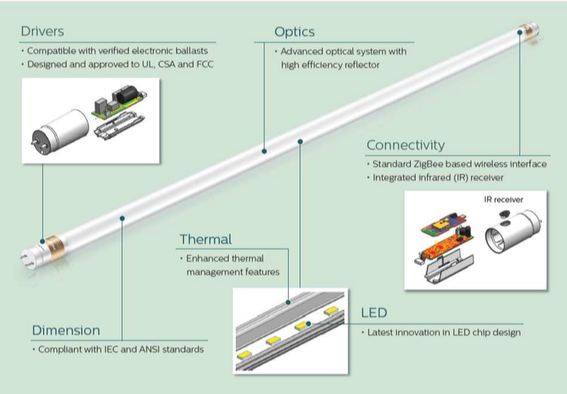
Figure 3: TLEDs (Tubular LEDs) Example (Courtesy of Philips Lighting)
Figure 3 displays a 4’ TLED replacement for a standard T8 fluorescent lamp that comes with an integral driver on one end (that works in concert with the existing T8 instant-start electronic ballast) and a ZigBee wireless interface with an integrated infrared (IR) receiver on the other end. This technology provides an all-in-one retrofit solution that streamlines installation significantly, given that a maintenance person can install them like a simple lamp replacement without having to re-wire a fixture. This would have the added benefit of significantly improved efficiency, controllability and length of operation before replacement. It represents a solid transitional technology versus full system replacement.

  - Add ADR-enabled lighting controls (several vendors produce these.) These systems could automate bi-directional consumption (load consuming and shedding) in settings where occupants would not be disturbed. Vendor and contractors would need to be educated on technology applications. Incentives could be required for both contractors and customers to encourage/incentivize automated response (programming and control) to temporal grid needs should the customer find it financially beneficial to participate in TOU rates, event-based rates and other DR programs. IOU lighting retrofit programs should either require or give extra incentives for lighting controls that have Open ADR.

- Add Efficient Fan Controls to DR- and Web-Enabled Thermostats for Small Business

Small package rooftop units on light commercial buildings have standalone controls. These controls may already be DR responsive to allow the air conditioner to cycle on and off. However, even when the compressor is cycling, the fan is running. And even if the building is unoccupied and the thermostat set point is adjusted to reflect this, the fan is still running. One can add DR controls functions that do two things:

- Slow the fan down if there is no heating or cooling needed in the space and the fan is just ventilating.
- Shut off the fan completely when the building isn’t occupied.

Staff understands that several vendors offer these technologies. A demonstration project that looks at the benefits and costs of efficient fans controls could reveal an untapped resource for the small commercial sector, where it is difficult to find automated EE and DR solutions. Retrofits should focus on existing units with enough remaining useful life to warrant a controls investment. Full replacement of the package units would not be necessary.

Staff recognizes there could be a split incentive barrier since many small businesses rent space. It could require downstream incentives for the small business to participate in the EE/DR program, and the property owner or manager to participate in the installation and retrofit.

One can also consider adding a behavioral component: the thermostat will show messages such as announcing a peak demand event so if someone goes to adjust it on a hot day they will see the message.

- Variable Frequency Pumps and Drives for Industrial and Agricultural Customers

The DR potential study identifies significant DR opportunities for variable frequency drives and pumps in the commercial and agricultural sectors, and a need for pilots, and overcoming barriers in information or costs:

- Agricultural pumping with variable frequency pumps (VFP) - According to the DR potential study Section 7.1.7, VFP technologies are proven to substantially reduce energy use. Irrigation pumps with VFPs and automation have the best potential to participate in DR and permanent load shifting. Nearly all irrigation pumps used for agriculture in California are manually controlled, according to a 2013 study that potential study cites. With internet access, the automated controller at the pump can receive the DR signal and adjust the irrigation schedule according to the DR event to permit ramping pumping up during off peak hours and down during on peak hours with no manual customer interaction. Agricultural customers might not be aware of EE and DR incentives – or might be put off by costs for upgrading equipment.

- Commercial variable frequency drives (VFDs) - According to the DR potential study, DR-enabled VFDs are an extremely responsive technology that can provide fast DR services at the system and local level. The functionality of the VFDs allows for full automation technology to maintain customer comfort levels, limit disruption to operations, and provide fast response DR service to the grid. The technologies should be piloted to test scalability, interconnection, and performance for distribution and transmission system services. (Section 7.1.4 of the DR potential study)

APPENDIX C
LBNL Demand Response Research Center 06/12/17

Appendix C: Energy Efficiency and Demand Response Retrofits: Technical Attributes and Cost Estimates
  - Introduction
The CPUC Energy Division has requested assistance in estimating the incremental costs for adding automated demand response (ADR) and Open ADR (2.0a or 2.0b) automation for controls, and how this relates to energy-efficient HVAC and Lighting end use system capabilities. While there is not a straightforward answer to this question, we provide some information on:

- OpenADR and ADR controls’ components
- How they relate to energy-efficient solutions
- Some first-order cost estimates

Additionally, we discuss these costs related to the EE/DR-enabling technologies necessary to activate buildings to provide responsive loads.

One of the challenges in preparing this information is that there is minimal DR automation cost data. This lack of data is related to how quickly the technology is, and has been, changing, as well as, the lack of concerted (and timely) efforts to collect and organize these data. Unlike energy efficiency, DR automation requires continuous communication, and in the future, California’s DR efforts will be most successful if we standardize information collection about DR system performance. We need to collect and to evaluate cost-effectiveness with consideration of our understanding of system commissioning and continuous operations’ attributes.
Most collected utility commercial buildings program cost data has been based on the $200-$400/kW that the investor-owned utilities (IOUs) have offered for DR automation. Given these targets, many of the costs in the field reflect invoicing that take advantage of this incentive, and it is difficult to ascertain what the costs might, or could have been minus these incentives.
  - Background on Open Standards and OpenADR
Automated DR programs typically cover the first costs to design, install and configure buildings’ or industrial electrical loads to shift, or shed demand in response to a signal. These investments often include control hardware and software that can last for years, and the communication standards that are embedded will in part determine the range of possible future uses for the systems.
Open standards allow multiple vendors to develop interoperable systems while minimizing the use of propriety standards that may result in vendor ‘lock in’. Open standards can lower technology costs by allowing an open competitive market for technology. Experience with OpenADR development is described in Piette et al, (2010). Today, two main open communication standards are used for DR automation in California (CA): Open Automated Demand Response (OpenADR 1.0 and 2.0) and the Smart Energy Profile (SEP 1.0 and 2.0).
“[OpenADR] is an open and standardized way for electricity providers and system operators to communicate DR signals with each other and with their customers using a common language over any existing IP-based communications network, such as the Internet.” Its use is widespread in the DR industry.

SEP 1.0 is communicated through the Zigbee radios in the advanced meters to home area network devices. This system has had limited use. SEP 2.0 is not in wide use yet but most of its development is related to inverter controls. Future SEP 2.0 use might include building loads, but there is limited support for this effort at this time.
Most automated DR in commercial and industrial systems have three key operational elements:
- Communication
- Control
- Telemetry
One configuration of this system architecture is shown below (Figure 1). All early OpenADR 1.0 system configurations used this architecture. The OpenADR signal was sent from the utility or program coordinator to the communication gateway. A gateway is a protocol-to-protocol translation device. Gateways can be hardware and software systems, or software only systems in the case of dedicated, embedded or native OpenADR communications, as further described below. The communication gateway sends a signal back to the program coordinator that the message is received. This continuous communication system operates year-round. When a DR event is received, the gateway communicates with the building controls, which in turn, coordinate and control building loads. Most DR telemetry or measurement is done with advanced meters, but in some cases, additional meters are installed for fast-DR or for aggregators’ measurement, if there is no advanced meter, or if here are telemetry needs beyond what an advanced meter can provide.
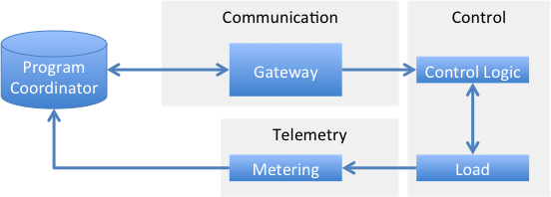
Figure 1. A common automated DR system architecture

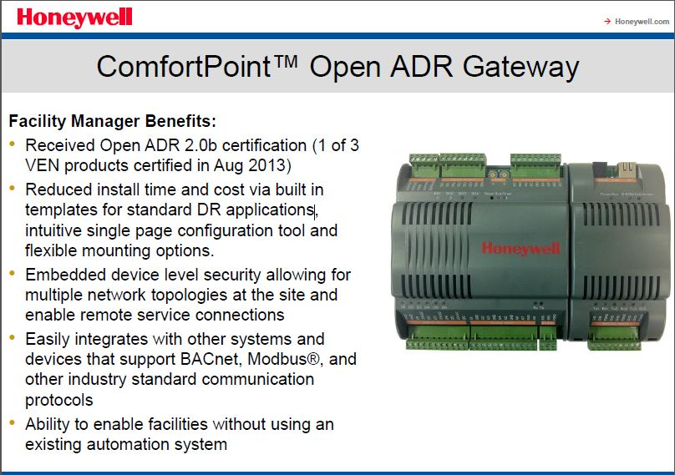
Figure 2. Example of a hardware/software gateway that translates OpenADR signals to BACnet or Modbus, and other communication protocols
  - DR Measurement and Telemetry
Telemetry is an important element of DR systems, as it is the feedback for coordinators to observe the loads under control. This DR automation system piece encompasses the electric meter, any additional measurement systems and measured data communication. Telemetry requirements for automated DR systems range from fast (such as four-second, real-time power measurements over dedicated system-operator networks) to slower, monthly electricity data. Most electric utilities in CA have installed advanced meters that collect suitable interval data to be telemetry for many DR applications (those that are not “fast”). This means additional project costs to cover telemetry can be avoided. Some DR programs and markets require near real-time power measurements, and additional hardware needs to be purchased and installed beyond the electric metering infrastructure.
  - Characteristics that Impact Enabling Automated DR System Costs
Communication Software – As mentioned, stand-alone hardware and software gateway systems are often required to receive DR signals. Some control systems come with an embedded OpenADR software client where no additional hardware is needed. OpenADR typically uses the customers’ existing Internet for communications. In other cases, new DR communications includes installing new or dedicated Internet connections.
Controls - One element that contributes to DR automation costs is control hardware or software purchases. In homes, the DR costs are often associated with installing WIFI or communicating new thermostats. This is also common in small commercial buildings. In many commercial buildings, there is no extra cost to retrofit controls because existing controls can be used for DR. This is most common where an existing building automation system (BAS), also known as energy management and control system (EMCS), is in place. To enable DR, one needs to program an operational sequence in the BAS or EMCS, which entails labor, but typically no additional control system costs. Recently, many utility DR programs have covered costs for control system upgrades, which entail software programming costs to automate most DR systems.
Labor - Labor costs to design and to configure OpenADR communications and DR control system logic can include up-front engineering, installation by a technician, and commissioning tests. In some cases, the hardware contractor is unqualified to make changes to controls. In these cases, a controls expert must be retained to program the requisite changes to the building control sequences. In all circumstances, these professionals must familiar with both the building systems and operational characteristics, and the electricity markets (including electricity rates and tariffs) driving the need for DR-responsive programming. One major caveat is that any systems programming must enable future changes to market conditions and DR programs. This may be mitigated through an ongoing maintenance contract, which of course adds additional cost, but is not captured in this document because it is so highly variable and idiosyncratic to the technology application.
To summarize, there are three types of OpenADR automation:
A – Cloud-based (most common in home Wi-Fi Thermostats) – using OpenADR as part of an internet-based communication system with devices. This is the lowest cost system. There are some plug load control products, produced by firms such as BOSS, that are 120V and 220V adapters that connect over IoT for approximately $100-200 per device. These devices can be utilized on HVAC units, plug loads, and vending machines in commercial applications, as well as residential homes, and there is no limit to the number of the plug load controls for each customer premise. All of the controls are managed in the cloud over the vendor platform, and can be DR-ready. These are some of the least expensive options but the communication link from the cloud to the end-use device is proprietary in the example used here.
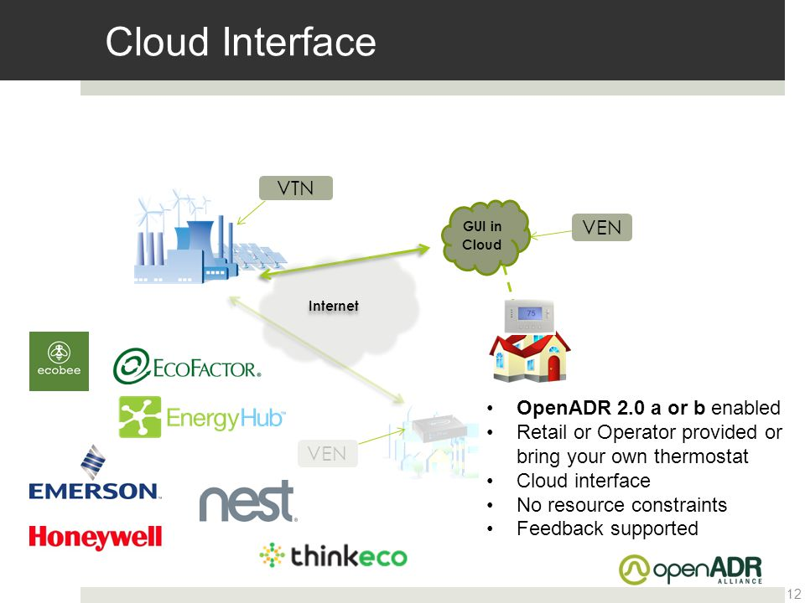
Figure 3. Cloud architecture for OpenADR communications, generally used for residential or small commercial.

B – Native, dedicated, embedded OpenADR – available in several control systems for HVAC and commercial advanced lighting control systems (ALCS). Figure 4 is an example of a Daintree user interface for a vendor who offers OpenADR native control for lighting and HVAC thermostat control. There are typically no additional costs for the DR automation software, but there are costs to program the controls. There may be extra costs for software if the control software is available with and without the OpenADR software gateway feature.
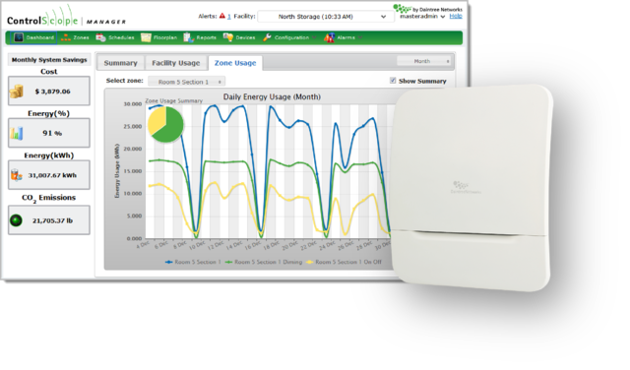
Figure 4. Example of embedded OpenADR for lighting and HVAC controls.

C – Custom gateway-enabled OpenADR – A gateway that receives the OpenADR signals is connected to existing controls, such as an EMCS (described above).
Table 1: OpenADR Hardware, Software, Configuration & End-to-End Communication Programming & Testing
OpenADR Automation Types | Hardware |  | Software |  | Configuration | Testing
Cloud WiFi TStat | $50-200 |  | Manufacturer or Platform Provider Variation |  | $5 one time  $1/month continuous | NA
Native Devices* | BAS: $? | ALCS: $0 | BAS: $? | ALCS: $0 | ALCS: $TBD | ALCS: $TBD
Custom Gateway** | $3k-5k |  | $1k-2k |  | $5k-50k | $2k-10k
*Native devices are systems that come with OpenADR embedded in them and therefore have no extra cost to the consumer. The configuration and testing costs for these devices require further study.
**The costs for the custom gateways depend on the scope of the automation and can be much greater costs for a large complex building.

  - Small Commercial and Residential HVAC units with DR enablement
The cost of an Energy Star-rated HVAC unit for residential customers can run anywhere from $6K to $20K and would typically include a programmable thermostat. If a communicated WIFI DR thermostat such as a NEST or EcoBee thermostat were included instead, the price is approximately $250 (1-5% of the overall project cost). Similar programmable thermostats only cost $100, so a small, approximately $150 incremental investment can enable the system to provide DR.
Wi-Fi thermostats come directly from the manufacturer (e.g., NEST, Ecobee, etc.) or an energy management platform provider such as, Whisker labs or EnergyHub.
 | Initial costs |  | Operating costs
Enabling Technology Component | Equipment and Installation Costs | Variable Initial costs ($/kW) | Fixed Operating Costs ($/yr) | Variable Operating Costs ($/kW/yr)
Direct load control switches (DLC) | $160 | $0 | $17 | $0
Smart thermostats | $300 | $0 | $20 | $0
Table 2: Residential and Small Commercial HVAC controls (OpenADR and ADR controls)
  - Commercial HVAC
As we consider DR costs and the relationship to efficiency upgrades, it is useful to consider the CA Title 24 (T24) baseline. Energy-efficient equipment can be thought of as those that exceed the baseline. There are requirements for DR automation in T24, but there is significant confusion about the interpretation of the requirements and we have seen little DR requirements’ influence (or DR-related standards enforcement) in new buildings and retrofits that “meet Title 24 standards” according to inspection.
For commercial HVAC systems, many DR service providers implement the OpenADR solutions as a complete system (i.e., EE end uses and ADR controls, OpenADR communication), with an EMCS or BMS (e.g., EnerNoc, Johnson Controls, etc.). Therefore, it is difficult to determine the incremental ADR controls and OpenADR platform costs. The 2025 CA DR Potential Study used an estimate of $235 per kW enabled in HVAC systems in medium and large commercial customers. This included the gateway (EMS or similar), controls and automation, installation and programming the software, and sometimes retrofitting or upgrading equipment. It is important to note that when an EMCS is installed, it can control several end uses within a customer building, and it is difficult to untangle the exact costs for DR automation and other end uses within a building.
The energy-efficient, commercial HVAC unit costs for a small commercial customer is a minimum of $20K, not including installation. For a SMB commercial customer that wanted to implement variable ventilation controls (DR capable) with the energy-efficient HVAC system to maximize EE savings and enable DR participation, it would cost them a minimum of $11K for the controls and communication platform, not including installation.
There are some vendors that deploy controls as an overlay on the existing HVAC system and connect to the EMS to receive signals via the OpenADR gateway/platform. The building owner may or may not chose to install EE equipment, because with these types of systems, customers can utilize the VFD system or EMS solution to control ventilation, and therefore, produce EE savings. These technologies can also provide DR, and the controls and platform can typically be installed for around $0.20 per sq. ft. of building space. For the Slice Energy solution, as well as some of the Johnson Controls, this may require that the end use measures are replaced with the more advanced systems, but often, existing end uses are used.
  - Commercial Lighting
Determining incremental costs for implementing OpenADR in commercial lighting systems is not a straightforward question to answer. It depends on whether or not the existing building networked lighting control system has embedded OpenADR already in the lighting controller software (and that it has been certified). If those elements are in place already, the cost to add OpenADR is $0 for hardware and software (see Table 1 above), but there are costs for configuration and testing, which in turn, are highly variable costs and dependent upon a range of factors:
- Building size
- Building type
- Lighting system type and controls/sensor granularity (i.e., zonal versus workstation-specific lighting in commercial offices)
- Building occupancy patterns
- Lighting task categories
- Controls contractor knowledge and market competitiveness

If the controls system is not in place or up to specification, the cost to retrofit depends on whether or not an existing building can readily be upgraded with the necessary hardware and software to bring it up to proper specification. A more fundamental question is: “Does the commercial building have advanced, networked lighting controls?” If not, then essentially, it needs to typically undergo a full system retrofit to fully enable DR employing OpenADR.
The full costs to install viable lighting controls systems range in cost from about $2.00/SF to about $4.50-$6.00/SF depending upon all the items in the bulleted list above, plus additional items. Other potential costs include whether or not the building possesses DR-enabling luminaires (i.e., either LED fixtures with appropriate drivers, or fluorescent fixtures with continuous dimming ballasts).
Fundamentally, within this discussion, one should be cognizant of the fact that commercial building owners will not buy DR-enabled lighting control systems for the DR value alone; they purchase them for the EE and non-energy benefits’ (NEBs) value. The incremental costs for the DR-enabling technology (with embedded OpenADR) are the configuration and testing costs. Determining the share of the rest of the system upgrade costs related to communication and control requires a more holistic assessment to “pro-rate” against the respective system values that can be provided by a single project – EE, DR and NEBs.
  - Integrated DSM Programs
As mentioned, DR automation consists of communication and control technology that can be installed alongside or in coordination with other demand-side technology (EE, etc.). In this section, we summarize some integrated DSM opportunities and examples to illustrate how DR fits.
There is a great opportunity for control system engineers to consider DR automation and control strategies when they are conducting “tune up” type evaluations. These retro-commissioning (Retro-C_{x}) approaches consist of evaluating how the controls are used to determine whether the building can be better controlled for greater energy efficiency. For large commercial buildings, one of the most important DR- enabling elements is programming the sequence of operations. For example, developing the temperature reset strategy for the controls and zones to reduce the cooling loads. With planning, this can be done as part of a “controls tune up” or Retro-C_{x} activity where both energy efficiency and DR are evaluated for relatively low incremental costs compared to commissioning projects. This could also be true for small and medium buildings, but there is less experience with tune-up programs and procedures, and less DR in small and medium commercial buildings.
During recent years, there have been challenges with Retro-C_{x} whole building program measurement and verification (M&V), which is important for incentive qualification and payments. Some new Retro-C_{x} and DR program M&V approaches are developed with whole building data in ways that are similar and potentially complementary to DR telemetry. The M&V 2.0 and the DR baseline work are based on similar methods that use 15-minute electric data with outside temperature data. These data are combined with regressions that characterize the day of week and hour of the day to develop customer baselines for EE and DR evaluation.
Figure 5 below shows the baseline and actual electric load shape for an office building with a two-stage global temperature adjustment from an automated critical peak-pricing event in 2006. The red line is the regression baseline and the dark blue is the actual whole building load shape during the DR event.
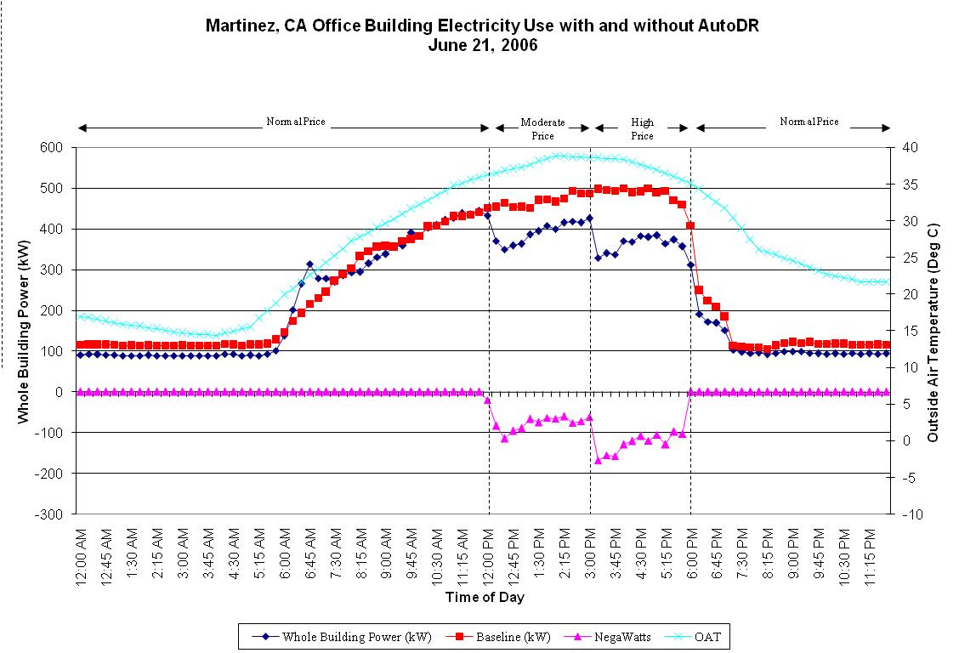
Figure 5: Weather regression baseline and actual whole building electric load shape for an office building with automated critical peak pricing response using global temperature adjustment.
Table 3 below shows the DR automation strategies for over 20 commercial buildings from a 2008 study on automated critical peak pricing. Each of these strategies was developed with the facility manager. Many of these strategies are also part of Retro-C_{x} evaluations. All of these sites used OpenADR 1.0 automation gateways.
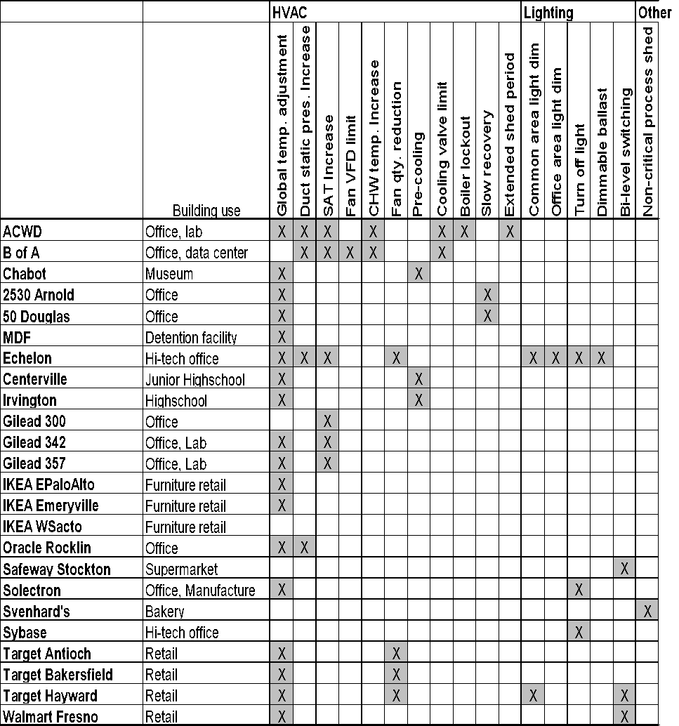
Table 3: Examples of DR control strategies from a 2006 automated critical peak pricing study of PG&E sites.
The majority of sites listed in Table 3 used global temperature adjustment (GTA). However, these sites had different indoor operating temperatures. Figure 6 shows the normal, mid-price and high price temperature reset for the sites with GTA strategies from 18 commercial buildings. Some of the buildings were on the demand bidding program and not critical peak pricing (CPP).
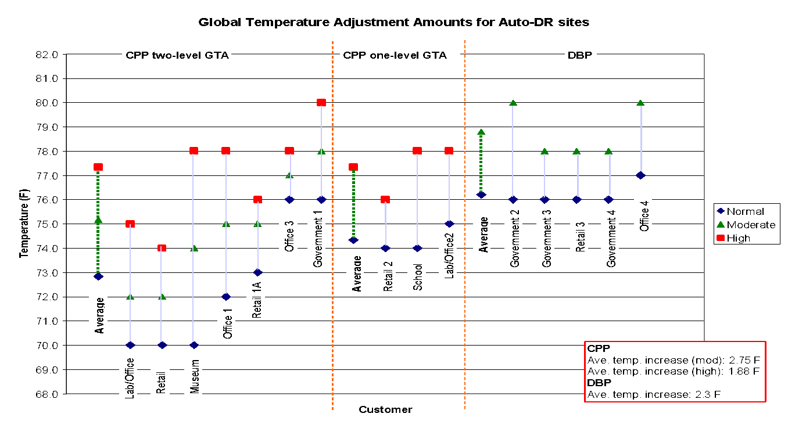
Figure 6: Examples of DR control strategies from a 2006 automated CPP study of PG&E sites.

  - SMUD’s IDSM commercial programs
SMUD has a long list of programs and services that couple OpenADR and ADR controls with energy efficient end uses. Information on their commercial advanced lighting control system incentive program is here. They also offer EMCS incentive programs, (information here) and EE/DR HVAC programs, (information is here and here).
  - Recommendations
This memo has reviewed some of the system architectures and cost data regarding DR automation. We have also described some of the issues related to Title 24 DR requirements and linkages to IDSM and Retro-C_{x}. In general, there are significant opportunities to combine EE and DR programs. However, there is a significant need to improve the understanding of the cost data associated with integrating these programs and coherent M&V methods need to be developed accommodating the integrated approach.

Itron, 2010-2012 CPUC Omnibus IDSM Process Evaluation, October 9, 2012. Available at: www.cpuc.ca.gov/WorkArea/DownloadAsset.aspx?id=10712.
In Volume 1, Page 12 of its 1-17-17 application filing, SCE recommends consolidation of demand-side management (DSM) (EE, DR, and distributed generation) planning and funding with DSM goals determined in the Integrated Resource Planning proceeding and resulting program funding requested in a combined proceeding.
Comverge, Inc., CPower, EnerNOC, Inc., and EnergyHub
D.07-10-032 at p.5
D.07-10-032 at 6
D.07-10-032 at 31
D.09-09-047 at 216
OIR 14-10-003 at 5
Available at: www.cpuc.ca.gov/WorkArea/DownloadAsset.aspx?id=10712.
Alstone, Peter et al. 2025 California Demand Response Potential Study: Charting California’s Demand Response Future, 1 March 2017, accessible at : http://www.cpuc.ca.gov/General.aspx?id=10622
Goldman, Charles et al. “Coordination of Energy Efficiency and Demand Response,” Lawrence Berkeley National Laboratory, January 2010
Alstone, Peter et al. 2025 California Demand Response Potential Study: Charting California’s Demand Response Future, 1 March 2017, p. 4-8 accessible at : http://www.cpuc.ca.gov/General.aspx?id=10622
Ibid, p.4-7
Ibid, p. 5-30
Gateway is a hardware or software system capable of joining two networks that use different base protocols. The gateway is part of the communication function in an automated DR system. The other parts are control, and telemetry.
SCE Application, Volume 1, Page 12.
D.15-07-001 sets a target of 2019 for residential default TOU, subject to making certain findings pursuant to Public Utilities Code Section 745(d).
Res E-4762 (PG&E opt-in TOU pilots), Res E-4761 (SCE opt-in), Res E-4769 (SDG&E opt-in), Res E-4847 (SCE default TOU pilot), Res E-4848 (SDG&E default), and PG&E AL 4970 pending resolution (PG&E default).
PG&E AL 4949-E, SCE AL 3500-E and SDG&E AL 2992-E
See Reso E-4820 adopting the IOUs AB 793 advice letters.
Alstone, Peter et al. 2025 California Demand Response Potential Study: Charting California’s Demand Response Future, 1 March 2017, p. 4-8 accessible at : http://www.cpuc.ca.gov/General.aspx?id=10622
Other IDSM program funds in EE include Local ME&O and Customer Audits programs. These budgets are not shown here as they are committed to specific programs.
Advice Letter 3753-G/4901-E
Advice Letter 3465-E
Advice Letter 2951-E/2512-G
See Christensen, Inc. (2015): “Statewide TOU Scenario Modeling for 2015 CEC IEPR,” available at http://docketpublic.energy.ca.gov/PublicDocuments/15-IEPR-03/TN207031_20151215T151300_Statewide_TimeofUse_Scenario_Modeling_for_2015_California_Energ.pdf.
Potentially good smart thermostat choices include the Venstar and Honeywell Wi-Fi thermostats, which had the highest usability scores in 2015 testing (81% and 73%, respectively) [10].
Although real-time energy data displays average savings of 2-5% [1,8,12,15] and are desired by customers [10], they are plagued by high relative costs and lack of sustained use by occupants. Since a thermostat already has a display screen, logic, and communications, the addition of energy information is much cheaper than would be a whole new device. Also, thermostats have a dedicated place in the home (on the wall) so there is less concern they will end up in a kitchen drawer.
CPUC Resolution-4820 provides guidance for the IOUs to comply with AB-793, a Bill intended to expand the use of energy management technologies in California. Examples of existing IOU marketplace websites at marketplace.pge.com and marketplace.sdge.com (May 2017).
http://www.openadr.org/overview
http://www.cpuc.ca.gov/General.aspx?id=10622
Our study took the average of numerous data points from field/case studies. Some of these case studies included end use upgrades, while other data points were only for OpenADR platforms and controls, but it wasn’t clear which was which. https://eta.lbl.gov/sites/all/files/publications/drrc_final_report_taxonomy.lbnl-1003924.pdf
Piette, Mary Ann et al. Automated Critical Peak Pricing Field Tests: 2006 Program Description and Results. March 2008. p.35

